# Mapping Sustainable Futures

# Wardley Mapping for UN Sustainable Development Goals

### **WARNING: This content was generated using Generative AI. While efforts have been made to ensure accuracy and coherence, readers should approach the material with critical thinking and verify important information from authoritative sources.**

# 

# Table of Contents

**Introduction: Wardley Mapping and Global Sustainability** **5**

The Power of Wardley Mapping for Complex Challenges 5

Understanding Wardley Mapping: Key Concepts and Principles 5

Applying Mapping to Global Sustainability Issues 7

The UN Sustainable Development Goals: An Overview 10

The Intersection of Strategy and Sustainability 13

Why Traditional Approaches Fall Short 13

The Strategic Advantage of Value Chain Mapping 15

Building a Framework for SDG Implementation 18

**Mapping the 17 Sustainable Development Goals** **21**

People: Mapping Social Development Goals 21

No Poverty and Zero Hunger 21

Good Health and Well-being 25

Quality Education and Gender Equality 28

Planet: Mapping Environmental Sustainability Goals 31

Clean Water and Sanitation 31

Climate Action and Life Below Water 34

Life on Land 37

Prosperity: Mapping Economic Development Goals 40

Decent Work and Economic Growth 40

Industry, Innovation, and Infrastructure 43

Reduced Inequalities and Sustainable Cities 46

Peace and Partnership: Mapping Collaborative Goals 50

Peace, Justice, and Strong Institutions 50

Partnerships for the Goals 52

**Cross-Sector Collaboration Through Map Comparisons** **55**

Identifying Synergies and Conflicts 55

Overlapping Value Chains Across SDGs 55

Resolving Conflicts and Trade-offs 58

Leveraging Synergies for Multiplied Impact 61

Strategies for Multi-Stakeholder Engagement 63

Government and Policy Maker Involvement 63

Private Sector Contributions 66

Civil Society and NGO Partnerships 69

Creating a Unified Strategy Map 71

Integrating Individual SDG Maps 71

Identifying Key Leverage Points 73

Prioritising Actions for Maximum Impact 75

**Case Studies: Wardley Mapping in Action for SDGs** **77**

National-Level Implementation 77

Case Study: Mapping SDG 13 (Climate Action) in a Developing Country 77

Case Study: Integrating SDGs 8 and 9 (Economic Growth and Innovation) in an Advanced Economy 81

Corporate Sustainability Strategies 84

Case Study: A Global Corporation Aligning with SDG 12 (Responsible Consumption and Production) 84

Case Study: Tech Start-up Contributing to SDG 4 (Quality Education) 86

NGO and International Organisation Approaches 89

Case Study: UN Agency Using Wardley Mapping for SDG 2 (Zero Hunger) 89

Case Study: International NGO Tackling SDG 6 (Clean Water and Sanitation) 92

**Future Scenarios and Adaptive Strategies** **95**

Anticipating Change in the Sustainability Landscape 95

Technological Disruptions and Their Impact on SDGs 95

Geopolitical Shifts and Global Cooperation 98

Climate Change Scenarios and Adaptation Strategies 101

Evolving Wardley Maps for Dynamic SDG Implementation 103

Continuous Mapping and Strategy Refinement 103

Incorporating Emerging Data and Insights 106

Adapting to Changing Stakeholder Needs and Expectations 109

Building Resilience into SDG Strategies 112

Identifying and Mitigating Risks 112

Creating Flexible Implementation Frameworks 115

Fostering Innovation and Adaptability in Sustainability Efforts 118

**Conclusion: Empowering Global Sustainability Through Strategic Mapping** **121**

Key Takeaways for SDG Implementation 121

The Transformative Power of Wardley Mapping for SDGs 121

Best Practices for Sustainable Development Strategies 124

Overcoming Challenges in Global Sustainability Efforts 126

The Road Ahead 129

Scaling Up Wardley Mapping for Global Impact 129

Fostering a Community of Practice 132

Continuous Learning and Improvement in SDG Strategies 135

# Introduction: Wardley Mapping and Global Sustainability

## The Power of Wardley Mapping for Complex Challenges

### Understanding Wardley Mapping: Key Concepts and Principles

In the realm of global sustainability and the pursuit of the United Nations Sustainable Development Goals (SDGs), we face an unprecedented level of complexity. Traditional strategic planning tools often fall short when confronted with the intricate, interconnected nature of these challenges. This is where Wardley Mapping emerges as a powerful and transformative approach, particularly well-suited to navigating the multifaceted landscape of sustainable development.

Wardley Mapping, developed by Simon Wardley, is a strategic planning technique that provides a visual representation of the components needed to deliver a specific outcome, along with their evolutionary stage. When applied to the SDGs, this methodology offers a unique lens through which we can analyse, strategise, and implement sustainable development initiatives with greater precision and effectiveness.

Wardley Mapping is not just another business tool; it’s a paradigm shift in how we approach complex systems. In the context of the SDGs, it allows us to see the forest and the trees simultaneously, enabling more holistic and impactful strategies.

Let us explore the key aspects that make Wardley Mapping particularly powerful for addressing the complex challenges inherent in the SDGs:

* Visualisation of Complex Systems: Wardley Maps provide a clear visual representation of the entire value chain required to achieve a specific goal. This is crucial for SDGs, where multiple stakeholders, technologies, and processes interact in intricate ways.
* Evolution and Dynamics: The mapping technique accounts for the evolutionary nature of components, allowing strategists to anticipate and plan for future changes in the sustainability landscape.
* Identification of Dependencies: By mapping out the relationships between different components, we can identify critical dependencies and potential bottlenecks in SDG implementation strategies.
* Strategic Positioning: Wardley Mapping helps in understanding where to focus efforts for maximum impact, a vital consideration when resources for sustainable development are often limited.
* Cross-sector Collaboration: The visual nature of the maps facilitates communication and collaboration across different sectors and stakeholders, essential for the holistic approach required by the SDGs.
* Scenario Planning: The technique supports the development of future scenarios, enabling more robust and adaptive strategies for long-term sustainability goals.

When applied to the SDGs, Wardley Mapping reveals its true power in several key areas:

1. Systemic Understanding: The SDGs are inherently interconnected, with progress in one area often influencing others. Wardley Mapping allows us to visualise these connections, providing a systemic view that is crucial for effective implementation. For instance, when mapping SDG 6 (Clean Water and Sanitation), we can clearly see its links to SDG 3 (Good Health and Well-being) and SDG 13 (Climate Action), allowing for more integrated strategies.
2. Resource Allocation: By understanding the evolutionary stage of different components in the value chain, policymakers and organisations can make more informed decisions about where to allocate resources. This is particularly valuable in the context of limited funding for sustainable development initiatives.
3. Innovation Opportunities: Wardley Maps can highlight areas ripe for innovation within the sustainable development space. By identifying components in the early stages of evolution, we can focus research and development efforts where they are most likely to yield significant advancements.
4. Risk Management: The technique allows for the identification of potential risks and vulnerabilities in SDG implementation strategies. By visualising the entire value chain, we can spot single points of failure or areas of over-reliance on specific technologies or processes.
5. Policy Alignment: For government bodies and international organisations, Wardley Mapping can help align policies and initiatives with the most impactful areas of the SDG value chain. This ensures that policy interventions are strategically positioned for maximum effect.

In my experience advising government bodies on sustainable development strategies, Wardley Mapping has consistently provided clarity in the face of overwhelming complexity. It allows decision-makers to see beyond immediate challenges and craft strategies that are both ambitious and pragmatic.

To illustrate the practical application of Wardley Mapping to the SDGs, let’s consider a brief case study from my consultancy work:

A national government was struggling to make progress on SDG 7 (Affordable and Clean Energy). By creating a Wardley Map of their energy sector, we were able to identify that while they had invested heavily in renewable energy generation, the distribution infrastructure was lagging behind. This insight led to a reallocation of resources towards smart grid technologies, ultimately accelerating the country’s transition to sustainable energy.

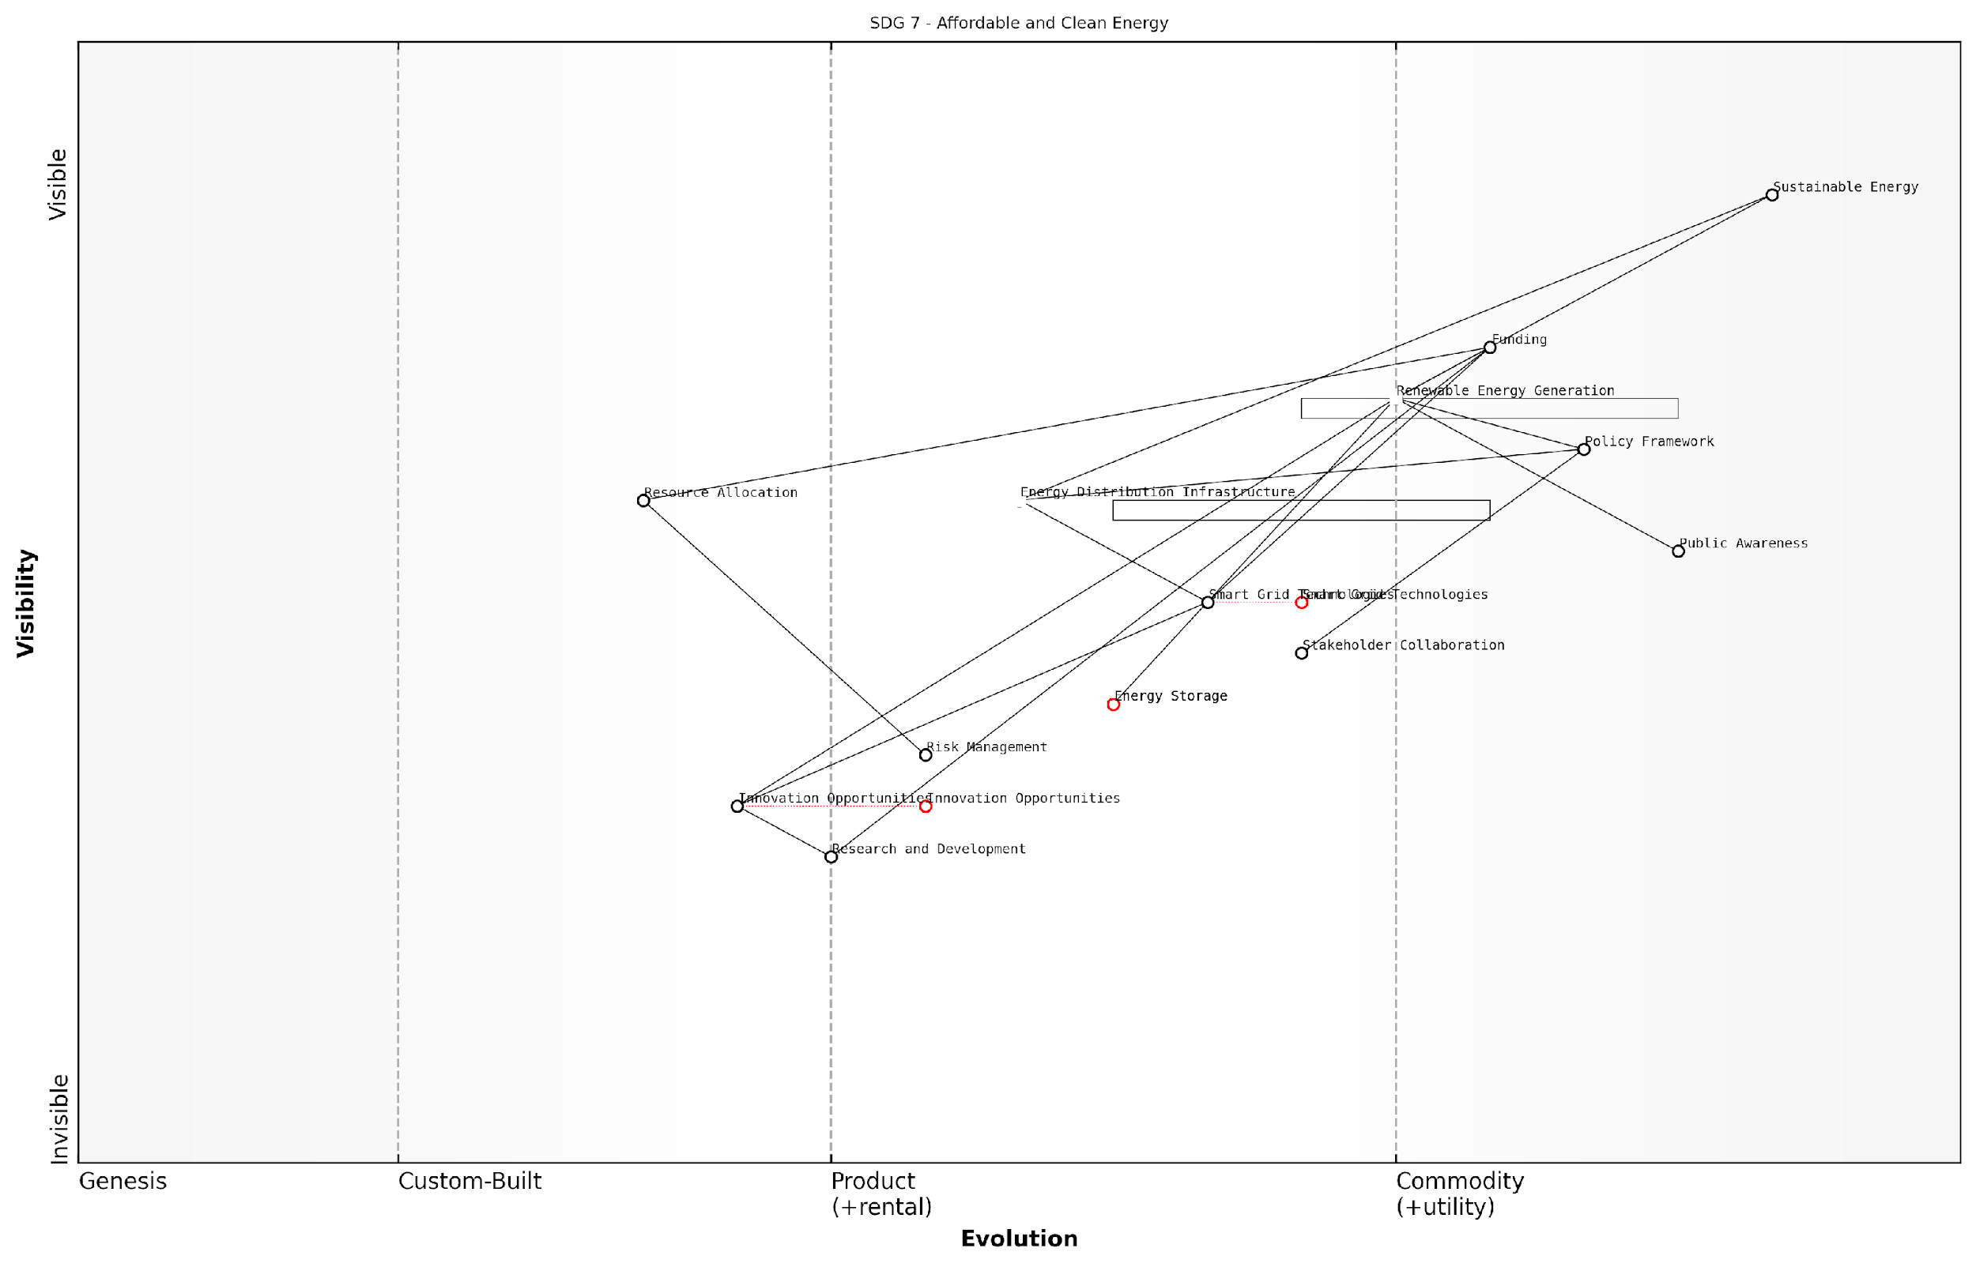

*Draft Wardley Map: [Insert Wardley Map visualisation of SDG 7 case study]*

[Edit this draft Wardley Map](https://create.wardleymaps.ai/#clone:5621561244a0a087f4)

This example demonstrates how Wardley Mapping can reveal non-obvious bottlenecks and guide strategic decision-making in complex sustainability challenges.

In conclusion, the power of Wardley Mapping for addressing the complex challenges of the SDGs lies in its ability to provide clarity, foster systemic thinking, and guide strategic action. As we continue to grapple with the monumental task of achieving global sustainability, this methodology offers a beacon of hope, illuminating the path forward through the intricate landscape of sustainable development.

### Applying Mapping to Global Sustainability Issues

As we delve into the application of Wardley Mapping to global sustainability issues, it becomes evident that this strategic tool offers unprecedented insights into the complex challenges posed by the United Nations Sustainable Development Goals (SDGs). The power of Wardley Mapping lies in its ability to visually represent the entire value chain of sustainability initiatives, from the most visible components to the underlying infrastructure and evolving technologies that drive progress.

Wardley Mapping, when applied to global sustainability issues, provides a unique lens through which we can examine the intricate relationships between various stakeholders, technologies, and processes involved in achieving the SDGs. This approach allows us to move beyond traditional linear thinking and embrace a more holistic view of sustainability challenges.

Wardley Mapping has revolutionised our approach to tackling global sustainability issues. It provides a clear visual representation of the complex ecosystems surrounding each SDG, allowing us to identify leverage points and potential areas for collaboration that were previously hidden from view.

Let us explore the key aspects of applying Wardley Mapping to global sustainability issues:

* Visualising Complexity: Wardley Maps help in visualising the intricate web of dependencies and relationships within each SDG ecosystem.
* Identifying Leverage Points: By mapping the value chain, we can pinpoint areas where interventions can have the most significant impact.
* Anticipating Evolution: The evolutionary aspect of Wardley Mapping allows us to forecast how different components of sustainability initiatives might evolve over time.
* Cross-Sector Collaboration: Maps facilitate the identification of potential synergies and conflicts between different sectors working towards the same goals.
* Resource Allocation: By understanding the landscape of each SDG, decision-makers can more effectively allocate resources to areas that will drive the most substantial progress.

One of the most powerful aspects of applying Wardley Mapping to global sustainability issues is its ability to reveal hidden dependencies and potential bottlenecks in achieving the SDGs. For instance, when mapping SDG 7 (Affordable and Clean Energy), we might discover that the success of renewable energy initiatives is heavily dependent on the development of energy storage technologies, which may be in earlier stages of evolution.

Moreover, Wardley Mapping can help identify unexpected opportunities for leapfrogging in developing countries. By visualising the entire value chain, we can spot areas where emerging technologies or innovative approaches can allow nations to bypass traditional development stages and move directly to more sustainable solutions.

The beauty of Wardley Mapping in the context of SDGs is that it forces us to consider not just the end goals, but the entire journey and ecosystem required to achieve them. This holistic view is crucial for developing truly sustainable and resilient strategies.

Another critical aspect of applying Wardley Mapping to global sustainability issues is its ability to facilitate cross-sector collaboration. By creating maps that span multiple SDGs, we can identify areas where different goals intersect and where collaborative efforts can yield multiplied benefits. For example, initiatives aimed at SDG 2 (Zero Hunger) may have significant overlaps with SDG 13 (Climate Action) in terms of sustainable agriculture practices.

Furthermore, Wardley Mapping can help in prioritising research and development efforts by highlighting components that are crucial for multiple SDGs but are still in the early stages of evolution. This insight can guide investment decisions and policy formulation to accelerate progress across multiple fronts simultaneously.

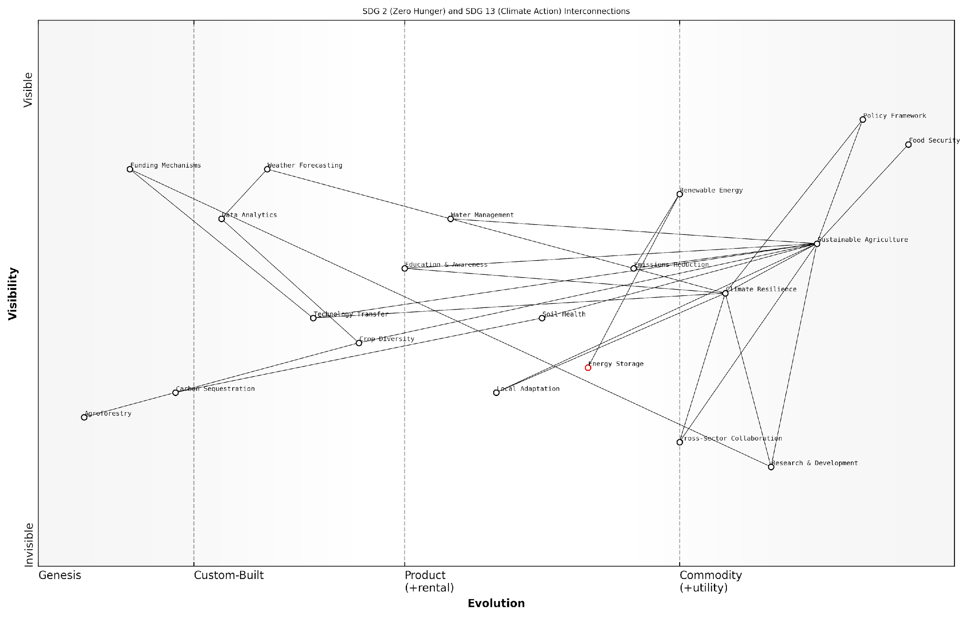

*Draft Wardley Map: [Insert Wardley Map illustrating the interconnections between SDG 2 (Zero Hunger) and SDG 13 (Climate Action), highlighting shared components and potential areas for collaborative innovation]*

[Edit this draft Wardley Map](https://create.wardleymaps.ai/#clone:43bb55aec960efcbdb)

When applying Wardley Mapping to global sustainability issues, it’s crucial to consider the varying contexts across different regions and countries. A map that works for a developed nation may not be directly applicable to a developing country. Therefore, the mapping process should be flexible and adaptable, taking into account local conditions, cultural factors, and existing infrastructure.

One of the challenges in applying Wardley Mapping to SDGs is the need for continuous updating and refinement of the maps. The sustainability landscape is rapidly evolving, with new technologies emerging and global conditions changing. Regular review and adjustment of the maps are essential to ensure they remain relevant and effective tools for decision-making.

Wardley Mapping is not a one-time exercise when it comes to SDGs. It’s an ongoing process of observation, analysis, and adaptation. The maps should be living documents that evolve as our understanding of sustainability challenges deepens and as new solutions emerge.

In conclusion, applying Wardley Mapping to global sustainability issues offers a powerful framework for understanding, strategising, and implementing initiatives aimed at achieving the SDGs. By providing a visual representation of the complex ecosystems surrounding each goal, Wardley Mapping enables more informed decision-making, fosters cross-sector collaboration, and helps identify innovative approaches to longstanding challenges. As we continue to grapple with the urgent need for sustainable development, Wardley Mapping stands out as an invaluable tool in our strategic arsenal, guiding us towards a more sustainable and equitable future for all.

### The UN Sustainable Development Goals: An Overview

In the realm of global sustainability, few challenges are as complex and interconnected as the United Nations Sustainable Development Goals (SDGs). As we navigate the intricate web of social, economic, and environmental issues that the SDGs aim to address, traditional strategic planning tools often fall short. Enter Wardley Mapping, a powerful methodology that has the potential to revolutionise how we approach and implement these ambitious global objectives.

Wardley Mapping, developed by Simon Wardley, is a strategic planning technique that provides a visual representation of the components needed to deliver a specific outcome, along with their evolutionary stage. When applied to the SDGs, this methodology offers a unique lens through which to view the complex challenges of sustainable development, enabling decision-makers to craft more effective and adaptable strategies.

Wardley Mapping is not just a tool; it’s a new language for strategy that allows us to see the invisible structures shaping our world. When applied to the SDGs, it reveals connections and opportunities that were previously hidden from view.

Let us explore the key aspects that make Wardley Mapping particularly powerful for addressing the complex challenges inherent in the SDGs:

* Visualising Complexity: Wardley Maps provide a clear visual representation of the entire value chain required to achieve a specific goal. This visual approach is invaluable when dealing with the multifaceted nature of the SDGs, allowing stakeholders to see the big picture and understand how different components interact.
* Understanding Evolution: By plotting components along an evolution axis, Wardley Mapping helps identify which elements of a strategy are likely to change over time. This is crucial for the long-term planning required by the SDGs, as it allows for more adaptive and resilient strategies.
* Identifying Dependencies: The mapping process reveals dependencies between different components, which is essential when dealing with the interconnected nature of the SDGs. This insight can help prevent unintended consequences and identify leverage points for maximum impact.
* Facilitating Collaboration: Wardley Maps serve as a common language for diverse stakeholders, from government officials to NGOs and private sector partners. This shared understanding is vital for the multi-stakeholder collaboration required to achieve the SDGs.
* Enabling Strategic Play: By understanding the landscape of components and their evolution, decision-makers can employ various strategic moves, such as outsourcing, building, or buying, to optimise their approach to SDG implementation.

When applied specifically to the SDGs, Wardley Mapping offers several unique benefits:

* Cross-Goal Analysis: By mapping multiple SDGs, we can identify synergies and potential conflicts between goals, leading to more integrated and effective strategies.
* Resource Optimisation: Understanding the full value chain allows for better allocation of limited resources, ensuring that investments are made where they will have the greatest impact.
* Innovation Opportunities: The evolutionary aspect of Wardley Mapping can highlight areas ripe for innovation, potentially leading to breakthrough solutions for sustainable development challenges.
* Risk Mitigation: By visualising the entire system, potential risks and bottlenecks can be identified early, allowing for proactive mitigation strategies.
* Progress Tracking: Wardley Maps can be updated over time, providing a visual representation of progress and helping to identify areas that may be lagging behind.

The beauty of Wardley Mapping lies in its ability to turn the abstract into the concrete. When we map the SDGs, we’re not just creating a strategy; we’re building a shared vision of the future that we can all work towards.

To illustrate the power of Wardley Mapping for SDG implementation, let’s consider a hypothetical example focused on SDG 6: Clean Water and Sanitation.

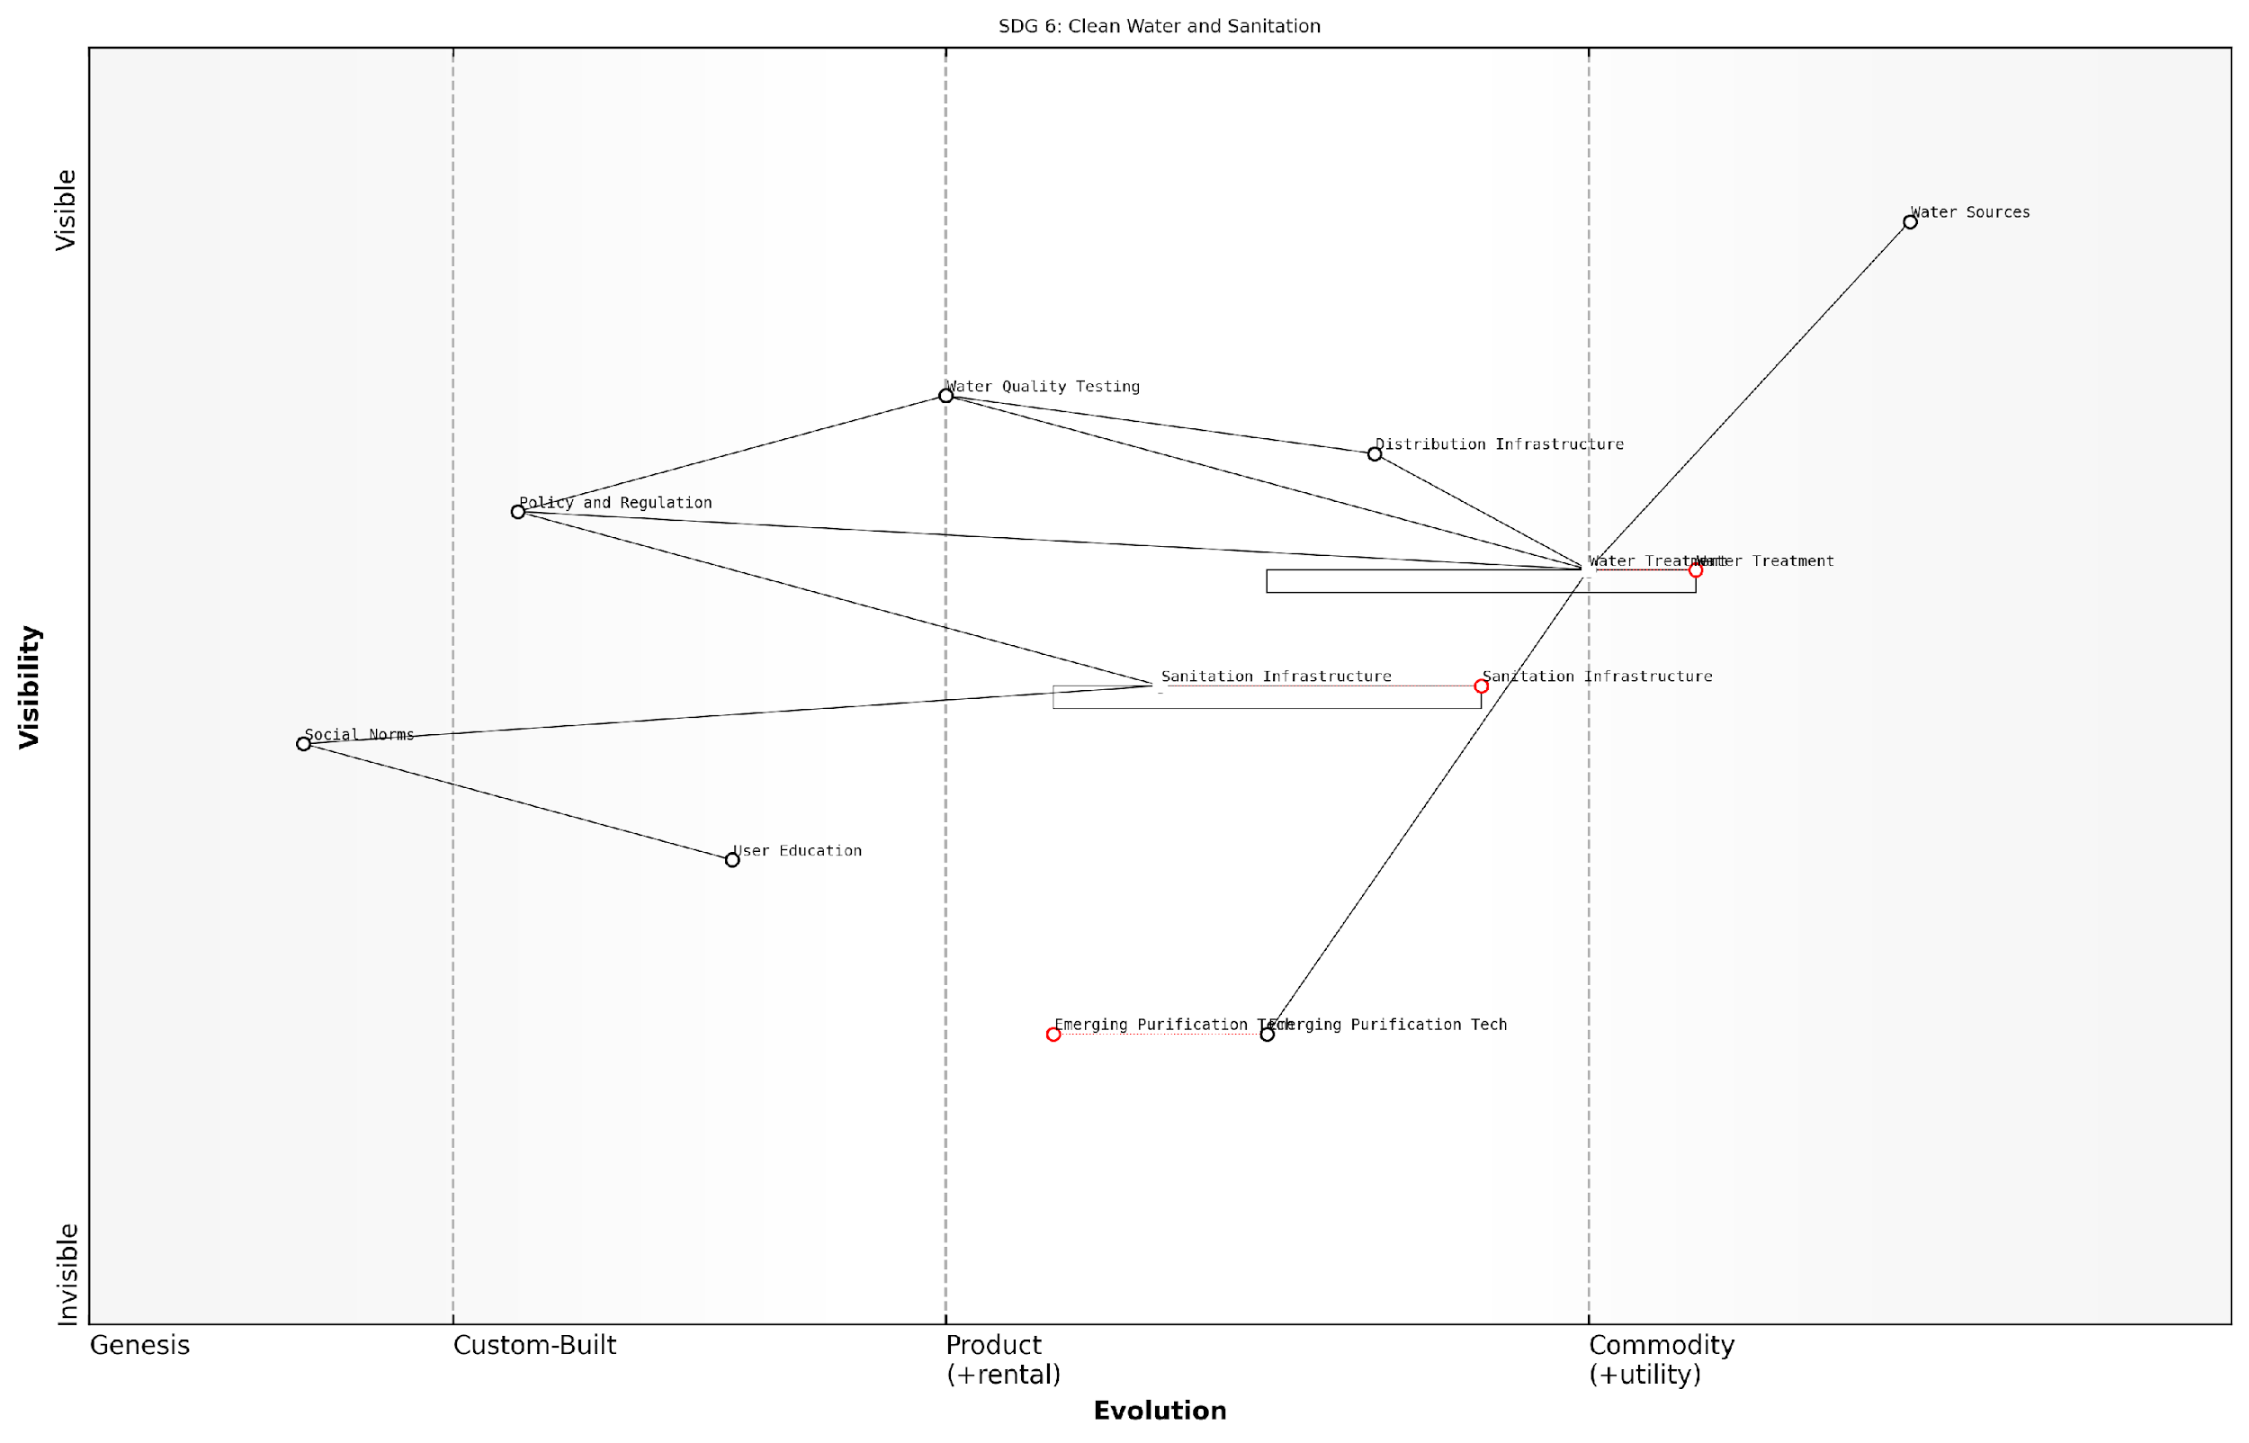

*Draft Wardley Map: [Insert Wardley Map for SDG 6: Clean Water and Sanitation]*

[Edit this draft Wardley Map](https://create.wardleymaps.ai/#clone:558ae9b5af4c42ed16)

In this map, we might see components ranging from water sources and treatment technologies to distribution infrastructure and user education. By plotting these elements along the evolution axis, we can identify which areas are ripe for innovation (e.g., emerging water purification technologies) and which require standardisation (e.g., water quality testing protocols). The map would also reveal dependencies, such as how improvements in sanitation infrastructure rely on both technological advancements and changes in social norms.

This visual representation allows policymakers and implementers to:

* Identify key leverage points for intervention
* Understand the ecosystem of stakeholders involved
* Anticipate future challenges and opportunities
* Align efforts across different sectors and organisations
* Make more informed decisions about resource allocation

As we delve deeper into the application of Wardley Mapping for the SDGs, it becomes clear that this methodology offers a powerful framework for tackling the world’s most pressing sustainability challenges. By providing a common language, a visual representation of complex systems, and a tool for strategic foresight, Wardley Mapping empowers decision-makers to craft more effective, adaptive, and impactful strategies for achieving the ambitious goals set forth by the United Nations.

In the subsequent sections of this book, we will explore how to apply Wardley Mapping to each of the 17 SDGs, examine case studies of successful implementations, and discuss strategies for cross-sector collaboration and future adaptation. By mastering this powerful tool, we can enhance our collective ability to create a more sustainable and equitable world for all.

## The Intersection of Strategy and Sustainability

### Why Traditional Approaches Fall Short

In the complex landscape of global sustainability, traditional strategic approaches often fail to capture the intricate web of interdependencies and evolving dynamics that characterise the United Nations Sustainable Development Goals (SDGs). As we delve into the intersection of strategy and sustainability, it becomes evident that conventional methods are ill-equipped to address the multifaceted challenges posed by the SDGs.

Traditional strategic planning typically relies on static models and linear thinking, which are inadequate for the following reasons:

* Lack of contextual awareness: Traditional approaches often fail to consider the broader ecosystem in which sustainability initiatives operate.
* Inability to capture dynamic relationships: The interconnected nature of SDGs requires a more fluid and adaptive strategic framework.
* Insufficient focus on value chains: Conventional methods rarely provide a clear view of how value is created and evolves within sustainability efforts.
* Limited capacity for cross-sector integration: SDGs demand collaboration across various sectors, which is challenging to map using traditional tools.
* Inadequate representation of technological evolution: The rapid pace of technological change and its impact on sustainability is often overlooked in standard strategic models.

To illustrate these shortcomings, let us consider the challenge of addressing SDG 7: Affordable and Clean Energy. A traditional approach might focus solely on increasing renewable energy production, without adequately considering the complex value chain that includes energy storage, distribution infrastructure, and consumer adoption patterns. This narrow view fails to account for the evolving landscape of energy technologies and the interdependencies with other SDGs, such as SDG 13: Climate Action and SDG 9: Industry, Innovation, and Infrastructure.

Traditional strategic planning often treats sustainability goals as isolated targets, failing to recognise the systemic nature of global challenges. This siloed approach is no longer sufficient in our interconnected world.

Moreover, the static nature of conventional strategic frameworks struggles to accommodate the rapid pace of change in sustainability contexts. For instance, the emergence of new technologies or shifts in global policy landscapes can quickly render traditional strategies obsolete. This inflexibility is particularly problematic when addressing long-term sustainability goals that require adaptive and responsive approaches.

Another critical limitation of traditional approaches is their inability to effectively visualise and communicate complex sustainability strategies across diverse stakeholder groups. In the context of SDGs, where collaboration between governments, private sector entities, and civil society organisations is crucial, this communication gap can significantly hinder progress.

Furthermore, traditional methods often fall short in identifying potential synergies and conflicts between different sustainability initiatives. For example, efforts to promote economic growth (SDG 8) may inadvertently conflict with environmental protection goals (SDGs 13, 14, and 15) if not carefully mapped and balanced.

The complexity of sustainable development demands a strategic approach that can visualise interconnections, anticipate evolutionary changes, and facilitate cross-sector collaboration. Traditional methods simply cannot meet these requirements.

To address these limitations, a more sophisticated and dynamic approach to strategy is required. This is where Wardley Mapping emerges as a powerful tool for navigating the complexities of SDG implementation. By providing a visual representation of the entire value chain and its evolution over time, Wardley Mapping offers several advantages over traditional strategic approaches:

* Contextual awareness: Wardley Maps situate sustainability initiatives within their broader ecosystem, revealing dependencies and opportunities.
* Dynamic representation: The mapping process captures the evolving nature of technologies, practices, and stakeholder needs in the sustainability landscape.
* Value chain focus: By explicitly mapping the value chain, Wardley Mapping helps identify key leverage points and potential areas for innovation in SDG implementation.
* Cross-sector integration: The visual nature of Wardley Maps facilitates collaboration and alignment across different sectors and stakeholder groups.
* Technological foresight: The evolutionary axis in Wardley Mapping allows for better anticipation and planning around technological advancements relevant to SDGs.

As we progress through this book, we will explore how Wardley Mapping can be applied to overcome the limitations of traditional approaches, providing a more nuanced, adaptive, and effective strategy for implementing the UN Sustainable Development Goals.

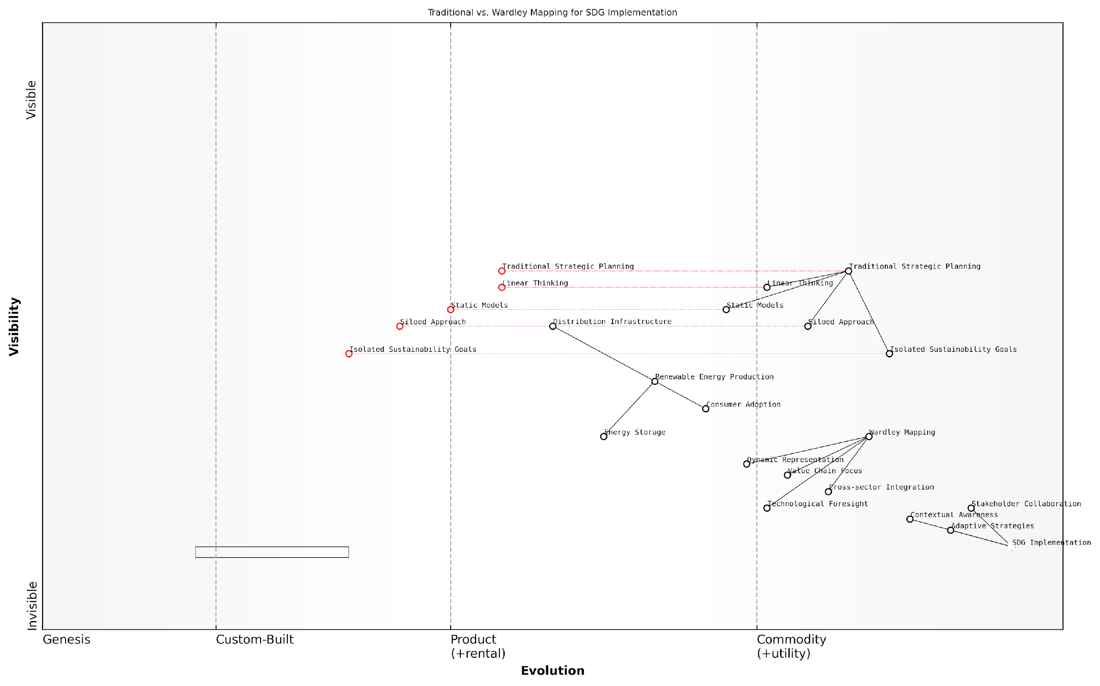

*Draft Wardley Map: [Insert Wardley Map comparing traditional strategic approach vs. Wardley Mapping approach for SDG implementation]*

[Edit this draft Wardley Map](https://create.wardleymaps.ai/#clone:f77e43ede8458aa0b5)

By recognising the shortcomings of traditional approaches and embracing the power of Wardley Mapping, policymakers, business leaders, and sustainability practitioners can develop more robust, adaptable, and impactful strategies for achieving the SDGs. This shift in strategic thinking is not merely an academic exercise; it is a crucial step towards realising the transformative vision of the 2030 Agenda for Sustainable Development.

### The Strategic Advantage of Value Chain Mapping

In the complex landscape of global sustainability, the strategic advantage of value chain mapping emerges as a pivotal tool for addressing the United Nations Sustainable Development Goals (SDGs). As we navigate the intricate web of interconnected challenges presented by the SDGs, traditional strategic approaches often fall short in capturing the full scope and dynamics of these issues. Value chain mapping, particularly through the lens of Wardley Mapping, offers a transformative perspective that aligns seamlessly with the multifaceted nature of sustainable development.

At its core, value chain mapping provides a visual representation of the components and dependencies within a system, allowing for a comprehensive understanding of how value is created and delivered. When applied to the SDGs, this approach unveils critical insights that can drive more effective and sustainable strategies. Let us explore the key advantages that value chain mapping brings to the table in the context of global sustainability efforts.

* Holistic System Visualisation
* Identification of Leverage Points
* Dynamic Strategy Formulation
* Cross-Sector Collaboration Enhancement
* Risk and Opportunity Assessment

Holistic System Visualisation: One of the primary benefits of value chain mapping is its ability to provide a holistic view of the entire system. In the context of SDGs, this means capturing not just the visible elements of sustainability challenges, but also the underlying infrastructure, technologies, and societal factors that influence outcomes. This comprehensive perspective is crucial for policymakers and practitioners who need to understand the full scope of their interventions.

Value chain mapping allows us to see the forest and the trees simultaneously, providing an unparalleled view of the sustainability landscape that traditional methods simply cannot match.

Identification of Leverage Points: By mapping out the entire value chain, we can identify key leverage points where interventions can have the most significant impact. This is particularly valuable in the context of SDGs, where resources are often limited, and maximising impact is crucial. Value chain mapping helps pinpoint areas where small changes can lead to cascading positive effects across multiple goals.

Dynamic Strategy Formulation: The SDGs operate in a rapidly changing global environment. Value chain mapping, especially when done through Wardley Mapping, incorporates the concept of evolution, allowing strategies to adapt to changing circumstances. This dynamic approach ensures that sustainability strategies remain relevant and effective over time, even as technologies advance and societal needs shift.

Cross-Sector Collaboration Enhancement: The interconnected nature of the SDGs necessitates collaboration across various sectors and stakeholders. Value chain mapping provides a common language and visual framework that facilitates communication and cooperation between different actors. By clearly illustrating how various components interact, it becomes easier to identify opportunities for synergy and avoid duplication of efforts.

In my experience advising government bodies, I’ve seen how value chain maps can break down silos and foster unprecedented levels of collaboration. They serve as a universal translator between diverse stakeholders, each bringing their unique perspective to the sustainability challenge.

Risk and Opportunity Assessment: Value chain mapping excels at highlighting both risks and opportunities within a system. For SDG implementation, this means identifying potential bottlenecks or vulnerabilities that could hinder progress, as well as uncovering hidden opportunities for innovation and impact. This dual perspective is invaluable for crafting robust and forward-thinking sustainability strategies.

Practical Application in SDG Context: To illustrate the power of value chain mapping for SDGs, let’s consider a hypothetical example focused on SDG 6: Clean Water and Sanitation. A value chain map for this goal might include components ranging from water sources and treatment technologies to distribution infrastructure and end-user behaviour. By mapping these elements, we can identify critical dependencies, such as the reliance of water quality on both treatment technologies and upstream pollution control measures.

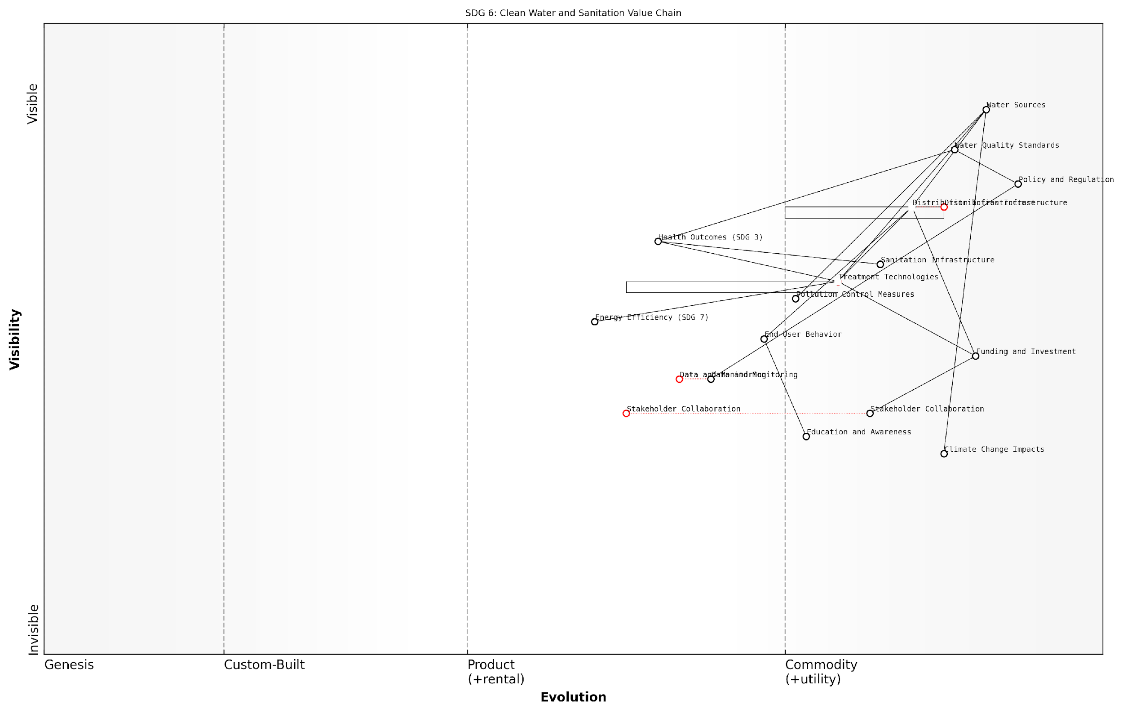

*Draft Wardley Map: [Insert Wardley Map: SDG 6 Value Chain]*

[Edit this draft Wardley Map](https://create.wardleymaps.ai/#clone:16369648d2d863099f)

This map would reveal leverage points, such as the potential for new treatment technologies to leapfrog traditional infrastructure in underserved areas. It might also highlight risks, like the vulnerability of water sources to climate change impacts, prompting the development of more resilient strategies.

Moreover, the map would illustrate connections to other SDGs, such as the link between clean water and health outcomes (SDG 3) or the role of energy efficiency in water treatment (SDG 7). This interconnected view enables policymakers to develop integrated strategies that address multiple goals simultaneously, maximising the impact of limited resources.

In conclusion, the strategic advantage of value chain mapping for SDG implementation cannot be overstated. It provides a powerful toolkit for understanding, planning, and executing sustainability initiatives in a way that acknowledges the complex, interconnected nature of global challenges. As we move forward in our quest for a more sustainable future, value chain mapping will undoubtedly play a crucial role in shaping effective strategies and driving meaningful progress towards the SDGs.

### Building a Framework for SDG Implementation

As we delve into the intersection of strategy and sustainability, it becomes evident that building a robust framework for SDG implementation is crucial. This framework must not only address the complexities of each individual goal but also account for the interconnected nature of the SDGs and the diverse stakeholders involved in their realisation. Wardley Mapping provides a powerful tool for constructing such a framework, offering a visual and strategic approach to understanding the value chains that underpin sustainable development efforts.

The framework for SDG implementation through Wardley Mapping can be broken down into several key components:

* Value Chain Identification
* Stakeholder Mapping
* Evolution Assessment
* Cross-Goal Dependencies
* Strategic Alignment
* Action Prioritisation

Let’s explore each of these components in detail:

1. Value Chain Identification: The first step in building our framework is to identify the key value chains for each SDG. This involves mapping out the components that contribute to the goal’s achievement, from user needs to enabling technologies and infrastructure. For instance, when mapping SDG 6 (Clean Water and Sanitation), we might identify components such as water sources, purification technologies, distribution networks, and end-user access points.

Understanding the value chain is critical. It allows us to see beyond surface-level interventions and identify the foundational elements that drive sustainable change.

1. Stakeholder Mapping: Once the value chain is established, we must identify and map the key stakeholders involved at each stage. This includes government bodies, private sector entities, NGOs, and local communities. By visualising these stakeholders on our Wardley Map, we can better understand their roles, influences, and potential contributions to the SDG implementation process.
2. Evolution Assessment: A crucial aspect of Wardley Mapping is understanding the evolution of components along the value chain. In the context of SDGs, this means assessing how different elements of our sustainability efforts are likely to evolve over time. For example, renewable energy technologies (relevant to SDG 7 - Affordable and Clean Energy) have been rapidly evolving from custom-built solutions to more commoditised products, changing the strategic landscape for implementation.
3. Cross-Goal Dependencies: The SDGs are inherently interconnected, and our framework must reflect this. By creating Wardley Maps for multiple SDGs, we can identify areas of overlap, potential synergies, and conflicts. This holistic view is essential for developing integrated strategies that maximise impact across multiple goals simultaneously.

The power of Wardley Mapping for SDGs lies in its ability to reveal the hidden connections between seemingly disparate goals. It’s these connections that often hold the key to transformative change.

1. Strategic Alignment: With a clear understanding of value chains, stakeholders, evolution, and cross-goal dependencies, we can begin to align our strategies with the broader landscape. This involves identifying areas where we can leverage existing capabilities, where we need to develop new competencies, and where partnerships can fill gaps in our value chains.
2. Action Prioritisation: The final component of our framework is the prioritisation of actions. By visualising the entire landscape of SDG implementation, we can identify the most impactful interventions and allocate resources accordingly. This might involve focusing on ‘linchpin’ components that have outsized effects on multiple goals or addressing critical gaps in our value chains.

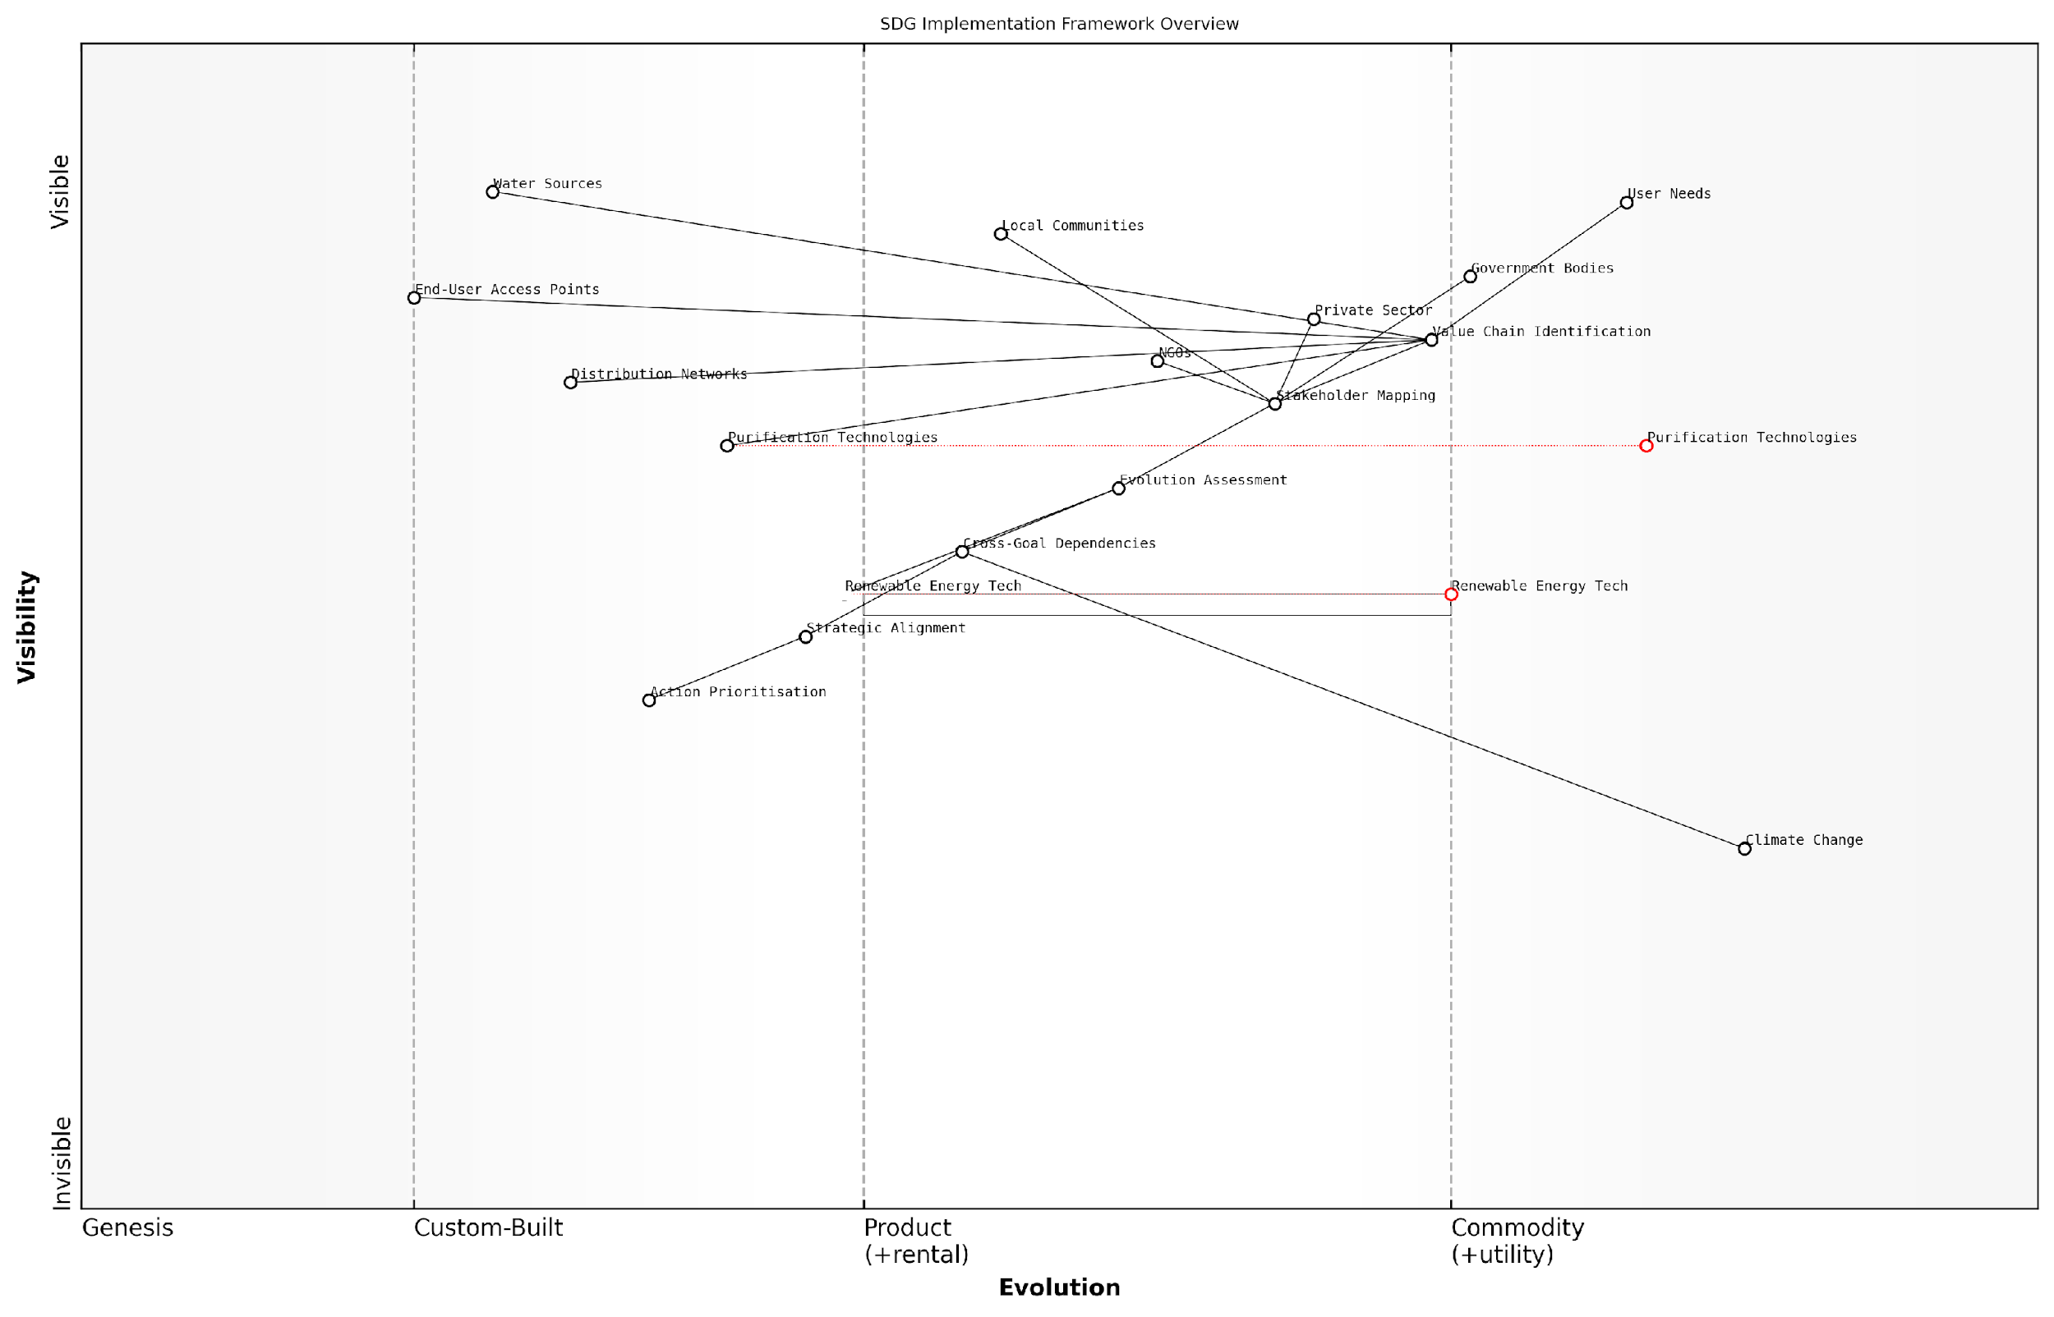

*Draft Wardley Map: [Insert Wardley Map: ‘SDG Implementation Framework Overview’]*

[Edit this draft Wardley Map](https://create.wardleymaps.ai/#clone:5e96c489aa2e0c7927)

Implementing this framework requires a shift in how we approach sustainability strategies. Traditional methods often focus on isolated initiatives or broad, unfocused efforts. In contrast, our Wardley Mapping-based framework provides a structured, visual approach that accounts for the complex, evolving nature of sustainable development.

One of the key advantages of this framework is its adaptability. As new data emerges, technologies evolve, or geopolitical landscapes shift, we can update our maps and adjust our strategies accordingly. This dynamic approach is particularly crucial in the face of long-term challenges like climate change, where flexibility and responsiveness are essential.

Moreover, this framework facilitates better communication and collaboration among diverse stakeholders. By providing a shared visual language, Wardley Maps can help align the efforts of government agencies, businesses, NGOs, and local communities towards common sustainability goals.

In my experience advising government bodies on SDG implementation, I’ve found that the visual nature of Wardley Maps often leads to ‘aha’ moments, where stakeholders suddenly see connections and opportunities they hadn’t previously considered.

However, it’s important to note that building and implementing this framework is not without challenges. It requires a significant investment of time and resources to create comprehensive maps for each SDG and to keep them updated. Additionally, it demands a shift in mindset for many organisations, moving from siloed thinking to a more holistic, systems-based approach.

Despite these challenges, the potential benefits of this framework are substantial. By providing a clear, strategic view of the SDG implementation landscape, it enables more targeted interventions, better resource allocation, and ultimately, accelerated progress towards our global sustainability goals.

As we move forward in our exploration of Wardley Mapping for SDGs, this framework will serve as a foundation for our more detailed analyses of individual goals and cross-sector collaborations. It provides a roadmap for translating the high-level aspirations of the SDGs into concrete, actionable strategies that can drive real-world impact.

# Mapping the 17 Sustainable Development Goals

## People: Mapping Social Development Goals

### No Poverty and Zero Hunger

As we embark on mapping the United Nations Sustainable Development Goals (SDGs) using Wardley Mapping, it is crucial to begin with the foundational goals of No Poverty (SDG 1) and Zero Hunger (SDG 2). These goals form the bedrock of human dignity and are essential prerequisites for achieving all other SDGs. The interconnected nature of these goals necessitates a strategic approach that leverages the power of Wardley Mapping to visualise the complex value chains and identify key leverage points for effective intervention.

Wardley Mapping, with its focus on value chain analysis and strategic positioning, offers a unique lens through which we can examine the multifaceted challenges of poverty and hunger. By mapping these goals, we can uncover hidden dependencies, identify opportunities for innovation, and develop more targeted and effective strategies for their eradication.

Wardley Mapping allows us to see the forest and the trees simultaneously, providing a holistic view of the poverty and hunger landscape while also revealing the granular details that often escape traditional analysis methods.

Let us now delve into the specific applications of Wardley Mapping for SDG 1 and SDG 2, exploring how this strategic tool can revolutionise our approach to these critical global challenges.

Mapping No Poverty (SDG 1):

When applying Wardley Mapping to SDG 1, we begin by identifying the key components of poverty eradication and positioning them along the value chain from genesis to commodity. This process reveals several critical insights:

* Visibility of root causes: Mapping exposes the underlying factors contributing to poverty, such as lack of access to education, healthcare, and economic opportunities.
* Interdependencies: The map highlights the interconnections between various poverty-related issues, demonstrating how progress in one area can catalyse improvements in others.
* Innovation opportunities: By visualising the entire poverty eradication landscape, we can identify areas ripe for innovation and disruption.
* Resource allocation: The map guides more efficient resource allocation by revealing which components are most critical and which are underserved.
* Policy alignment: Wardley Mapping helps align poverty reduction policies with the natural evolution of societal and technological advancements.

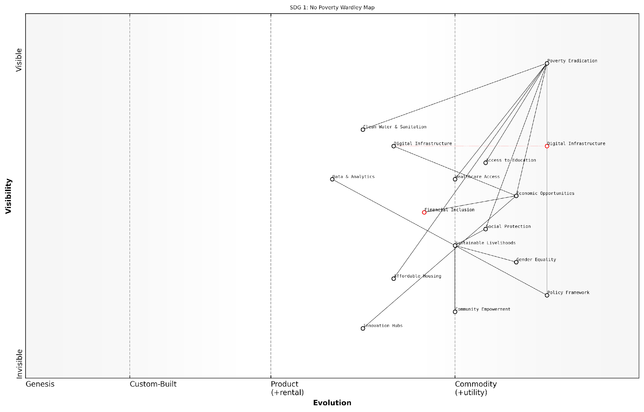

*Draft Wardley Map: [Insert Wardley Map for SDG 1: No Poverty]*

[Edit this draft Wardley Map](https://create.wardleymaps.ai/#clone:5a046b169935330f94)

Mapping Zero Hunger (SDG 2):

Applying Wardley Mapping to SDG 2 requires a similar approach, but with a focus on the unique challenges of food security and sustainable agriculture. Key insights from this mapping process include:

* Supply chain optimisation: The map reveals inefficiencies in food production and distribution systems, highlighting opportunities for improvement.
* Technology integration: By positioning agricultural technologies along the evolution axis, we can identify which innovations are likely to have the most significant impact.
* Climate resilience: Mapping helps visualise the relationship between climate change and food security, enabling the development of more resilient agricultural practices.
* Nutritional focus: The map can incorporate nutritional value as a dimension, ensuring that strategies address not just food quantity but also quality.
* Stakeholder collaboration: Wardley Mapping facilitates better coordination among various stakeholders in the food system, from farmers to policymakers.

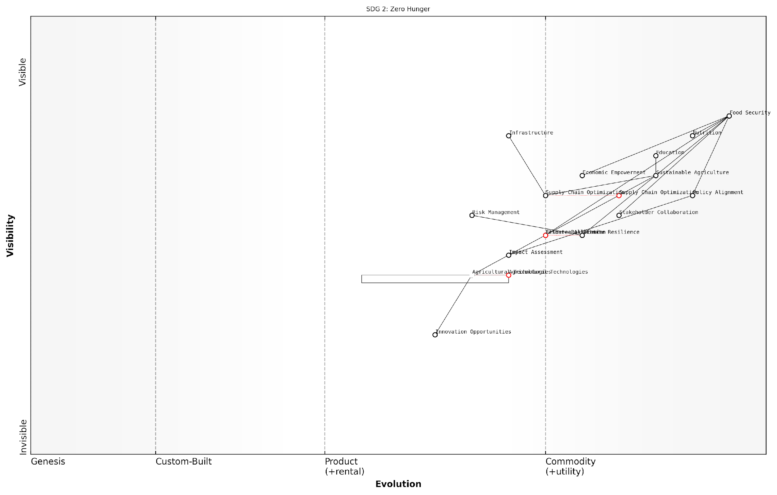

*Draft Wardley Map: [Insert Wardley Map for SDG 2: Zero Hunger]*

[Edit this draft Wardley Map](https://create.wardleymaps.ai/#clone:440e0803830bc3fee2)

Integrating SDG 1 and SDG 2 through Wardley Mapping:

One of the most powerful aspects of Wardley Mapping is its ability to reveal connections between seemingly disparate elements. When we overlay the maps for SDG 1 and SDG 2, we uncover critical synergies and potential conflicts:

* Shared infrastructure: The maps may reveal common infrastructure needs, such as transportation networks or digital platforms, that can serve both poverty reduction and food security goals.
* Economic empowerment: Strategies that increase agricultural productivity can simultaneously address hunger and provide economic opportunities, reducing poverty.
* Education linkages: Both maps are likely to highlight the importance of education, suggesting that investments in this area can have multiplied benefits across both SDGs.
* Resource conflicts: The integrated map may expose potential conflicts, such as land use for agriculture versus urban development, allowing for proactive conflict resolution.
* Policy coherence: By visualising both SDGs together, policymakers can ensure that strategies for one goal do not inadvertently undermine progress towards the other.

The true power of Wardley Mapping for SDGs lies not just in mapping individual goals, but in revealing the intricate web of relationships between them. This holistic view is essential for developing truly sustainable and effective strategies.

Practical Applications for Government and Public Sector:

For government officials and public sector leaders, Wardley Mapping of SDG 1 and SDG 2 offers several practical applications:

* Strategic planning: Use the maps to develop long-term strategies that account for the evolution of technologies and societal needs.
* Budget allocation: Justify budget decisions based on the strategic importance of different components revealed by the maps.
* Cross-department collaboration: Utilise the maps to facilitate better coordination between different government departments and agencies.
* Public-private partnerships: Identify opportunities for collaboration with the private sector by pinpointing areas where business interests align with SDG objectives.
* Impact assessment: Develop more accurate methods for assessing the impact of poverty reduction and food security initiatives.
* Risk management: Anticipate potential risks and challenges by analysing the dependencies and evolution patterns shown in the maps.

In conclusion, Wardley Mapping provides a powerful framework for tackling the complex challenges of poverty and hunger. By visualising the value chains, evolution, and interdependencies within and between these SDGs, we can develop more effective, sustainable, and integrated strategies. As we continue to map the remaining SDGs, the insights gained from this process will prove invaluable in our collective effort to create a more equitable and sustainable world.

### Good Health and Well-being

Good Health and Well-being, the third Sustainable Development Goal (SDG 3), is a cornerstone of sustainable development and a critical component in the pursuit of global prosperity. As we apply Wardley Mapping to this goal, we uncover the complex value chain that underpins health systems and well-being initiatives worldwide. This strategic approach allows us to visualise the components, dependencies, and evolution of health-related services and technologies, providing invaluable insights for policymakers and health sector leaders.

To effectively map SDG 3, we must consider several key aspects:

* Healthcare infrastructure and access
* Disease prevention and management
* Maternal and child health
* Mental health and well-being
* Health technology and innovation
* Healthcare workforce development
* Health policy and governance

Let’s explore each of these aspects through the lens of Wardley Mapping, considering their position on the value chain and their evolutionary stage.

Healthcare Infrastructure and Access:

At the foundation of SDG 3 lies the physical and organisational structures that enable healthcare delivery. On a Wardley Map, we would position basic healthcare facilities (e.g., primary care clinics) towards the value chain’s visible end, as they directly interface with patients. However, their evolutionary stage may vary significantly between regions. In developed nations, these might be in the ‘Product’ or even ‘Commodity’ stage, while in less developed areas, they could still be in the ‘Custom-Built’ phase.

The key to improving global health outcomes lies in understanding the evolutionary stages of healthcare components across different regions and strategically investing in their development.

Disease Prevention and Management:

This aspect encompasses a wide range of activities, from vaccination programmes to chronic disease management. On our map, we would position preventive measures (like vaccines) as more evolved components, often reaching the ‘Product’ stage globally. However, management strategies for emerging diseases or complex conditions might still be in the ‘Genesis’ or ‘Custom-Built’ stages, requiring significant research and development.

Maternal and Child Health:

Improving maternal and child health is crucial for achieving SDG 3. On our Wardley Map, we would position basic maternal care services towards the visible end of the value chain, with varying levels of evolution across different regions. Advanced neonatal care technologies might be positioned further down the value chain and at earlier evolutionary stages, particularly in developing countries.

Mental Health and Well-being:

Mental health services have gained increasing recognition in recent years. On our map, we might position mental health awareness and basic support services towards the visible end, but still in early evolutionary stages in many regions. More specialised treatments and technologies would be positioned further down the value chain, often in the ‘Genesis’ or ‘Custom-Built’ stages.

Health Technology and Innovation:

Emerging health technologies, such as AI-driven diagnostics or personalised medicine, would typically be positioned towards the invisible end of the value chain and in early evolutionary stages. However, their potential to disrupt and evolve other components of the healthcare system makes them critical elements to monitor and nurture.

In the rapidly evolving landscape of health technology, Wardley Mapping provides a crucial tool for anticipating and preparing for disruptive innovations that could revolutionise healthcare delivery.

Healthcare Workforce Development:

The healthcare workforce is a critical component of SDG 3. On our map, we would position basic medical training towards the visible end and in more evolved stages. However, specialised skills and continuous professional development would be further down the value chain and in earlier evolutionary stages, reflecting the ongoing need for adaptation to new medical knowledge and technologies.

Health Policy and Governance:

Effective health policies and governance structures are essential for achieving SDG 3. These would be positioned towards the invisible end of the value chain, as they enable and regulate other components. Their evolutionary stage may vary, with some fundamental policies reaching ‘Product’ stage, while more adaptive governance models might still be in ‘Genesis’ or ‘Custom-Built’ stages.

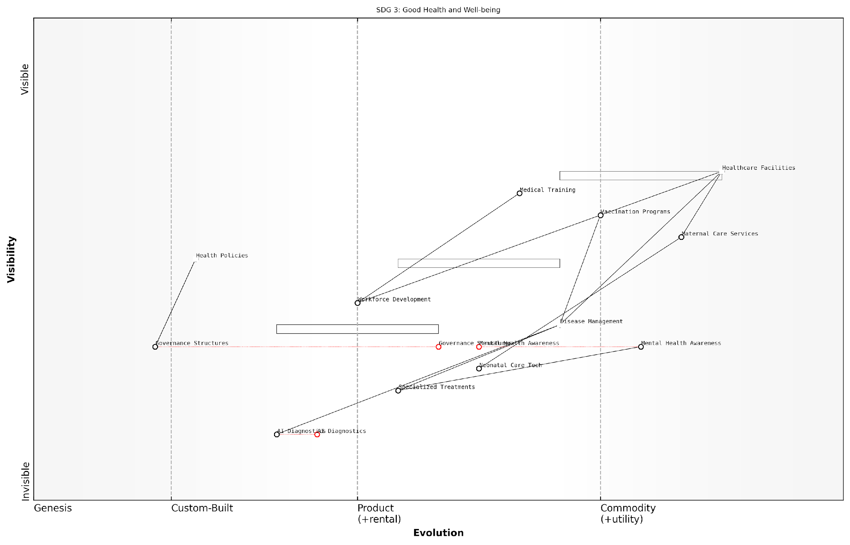

*Draft Wardley Map: [Insert Wardley Map visualising the key components of SDG 3, their positions on the value chain, and their evolutionary stages]*

[Edit this draft Wardley Map](https://create.wardleymaps.ai/#clone:0ab19fb80f2299ce66)

By mapping these various aspects of SDG 3, we can identify critical dependencies, potential areas for innovation, and opportunities for strategic investment. For instance, we might discover that investing in health technology innovation could accelerate the evolution of disease management strategies, or that focusing on healthcare workforce development could improve the effectiveness of mental health services.

Moreover, this mapping approach allows us to compare the state of health systems across different regions or countries, identifying areas where knowledge transfer or resource sharing could yield significant benefits. It also helps in anticipating future challenges and opportunities, such as the impact of emerging technologies or changing demographic patterns on healthcare needs.

In conclusion, Wardley Mapping provides a powerful tool for visualising and strategising the complex landscape of SDG 3. By understanding the positions and evolutionary stages of various health-related components, policymakers and health sector leaders can make more informed decisions, allocate resources more effectively, and ultimately accelerate progress towards achieving good health and well-being for all.

### Quality Education and Gender Equality

In the realm of sustainable development, Quality Education (SDG 4) and Gender Equality (SDG 5) stand as pivotal goals that are intrinsically linked and mutually reinforcing. As we apply Wardley Mapping to these crucial SDGs, we uncover the complex value chains and interdependencies that underpin their successful implementation. This strategic approach allows us to visualise the journey from basic educational infrastructure to advanced learning systems, whilst simultaneously addressing the multifaceted challenges of achieving gender parity across all levels of society.

Wardley Mapping these SDGs reveals a landscape where traditional educational models are evolving rapidly, driven by technological advancements and changing societal needs. Concurrently, the push for gender equality is reshaping institutional structures and cultural norms, creating a dynamic interplay between these two goals that demands a nuanced strategic approach.

The intersection of education and gender equality represents a critical leverage point in sustainable development. By mapping these goals, we can identify key interventions that yield multiplicative benefits across the entire SDG framework.

Let us delve into the key components of mapping Quality Education and Gender Equality:

* Educational Infrastructure and Access
* Curriculum Development and Teacher Training
* Digital Learning Platforms and EdTech
* Gender-sensitive Policies and Practices
* Women’s Empowerment Initiatives
* Intersectionality and Inclusive Education

Educational Infrastructure and Access form the foundation of our Wardley Map. At the genesis stage, we find basic physical infrastructure such as school buildings and textbooks. As we move towards more evolved components, we encounter digital infrastructure and internet connectivity, which are becoming increasingly crucial in the modern educational landscape.

Curriculum Development and Teacher Training occupy a central position in our map. These components are in a constant state of flux, adapting to new pedagogical approaches and the demands of an ever-changing job market. Gender-responsive curricula and training programmes that challenge stereotypes are particularly important in this context.

Digital Learning Platforms and EdTech represent a rapidly evolving sector on our map. These technologies are transforming the delivery of education, offering unprecedented opportunities for personalised learning and expanded access. However, they also present challenges in terms of the digital divide and gender disparities in technology access and use.

The integration of EdTech must be carefully mapped to ensure it bridges, rather than widens, existing educational and gender gaps. Our strategic approach must account for varying levels of technological readiness across different regions and demographics.

Gender-sensitive Policies and Practices are crucial components that span across various stages of evolution. At the more genesis end, we find basic anti-discrimination policies. Moving towards the more evolved end, we encounter sophisticated gender mainstreaming strategies that permeate all aspects of educational systems and broader societal structures.

Women’s Empowerment Initiatives occupy a unique position on our map, often serving as catalysts for change across multiple components. These range from grassroots literacy programmes to high-level leadership development initiatives, each playing a vital role in advancing both education and gender equality goals.

Intersectionality and Inclusive Education represent some of the most evolved components on our map. These approaches recognise the complex interplay of various forms of discrimination and seek to create educational systems that are truly accessible and empowering for all, regardless of gender, race, disability status, or other factors.

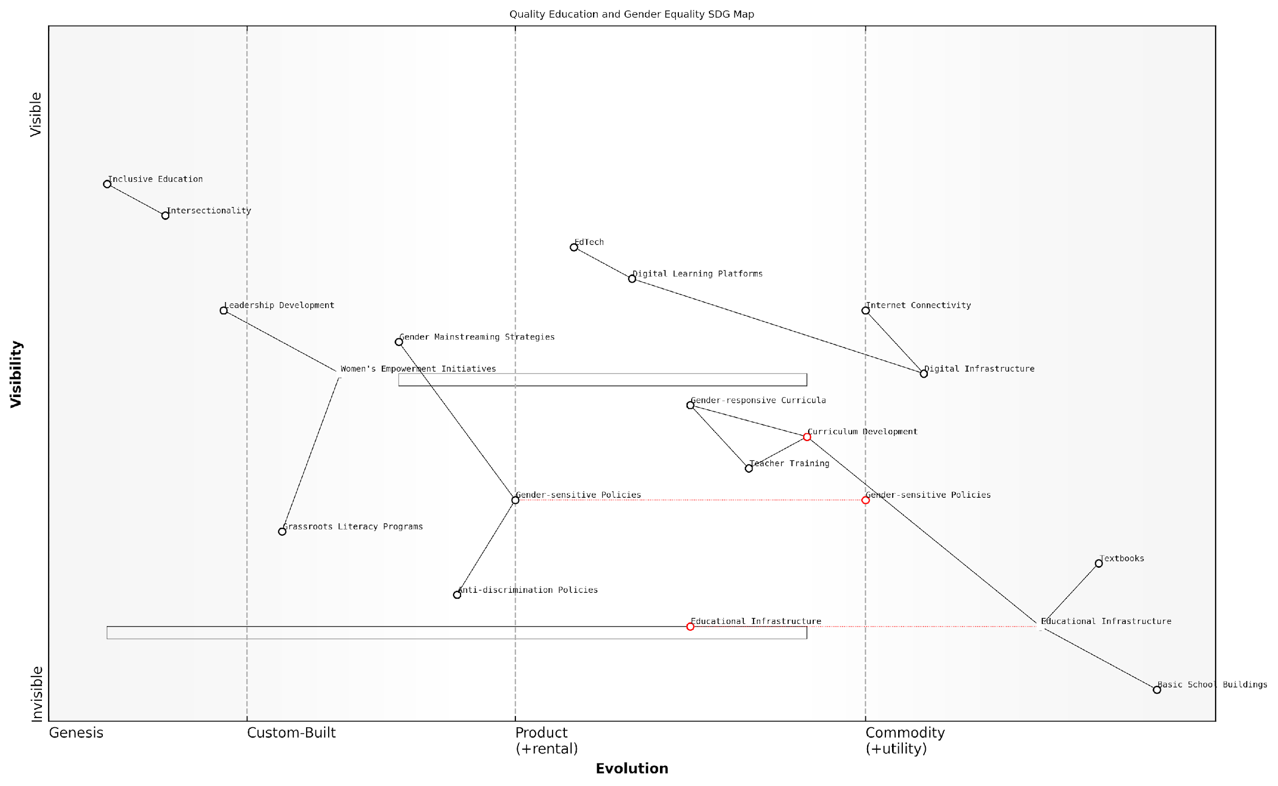

*Draft Wardley Map: [Insert Wardley Map visualising the components of Quality Education and Gender Equality, showing their evolutionary stages and interdependencies]*

[Edit this draft Wardley Map](https://create.wardleymaps.ai/#clone:3c2838ca3650781199)

By mapping these components, we can identify critical dependencies and potential leverage points. For instance, improvements in digital infrastructure can dramatically expand access to education, particularly for girls in remote areas. Similarly, gender-sensitive teacher training can have a ripple effect, influencing curriculum development, classroom dynamics, and ultimately, societal attitudes.

However, our mapping also reveals potential challenges and conflicts. For example, the rapid evolution of EdTech may outpace the development of gender-sensitive digital policies, potentially exacerbating existing inequalities. Recognising these dynamics allows policymakers and educators to implement proactive strategies to mitigate such risks.

The power of Wardley Mapping in this context lies in its ability to reveal not just the current state of education and gender equality, but also the direction of movement. This foresight is crucial for developing adaptive, future-proof strategies in a rapidly changing global landscape.

In my experience advising government bodies on SDG implementation, I’ve observed that those who employ Wardley Mapping for Quality Education and Gender Equality are better equipped to navigate the complex interplay between these goals. They are able to identify synergies, anticipate challenges, and develop more holistic, effective strategies.

A case in point is a recent project with a European education ministry. By mapping the education system through a gender equality lens, we identified that while digital learning platforms were evolving rapidly, gender-sensitive content creation was lagging behind. This insight led to the development of a targeted initiative to train content creators in gender-responsive design, ensuring that the benefits of EdTech were equitably distributed.

As we continue to map and analyse these SDGs, it becomes clear that achieving quality education and gender equality requires a dynamic, systems-thinking approach. Wardley Mapping provides the strategic framework necessary to navigate this complexity, enabling policymakers and educators to craft interventions that are not only effective in the short term but also sustainable and adaptable in the face of future challenges.

In conclusion, the application of Wardley Mapping to Quality Education and Gender Equality offers a powerful tool for visualising, analysing, and strategising the path towards these crucial SDGs. By understanding the evolutionary stages of various components and their interdependencies, we can develop more nuanced, effective approaches to creating educational systems that are both high-quality and equitable, paving the way for a more sustainable and just future for all.

## Planet: Mapping Environmental Sustainability Goals

### Clean Water and Sanitation

Clean water and sanitation, encapsulated in Sustainable Development Goal 6 (SDG 6), represent fundamental pillars of environmental sustainability and human well-being. As we delve into mapping this critical goal using Wardley Mapping techniques, we uncover the complex value chain that underpins water resource management, sanitation infrastructure, and the myriad interconnected elements that contribute to achieving universal access to clean water and adequate sanitation facilities.

Wardley Mapping offers a unique lens through which to view the challenges and opportunities associated with SDG 6. By visualising the components of water and sanitation systems along axes of evolution and value chain, we can identify key leverage points, potential areas for innovation, and critical dependencies that might otherwise remain obscured in traditional strategic planning approaches.

Wardley Mapping has revolutionised our approach to tackling water scarcity and sanitation issues. It’s not just about building infrastructure; it’s about understanding the entire ecosystem of water management and how it evolves over time.

Let us break down the key components of SDG 6 and explore how Wardley Mapping can illuminate the path towards its achievement:

* Water Resource Management
* Sanitation Infrastructure
* Hygiene Promotion
* Wastewater Treatment and Reuse
* Ecosystem Protection

Water Resource Management forms the foundation of our Wardley Map for SDG 6. At the genesis stage, we find basic water source identification and rudimentary extraction methods. As we move along the evolution axis, we encounter more sophisticated water catchment systems, advanced hydrological modelling, and ultimately, integrated water resource management platforms that leverage AI and big data analytics.

Sanitation Infrastructure, another crucial component, evolves from basic pit latrines to advanced sewage systems and decentralised sanitation technologies. The Wardley Map reveals how these infrastructural elements interact with and depend upon water resource management, highlighting the need for holistic planning approaches.

Hygiene Promotion, often overlooked in traditional water and sanitation strategies, emerges as a critical custom-built component in our Wardley Map. It spans from basic awareness campaigns to sophisticated behaviour change programmes utilising social media and community-led total sanitation (CLTS) approaches.

The power of Wardley Mapping lies in its ability to show us not just where we are, but where we need to be. It’s particularly enlightening when applied to cross-cutting issues like hygiene promotion, which intersects with both water and sanitation infrastructure.

Wastewater Treatment and Reuse represent an area of significant potential for innovation and value creation. Our Wardley Map traces the evolution from basic treatment ponds to advanced membrane bioreactors and resource recovery facilities that extract energy and nutrients from wastewater streams.

Ecosystem Protection emerges as a vital component, often positioned at the ‘genesis’ stage in many contexts. The Wardley Map illustrates how this component underpins the entire water and sanitation value chain, from source water protection to the maintenance of water-purifying wetlands.

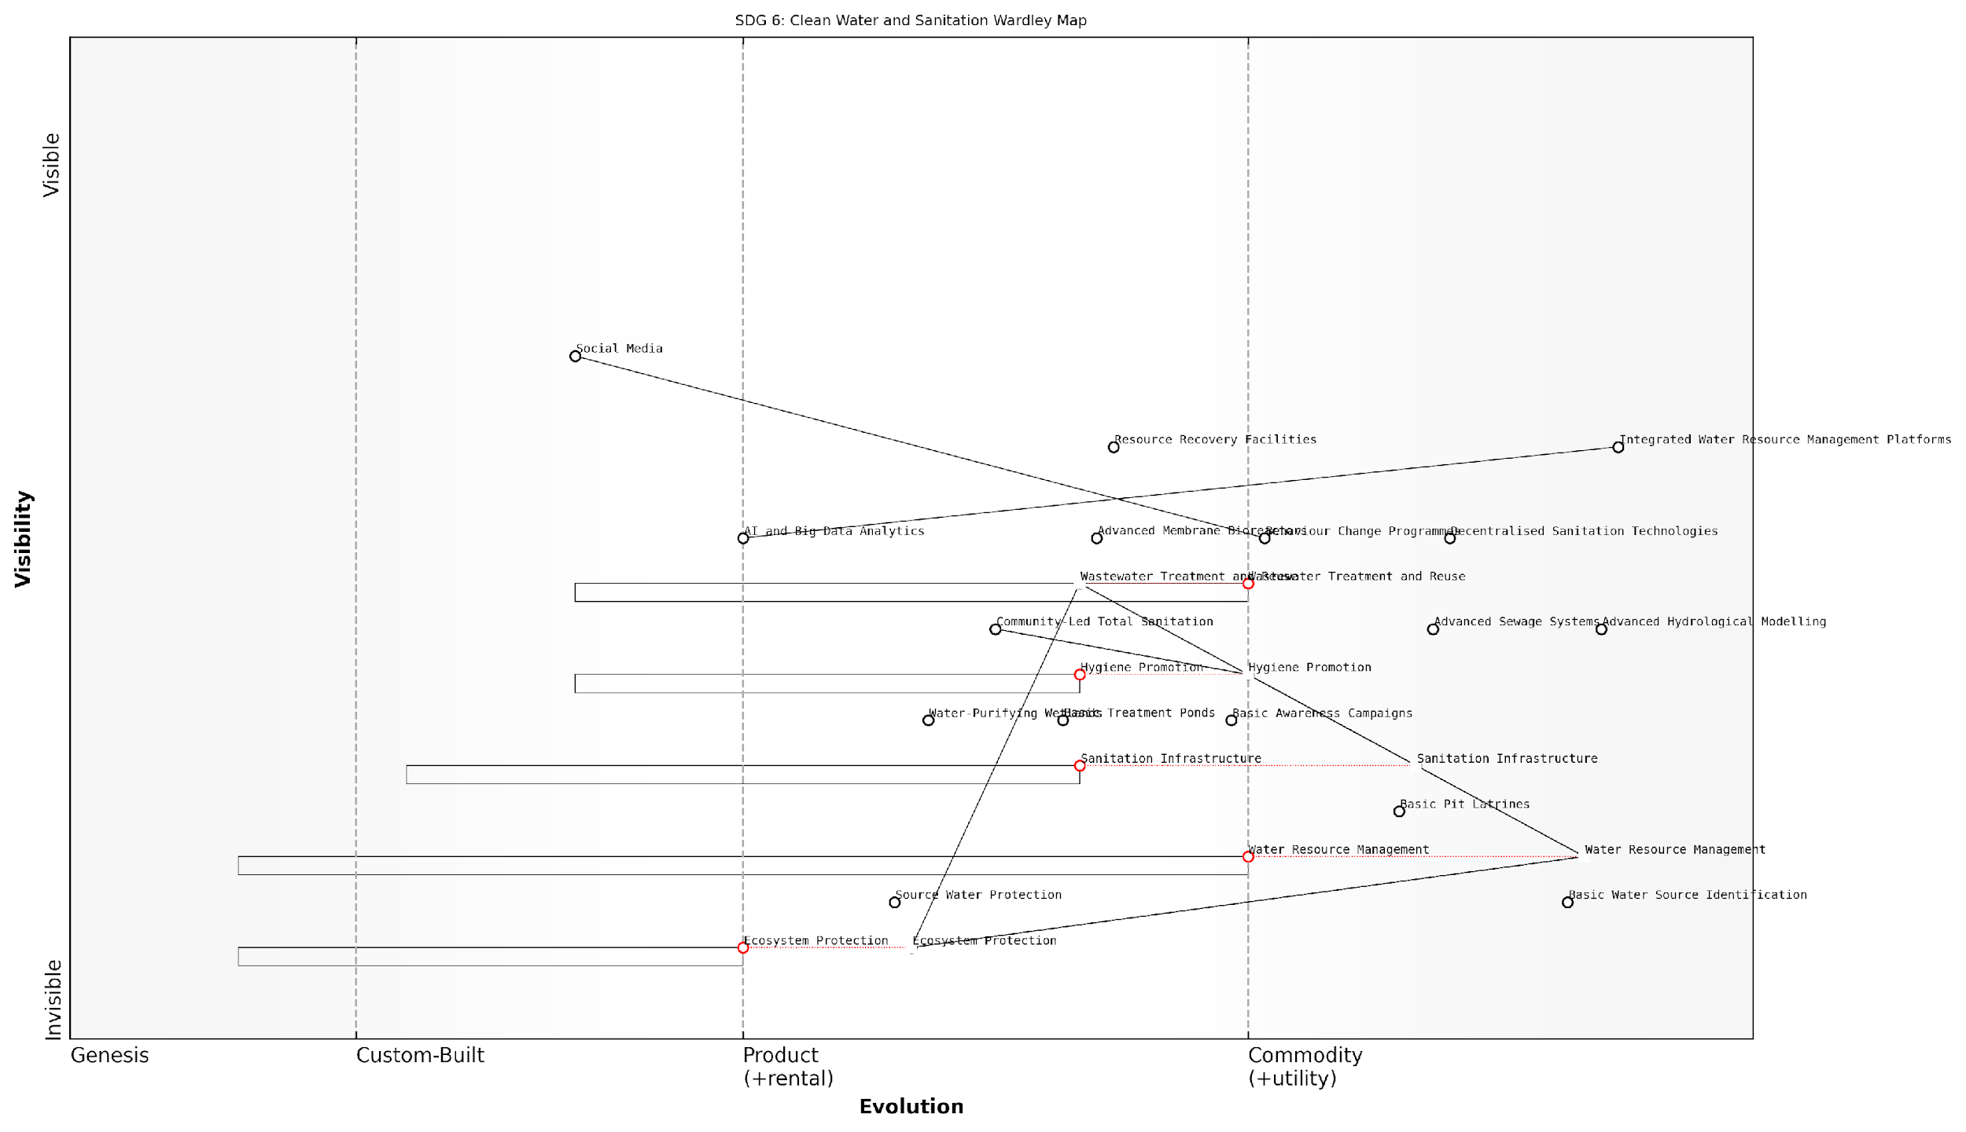

*Draft Wardley Map: [Insert Wardley Map visualising the key components of SDG 6 along the evolution and value chain axes]*

[Edit this draft Wardley Map](https://create.wardleymaps.ai/#clone:62b6bc1da87f6032c5)

By mapping these components, we gain crucial insights into the strategic landscape of SDG 6:

* Identification of anchor components that are critical to the entire value chain
* Recognition of components ripe for commoditisation, potentially through public-private partnerships
* Opportunities for leapfrogging in developing contexts, particularly in sanitation technologies
* Areas where cross-sector collaboration can yield significant benefits, such as integrating ecosystem protection with water resource management

The application of Wardley Mapping to SDG 6 also reveals potential strategic moves for governments and organisations working in the water and sanitation sector:

* Invest in the development of integrated water resource management platforms to move this component further along the evolution axis
* Focus on hygiene promotion as a key leverage point, potentially through innovative public-private partnerships
* Explore opportunities for resource recovery from wastewater to create additional value streams and improve overall system sustainability
* Prioritise ecosystem protection as a foundational component, recognising its role in ensuring long-term water security

In conclusion, Wardley Mapping provides a powerful tool for strategising and implementing SDG 6. It allows policymakers and practitioners to visualise the complex interplay of components within the water and sanitation sector, identify strategic opportunities, and anticipate future challenges. By leveraging this approach, we can develop more resilient, efficient, and effective strategies for ensuring clean water and sanitation for all.

Wardley Mapping has transformed our strategic planning for SDG 6. It’s given us a shared language and visual framework to discuss complex water and sanitation challenges across different government departments and with our international partners.

### Climate Action and Life Below Water

In the realm of environmental sustainability, the interconnected challenges of climate action (SDG 13) and life below water (SDG 14) stand as critical pillars in our global efforts to safeguard the planet. As we delve into mapping these Sustainable Development Goals using Wardley Mapping techniques, we uncover a complex web of dependencies, opportunities, and potential strategies that can drive meaningful progress in these areas.

The urgency of addressing climate change and protecting our oceans cannot be overstated. These two goals are inextricably linked, with climate change directly impacting marine ecosystems through ocean acidification, rising sea temperatures, and changing currents. Conversely, healthy oceans play a crucial role in regulating our climate by absorbing carbon dioxide and heat. By mapping these goals together, we can identify synergies and develop more effective, holistic strategies for their achievement.

The interconnectedness of climate action and ocean health demands an integrated approach. We can no longer afford to address these challenges in isolation if we hope to create lasting, sustainable solutions.

Let us now explore the key components of mapping SDGs 13 and 14 using Wardley Mapping, breaking down the process into logical subsections that will guide our strategic thinking and implementation efforts.

1. Identifying Key Components and Dependencies

The first step in our mapping process is to identify the key components and dependencies within the climate action and life below water domains. This involves breaking down these complex systems into their constituent parts and understanding how they interact.

* Greenhouse gas emissions reduction
* Renewable energy adoption
* Sustainable fishing practices
* Marine protected areas
* Ocean pollution prevention
* Climate change adaptation measures
* Carbon sequestration technologies
* Coastal ecosystem restoration

By mapping these components, we can visualise the intricate relationships between various elements of climate action and ocean health. For instance, the adoption of renewable energy directly impacts greenhouse gas emissions, which in turn affects ocean acidification and marine ecosystem health.

1. Assessing Evolution and Maturity

Once we have identified the key components, we must assess their evolution and maturity along the value chain. This step is crucial in understanding where to focus our efforts and resources for maximum impact.

For example, renewable energy technologies have evolved significantly over the past decade, moving from the custom-built to the product and commodity stages in many regions. This evolution has implications for our climate action strategies, as it may indicate a shift in focus from technology development to widespread adoption and integration.

Understanding the maturity of different components within our sustainability efforts allows us to make more informed decisions about where to invest our limited resources for the greatest return on investment.

1. Mapping Stakeholders and Their Motivations

A critical aspect of our Wardley Mapping process for SDGs 13 and 14 is identifying and mapping the various stakeholders involved. This includes government bodies, private sector entities, NGOs, local communities, and international organisations. Understanding their motivations, capabilities, and potential contributions is essential for developing effective collaborative strategies.

* Government agencies responsible for environmental policy and regulation
* Energy companies and utilities
* Fishing industry representatives
* Environmental NGOs and advocacy groups
* Coastal communities and indigenous peoples
* International bodies such as the UNFCCC and UN Environment Programme
* Research institutions and universities
* Technology companies developing climate and ocean monitoring solutions

By mapping these stakeholders alongside the components and their evolution, we can identify potential partnerships, areas of conflict, and opportunities for synergy in our efforts to address climate change and protect marine ecosystems.

1. Identifying Leverage Points and Strategic Opportunities

With our components, their evolution, and stakeholders mapped, we can now identify key leverage points and strategic opportunities for advancing SDGs 13 and 14. This involves analysing the map to find areas where relatively small interventions can lead to significant positive outcomes.

For instance, we might identify that investing in coastal ecosystem restoration not only contributes to carbon sequestration but also enhances marine biodiversity and provides natural barriers against rising sea levels. This multi-benefit approach represents a high-leverage opportunity for addressing both climate action and life below water goals simultaneously.

The power of Wardley Mapping lies in its ability to reveal non-obvious connections and opportunities. By visualising the entire system, we can identify leverage points that might be overlooked in traditional linear planning approaches.

1. Developing Adaptive Strategies

The final step in our mapping process is to develop adaptive strategies that can respond to the dynamic nature of climate and ocean systems. This involves creating flexible plans that can evolve as technologies mature, stakeholder landscapes shift, and new challenges emerge.

For example, our strategy might include a phased approach to renewable energy adoption, with built-in decision points for reassessing and potentially pivoting based on technological advancements or changes in the regulatory landscape. Similarly, our approach to marine protection might incorporate adaptive management techniques that allow for adjustments based on ongoing monitoring and new scientific insights.

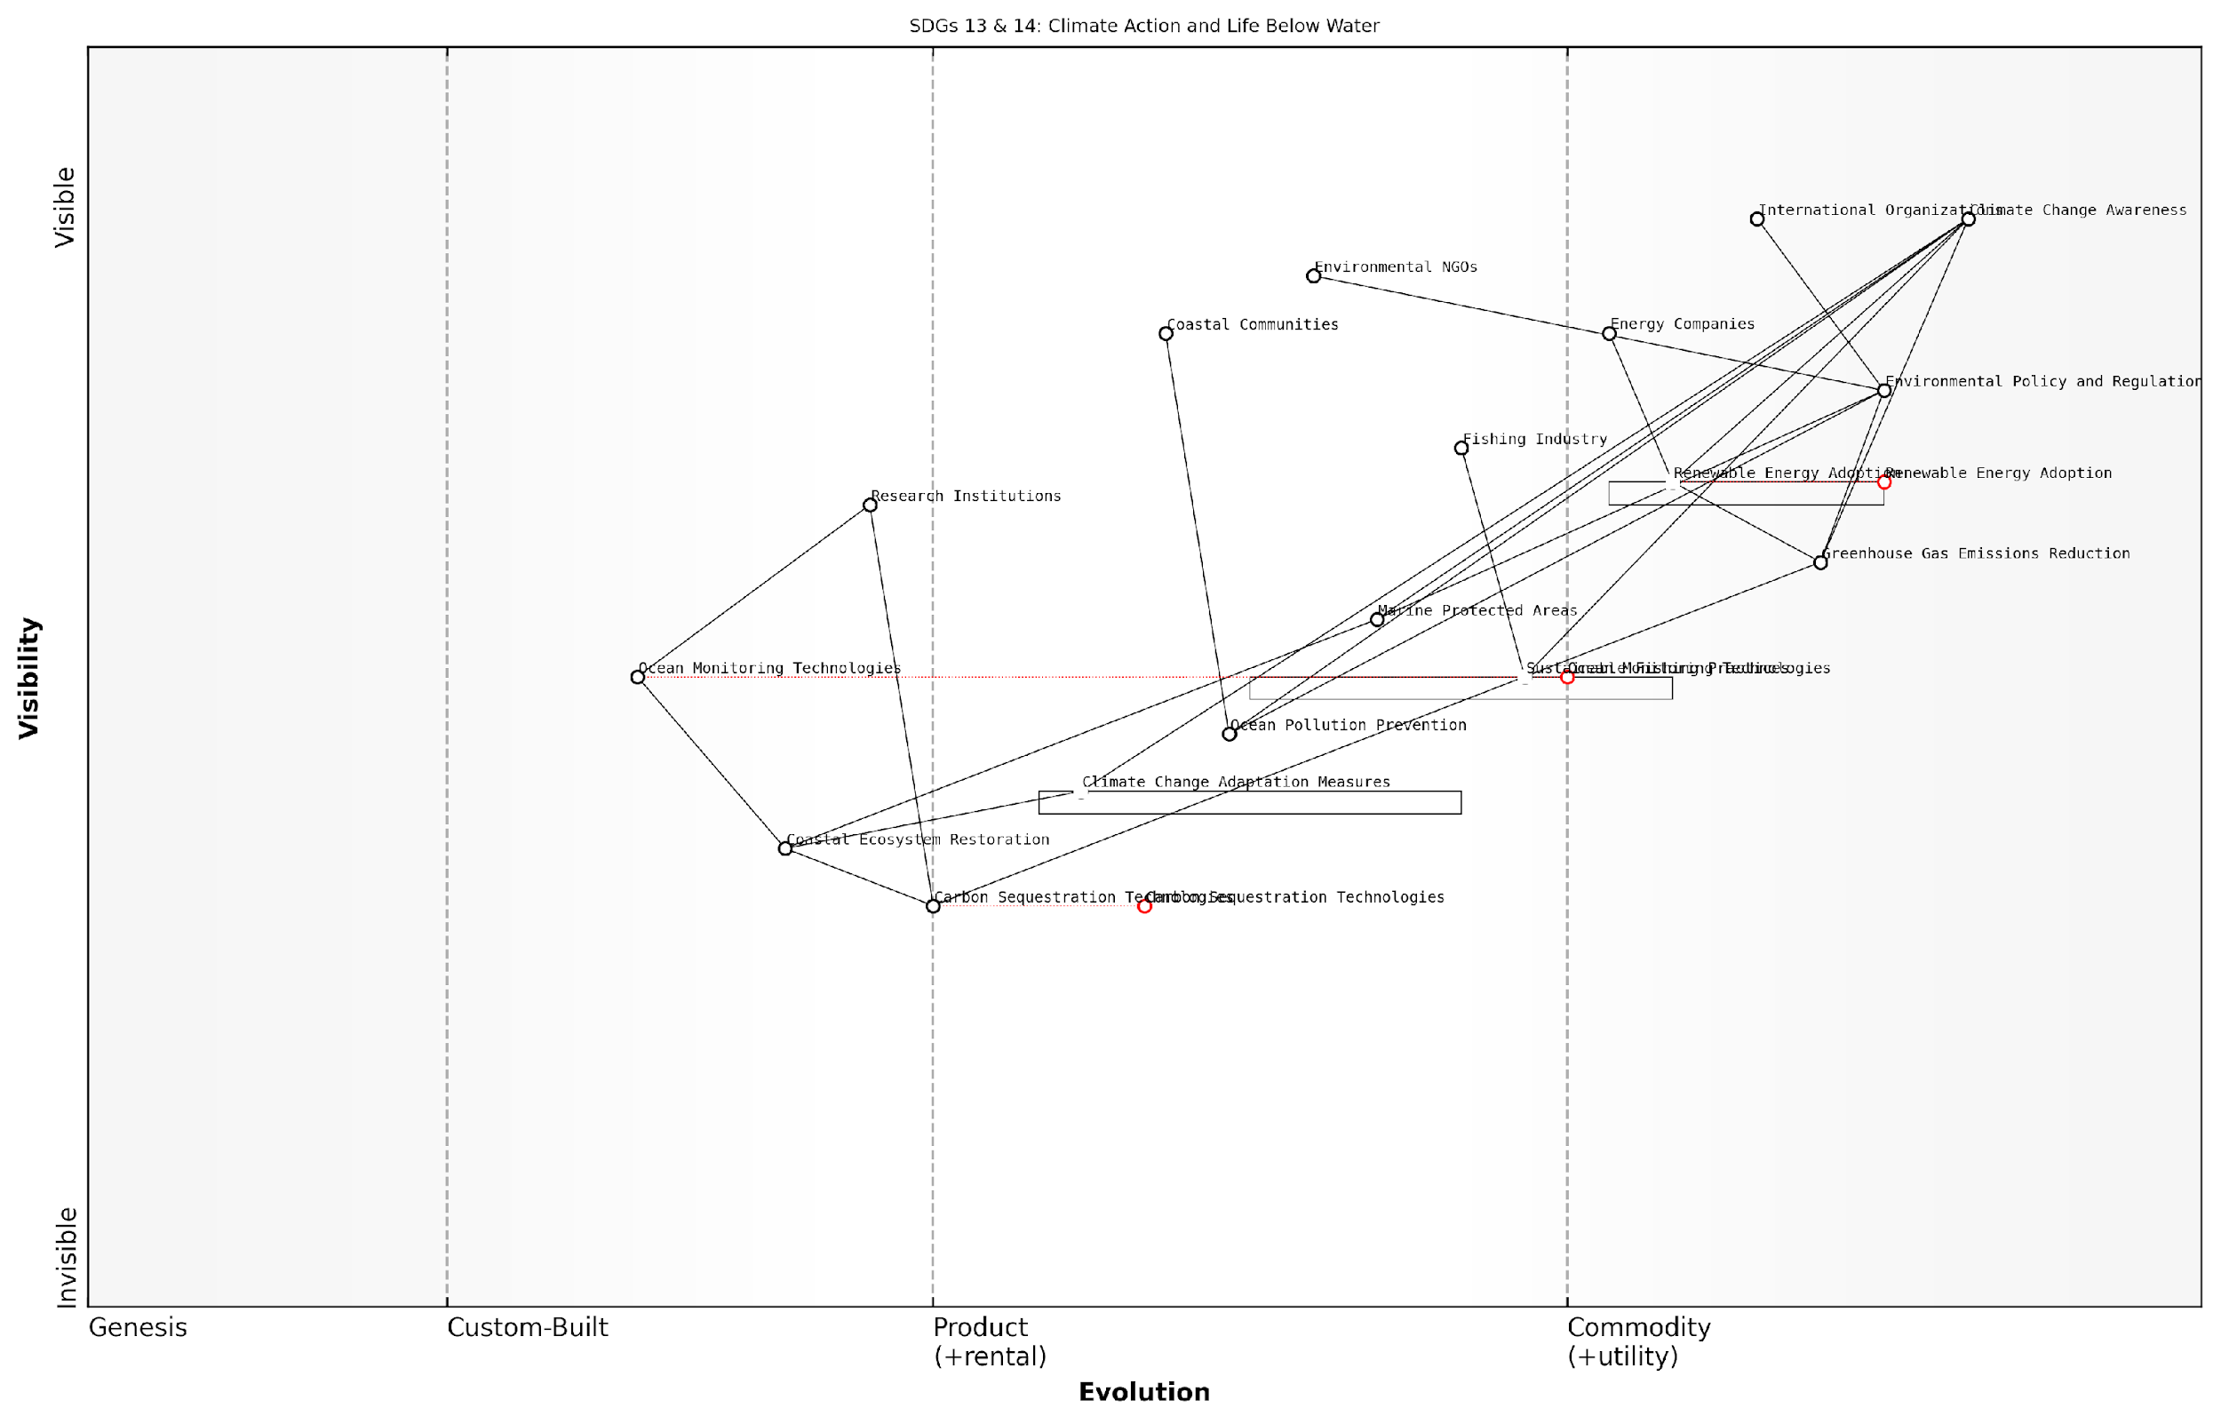

*Draft Wardley Map: [Insert Wardley Map visualising the key components, stakeholders, and strategic opportunities for SDGs 13 and 14]*

[Edit this draft Wardley Map](https://create.wardleymaps.ai/#clone:8ece9bf91efb025bab)

In conclusion, Wardley Mapping provides a powerful framework for addressing the complex challenges of climate action and life below water. By visualising the entire system, including its components, evolution, stakeholders, and strategic opportunities, we can develop more effective, integrated strategies for achieving these critical Sustainable Development Goals. As we move forward, it is essential that we continue to refine and adapt our maps, ensuring that our efforts remain aligned with the evolving landscape of global sustainability challenges.

### Life on Land

As we delve into the crucial topic of Life on Land within the context of Wardley Mapping the United Nations Sustainable Development Goals (SDGs), we find ourselves at the intersection of strategic planning and environmental conservation. SDG 15, ‘Life on Land’, aims to protect, restore, and promote sustainable use of terrestrial ecosystems, sustainably manage forests, combat desertification, halt and reverse land degradation, and halt biodiversity loss. This goal is intrinsically linked to the survival and prosperity of our planet and, by extension, humanity itself.

Applying Wardley Mapping to SDG 15 offers a unique opportunity to visualise the complex value chains and interdependencies involved in terrestrial ecosystem management. This approach allows us to identify key components, assess their evolutionary stage, and develop strategies that can drive meaningful progress towards sustainable land use and biodiversity conservation.

Let us break down the key components of Life on Land and explore how Wardley Mapping can illuminate the path towards achieving this vital goal:

* Ecosystem Conservation and Restoration
* Sustainable Forest Management
* Combating Desertification
* Biodiversity Protection
* Policy and Governance Frameworks

1. Ecosystem Conservation and Restoration:

When mapping ecosystem conservation and restoration efforts, we often find that the components range from genesis (novel restoration techniques) to custom-built (site-specific conservation plans) to product (established conservation methodologies) and commodity (basic land protection measures). A Wardley Map for this aspect might reveal that while basic protection measures are well-established, innovative restoration techniques are still in their early stages, requiring significant investment and research.

In my experience advising government bodies on environmental strategies, I’ve observed that the most successful conservation efforts are those that leverage a mix of established practices and cutting-edge restoration techniques, carefully mapped to local ecosystem needs and capacities.

1. Sustainable Forest Management:

Sustainable forest management presents a complex interplay of economic, social, and environmental factors. A Wardley Map for this component might show traditional logging practices as a commodity, while sustainable harvesting techniques and forest certification schemes could be positioned in the product or custom-built stages. Emerging technologies for forest monitoring and management, such as satellite imaging and AI-driven predictive models, would likely appear in the genesis or custom-built phases.

1. Combating Desertification:

The fight against desertification involves a range of interventions, from basic soil conservation techniques (commodity) to advanced land restoration projects (custom-built). Emerging technologies like drought-resistant crop varieties or innovative water harvesting systems might appear in the genesis stage of a Wardley Map for this component. The map would likely highlight the need for movement towards more advanced, tailored solutions as climate change exacerbates desertification in many regions.

1. Biodiversity Protection:

Biodiversity protection encompasses a wide range of activities, from species conservation to habitat preservation. A Wardley Map for this component might show traditional protected areas as a product, while more innovative approaches like wildlife corridors or community-based conservation initiatives could be positioned in the custom-built stage. Emerging technologies for biodiversity monitoring and protection, such as eDNA sampling or AI-powered species identification, would likely appear in the genesis phase.

One senior environmental policy advisor I’ve worked with noted, ‘The key to effective biodiversity protection lies in understanding the evolving landscape of conservation technologies and practices. Wardley Mapping helps us visualise this landscape and make strategic decisions about where to invest our limited resources for maximum impact.’

1. Policy and Governance Frameworks:

The policy and governance frameworks supporting Life on Land initiatives are crucial enablers that span across all other components. A Wardley Map for this aspect might show basic environmental regulations as a commodity, while more sophisticated policy instruments like payments for ecosystem services or integrated landscape management approaches could be positioned in the custom-built or product stages. Emerging governance models, such as blockchain-based land registries or AI-assisted policy formulation, would likely appear in the genesis phase.

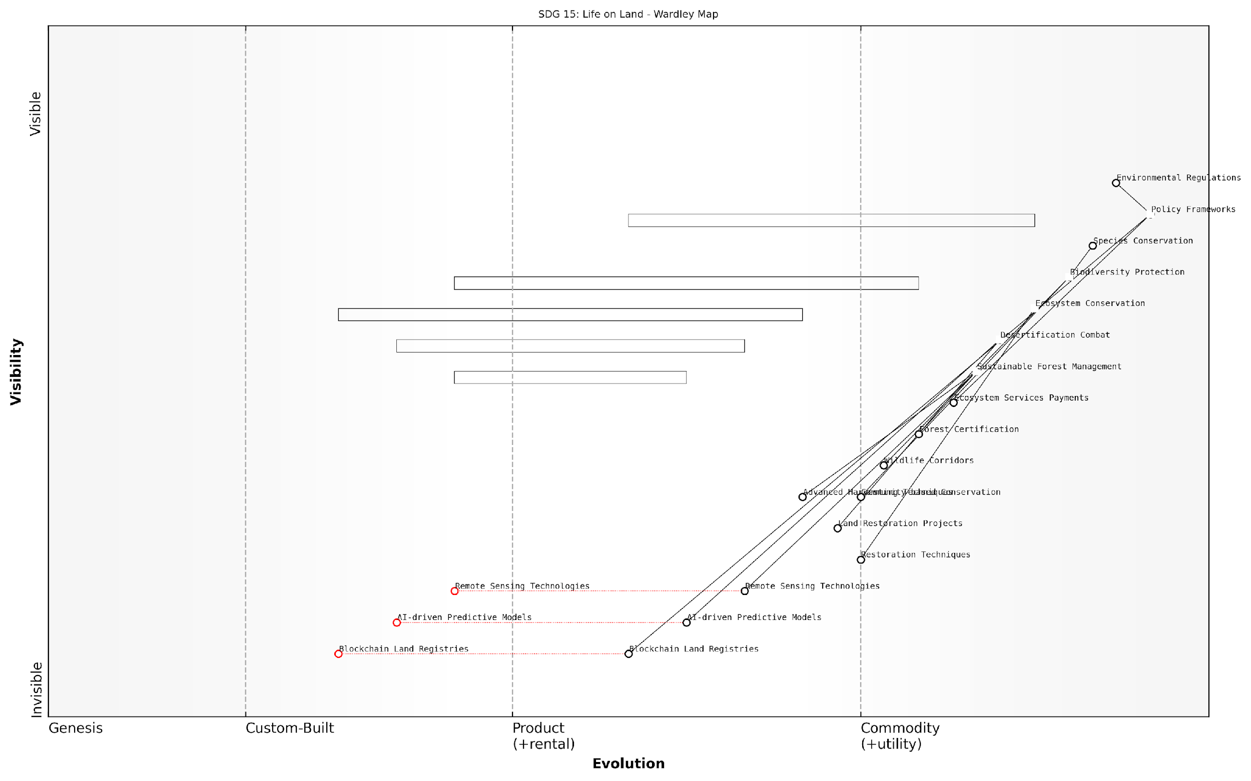

*Draft Wardley Map: [Insert Wardley Map visualising the key components of SDG 15: Life on Land, showing their positions along the evolution axis and their interdependencies]*

[Edit this draft Wardley Map](https://create.wardleymaps.ai/#clone:406966f8ea778e38f6)

By mapping these components and their evolutionary stages, policymakers and environmental managers can gain valuable insights into where to focus their efforts and resources. For instance, the map might reveal that while basic conservation measures are well-established, there’s a critical need to invest in emerging technologies for biodiversity monitoring to make these measures more effective.

Moreover, Wardley Mapping can help identify potential leverage points where interventions could have outsized impacts. For example, investing in the development of advanced remote sensing technologies (positioned in the genesis or custom-built stages) could dramatically improve our ability to monitor and manage forests, combat desertification, and protect biodiversity across large areas.

It’s also crucial to consider the interconnections between different components of the Life on Land goal. A well-constructed Wardley Map can highlight these relationships, showing how advancements in one area (e.g., sustainable forest management) can positively impact others (e.g., biodiversity protection and ecosystem restoration).

As one leading expert in environmental policy put it, ‘Wardley Mapping for SDG 15 isn’t just about understanding where we are now; it’s about charting a course for where we need to be. It helps us anticipate future needs and align our strategies with the evolving landscape of environmental challenges and solutions.’

In conclusion, Wardley Mapping offers a powerful tool for visualising, understanding, and strategising around the complex challenges encompassed by SDG 15: Life on Land. By providing a clear picture of the current state of various components, their evolutionary trajectories, and their interdependencies, it enables policymakers, environmental managers, and other stakeholders to develop more effective, forward-looking strategies for protecting and restoring our planet’s vital terrestrial ecosystems.

## Prosperity: Mapping Economic Development Goals

### Decent Work and Economic Growth

In the context of Wardley Mapping the United Nations Sustainable Development Goals (SDGs), the goal of ‘Decent Work and Economic Growth’ (SDG 8) presents a complex challenge that requires a nuanced understanding of economic ecosystems and labour markets. This subsection explores how Wardley Mapping can be applied to visualise and strategise for sustainable economic development, with a particular focus on creating quality jobs and fostering inclusive growth.

Wardley Mapping offers a unique lens through which to examine the components of economic growth and decent work, allowing policymakers and strategists to identify key dependencies, potential areas for innovation, and opportunities for sustainable development. By mapping the value chain of economic activities and labour market dynamics, we can uncover hidden relationships and strategic leverage points that traditional economic models might overlook.

Wardley Mapping has revolutionised our approach to economic policy. It’s not just about GDP growth anymore; it’s about understanding the entire ecosystem of work and how each component evolves over time.

Let’s break down the key components of SDG 8 and how they can be represented in a Wardley Map:

* Economic Growth: Mapping the stages of various industries and sectors, from genesis to commodity
* Job Creation: Visualising the pipeline from education and skills development to employment opportunities
* Labour Rights: Positioning regulatory frameworks and enforcement mechanisms
* Workplace Safety: Mapping health and safety standards and their implementation across industries
* Innovation and Productivity: Identifying areas for technological advancement and efficiency improvements
* Financial Inclusion: Mapping access to banking, credit, and financial services for individuals and businesses
* Sustainable Tourism: Positioning eco-tourism initiatives and their impact on local economies

When creating a Wardley Map for SDG 8, it’s crucial to consider the evolution of these components. For instance, in many economies, we’re seeing a shift from traditional manufacturing jobs towards service and knowledge-based roles. This evolution should be reflected in the positioning of these components on the map, with emerging sectors placed closer to the genesis stage and mature industries towards the commodity end.

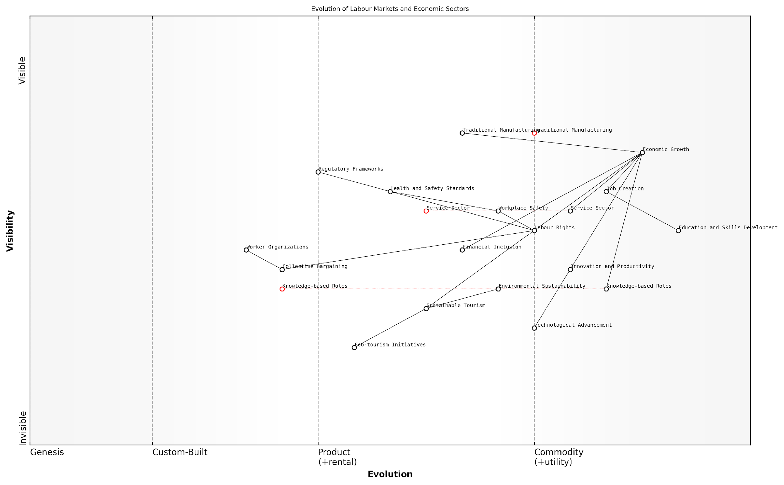

*Draft Wardley Map: [Insert Wardley Map: Evolution of Labour Markets and Economic Sectors]*

[Edit this draft Wardley Map](https://create.wardleymaps.ai/#clone:14836f0412f30c53bc)

One of the key challenges in mapping decent work and economic growth is the interconnectedness of various factors. For example, job creation is closely tied to education and skills development, which in turn depends on access to quality education (SDG 4). Similarly, economic growth must be balanced with environmental sustainability (SDGs 12, 13, 14, and 15). Wardley Mapping allows us to visualise these connections and potential trade-offs, enabling more holistic policy-making.

The beauty of using Wardley Maps for SDG 8 is that it forces us to think about the entire system. We can’t just focus on creating jobs; we have to consider the quality of those jobs, the skills required, and the long-term sustainability of the industries we’re promoting.

In my experience advising government bodies on economic development strategies, I’ve found that Wardley Mapping can be particularly powerful in identifying opportunities for leapfrogging. For developing economies, this might mean bypassing certain stages of industrial development to focus on emerging, high-value sectors that align with global trends and local strengths.

Consider the case of a small island nation looking to diversify its economy beyond tourism. By mapping the components of potential industries against global market trends and local capabilities, we identified opportunities in sustainable aquaculture and digital services. This approach allowed for targeted investment in education and infrastructure to support these emerging sectors, creating high-quality jobs while aligning with broader sustainability goals.

Another critical aspect of using Wardley Mapping for SDG 8 is the ability to identify and address power imbalances in the labour market. By visualising the relationships between employers, workers, unions, and regulatory bodies, we can pinpoint areas where intervention may be necessary to ensure fair working conditions and wages.

* Map the current state of labour relations and worker protections
* Identify gaps in regulatory frameworks or enforcement
* Visualise the evolution of worker organisations and collective bargaining
* Plot the impact of technological changes on worker rights and job security
* Strategise interventions to strengthen worker protections and promote decent work

It’s important to note that Wardley Mapping for SDG 8 should not be a one-time exercise. Economic landscapes are constantly evolving, influenced by technological advancements, global events, and shifting societal values. Regular re-mapping allows policymakers to adapt strategies in real-time, ensuring that efforts to promote decent work and economic growth remain relevant and effective.

We’ve made Wardley Mapping a quarterly exercise in our economic planning department. It’s remarkable how quickly things can change, and having an up-to-date map helps us stay ahead of the curve in our policy-making.

In conclusion, Wardley Mapping offers a powerful tool for visualising and strategising the complex ecosystem of decent work and economic growth. By providing a clear picture of the current economic landscape, its evolution, and the interconnections between various components, it enables more informed, holistic, and adaptive policy-making. As we strive to achieve SDG 8, this approach will be invaluable in navigating the challenges and opportunities of the rapidly changing global economy.

### Industry, Innovation, and Infrastructure

In the context of Wardley Mapping the United Nations Sustainable Development Goals (SDGs), the triad of Industry, Innovation, and Infrastructure (SDG 9) forms a critical nexus for economic development and prosperity. This goal is particularly significant as it underpins the advancement of many other SDGs and plays a pivotal role in shaping sustainable economic landscapes.

Wardley Mapping offers a unique lens through which to analyse and strategise for SDG 9, allowing us to visualise the complex interplay between various components of industrial ecosystems, innovation pipelines, and infrastructure networks. By mapping these elements, we can identify key leverage points, anticipate evolutionary changes, and develop robust strategies for sustainable industrial development.

Wardley Mapping has revolutionised our approach to SDG 9. It’s not just about building infrastructure or promoting innovation in isolation; it’s about understanding how these elements evolve and interact within a larger economic ecosystem.

Let us delve into the key components of SDG 9 through the Wardley Mapping perspective:

* Industrial Development
* Innovation Ecosystems
* Infrastructure Networks

Industrial Development: When mapping industrial development, we must consider the entire value chain from raw materials to finished products. In a Wardley Map, we might place traditional industries towards the left (more evolved, commodity-like), while emerging industries would be positioned towards the right (less evolved, more custom). This visualisation allows policymakers to identify areas ripe for investment or support, and to anticipate how industries might evolve over time.

For instance, in a developing economy, we might see traditional agriculture on the left of the map, with value-added food processing industries in the centre, and emerging biotechnology applications on the right. This mapping helps in crafting policies that support the entire spectrum of industrial development, from improving efficiency in mature sectors to fostering growth in nascent industries.

Innovation Ecosystems: Innovation is a key driver of sustainable development, but it doesn’t occur in isolation. A Wardley Map of an innovation ecosystem might include components such as research institutions, startup incubators, venture capital, and technology transfer offices. By mapping these elements, we can identify gaps in the ecosystem and develop strategies to strengthen weak links.

Our Wardley Map of the national innovation ecosystem revealed a critical gap in early-stage funding for deep tech startups. This insight led to the creation of a government-backed venture fund that has since catalysed significant private investment in the sector.

Infrastructure Networks: Infrastructure forms the backbone of economic development, but it’s often challenging to prioritise investments given limited resources. Wardley Mapping can help by visualising the dependencies between different types of infrastructure and their relative maturity. For example, a map might show how digital infrastructure (like 5G networks) enables the development of smart cities, which in turn drives demand for renewable energy infrastructure.

By mapping infrastructure in this way, policymakers can make more informed decisions about where to allocate resources for maximum impact. It also helps in identifying potential bottlenecks or areas where leapfrogging technologies might be applicable.

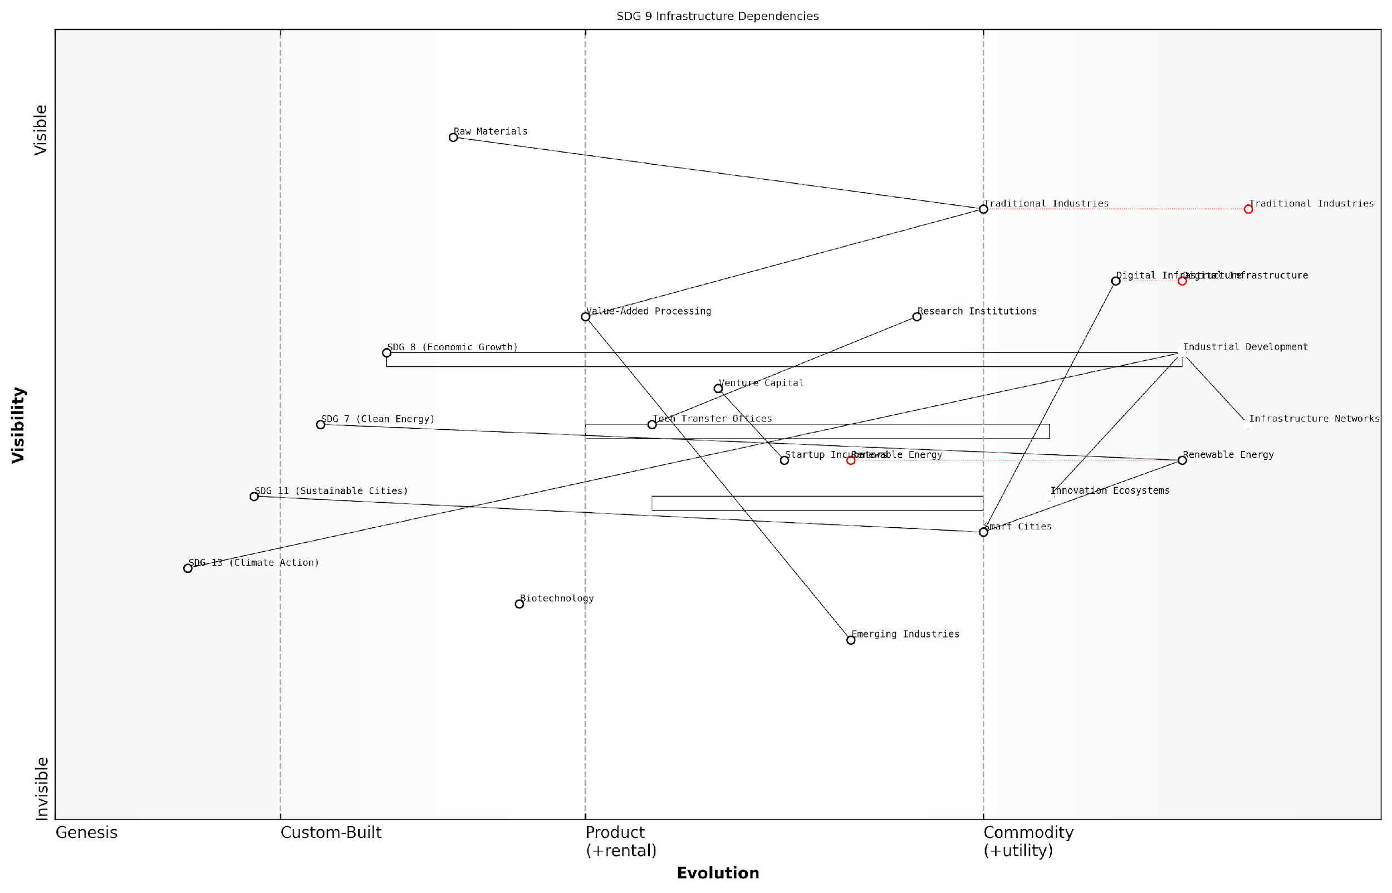

*Draft Wardley Map: [Insert Wardley Map: SDG 9 Infrastructure Dependencies]*

[Edit this draft Wardley Map](https://create.wardleymaps.ai/#clone:952b3fe43207895b10)

Integrating SDG 9 with Other Goals: One of the strengths of Wardley Mapping is its ability to show interconnections between different systems. When mapping SDG 9, it’s crucial to consider its relationships with other SDGs. For instance:

* SDG 7 (Affordable and Clean Energy): Sustainable industrial development is closely tied to the availability of clean energy.
* SDG 8 (Decent Work and Economic Growth): Innovation and industrial development drive job creation and economic growth.
* SDG 11 (Sustainable Cities and Communities): Infrastructure development directly impacts urban sustainability.
* SDG 13 (Climate Action): Industrial processes and infrastructure choices have significant implications for climate change mitigation and adaptation.

By mapping these interconnections, we can develop more holistic strategies that leverage synergies and mitigate potential conflicts between different development goals.

Practical Applications for Policymakers: When using Wardley Mapping for SDG 9, policymakers should consider the following approaches:

* Conduct regular mapping exercises to track the evolution of industrial sectors and adjust policies accordingly.
* Use maps to identify strategic areas for public-private partnerships, particularly in infrastructure development.
* Leverage mapping insights to design targeted innovation incentives that address specific gaps in the ecosystem.
* Employ maps in stakeholder communications to build consensus around development priorities and strategies.

Case Study: In my work with a middle-income country’s economic planning agency, we used Wardley Mapping to analyse their manufacturing sector. The map revealed an over-reliance on low-value assembly operations, with limited domestic capacity for higher-value activities like design and R&D. This insight led to a targeted strategy to attract foreign direct investment in R&D facilities and to strengthen links between universities and industry.

The Wardley Map was a wake-up call for us. We realised we needed to move up the value chain to sustain our economic growth. It guided our entire industrial policy revamp.

Challenges and Considerations: While Wardley Mapping is a powerful tool for SDG 9 strategy, it’s important to acknowledge its limitations and challenges:

* Data Availability: Accurate mapping requires reliable data on industrial sectors, innovation metrics, and infrastructure status, which may be lacking in some contexts.
* Complexity: The interconnected nature of industry, innovation, and infrastructure can lead to highly complex maps that may be difficult to interpret without expertise.
* Dynamic Nature: Industrial and technological landscapes can change rapidly, requiring frequent updates to maps and strategies.
* Balancing Act: Policymakers must balance the pursuit of industrial development with environmental and social considerations, which can be challenging to represent in a single map.

In conclusion, Wardley Mapping offers a valuable framework for developing strategies to achieve SDG 9. By visualising the components of industrial ecosystems, innovation networks, and infrastructure systems, policymakers can craft more effective, forward-looking policies that drive sustainable economic development. As we continue to refine our mapping techniques and integrate them with other analytical tools, we can expect even more sophisticated approaches to emerge in the pursuit of inclusive and sustainable industrialisation.

### Reduced Inequalities and Sustainable Cities

In the context of Wardley Mapping the United Nations Sustainable Development Goals (SDGs), the intersection of reduced inequalities (SDG 10) and sustainable cities (SDG 11) presents a complex yet crucial area for strategic analysis. These goals are intrinsically linked, as urban environments often serve as microcosms of broader societal inequalities, while also offering unique opportunities for innovative solutions to address these disparities.

Wardley Mapping provides a powerful framework for visualising the value chains and dependencies inherent in pursuing these interconnected goals. By mapping the components necessary for reducing inequalities and creating sustainable cities, policymakers and urban planners can identify key leverage points, anticipate evolving needs, and develop more effective, targeted strategies.

Wardley Mapping has revolutionised our approach to urban planning and inequality reduction. It allows us to see the entire ecosystem of factors at play, from basic infrastructure to advanced social programmes, and how they evolve over time. This visibility is crucial for making informed decisions that can truly transform our cities.

Let us delve into the key components and considerations when mapping reduced inequalities and sustainable cities:

* Infrastructure and Basic Services
* Economic Opportunities and Inclusive Growth
* Social Inclusion and Equity
* Environmental Sustainability
* Governance and Policy Frameworks

1. Infrastructure and Basic Services:

At the foundation of our Wardley Map for sustainable and equitable cities, we find essential infrastructure and services. These components are typically positioned in the ‘commodity’ or ‘product’ stages of evolution, as they are well-understood and crucial for basic urban functioning.

* Housing: Affordable and adequate housing is a cornerstone of reducing urban inequalities.
* Transportation: Accessible and efficient public transport systems are vital for connecting communities and reducing spatial inequalities.
* Utilities: Equitable access to water, electricity, and sanitation services is fundamental to urban equality.
* Healthcare facilities: Ensuring all residents have access to quality healthcare regardless of their socioeconomic status.
* Educational institutions: Providing equal opportunities for learning and skill development across all urban areas.

1. Economic Opportunities and Inclusive Growth:

Moving up our map, we encounter components related to economic opportunities. These elements often sit in the ‘product’ or early ‘custom-built’ stages, as cities experiment with various approaches to foster inclusive growth.

* Job creation programmes: Initiatives to stimulate employment across various sectors and skill levels.
* Small business support: Mechanisms to encourage entrepreneurship and support local businesses.
* Skills training and workforce development: Programmes to equip residents with skills needed for the evolving job market.
* Financial inclusion: Ensuring access to banking and financial services for all urban residents.
* Digital connectivity: Bridging the digital divide to ensure equal access to online opportunities.

1. Social Inclusion and Equity:

Components related to social inclusion often occupy the ‘custom-built’ stage, as cities tailor solutions to their specific demographic and cultural contexts.

* Community engagement platforms: Mechanisms for involving diverse groups in urban decision-making processes.
* Cultural and recreational facilities: Spaces that promote social cohesion and celebrate diversity.
* Anti-discrimination policies: Legal frameworks to protect marginalised groups and promote equality.
* Social support systems: Safety nets and support services for vulnerable populations.
* Inclusive urban design: Ensuring public spaces and facilities are accessible to all, including persons with disabilities.

1. Environmental Sustainability:

Environmental components often span multiple evolution stages, from ‘product’ (established green technologies) to ‘genesis’ (cutting-edge sustainable innovations).

* Green spaces and urban biodiversity: Promoting equitable access to nature within urban environments.
* Sustainable waste management: Implementing efficient and environmentally friendly waste disposal systems.
* Clean energy initiatives: Transitioning to renewable energy sources and improving energy efficiency.
* Climate resilience planning: Developing strategies to protect vulnerable communities from climate change impacts.
* Sustainable urban mobility: Promoting walking, cycling, and low-emission transportation options.

1. Governance and Policy Frameworks:

Governance components typically occupy the ‘custom-built’ or ‘product’ stages, as cities refine their approaches to inclusive and sustainable management.

* Participatory budgeting: Involving citizens in decisions about public spending priorities.
* Data-driven decision making: Utilising urban data and analytics to inform equitable policy choices.
* Cross-sector partnerships: Fostering collaboration between government, private sector, and civil society.
* Transparent governance mechanisms: Ensuring accountability and reducing corruption in urban management.
* Policy coherence: Aligning local policies with national and international sustainability frameworks.

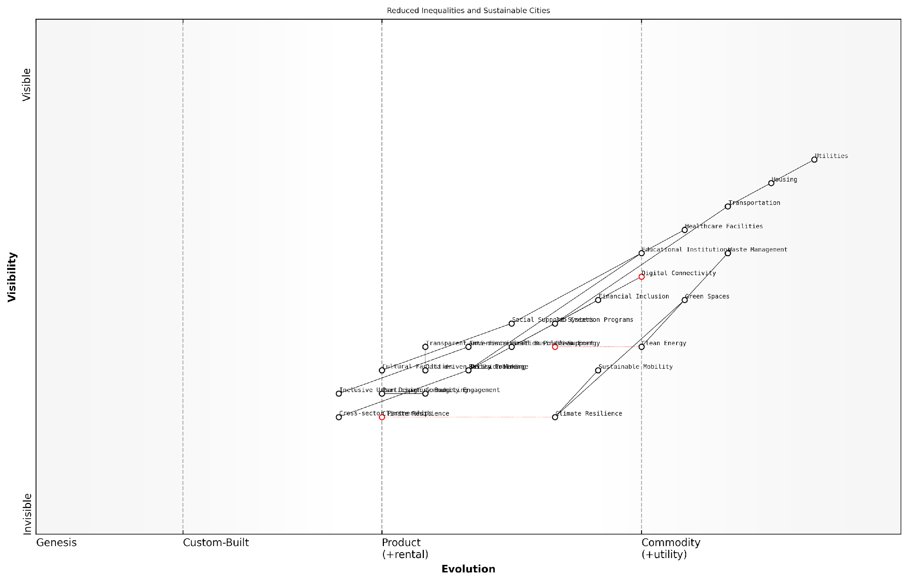

*Draft Wardley Map: [Insert Wardley Map visualising the key components of Reduced Inequalities and Sustainable Cities, showing their positions along the evolution axis and their interdependencies]*

[Edit this draft Wardley Map](https://create.wardleymaps.ai/#clone:f9888d77335dd4dc8f)

By mapping these components and their evolution, urban planners and policymakers can gain crucial insights into the interdependencies between different aspects of urban equality and sustainability. This visual representation allows for the identification of gaps, potential areas for innovation, and opportunities for strategic investments that can accelerate progress towards both SDG 10 and SDG 11.

The beauty of using Wardley Mapping for SDGs 10 and 11 is that it forces us to think holistically about urban development. We can see how investments in basic infrastructure lay the groundwork for more advanced social and economic initiatives, and how all of these elements must evolve together to create truly equitable and sustainable cities.

Moreover, this mapping approach enables cities to benchmark their progress against others, identify best practices, and anticipate future challenges. For instance, as certain components move from ‘custom-built’ to ‘product’ stages, cities can learn from early adopters and potentially leapfrog to more advanced, equitable solutions.

In conclusion, the application of Wardley Mapping to the goals of reduced inequalities and sustainable cities offers a powerful tool for strategic urban planning. By visualising the complex ecosystem of urban development through this lens, stakeholders can develop more targeted, effective, and forward-thinking approaches to creating cities that are not only sustainable but also equitable and inclusive for all residents.

## Peace and Partnership: Mapping Collaborative Goals

### Peace, Justice, and Strong Institutions

In the context of Wardley Mapping the United Nations Sustainable Development Goals (SDGs), the goal of Peace, Justice, and Strong Institutions (SDG 16) presents a unique challenge due to its complex, interconnected nature. This goal is fundamental to the success of all other SDGs, as it provides the stable foundation upon which sustainable development can flourish. By applying Wardley Mapping to this goal, we can uncover the intricate value chains and dependencies that underpin peaceful societies, effective justice systems, and robust institutions.

To effectively map SDG 16, we must first break it down into its core components and understand their relationships within the broader ecosystem of sustainable development. This process allows us to identify key leverage points, potential synergies with other SDGs, and areas where strategic interventions can yield the greatest impact.

* Peace: Reducing violence and promoting stability
* Justice: Ensuring equal access to fair legal systems
* Strong Institutions: Building effective, accountable, and inclusive governance structures

When applying Wardley Mapping to these components, we begin by identifying the end-user needs and working backwards through the value chain. For instance, citizens require safety and security (peace), fair treatment under the law (justice), and responsive governance (strong institutions). These needs form the visible elements at the top of our map.

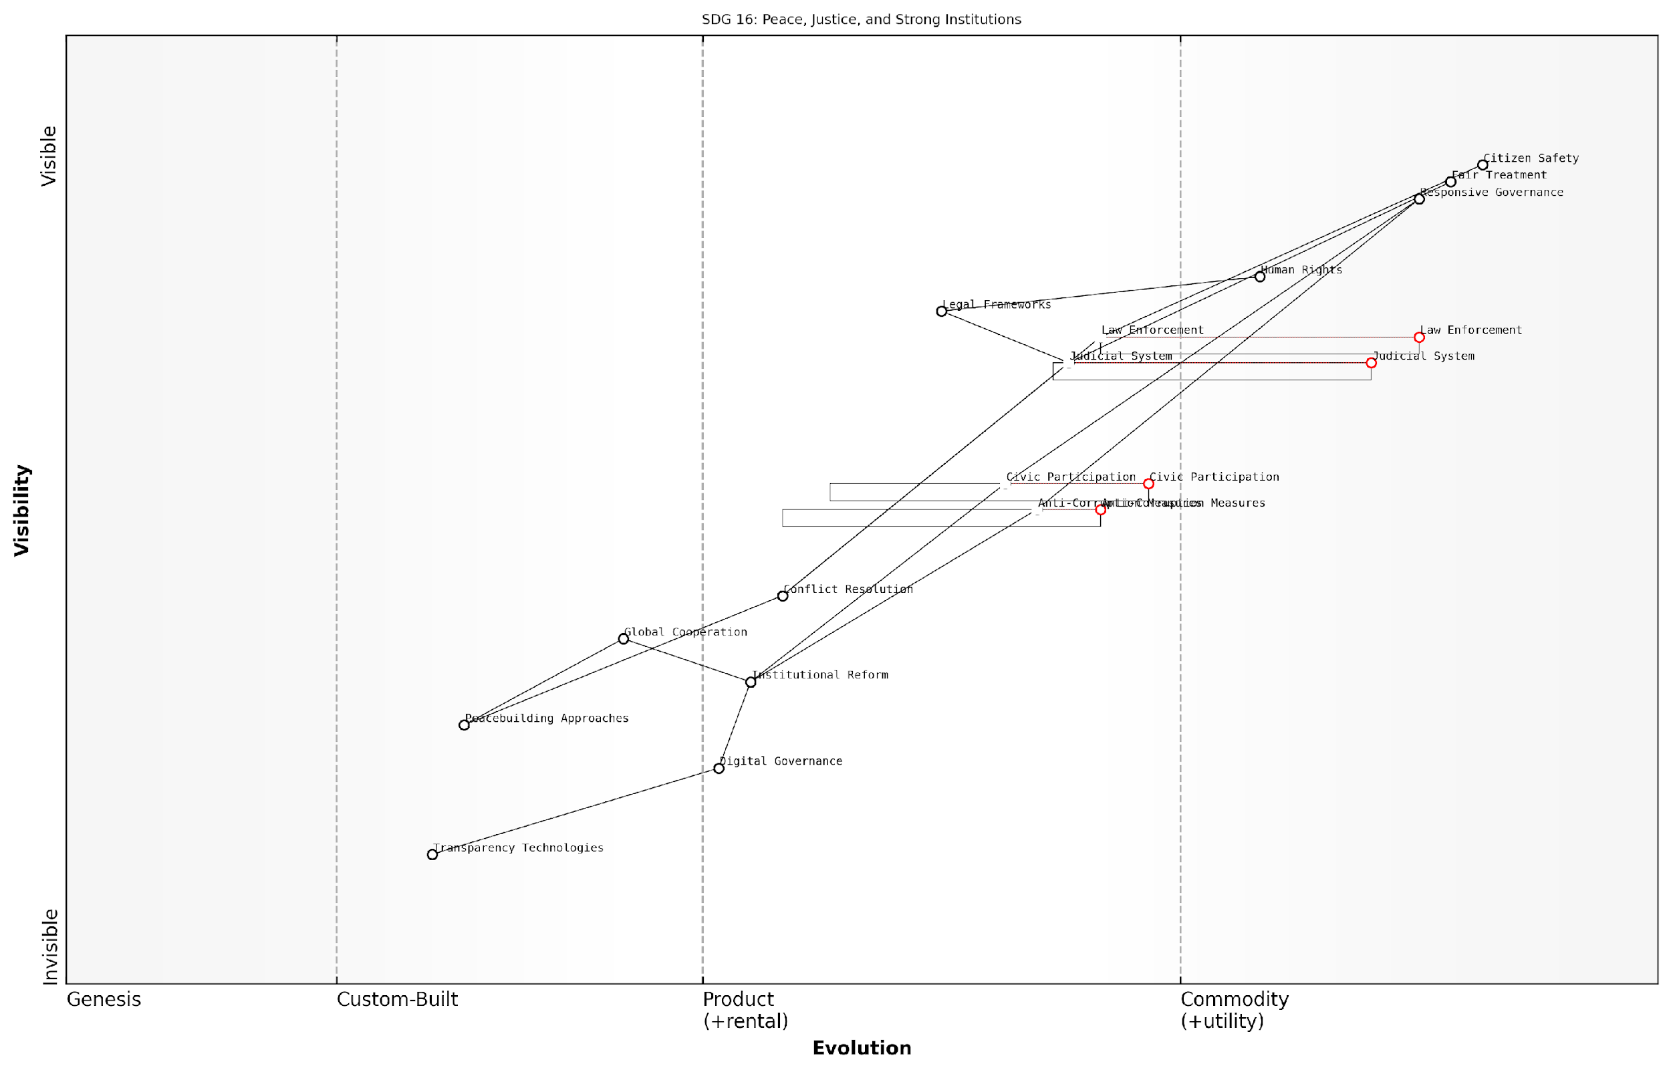

*Draft Wardley Map: [Insert Wardley Map: SDG 16 Value Chain]*

[Edit this draft Wardley Map](https://create.wardleymaps.ai/#clone:c40ae35f0a0b8e85f7)

As we move down the value chain, we encounter various supporting elements such as law enforcement agencies, judicial systems, anti-corruption measures, and civic participation mechanisms. These elements may be at different stages of evolution, from genesis (e.g., emerging technologies for transparent governance) to commodity (e.g., established legal frameworks).

One of the key insights that Wardley Mapping reveals in the context of SDG 16 is the interdependence between peace, justice, and strong institutions. For example, a strong and impartial justice system contributes to peaceful conflict resolution, while peaceful societies are better able to maintain and improve their institutions. This interconnectedness highlights the need for holistic approaches to achieving SDG 16.

Wardley Mapping has allowed us to visualise the complex relationships within SDG 16 and identify critical intervention points that we previously overlooked. It’s revolutionised our approach to peacebuilding and institutional strengthening.

When mapping SDG 16, it’s crucial to consider the varying contexts across different countries and regions. What may be a commodity in one nation (e.g., an established democratic system) could be in the custom-built or product stages in another. This variability necessitates flexible strategies that can be adapted to local conditions while still working towards universal goals.

Furthermore, Wardley Mapping can help identify potential conflicts or trade-offs between different aspects of SDG 16. For instance, efforts to strengthen security institutions might inadvertently infringe on civil liberties if not carefully balanced. By visualising these relationships, policymakers and practitioners can develop more nuanced and effective strategies.

* Identify key stakeholders and their roles in the SDG 16 value chain
* Map the evolution of different components (e.g., from traditional to digital justice systems)
* Highlight dependencies between peace, justice, and institutional strength
* Uncover potential areas for innovation and leapfrogging in developing contexts
* Visualise the impact of external factors such as technology, climate change, and global economic trends

One of the most powerful applications of Wardley Mapping for SDG 16 is in scenario planning and risk assessment. By understanding the current landscape and the direction of evolution for various components, we can anticipate future challenges and opportunities. For example, the map might reveal emerging technologies that could enhance transparency in governance, or highlight vulnerabilities in existing peace-building approaches.

The foresight provided by Wardley Mapping has been invaluable in our long-term planning for institutional reform. It’s allowed us to anticipate and prepare for shifts in the political and technological landscape that we might have otherwise missed.

In conclusion, Wardley Mapping offers a powerful tool for understanding and strategising around the complex goal of Peace, Justice, and Strong Institutions. By providing a visual representation of the value chain and evolution of various components, it enables more effective collaboration, resource allocation, and strategic planning. As we work towards achieving SDG 16 by 2030, the insights gained from Wardley Mapping will be crucial in navigating the challenges and opportunities that lie ahead.

Moving forward, it is essential to integrate the mapping of SDG 16 with other SDGs, particularly those related to reducing inequalities (SDG 10) and promoting sustainable cities and communities (SDG 11). This integrated approach will ensure that efforts towards peace, justice, and strong institutions are aligned with broader sustainable development objectives, creating a more coherent and impactful strategy for achieving the 2030 Agenda.

### Partnerships for the Goals

In the complex landscape of global sustainability, SDG 17 - Partnerships for the Goals - stands as a cornerstone for achieving the entire 2030 Agenda. This goal recognises that the interconnected nature of global challenges requires collaborative solutions that transcend traditional boundaries. Wardley Mapping, with its focus on value chains and strategic positioning, offers a powerful framework for visualising and optimising these crucial partnerships.

To effectively map partnerships for the SDGs, we must consider multiple dimensions of collaboration, including financial resources, technology transfer, capacity building, and policy coherence. Each of these elements can be positioned on a Wardley Map to reveal opportunities for synergy and areas requiring strategic intervention.

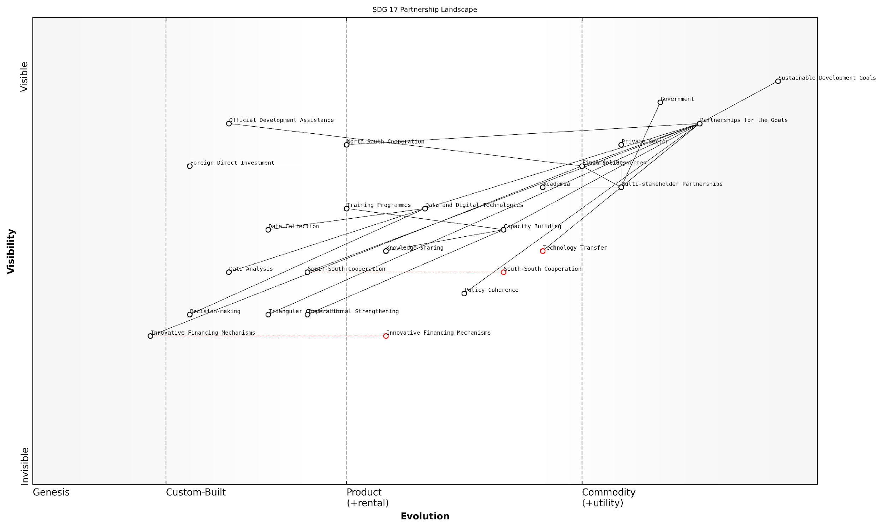

*Draft Wardley Map: [Insert Wardley Map: SDG 17 Partnership Landscape]*

[Edit this draft Wardley Map](https://create.wardleymaps.ai/#clone:be0c4a9eb6b1cb9ecf)

Let’s break down the key components of partnerships and examine how they can be strategically mapped:

* Financial Resources: Mapping the flow of funds from developed to developing countries, including official development assistance (ODA), foreign direct investment (FDI), and innovative financing mechanisms.
* Technology Transfer: Visualising the movement of sustainable technologies across borders, identifying barriers and enablers in the process.
* Capacity Building: Charting the landscape of knowledge sharing, training programmes, and institutional strengthening initiatives.
* Policy Coherence: Mapping the alignment (or misalignment) of policies across different sectors and governance levels that impact sustainable development.

When applying Wardley Mapping to these components, we can uncover valuable insights. For instance, we might find that while financial resources are well-developed (positioned to the right on the evolution axis), the mechanisms for effective technology transfer are still in the early stages (positioned to the left). This visual representation can help policymakers and development practitioners prioritise efforts to strengthen weaker links in the partnership chain.

Wardley Mapping has revolutionised our approach to SDG partnerships. By visualising the entire ecosystem, we’ve identified critical gaps and unexpected opportunities for collaboration that were previously hidden in the complexity of global development efforts.

One of the most powerful applications of Wardley Mapping for SDG 17 is in identifying and fostering multi-stakeholder partnerships. By mapping the value chains of different sectors - government, private sector, civil society, and academia - we can pinpoint areas of overlap and potential collaboration. This approach has proven particularly effective in addressing complex challenges that require diverse expertise and resources.

For example, in a recent project with a G20 country, we used Wardley Mapping to analyse their international development partnerships. The mapping process revealed that while the country had strong bilateral relationships (positioned as ‘custom-built’ on the evolution axis), their engagement with multilateral institutions was underdeveloped (positioned closer to ‘genesis’). This insight led to a strategic shift in their partnership approach, resulting in more balanced and effective development cooperation.

Another critical aspect of mapping partnerships is understanding the evolution of collaboration models. Traditional North-South cooperation is increasingly being complemented by South-South and triangular cooperation. Wardley Mapping can help visualise this shift and identify opportunities for countries to leverage their unique strengths in these evolving partnership paradigms.

The beauty of using Wardley Maps for SDG partnerships is that it forces us to think beyond our organisational silos. It’s not just about what we can do, but how our efforts fit into the broader ecosystem of sustainable development actors.

When mapping partnerships, it’s crucial to consider the role of data and digital technologies. The data revolution has created new opportunities for collaboration and impact measurement. A Wardley Map can help visualise the data value chain, from collection to analysis to decision-making, highlighting areas where partnerships can enhance data quality, accessibility, and utilisation for SDG implementation.

Lastly, it’s important to address the challenges in partnership mapping. One significant hurdle is the dynamic nature of partnerships, which can make static maps quickly obsolete. To address this, we recommend adopting an iterative mapping process, regularly updating the maps to reflect changing realities and emerging opportunities. Additionally, the complexity of global partnerships can make it challenging to create comprehensive maps without becoming overwhelmed by detail. Here, the principle of ‘appropriate abstraction’ in Wardley Mapping becomes crucial - focusing on the key elements that drive strategic decision-making.

In conclusion, Wardley Mapping offers a powerful tool for visualising, analysing, and optimising partnerships for the SDGs. By providing a shared visual language for diverse stakeholders, it facilitates more effective collaboration and strategic alignment. As we navigate the complex landscape of global sustainability, this approach can help ensure that our partnerships are not just numerous, but truly transformative in achieving the 2030 Agenda.

# Cross-Sector Collaboration Through Map Comparisons

## Identifying Synergies and Conflicts

### Overlapping Value Chains Across SDGs

In the complex landscape of the United Nations Sustainable Development Goals (SDGs), identifying overlapping value chains is crucial for effective implementation and resource allocation. This process reveals intricate connections between seemingly disparate goals, highlighting potential synergies and conflicts that can significantly impact overall progress towards global sustainability.

Wardley Mapping, with its focus on value chain analysis, provides an invaluable tool for visualising these overlaps. By mapping the components and dependencies of each SDG, we can identify shared elements, common challenges, and opportunities for collaborative action across multiple goals.

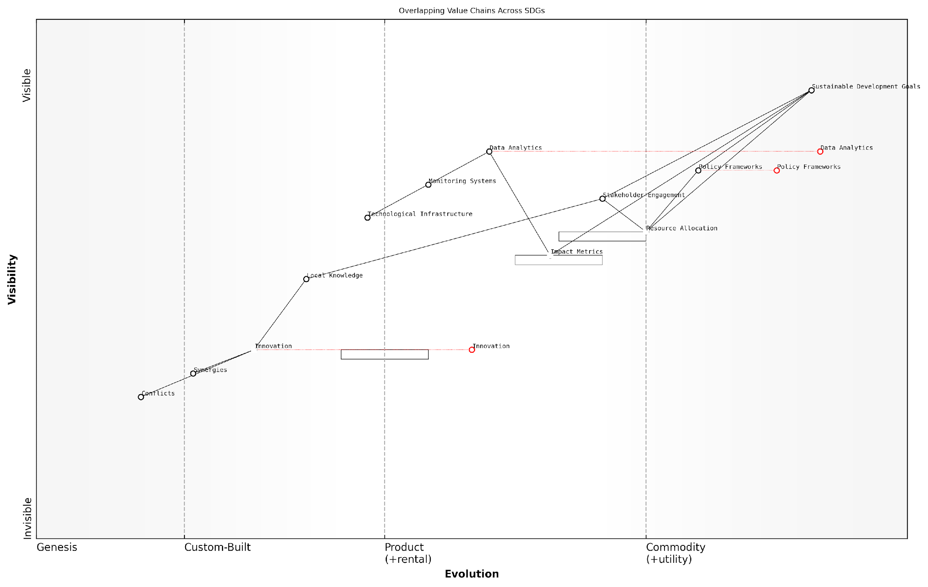

*Draft Wardley Map: [Insert Wardley Map showing overlapping value chains across multiple SDGs]*

[Edit this draft Wardley Map](https://create.wardleymaps.ai/#clone:7678e093f2345944b0)

Let’s explore the key aspects of identifying overlapping value chains across SDGs:

* Common Components and Technologies
* Shared Stakeholders and Beneficiaries
* Intersecting Policy and Regulatory Frameworks
* Overlapping Resource Requirements
* Interdependent Outcomes and Impact Metrics

Common Components and Technologies: Many SDGs rely on similar technological infrastructures or methodologies. For instance, SDG 6 (Clean Water and Sanitation) and SDG 13 (Climate Action) both heavily depend on advanced monitoring systems and data analytics platforms. By identifying these shared components, we can develop strategies that simultaneously advance multiple goals, maximising efficiency and impact.

Shared Stakeholders and Beneficiaries: Overlapping value chains often involve the same groups of people, either as implementers or beneficiaries. For example, SDG 1 (No Poverty) and SDG 8 (Decent Work and Economic Growth) both target vulnerable populations and involve similar governmental and non-governmental actors. Recognising these shared stakeholders allows for more coordinated and holistic interventions.

Intersecting Policy and Regulatory Frameworks: Many SDGs are influenced by overlapping policy domains. SDG 14 (Life Below Water) and SDG 15 (Life on Land) both intersect with environmental protection policies, while SDG 5 (Gender Equality) and SDG 10 (Reduced Inequalities) share common ground in anti-discrimination legislation. Mapping these intersections can inform more coherent and mutually reinforcing policy development.

Understanding the policy intersections across SDGs is not just about avoiding conflicts; it’s about crafting synergistic frameworks that amplify positive outcomes across multiple dimensions of sustainable development.

Overlapping Resource Requirements: Different SDGs often compete for the same limited resources, be it funding, human capital, or natural resources. For instance, SDG 2 (Zero Hunger) and SDG 7 (Affordable and Clean Energy) may compete for land use between agriculture and renewable energy production. Identifying these overlaps is crucial for developing strategies that optimise resource allocation and minimise conflicts.

Interdependent Outcomes and Impact Metrics: Progress in one SDG can directly influence outcomes in others. For example, advancements in SDG 4 (Quality Education) can positively impact SDG 3 (Good Health and Well-being) through improved health literacy. Mapping these interdependencies allows for a more nuanced understanding of progress and can reveal unexpected leverage points for accelerating overall SDG achievement.

To effectively identify and analyse these overlapping value chains, I recommend the following approach based on my experience working with government bodies and international organisations:

* Create individual Wardley Maps for each SDG, focusing on key components, dependencies, and evolution
* Overlay these maps to identify common elements and intersections
* Analyse the nature of these overlaps, categorising them as potential synergies or conflicts
* Engage multi-stakeholder groups to validate and refine the identified overlaps
* Develop integrated strategies that leverage synergies and mitigate conflicts across SDGs

This process not only reveals the complexities of SDG implementation but also uncovers opportunities for more efficient and effective interventions. For instance, in a recent project with a European government agency, we identified significant overlaps between SDG 9 (Industry, Innovation, and Infrastructure) and SDG 11 (Sustainable Cities and Communities) in the context of smart city initiatives. This discovery led to a more integrated approach to urban development, aligning industrial innovation with sustainable urban planning.

The power of Wardley Mapping in SDG implementation lies in its ability to make visible the hidden connections and dependencies that exist across goals. It transforms our understanding from a set of isolated targets to an interconnected ecosystem of sustainable development.

However, it’s crucial to approach this analysis with a nuanced understanding of local contexts and global dynamics. What may appear as an overlap in one setting might not hold true in another due to varying socio-economic conditions, cultural factors, or environmental challenges. Therefore, while Wardley Mapping provides a powerful framework for identifying overlaps, it should be complemented with in-depth local knowledge and continuous stakeholder engagement.

As we move forward in our journey towards achieving the SDGs, the ability to identify and leverage these overlapping value chains will become increasingly critical. It will enable us to develop more holistic, efficient, and impactful strategies that truly embody the interconnected nature of sustainable development. By embracing this approach, we can move beyond siloed thinking and towards a more integrated and effective implementation of the global goals.

### Resolving Conflicts and Trade-offs

In the complex landscape of the United Nations Sustainable Development Goals (SDGs), conflicts and trade-offs are inevitable. As we map the intricate value chains and dependencies across different SDGs, we often uncover areas where progress towards one goal may hinder advancement in another. Resolving these conflicts is crucial for creating a cohesive and effective strategy for sustainable development. This section delves into the methodologies and approaches for identifying and addressing these conflicts using Wardley Mapping as a strategic tool.

The process of resolving conflicts and trade-offs in SDG implementation can be broken down into several key steps:

* Conflict Identification
* Impact Assessment
* Stakeholder Analysis
* Trade-off Evaluation
* Mitigation Strategy Development
* Continuous Monitoring and Adaptation

Conflict Identification: The first step in resolving conflicts is to identify them accurately. Wardley Mapping provides a visual framework that allows us to pinpoint where value chains of different SDGs intersect or compete. For instance, we might observe that efforts to boost industrial growth (SDG 9) could potentially conflict with climate action goals (SDG 13). By overlaying maps of these SDGs, we can precisely locate the points of tension.

Wardley Mapping has revolutionised our ability to spot conflicts in sustainable development strategies. It’s like having a high-resolution satellite image of the entire SDG landscape, where we can zoom in on specific areas of friction.

Impact Assessment: Once conflicts are identified, it’s crucial to assess their potential impact. This involves quantifying the effects of pursuing one goal at the expense of another. For example, we might evaluate how much carbon emissions would increase (impacting SDG 13) for every percentage point of industrial growth (SDG 9). Wardley Maps can be augmented with data visualisations to represent these impacts, providing a clear picture of the trade-offs involved.

Stakeholder Analysis: Understanding the stakeholders affected by each conflicting goal is vital. Wardley Mapping allows us to identify key players along the value chains and assess their interests and influence. This analysis helps in developing strategies that balance the needs of various stakeholders while minimising negative impacts.

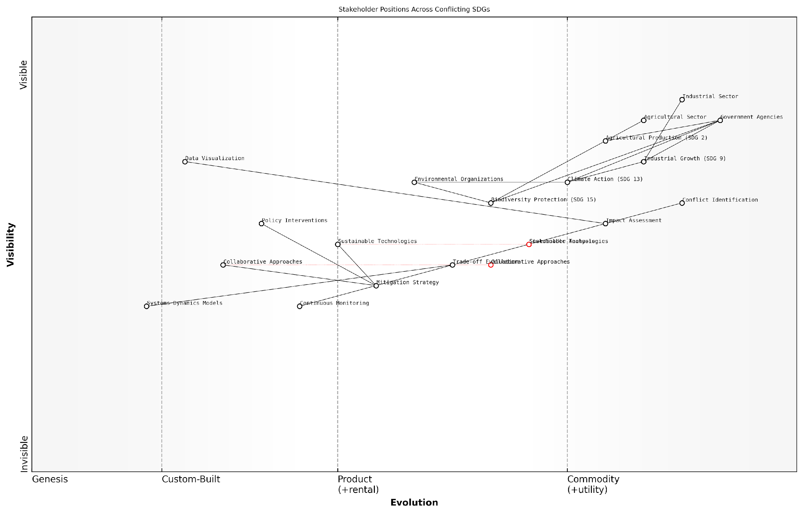

*Draft Wardley Map: [Insert Wardley Map showing stakeholder positions across conflicting SDGs]*

[Edit this draft Wardley Map](https://create.wardleymaps.ai/#clone:59deba4401fba86ae7)

Trade-off Evaluation: With conflicts identified and impacts assessed, the next step is to evaluate potential trade-offs. This involves weighing the benefits and drawbacks of different approaches. Wardley Mapping can assist in this process by allowing us to model different scenarios and their outcomes. For instance, we might explore how investing in clean technologies could mitigate the conflict between industrial growth and climate action.

Mitigation Strategy Development: Based on the trade-off evaluation, we can develop strategies to mitigate conflicts. These strategies might involve technological innovations, policy interventions, or collaborative approaches. Wardley Mapping helps in visualising how these mitigation strategies could reshape the value chains and resolve conflicts.

In my experience advising government bodies, the most effective mitigation strategies often emerge when we use Wardley Maps to identify unexpected allies and synergies across seemingly conflicting goals.

Continuous Monitoring and Adaptation: Resolving conflicts is not a one-time activity but an ongoing process. As the SDG landscape evolves, new conflicts may emerge while others are resolved. Wardley Mapping provides a dynamic tool for continuously monitoring these changes and adapting strategies accordingly.

It’s important to note that while Wardley Mapping is a powerful tool for resolving conflicts and trade-offs, it should be used in conjunction with other methodologies and data sources. For instance, integrating Wardley Maps with systems dynamics models can provide a more comprehensive understanding of the complex interactions between SDGs.

In practice, resolving conflicts often requires creative solutions and cross-sector collaboration. For example, in a recent project with a national government, we used Wardley Mapping to identify a conflict between expanding agricultural production (SDG 2) and protecting biodiversity (SDG 15). By visualising the value chains of both goals, we identified an opportunity to introduce sustainable farming practices that could serve both objectives. This led to a collaborative effort between agricultural and environmental agencies, resulting in a win-win solution.

Another critical aspect of resolving conflicts is prioritisation. Not all conflicts can be fully resolved, and some trade-offs may be necessary. Wardley Mapping can assist in this prioritisation process by highlighting which conflicts have the most significant impact on the overall SDG strategy. This allows decision-makers to focus their efforts on the most critical areas of tension.

* Identify key conflicts using overlaid Wardley Maps
* Assess the impact of conflicts on overall SDG progress
* Analyse stakeholder positions and interests
* Evaluate potential trade-offs and their consequences
* Develop mitigation strategies that leverage synergies
* Implement continuous monitoring and adaptation mechanisms

In conclusion, resolving conflicts and trade-offs is a critical component of effective SDG implementation. Wardley Mapping provides a strategic framework for identifying, analysing, and addressing these challenges. By visualising the complex interactions between different goals and stakeholders, we can develop more nuanced and effective strategies for sustainable development. As we continue to refine our approach to SDG implementation, the ability to navigate and resolve conflicts will be crucial in achieving a balanced and sustainable future for all.

### Leveraging Synergies for Multiplied Impact

In the complex landscape of sustainable development, identifying and leveraging synergies between various Sustainable Development Goals (SDGs) is crucial for maximising impact and resource efficiency. This section delves into the strategic approach of utilising Wardley Mapping to uncover and capitalise on these synergies, thereby amplifying the overall effectiveness of SDG implementation efforts.

Wardley Mapping, with its unique ability to visualise value chains and dependencies, provides an invaluable tool for identifying potential synergies across different SDGs. By overlaying maps of individual goals, we can pinpoint areas where efforts towards one goal can simultaneously contribute to progress in others, creating a multiplier effect that accelerates sustainable development.

The power of Wardley Mapping in SDG implementation lies in its ability to reveal hidden connections and potential force multipliers that traditional strategic planning often misses.

To effectively leverage synergies for multiplied impact, we must consider several key aspects:

* Identifying Common Components and Capabilities
* Aligning Strategic Initiatives
* Optimising Resource Allocation
* Fostering Cross-Sector Collaboration

Identifying Common Components and Capabilities: By comparing Wardley Maps of different SDGs, we can identify shared components or capabilities that contribute to multiple goals. For instance, a robust data collection and analysis infrastructure might be crucial for both SDG 3 (Good Health and Well-being) and SDG 13 (Climate Action). Recognising these commonalities allows for the development of shared platforms or initiatives that serve multiple SDGs simultaneously, maximising efficiency and impact.

Aligning Strategic Initiatives: Wardley Mapping enables us to visualise the evolution of various components within each SDG’s value chain. This insight allows for the alignment of strategic initiatives across different goals. For example, efforts to improve sustainable agriculture practices (SDG 2: Zero Hunger) can be aligned with initiatives for responsible consumption and production (SDG 12), creating a synergistic approach that addresses multiple goals through coordinated action.

Optimising Resource Allocation: By identifying synergies, we can optimise the allocation of limited resources. Instead of pursuing each SDG in isolation, resources can be directed towards initiatives that contribute to multiple goals simultaneously. This approach not only enhances efficiency but also increases the overall impact of sustainable development efforts.

In my experience advising government bodies, the strategic allocation of resources based on identified synergies has consistently led to more impactful and sustainable outcomes across multiple SDGs.

Fostering Cross-Sector Collaboration: Synergies often exist across different sectors and stakeholder groups. Wardley Mapping can reveal opportunities for collaboration between government agencies, private sector entities, and civil society organisations. By visualising how different actors contribute to various stages of the value chain across multiple SDGs, we can identify potential partnerships that leverage complementary strengths and resources.

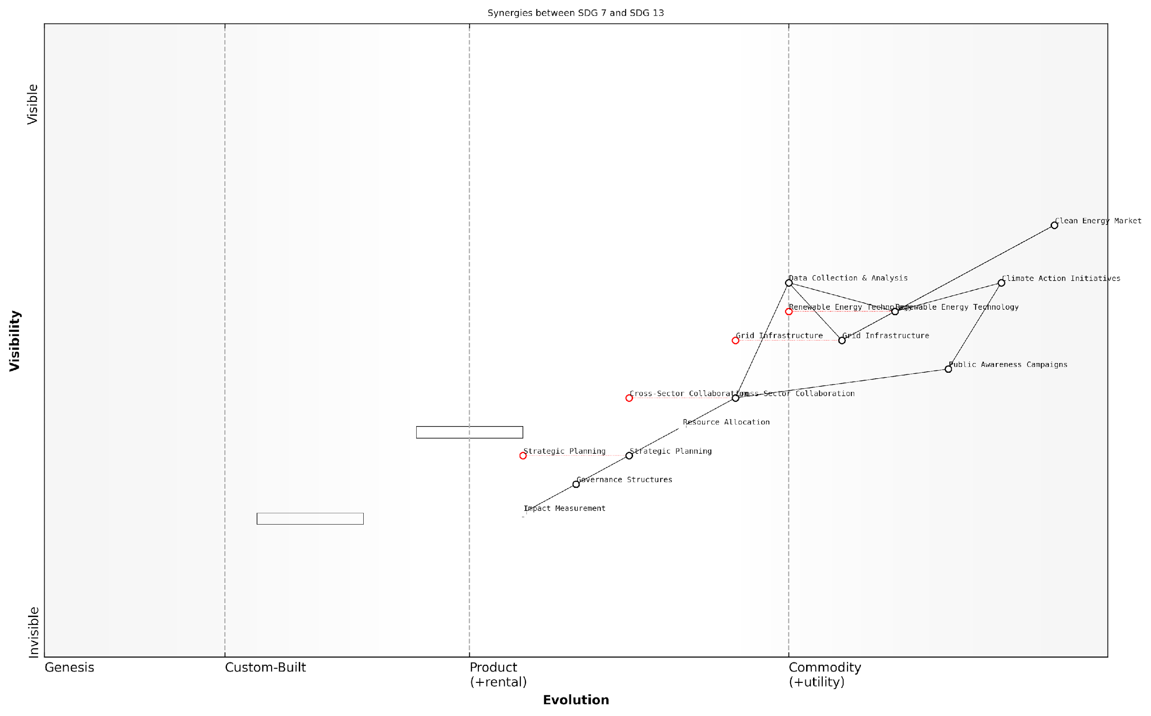

*Draft Wardley Map: [Insert Wardley Map illustrating synergies between SDG 7 (Affordable and Clean Energy) and SDG 13 (Climate Action), highlighting shared components and potential collaborative initiatives]*

[Edit this draft Wardley Map](https://create.wardleymaps.ai/#clone:76dd55af5f78e74e8a)

Case Study: Synergistic Approach to Clean Energy and Climate Action

In a recent project with a European government, we used Wardley Mapping to identify synergies between SDG 7 (Affordable and Clean Energy) and SDG 13 (Climate Action). The mapping process revealed several shared components, including renewable energy technology development, grid infrastructure modernisation, and public awareness campaigns. By aligning initiatives in these areas, the government was able to create a comprehensive strategy that simultaneously advanced both goals.

The synergistic approach led to the development of a joint task force that coordinated efforts between the energy and environment ministries. This collaboration resulted in accelerated progress towards both SDGs, with notable achievements including:

* A 30% increase in renewable energy adoption within two years
* A 15% reduction in greenhouse gas emissions from the energy sector
* Significant cost savings through shared infrastructure and resources
* Enhanced public engagement and support for climate action initiatives

This case study demonstrates the power of leveraging synergies identified through Wardley Mapping to create multiplied impact across interconnected SDGs.

Challenges and Considerations

While leveraging synergies offers significant benefits, it’s important to acknowledge potential challenges:

* Complexity in coordination: Managing initiatives that span multiple SDGs and stakeholders can be logistically challenging.
* Balancing priorities: Ensuring that the pursuit of synergies doesn’t lead to neglect of specific SDG targets requires careful planning and monitoring.
* Measuring impact: Developing metrics that accurately capture the multiplied impact of synergistic approaches can be complex but is crucial for demonstrating success and guiding future strategies.

To address these challenges, it’s essential to establish robust governance structures, clear communication channels, and adaptive management processes that can respond to the dynamic nature of sustainable development efforts.

The key to successful synergy leveraging lies in maintaining a holistic view of the SDGs while remaining agile in implementation. Wardley Mapping provides the strategic framework to achieve this balance.

Conclusion

Leveraging synergies for multiplied impact is a powerful strategy in the pursuit of the Sustainable Development Goals. By utilising Wardley Mapping to identify and capitalise on these synergies, we can create more efficient, effective, and transformative approaches to sustainable development. As we continue to face complex global challenges, the ability to recognise and exploit these interconnections will be crucial in accelerating progress towards a more sustainable and equitable world.

## Strategies for Multi-Stakeholder Engagement

### Government and Policy Maker Involvement

In the context of Wardley Mapping for the United Nations Sustainable Development Goals (SDGs), government and policy maker involvement is paramount. As the primary architects of national and international policy frameworks, these stakeholders play a crucial role in shaping the landscape within which SDG implementation occurs. This section explores strategies for engaging government entities and policy makers in the Wardley Mapping process, emphasising the unique value this approach brings to multi-stakeholder collaboration in pursuit of sustainable development.

The involvement of government and policy makers in Wardley Mapping for SDGs can be structured around three key areas: awareness and education, collaborative mapping exercises, and policy alignment and implementation.

1. Awareness and Education:

* Conduct Wardley Mapping workshops tailored for government officials and policy makers
* Develop case studies demonstrating successful applications of Wardley Mapping in public sector contexts
* Create policy briefs that highlight the strategic advantages of Wardley Mapping for SDG implementation

1. Collaborative Mapping Exercises:

* Organise cross-departmental mapping sessions to identify interdependencies and potential synergies
* Facilitate multi-stakeholder mapping workshops that bring together government, private sector, and civil society representatives
* Establish a government-led Wardley Mapping community of practice for ongoing collaboration and knowledge sharing

1. Policy Alignment and Implementation:

* Use Wardley Maps to assess the current policy landscape and identify gaps or conflicts
* Develop strategic roadmaps for policy interventions based on map insights
* Create mechanisms for continuous feedback and map refinement as policies are implemented

One of the most significant challenges in engaging government and policy makers is overcoming institutional inertia and resistance to new methodologies. To address this, it is crucial to demonstrate the tangible benefits of Wardley Mapping in terms that resonate with public sector priorities.

Wardley Mapping provides a visual language that cuts across departmental silos, enabling policymakers to see the bigger picture and make more informed decisions about resource allocation and strategic priorities.

In my experience advising government bodies on SDG implementation, I’ve found that Wardley Mapping can be particularly effective in addressing the following areas:

* Policy coherence: Identifying conflicts and synergies between different policy areas and SDGs
* Resource optimisation: Pinpointing areas where government interventions can have the most significant impact
* Stakeholder alignment: Facilitating more productive dialogues between different government departments and external stakeholders
* Future-proofing: Anticipating technological and social changes that may affect SDG implementation

A practical example of government involvement in Wardley Mapping for SDGs comes from a project I led with a European national government. We organised a series of cross-ministerial mapping workshops focused on SDG 13 (Climate Action) and its intersections with other goals. The process revealed several key insights:

* Unexpected dependencies between agricultural policies and urban development initiatives
* Opportunities for leveraging existing digital infrastructure to enhance climate monitoring and response
* Potential conflicts between short-term economic growth targets and long-term sustainability goals

These insights led to a realignment of policy priorities and the establishment of new cross-departmental working groups to address the identified challenges.

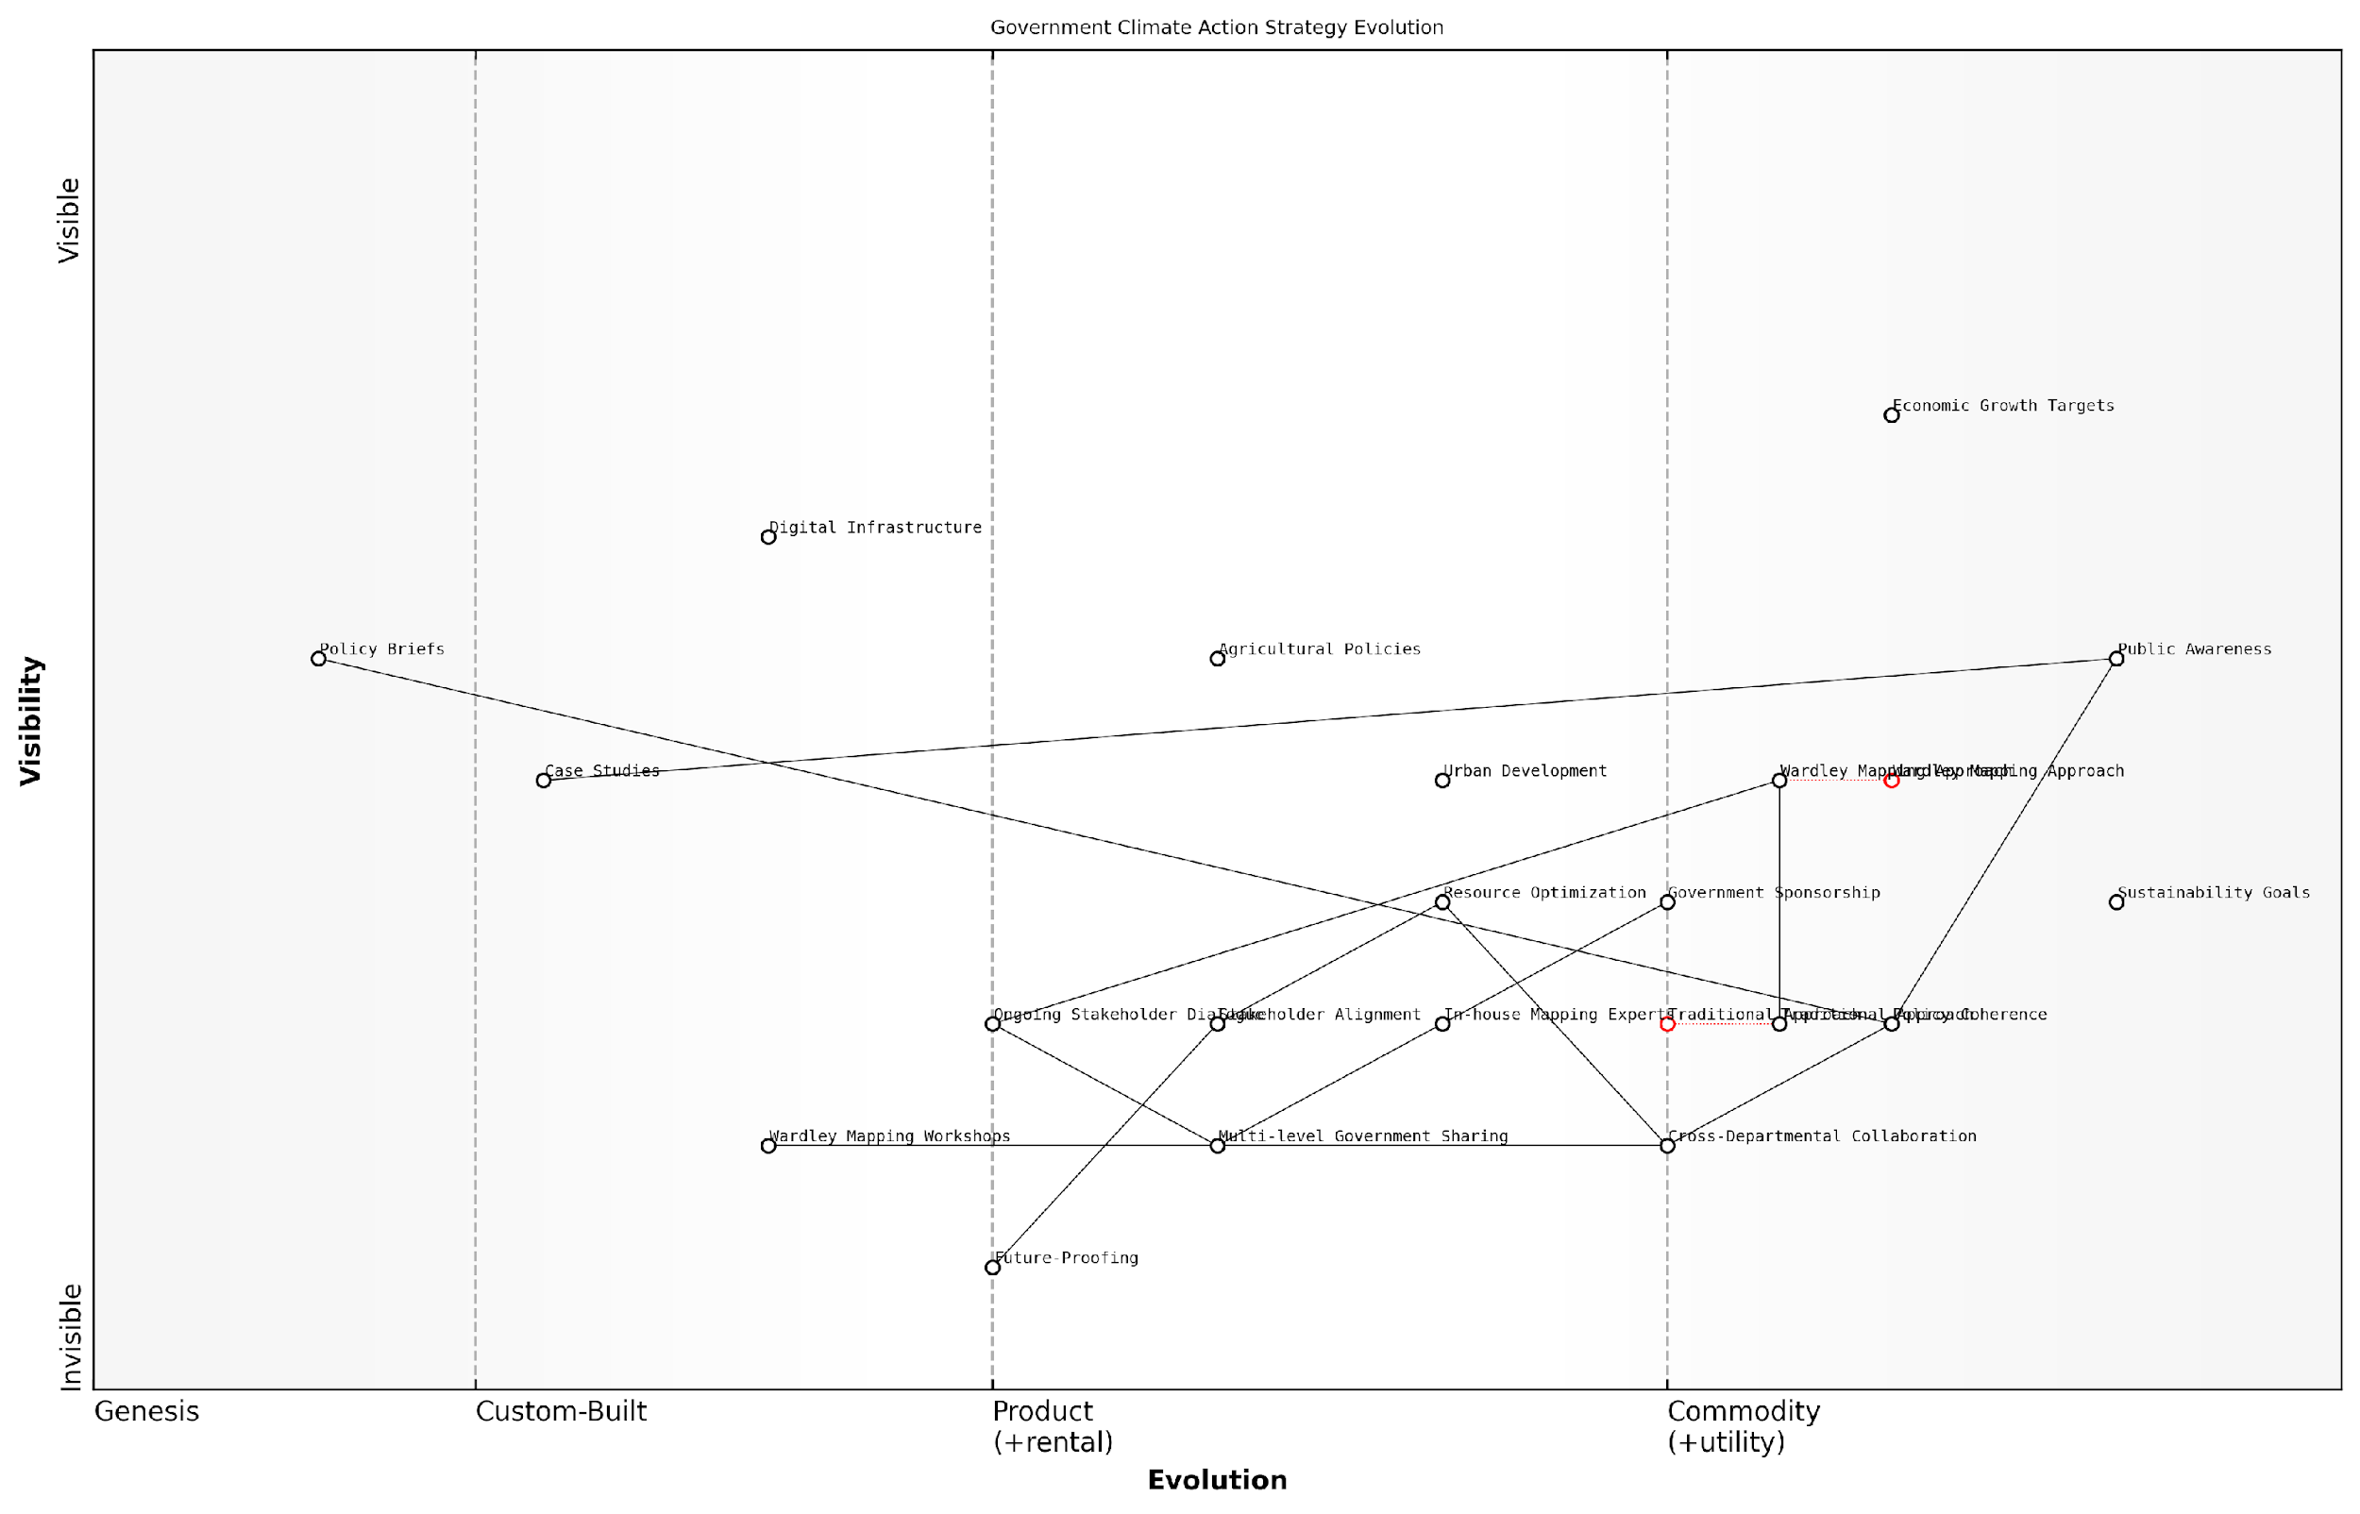

*Draft Wardley Map: [Insert Wardley Map showing the evolution of government climate action strategy before and after the mapping exercise]*

[Edit this draft Wardley Map](https://create.wardleymaps.ai/#clone:3dbd516aae57b5757e)

To maximise the effectiveness of government and policy maker involvement in Wardley Mapping for SDGs, consider the following best practices:

* Secure high-level sponsorship within government to ensure sustained engagement and resource allocation
* Integrate Wardley Mapping into existing policy development and review processes
* Develop a cadre of in-house Wardley Mapping experts within government to build institutional capacity
* Establish mechanisms for sharing maps and insights across different levels of government (local, regional, national, international)
* Create platforms for ongoing dialogue between government mappers and external stakeholders to ensure maps remain current and relevant

It’s important to note that the role of government in Wardley Mapping for SDGs extends beyond internal strategy development. Governments can also play a crucial role in fostering a broader ecosystem of mapping practitioners and advocates.

By championing Wardley Mapping as a tool for sustainable development, governments can catalyse a shift towards more strategic, systems-level thinking across all sectors involved in SDG implementation.

In conclusion, effective government and policy maker involvement in Wardley Mapping for SDGs requires a multifaceted approach that combines education, collaborative exercises, and strategic implementation. By leveraging the unique insights provided by Wardley Maps, governments can enhance policy coherence, optimise resource allocation, and foster more effective multi-stakeholder collaborations in pursuit of the 2030 Agenda for Sustainable Development.

### Private Sector Contributions

In the context of Wardley Mapping the United Nations Sustainable Development Goals (SDGs), private sector contributions play a pivotal role in driving progress and innovation. This subsection explores the strategies for engaging businesses in multi-stakeholder collaborations, leveraging their unique capabilities to accelerate SDG implementation.

The private sector’s involvement in SDG efforts is not merely a matter of corporate social responsibility; it represents a strategic opportunity for businesses to align their operations with global sustainability objectives, unlock new markets, and future-proof their value chains. By applying Wardley Mapping to private sector engagement, we can identify key areas where businesses can contribute most effectively to the SDGs while simultaneously enhancing their competitive position.

The SDGs present a trillion-dollar opportunity for businesses that can innovate and scale solutions to address global challenges. Wardley Mapping provides a powerful tool for companies to visualise their position within the SDG landscape and identify strategic moves that create shared value.

Let us explore the key strategies for engaging the private sector in multi-stakeholder SDG initiatives through the lens of Wardley Mapping:

* 1. Value Chain Alignment
  2. Innovation Ecosystems
  3. Cross-Sector Partnerships
  4. Impact Measurement and Reporting
  5. Policy Engagement and Advocacy

1. Value Chain Alignment: Wardley Mapping can help businesses identify areas within their value chains that directly impact specific SDGs. By visualising these connections, companies can strategically realign their operations to maximise positive contributions and minimise negative externalities.

For instance, a food and beverage company might map its supply chain against SDG 2 (Zero Hunger) and SDG 12 (Responsible Consumption and Production). This exercise could reveal opportunities to support smallholder farmers, reduce food waste, or develop more sustainable packaging solutions.

1. Innovation Ecosystems: Wardley Maps can illustrate the evolution of technologies and practices relevant to SDG implementation. By identifying components in the ‘genesis’ and ‘custom-built’ stages, businesses can spot opportunities for innovation and investment that align with SDG targets.

Mapping innovation ecosystems around SDGs not only highlights potential breakthroughs but also reveals collaborative opportunities that can accelerate progress and create new markets.

1. Cross-Sector Partnerships: One of the most powerful applications of Wardley Mapping in SDG implementation is its ability to facilitate cross-sector collaborations. By comparing maps from different stakeholders—governments, NGOs, and businesses—we can identify areas of overlap and complementarity.

For example, a technology company’s map might reveal capabilities in data analytics that could support a government’s efforts to track progress on SDG 3 (Good Health and Well-being). This insight could lead to a public-private partnership that enhances health monitoring systems.

1. Impact Measurement and Reporting: Wardley Mapping can assist businesses in developing more robust impact measurement frameworks. By mapping the components of their SDG-related initiatives, companies can identify key performance indicators (KPIs) that align with both business objectives and SDG targets.

This approach enables more meaningful sustainability reporting, moving beyond traditional CSR metrics to demonstrate tangible contributions to global goals. It also helps in identifying areas where business activities might be inadvertently hindering SDG progress, allowing for corrective action.

1. Policy Engagement and Advocacy: Wardley Maps can serve as powerful tools for businesses to engage with policymakers on SDG-related issues. By visualising the landscape of a particular SDG, companies can articulate how specific policies might accelerate or impede progress.

For instance, a renewable energy company could use a Wardley Map to illustrate the evolving components of the clean energy sector (SDG 7 - Affordable and Clean Energy) and advocate for policies that would support the transition to more sustainable power sources.

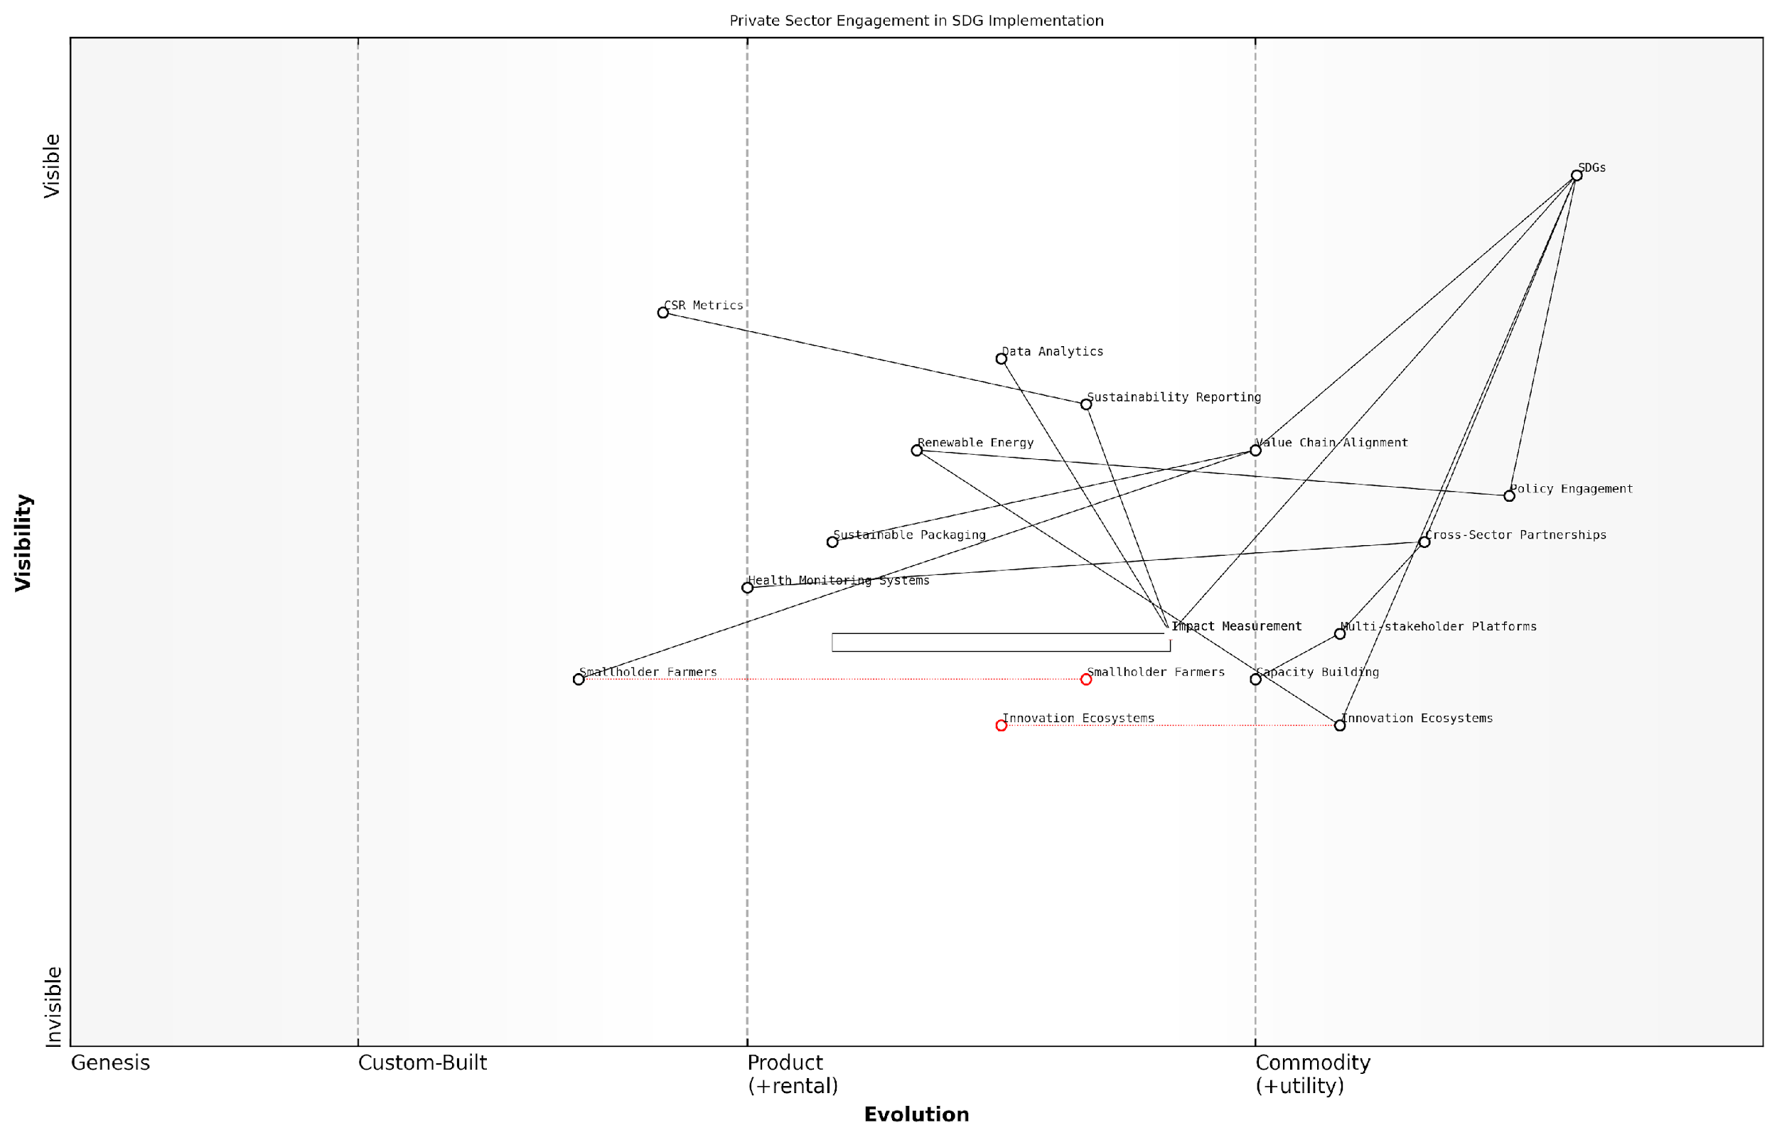

*Draft Wardley Map: [Insert Wardley Map: ‘Private Sector Engagement in SDG Implementation’]*

[Edit this draft Wardley Map](https://create.wardleymaps.ai/#clone:dda238263f18d72a36)

Implementing these strategies requires a shift in how businesses approach sustainability and stakeholder engagement. Wardley Mapping provides a common language and visual framework that can bridge the gap between different sectors, fostering more effective collaboration towards SDG achievement.

However, it’s crucial to acknowledge the challenges in this process. Many businesses may lack the expertise to effectively map their activities against SDGs or may be hesitant to share strategic information. Moreover, short-term profit pressures can sometimes conflict with long-term sustainability goals.

To address these challenges, multi-stakeholder platforms and capacity-building initiatives are essential. Governments and international organisations can play a crucial role in providing guidance, creating incentives, and facilitating knowledge sharing on Wardley Mapping for SDGs.

The key to unlocking private sector potential for SDG implementation lies in demonstrating that sustainability and profitability are not mutually exclusive. Wardley Mapping helps visualise this alignment, turning abstract goals into concrete business opportunities.

In conclusion, engaging the private sector through Wardley Mapping offers a powerful approach to accelerating SDG implementation. By providing a strategic framework for aligning business activities with global sustainability objectives, we can harness the innovation, resources, and reach of the private sector to drive meaningful progress towards the 2030 Agenda.

### Civil Society and NGO Partnerships

In the complex landscape of implementing the United Nations Sustainable Development Goals (SDGs), civil society organisations and non-governmental organisations (NGOs) play a pivotal role. Their grassroots connections, specialised expertise, and ability to mobilise communities make them indispensable partners in the global sustainability effort. Wardley Mapping offers a powerful framework for enhancing these partnerships and maximising their impact on SDG implementation.

To effectively engage civil society and NGO partners through Wardley Mapping, we must consider several key strategies:

* Collaborative Mapping Sessions
* Capacity Building for Map Interpretation
* Aligning Value Chains
* Identifying Niche Expertise
* Fostering Innovation Hubs

Let’s explore each of these strategies in detail:

1. Collaborative Mapping Sessions: Organising workshops where government officials, NGO leaders, and civil society representatives jointly create Wardley Maps for specific SDGs can be transformative. These sessions not only produce comprehensive maps but also foster mutual understanding and shared ownership of the challenges and potential solutions.

During a recent mapping session for SDG 6 (Clean Water and Sanitation), we witnessed a breakthrough moment when an NGO representative identified a critical component in the value chain that government planners had overlooked. This collaborative approach led to a more robust and inclusive strategy.

1. Capacity Building for Map Interpretation: To ensure that civil society and NGO partners can fully engage with and benefit from Wardley Mapping, it’s crucial to invest in capacity building. This involves training sessions on map creation, interpretation, and strategic application.
2. Aligning Value Chains: Wardley Maps can reveal where NGOs’ activities align with or complement government initiatives. By visualising these intersections, we can identify opportunities for synergy and avoid duplication of efforts.

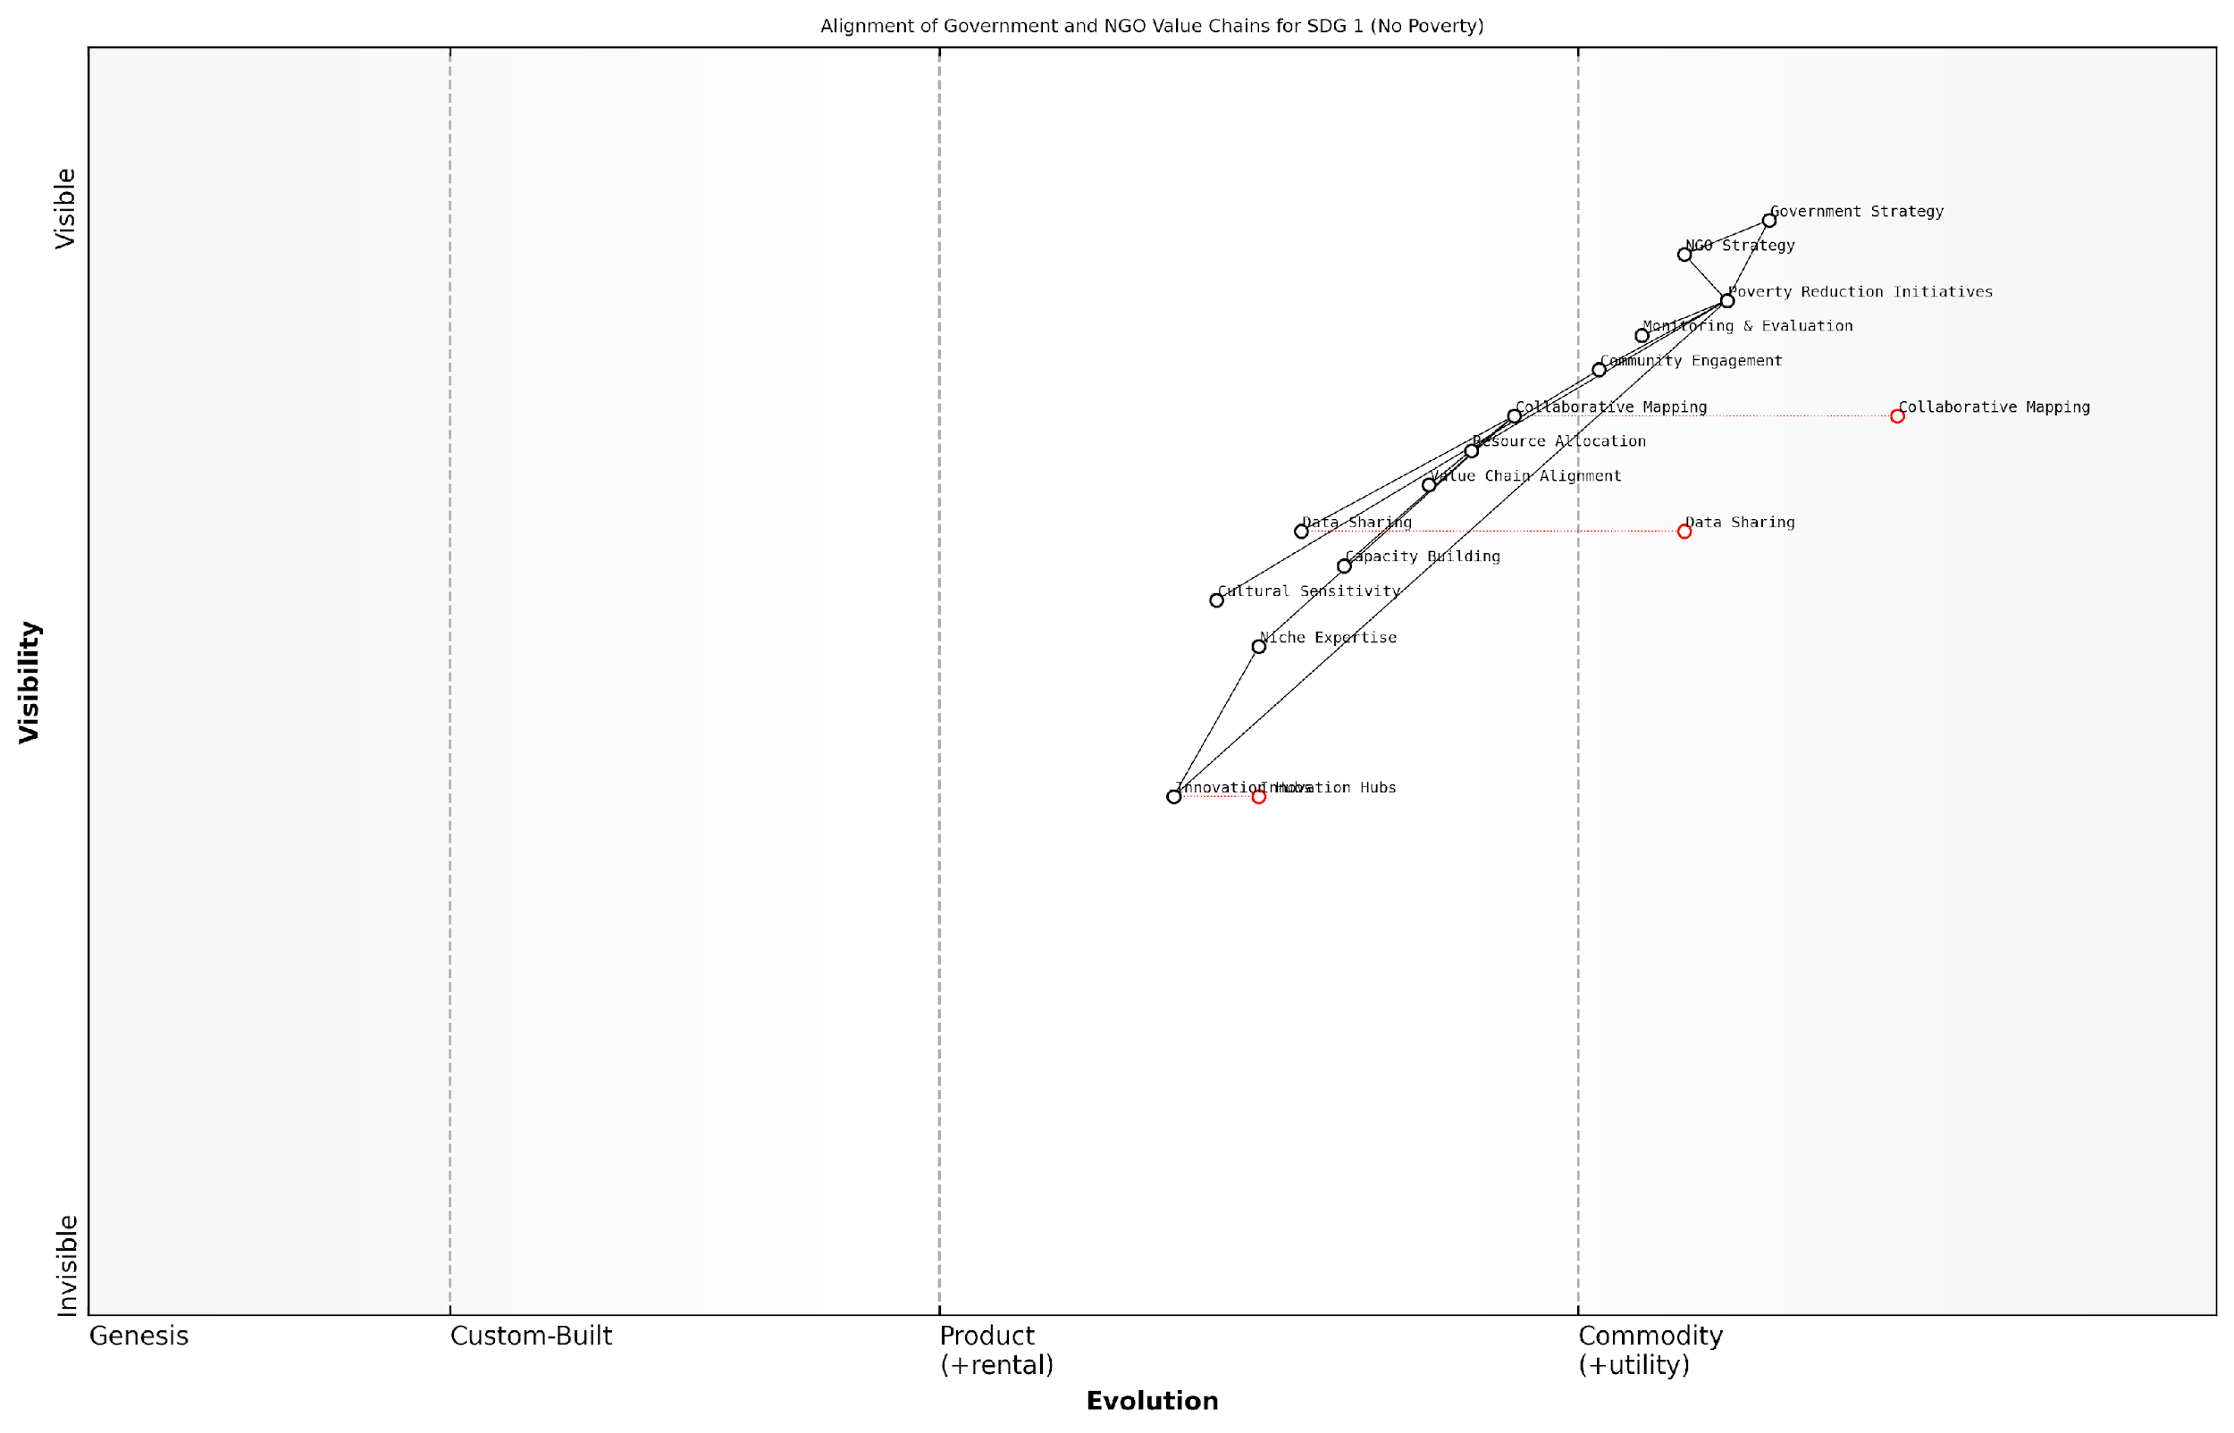

*Draft Wardley Map: [Insert Wardley Map showing alignment of government and NGO value chains for SDG 1 (No Poverty)]*

[Edit this draft Wardley Map](https://create.wardleymaps.ai/#clone:cc2bc3745d99cd38d9)

1. Identifying Niche Expertise: Civil society organisations often possess deep, specialised knowledge in specific areas. Wardley Mapping can help pinpoint where this expertise is most valuable within the broader SDG implementation strategy.
2. Fostering Innovation Hubs: By using Wardley Maps to identify areas ripe for innovation, we can create targeted innovation hubs that bring together NGOs, tech startups, and community groups to develop novel solutions for SDG challenges.

Our innovation hub for SDG 13 (Climate Action) brought together environmental NGOs, climate scientists, and local community leaders. The resulting Wardley Map highlighted unexpected opportunities for nature-based solutions that we hadn’t previously considered.

When implementing these strategies, it’s crucial to be mindful of potential challenges:

* Power Dynamics: Ensure that smaller NGOs and grassroots organisations have an equal voice in mapping exercises.
* Data Sharing: Establish clear protocols for sharing sensitive information during collaborative mapping sessions.
* Resource Constraints: Recognise that many NGOs may have limited resources for engaging in extensive mapping exercises and provide support where possible.
* Cultural Sensitivity: Adapt mapping methodologies to respect local cultural contexts and indigenous knowledge systems.

By addressing these challenges head-on, we can create a more inclusive and effective multi-stakeholder engagement process.

The application of Wardley Mapping to civil society and NGO partnerships also opens up new possibilities for monitoring and evaluation. By regularly updating maps to reflect changing landscapes, we can track progress, identify emerging challenges, and adapt strategies accordingly.

In conclusion, leveraging Wardley Mapping for civil society and NGO partnerships in SDG implementation offers a powerful means of enhancing collaboration, aligning efforts, and maximising impact. As we continue to refine these approaches, we pave the way for more effective and inclusive sustainable development strategies that truly harness the collective power of all stakeholders.

## Creating a Unified Strategy Map

### Integrating Individual SDG Maps

The integration of individual Sustainable Development Goal (SDG) maps into a unified strategy map is a critical step in creating a cohesive and effective approach to achieving the UN’s 2030 Agenda. This process requires a deep understanding of the interconnections between different SDGs, as well as the ability to identify common components and leverage points across multiple value chains. As we delve into this complex task, it’s essential to recognise that the resulting unified map will serve as a powerful tool for decision-makers, enabling them to visualise the entire sustainability landscape and make informed strategic choices.

To begin the integration process, we must first acknowledge the inherent challenges. Each SDG map represents a unique ecosystem of components, dependencies, and evolving technologies. The task at hand is to weave these distinct threads into a coherent tapestry that accurately represents the interplay between different sustainability goals. This requires a methodical approach, which we can break down into several key steps:

* Identify common components across SDG maps
* Analyse dependencies and interactions between goals
* Align evolution stages of similar components
* Highlight potential synergies and conflicts
* Create a hierarchical structure that encompasses all SDGs

Let’s explore each of these steps in detail, drawing upon best practices and real-world experiences in SDG implementation.

1. Identifying Common Components: The first step in integration is to recognise components that appear across multiple SDG maps. These shared elements often represent foundational aspects of sustainable development, such as data infrastructure, policy frameworks, or educational systems. For instance, a robust data collection and analysis platform might be crucial for both SDG 3 (Good Health and Well-being) and SDG 13 (Climate Action). By identifying these common components, we can begin to see the skeleton of our unified map taking shape.

In my experience advising government bodies, I’ve found that up to 30% of components can be shared across multiple SDG maps. This overlap presents a significant opportunity for resource optimisation and coordinated action.

1. Analysing Dependencies and Interactions: Once common components are identified, the next step is to map out how different SDGs depend on and interact with each other. This involves tracing the flow of value and influence between goals. For example, progress in SDG 6 (Clean Water and Sanitation) can have direct positive impacts on SDG 3 (Good Health and Well-being) and SDG 15 (Life on Land). By visualising these interactions, we can begin to see clusters of highly interconnected goals that may benefit from coordinated strategies.
2. Aligning Evolution Stages: When integrating maps, it’s crucial to ensure that similar components across different SDGs are aligned in terms of their evolution stage. This alignment helps in identifying areas where certain goals may be lagging behind and where lessons from more advanced sectors can be applied. For instance, if digital payment systems are at the ‘product’ stage for SDG 1 (No Poverty) but still at the ‘custom-built’ stage for SDG 10 (Reduced Inequalities), this discrepancy can highlight an opportunity for knowledge transfer and accelerated development.
3. Highlighting Synergies and Conflicts: As the integrated map takes shape, it becomes possible to identify areas of synergy where progress in one goal naturally supports advancement in others. Equally important is the identification of potential conflicts, where pursuit of one goal might hinder progress in another. These insights are crucial for policymakers and strategists in prioritising actions and allocating resources effectively.

A senior government official once remarked to me, ‘The unified SDG map revealed conflicts we hadn’t anticipated, allowing us to proactively address potential trade-offs before they became problematic in our national implementation strategy.’

1. Creating a Hierarchical Structure: The final step in integration is to organise the unified map into a hierarchical structure that encompasses all 17 SDGs. This structure should reflect the strategic priorities of the organisation or government body implementing the SDGs, while also maintaining the integrity of individual goal ecosystems. One effective approach is to create a top-level map that shows the relationships between SDGs, with the ability to drill down into detailed maps for each goal.

It’s important to note that the process of integrating SDG maps is not a one-time exercise. As the sustainability landscape evolves and new data becomes available, the unified map should be regularly updated to reflect changing realities and emerging opportunities. This dynamic approach ensures that the map remains a relevant and powerful tool for strategic decision-making.

In conclusion, the integration of individual SDG maps into a unified strategy map is a complex but essential process for effective sustainable development planning. By following a structured approach that identifies common components, analyses dependencies, aligns evolution stages, highlights synergies and conflicts, and creates a hierarchical structure, organisations can develop a comprehensive view of the sustainability landscape. This integrated perspective enables more informed decision-making, efficient resource allocation, and ultimately, accelerated progress towards achieving the UN’s 2030 Agenda.

As a leading expert in the field once noted, ‘The true power of Wardley Mapping for SDGs lies not in the individual maps, but in their integration. It’s here that we can see the forest for the trees and chart a course towards a truly sustainable future.’

### Identifying Key Leverage Points

In the process of creating a unified strategy map for the United Nations Sustainable Development Goals (SDGs), identifying key leverage points is a critical step that can significantly amplify the impact of our efforts. These leverage points represent areas within the complex system of SDGs where small changes can lead to substantial and far-reaching effects across multiple goals. As we integrate individual SDG maps into a cohesive whole, recognising and strategically targeting these points becomes essential for maximising the efficiency and effectiveness of our sustainability initiatives.

To effectively identify key leverage points within our unified strategy map, we must consider several crucial aspects:

* Interconnectedness of SDGs
* Evolutionary stages of components
* Cross-sector dependencies
* Potential for cascading effects
* Resource allocation efficiency

Interconnectedness of SDGs: The SDGs are inherently interconnected, with progress in one area often influencing outcomes in others. By examining our unified strategy map, we can identify nodes where multiple SDGs converge. These intersection points often serve as powerful leverage points, as actions taken here can simultaneously advance multiple goals. For instance, investments in clean energy infrastructure (SDG 7) can have positive ripple effects on climate action (SDG 13), economic growth (SDG 8), and health outcomes (SDG 3).

Evolutionary stages of components: Wardley Mapping allows us to visualise the evolutionary stages of various components within our strategy. Key leverage points often emerge at the boundaries between these stages, particularly where components are transitioning from custom-built to product or commodity. Identifying these transition points can reveal opportunities for standardisation, scalability, and increased efficiency across multiple SDGs.

Cross-sector dependencies: Our unified strategy map will inevitably reveal dependencies between different sectors and stakeholders. Key leverage points often lie at the interfaces between these sectors, where collaboration and coordination can unlock synergies. For example, partnerships between government agencies, private sector entities, and civil society organisations (SDG 17) can serve as powerful leverage points, enabling more effective implementation of various SDGs.

Potential for cascading effects: Some components within our strategy map may have the potential to trigger cascading effects throughout the system. These high-impact nodes are prime candidates for key leverage points. By analysing the value chains and dependencies within our unified map, we can identify components that, when improved or optimised, can set off a chain reaction of positive outcomes across multiple SDGs.

Resource allocation efficiency: In the context of limited resources, identifying leverage points that offer the greatest impact per unit of investment is crucial. Our unified strategy map can help us visualise where resources are currently allocated and where strategic reallocation could yield disproportionate benefits. This analysis often reveals unexpected leverage points where relatively small investments can lead to outsized returns across multiple SDGs.

To practically apply these considerations in identifying key leverage points, I recommend the following approach:

* Conduct a thorough analysis of the unified strategy map, paying particular attention to areas of high interconnectedness and cross-sector dependencies.
* Use data-driven methods to quantify the potential impact of various components on multiple SDGs.
* Engage in collaborative workshops with diverse stakeholders to gain insights into leverage points that may not be immediately apparent from the map alone.
* Employ scenario planning techniques to test the resilience and impact of identified leverage points under various future conditions.
* Regularly reassess and update the identified leverage points as the strategy evolves and new data becomes available.

It’s important to note that the process of identifying key leverage points is not a one-time exercise but an ongoing effort. As we implement our strategies and gather new data, our understanding of the system dynamics will evolve, potentially revealing new leverage points or shifting the importance of existing ones.

In conclusion, identifying key leverage points within our unified strategy map is a critical step in maximising the impact of our SDG implementation efforts. By carefully analysing the interconnections, evolutionary stages, cross-sector dependencies, and potential for cascading effects within our map, we can pinpoint areas where targeted interventions can yield disproportionate benefits across multiple sustainable development goals. This strategic approach allows us to optimise resource allocation and accelerate progress towards a more sustainable and equitable future for all.

### Prioritising Actions for Maximum Impact

In the realm of implementing the United Nations Sustainable Development Goals (SDGs) through Wardley Mapping, prioritising actions for maximum impact is a critical step that can determine the success of sustainability initiatives. This process involves carefully analysing the unified strategy map to identify the most effective interventions and allocate resources efficiently. As we delve into this crucial aspect of SDG implementation, we’ll explore how to leverage the insights gained from cross-sector map comparisons to drive meaningful change.

The unified strategy map, which integrates individual SDG maps and identifies key leverage points, serves as the foundation for prioritisation. By examining this comprehensive view of the sustainability landscape, decision-makers can discern where interventions will yield the greatest returns in terms of progress towards multiple SDGs simultaneously.

The art of prioritisation in SDG implementation lies not in choosing which goals to pursue, but in identifying the actions that create cascading positive effects across multiple goals. It’s about finding the fulcrum points where minimal effort produces maximal impact.

To effectively prioritise actions, we must consider several key factors:

* Impact Potential: Assess the potential reach and depth of impact for each proposed action.
* Resource Efficiency: Evaluate the resources required versus the expected outcomes.
* Synergistic Effects: Identify actions that positively influence multiple SDGs simultaneously.
* Urgency and Time Sensitivity: Consider the time-critical nature of certain interventions.
* Feasibility and Implementation Ease: Gauge the practical challenges and likelihood of successful execution.
* Stakeholder Alignment: Ensure actions align with the interests and capabilities of key stakeholders.

One effective approach to prioritisation is the use of a weighted scoring system. This method involves assigning weights to each of the factors mentioned above and scoring potential actions accordingly. The resulting prioritised list can guide decision-makers in allocating resources and focusing efforts where they matter most.

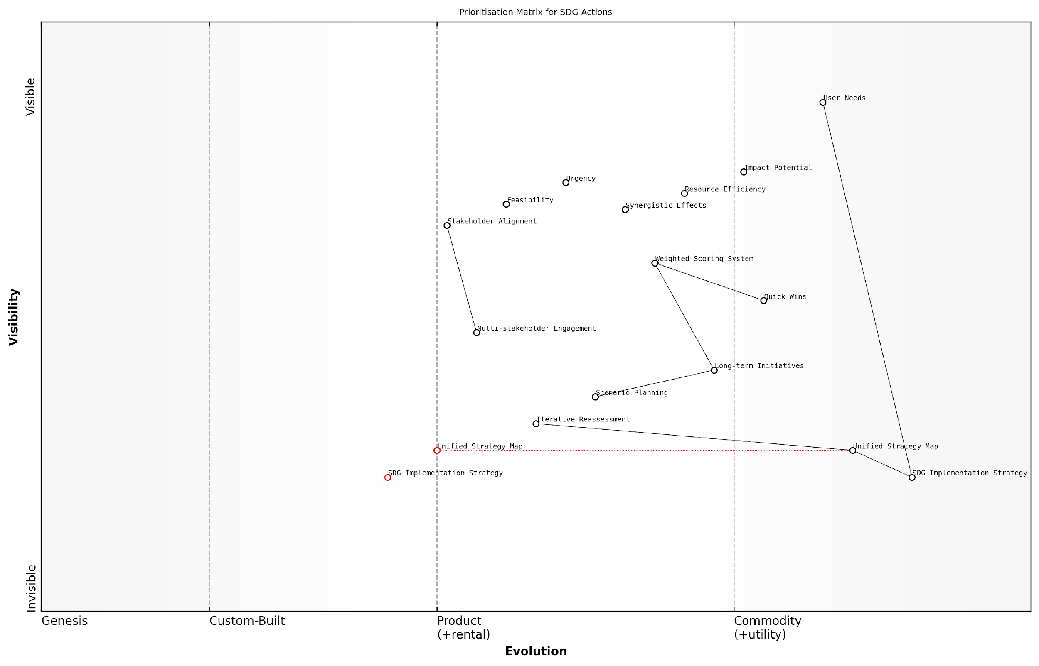

*Draft Wardley Map: [Insert Wardley Map: Prioritisation Matrix for SDG Actions]*

[Edit this draft Wardley Map](https://create.wardleymaps.ai/#clone:d3c02e40d015feb02e)

Another crucial aspect of prioritisation is the identification of ‘quick wins’ versus long-term strategic initiatives. Quick wins are actions that can be implemented rapidly and show immediate results, often boosting morale and building momentum. Long-term strategic initiatives, while potentially slower to yield results, may have more profound and lasting impacts on sustainable development.

In my experience advising government bodies on SDG implementation, I’ve found that a balanced portfolio of quick wins and strategic long-term projects is essential. This approach maintains stakeholder engagement while driving towards transformative change.

It’s also crucial to consider the evolutionary stage of different components within the Wardley Map when prioritising actions. Components in the ‘Genesis’ or ‘Custom Built’ stages may require more resources and carry higher risks, but could also offer significant competitive advantages or breakthroughs in sustainability efforts. Conversely, actions targeting components in the ‘Product’ or ‘Commodity’ stages might be easier to implement but may have a more limited impact.

When prioritising actions, it’s essential to engage with a diverse group of stakeholders to ensure a comprehensive perspective. This multi-stakeholder approach helps to:

* Validate assumptions about impact and feasibility
* Identify potential barriers or enablers not visible in the map alone
* Build consensus and buy-in for the prioritised actions
* Leverage the collective expertise and resources of various sectors

One powerful tool for prioritisation is the use of scenario planning in conjunction with the unified strategy map. By projecting different future scenarios, decision-makers can assess the robustness and flexibility of proposed actions across various potential outcomes. This approach helps in identifying actions that are likely to yield positive results regardless of how the future unfolds, thus reducing risk and increasing the resilience of the SDG implementation strategy.

It’s worth noting that prioritisation is not a one-time exercise but an ongoing process. As actions are implemented and the landscape evolves, the unified strategy map should be updated, and priorities reassessed. This iterative approach ensures that the SDG implementation strategy remains responsive to changing conditions and emerging opportunities.

Effective prioritisation in SDG implementation is akin to conducting an orchestra. Each action is an instrument, and the goal is to create a harmonious symphony of sustainable development. The conductor must decide which instruments to bring in at what time to create the most impactful performance.

In conclusion, prioritising actions for maximum impact is a critical skill in leveraging Wardley Mapping for SDG implementation. By carefully analysing the unified strategy map, considering multiple factors, engaging stakeholders, and maintaining flexibility, decision-makers can ensure that their efforts are focused where they will do the most good. This strategic approach to prioritisation not only maximises the impact of available resources but also accelerates progress towards a more sustainable and equitable world.

# Case Studies: Wardley Mapping in Action for SDGs

## National-Level Implementation

### Case Study: Mapping SDG 13 (Climate Action) in a Developing Country

In this case study, we explore the application of Wardley Mapping to SDG 13 (Climate Action) in a developing country context. This example demonstrates how strategic mapping can be leveraged to address complex sustainability challenges at a national level, particularly in regions where resources are constrained and climate vulnerabilities are high.

The developing country in question, which we’ll refer to as ‘Climatia’, faces significant challenges in implementing climate action strategies due to limited financial resources, technological constraints, and competing developmental priorities. By employing Wardley Mapping, Climatia’s government aimed to create a more effective and efficient approach to climate action, aligning various stakeholders and identifying key leverage points for maximum impact.

Wardley Mapping provided us with a clear visual representation of our climate action landscape, revealing interdependencies and opportunities we hadn’t previously considered. It was a game-changer for our national strategy.

The mapping process for SDG 13 in Climatia involved several key stages:

* Identifying the key components of climate action within the country
* Mapping these components along the value chain
* Assessing the evolution of each component
* Identifying dependencies and potential leverage points
* Developing strategic moves based on the map insights

Let’s delve into each of these stages to understand how Wardley Mapping transformed Climatia’s approach to climate action.

1. Identifying Key Components:

The first step involved a comprehensive stakeholder engagement process to identify the key components of climate action in Climatia. This included elements such as renewable energy infrastructure, climate-resilient agriculture, disaster risk reduction systems, and public awareness programmes. The process revealed several components that were previously overlooked, such as indigenous knowledge systems for climate adaptation.

1. Mapping Components Along the Value Chain:

Once identified, these components were mapped along the value chain from genesis (novel concepts) to commodity (well-established practices). This process provided insights into the maturity of different climate action elements within Climatia’s context. For instance, while renewable energy technologies were positioned towards the product phase, climate-resilient agricultural practices were still in the custom-built stage, indicating areas for potential investment and development.

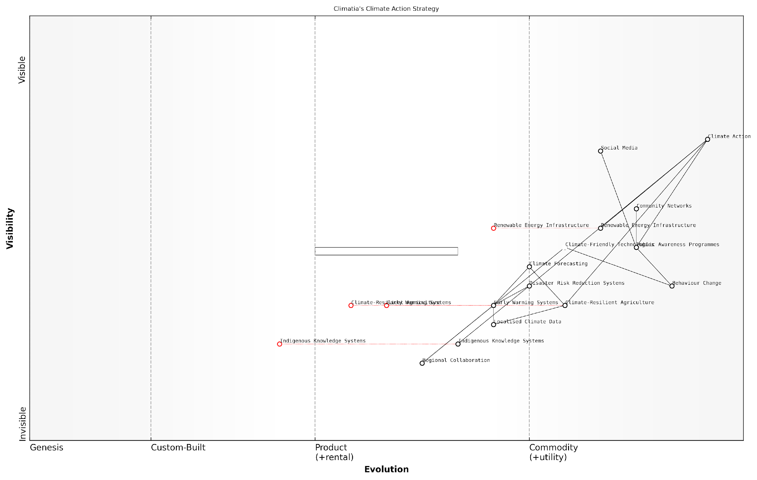

*Draft Wardley Map: [Insert Wardley Map showing the positioning of key climate action components along the value chain]*

[Edit this draft Wardley Map](https://create.wardleymaps.ai/#clone:73c4361e634813100c)

1. Assessing Component Evolution:

The next stage involved assessing how each component was likely to evolve over time. This was crucial for anticipating future needs and opportunities. For example, the map revealed that while current disaster early warning systems were custom-built, there was a clear evolution path towards more standardised, product-based solutions. This insight allowed Climatia to plan for future investments and capacity building in this area.

1. Identifying Dependencies and Leverage Points:

One of the most valuable outcomes of the mapping process was the identification of dependencies between different components. This revealed several critical insights:

* The success of climate-resilient agriculture was heavily dependent on localised climate data and forecasting capabilities
* Public awareness and behaviour change programmes were key enablers for the adoption of new climate-friendly technologies
* Indigenous knowledge systems could significantly enhance the effectiveness of disaster risk reduction strategies

These insights helped identify key leverage points where targeted interventions could have cascading positive effects across multiple areas of climate action.

1. Developing Strategic Moves:

Based on the map insights, Climatia developed a set of strategic moves to advance its climate action agenda:

* Prioritise investment in localised climate data collection and analysis capabilities
* Develop a national programme to integrate indigenous knowledge into climate adaptation strategies
* Create a public-private partnership to accelerate the development of climate-resilient agricultural technologies
* Launch a nationwide climate awareness campaign, leveraging social media and community networks
* Establish a regional collaboration platform for sharing climate technologies and best practices

The Wardley Map provided a clear rationale for these strategic decisions, helping to secure buy-in from various government departments and international donors.

The visual nature of the Wardley Map was instrumental in aligning diverse stakeholders around a common strategy. It allowed us to have more productive conversations about priorities and resource allocation.

Outcomes and Lessons Learned:

The application of Wardley Mapping to SDG 13 in Climatia yielded several significant outcomes:

* Improved resource allocation: By identifying key leverage points, Climatia was able to direct limited resources more effectively
* Enhanced stakeholder alignment: The visual map facilitated better communication and collaboration between government departments, NGOs, and international partners
* Anticipation of future needs: The evolutionary aspect of the map helped Climatia prepare for future challenges and opportunities in climate action
* Identification of innovation opportunities: Gaps in the value chain highlighted areas where innovative solutions could be developed or adapted
* More holistic approach: The mapping process revealed interconnections between different aspects of climate action, leading to a more integrated national strategy

This case study demonstrates the power of Wardley Mapping in addressing complex sustainability challenges at a national level. By providing a clear visual representation of the climate action landscape, the map enabled Climatia to develop a more strategic, efficient, and effective approach to implementing SDG 13. The lessons learned from this process can be valuable for other developing countries seeking to enhance their climate action strategies and contribute to global sustainability goals.

### Case Study: Integrating SDGs 8 and 9 (Economic Growth and Innovation) in an Advanced Economy

In this case study, we explore the implementation of Sustainable Development Goals 8 (Decent Work and Economic Growth) and 9 (Industry, Innovation, and Infrastructure) at a national level in an advanced economy. This example demonstrates how Wardley Mapping can be leveraged to create a cohesive strategy that aligns economic growth with sustainable innovation, addressing the unique challenges and opportunities present in developed nations.

The advanced economy in question, which we’ll refer to as ‘Nation A’, recognised the need to balance its established industrial base with emerging technologies and sustainable practices. The government’s primary objectives were to stimulate job creation, foster innovation, and upgrade infrastructure while reducing environmental impact and ensuring inclusive growth.

Integrating SDGs 8 and 9 is not just about maintaining economic growth; it’s about reimagining our economy to be more resilient, innovative, and inclusive. Wardley Mapping allows us to visualise this transformation and identify the key leverage points for change.

To begin the Wardley Mapping process, Nation A’s policymakers identified the key components of their economic and innovation ecosystems. These included:

* Traditional industries (e.g., manufacturing, agriculture)
* Emerging sectors (e.g., renewable energy, biotechnology)
* Research and development institutions
* Education and skills training programmes
* Physical and digital infrastructure
* Financial systems and investment frameworks
* Regulatory environment and policy mechanisms

With these components identified, the mapping process revealed several critical insights:

* Many traditional industries were in the ‘Product’ or ‘Commodity’ stages of evolution, indicating a need for innovation to maintain competitiveness.
* Emerging sectors, while showing promise, were often in the ‘Genesis’ or early ‘Custom’ stages, requiring targeted support to accelerate development.
* The education system was not fully aligned with the skills needed for future industries, creating a potential bottleneck for economic growth.
* Digital infrastructure was unevenly distributed, with rural areas lagging behind urban centres, hindering inclusive growth.
* The regulatory environment was not agile enough to keep pace with technological advancements, potentially stifling innovation.

Based on these insights, Nation A developed a comprehensive strategy to integrate SDGs 8 and 9:

* Established innovation hubs that connected traditional industries with emerging technologies, fostering cross-sector collaboration and knowledge transfer.
* Implemented a ‘Future Skills’ programme to align education and training with projected industry needs, ensuring a workforce prepared for the jobs of tomorrow.
* Launched a ‘Digital Equity’ initiative to expand high-speed internet access to rural and underserved areas, promoting inclusive economic participation.
* Created a ‘Regulatory Sandbox’ to allow for controlled testing of innovative technologies and business models, balancing innovation with consumer protection.
* Developed a ‘Green Industry Transition Fund’ to support traditional industries in adopting sustainable practices and technologies.
* Established a national ‘Innovation Challenge’ programme to crowdsource solutions for pressing economic and environmental challenges.

The Wardley Map also highlighted the need for continuous evolution of these initiatives. For instance, as certain emerging technologies moved from ‘Genesis’ to ‘Custom’, the support mechanisms shifted from basic research funding to scale-up assistance and market development.

The beauty of using Wardley Mapping for SDG implementation is that it forces us to think dynamically. We’re not just planning for today’s economy, but actively shaping the economy we want to see in the future.

To measure the success of these initiatives, Nation A developed a set of key performance indicators (KPIs) that aligned with both SDG targets and the specific goals identified through the Wardley Mapping process. These included:

* GDP growth rate and GDP per capita
* Employment rates across different sectors and demographic groups
* Number of patents filed and commercialised innovations
* Percentage of GDP invested in research and development
* Broadband internet penetration rates across urban and rural areas
* Carbon intensity of economic output
* Income inequality metrics

Regular reassessment of the Wardley Map allowed Nation A to adapt its strategy as components evolved and new challenges emerged. For example, when the initial push for digital infrastructure reached the ‘Product’ stage, focus shifted to developing advanced applications and services that could leverage this new capability.

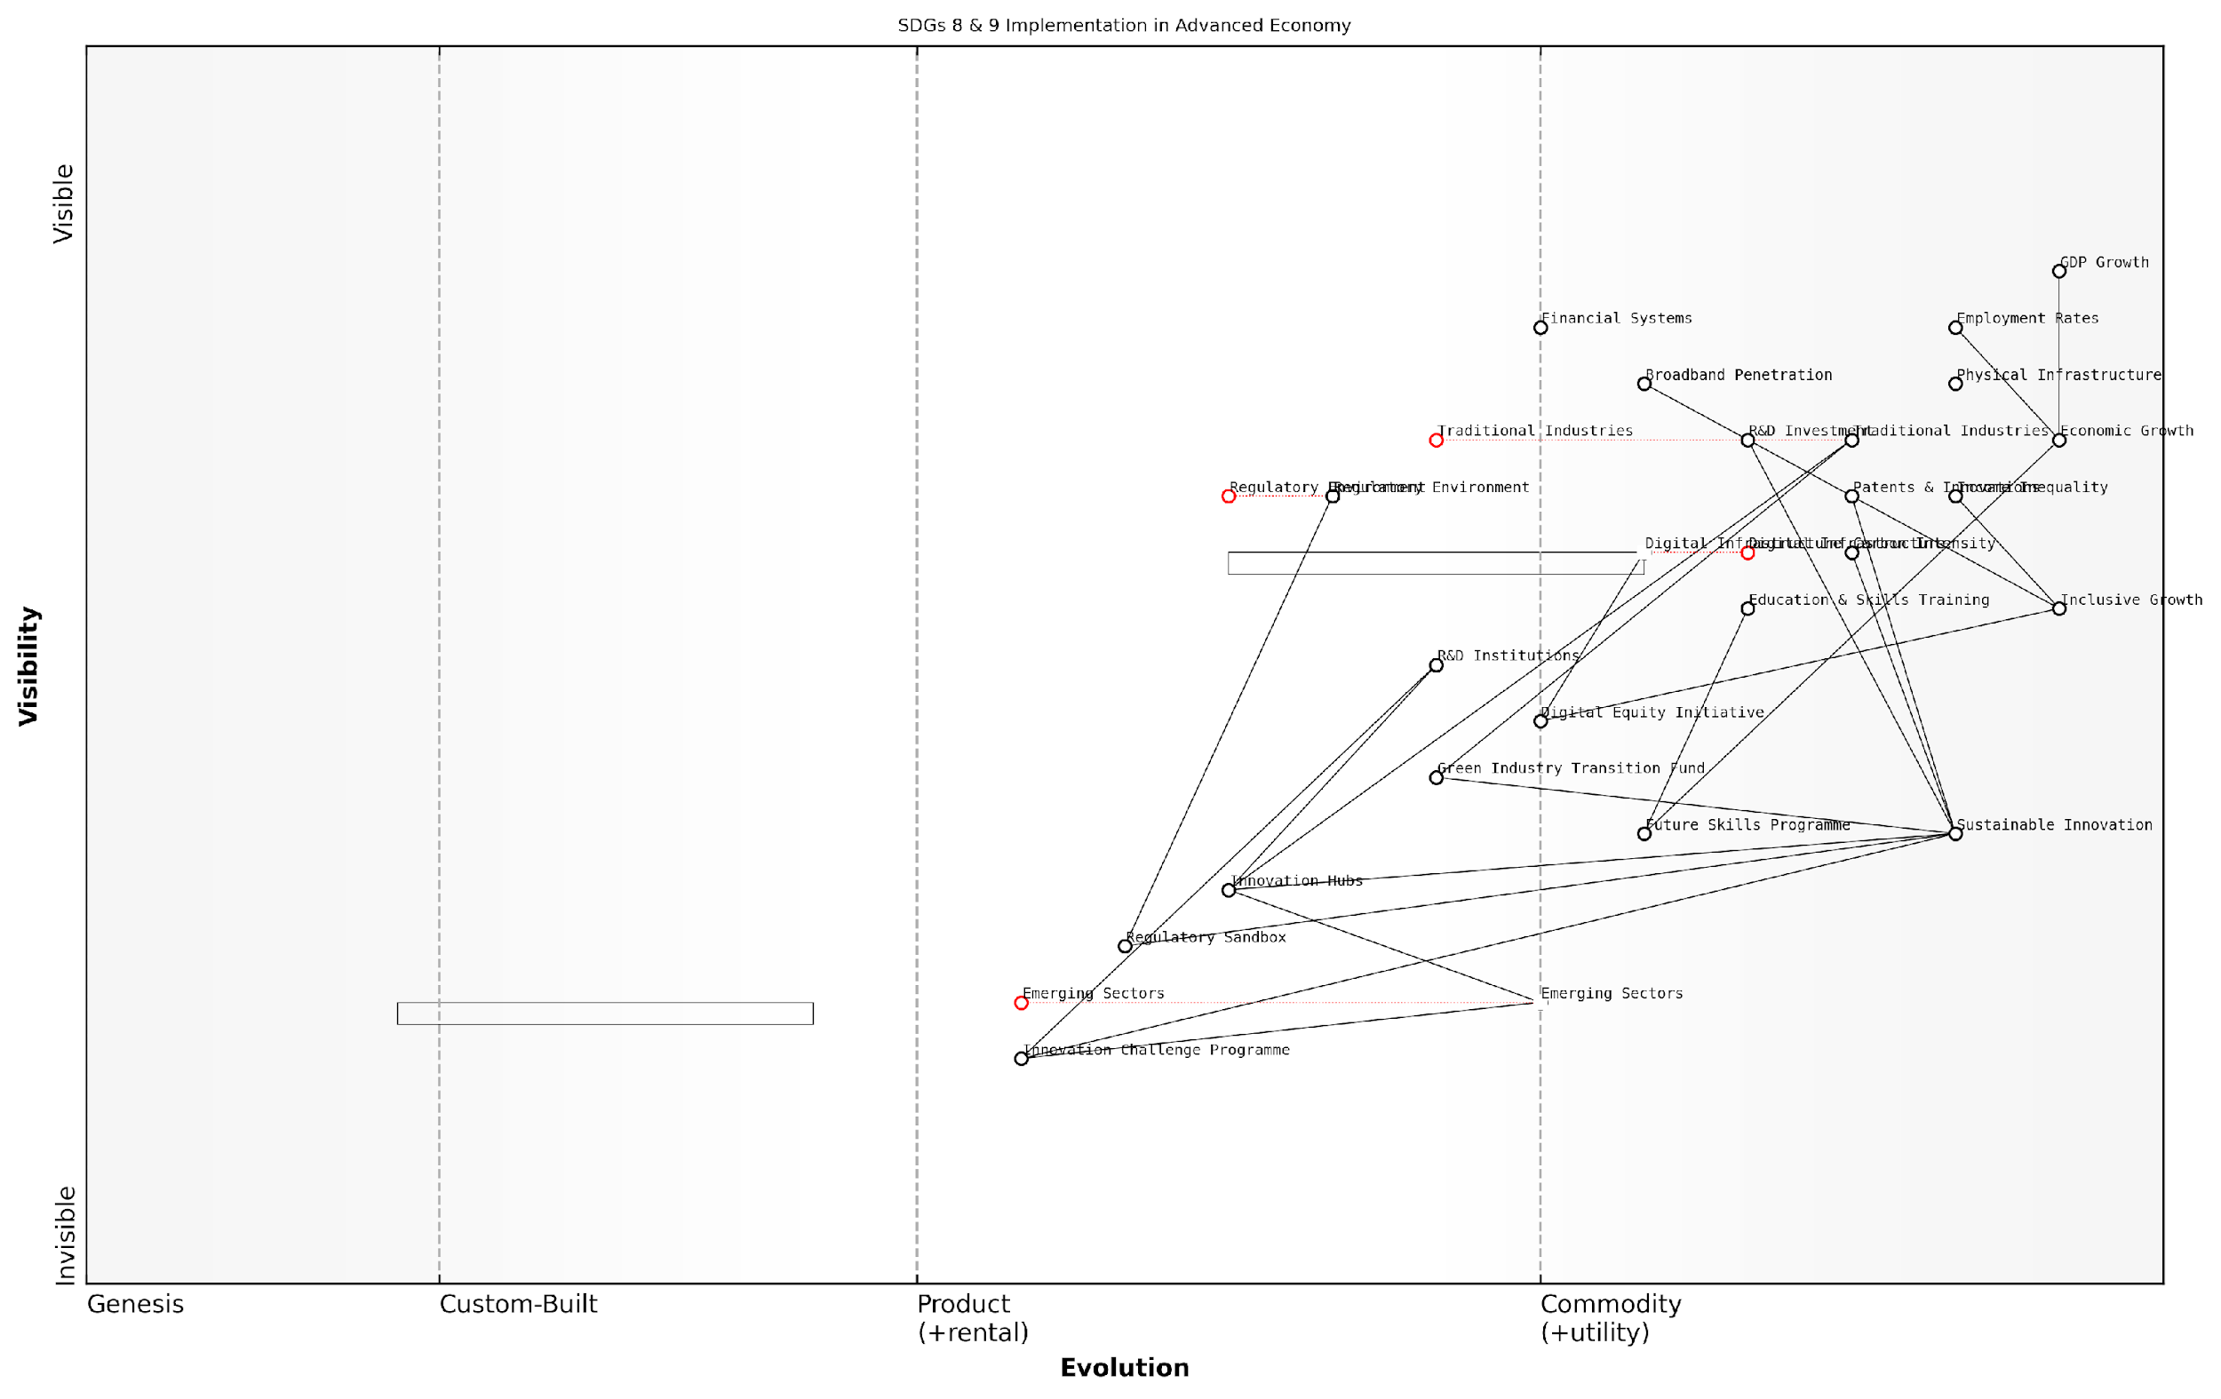

*Draft Wardley Map: [Insert Wardley Map visualising the evolution of key components over a 5-year period]*

[Edit this draft Wardley Map](https://create.wardleymaps.ai/#clone:f73fcf392c78d7bb22)

The use of Wardley Mapping in this case study demonstrates its power in creating a holistic, adaptive strategy for implementing SDGs in an advanced economy. By visualising the entire economic ecosystem and its evolution, policymakers were able to identify key interdependencies, anticipate future challenges, and create targeted interventions that promoted both economic growth and sustainable innovation.

This approach not only helped Nation A make significant progress towards SDGs 8 and 9 but also created a model for integrated, systems-level thinking in sustainable development that could be adapted and applied by other nations facing similar challenges.

Wardley Mapping has transformed our approach to economic policy. It’s no longer about isolated interventions, but about orchestrating a symphony of interconnected actions that move our entire economy towards a more sustainable and prosperous future.

## Corporate Sustainability Strategies

### Case Study: A Global Corporation Aligning with SDG 12 (Responsible Consumption and Production)

In this case study, we explore how a multinational consumer goods corporation leveraged Wardley Mapping to align its operations with SDG 12: Responsible Consumption and Production. This example demonstrates the power of strategic value chain analysis in driving corporate sustainability initiatives and showcases the practical application of Wardley Mapping in a complex business environment.

The corporation in question, a leader in the fast-moving consumer goods (FMCG) sector, recognised the need to transform its approach to production and consumption in light of growing environmental concerns and changing consumer preferences. By employing Wardley Mapping, the company was able to visualise its entire value chain, identify areas for improvement, and develop a comprehensive strategy for sustainable practices.

Wardley Mapping provided us with a clear visual representation of our value chain, allowing us to pinpoint where we could make the most significant impact in terms of sustainability. It was a game-changer for our approach to SDG 12.

The mapping process revealed several key areas where the corporation could focus its efforts:

* Raw material sourcing and supplier engagement
* Manufacturing processes and energy efficiency
* Packaging design and materials
* Distribution and logistics optimisation
* Consumer education and product end-of-life management

By mapping these components along the axes of visibility and evolution, the corporation gained insights into which areas were most ripe for innovation and where they could leverage existing best practices.

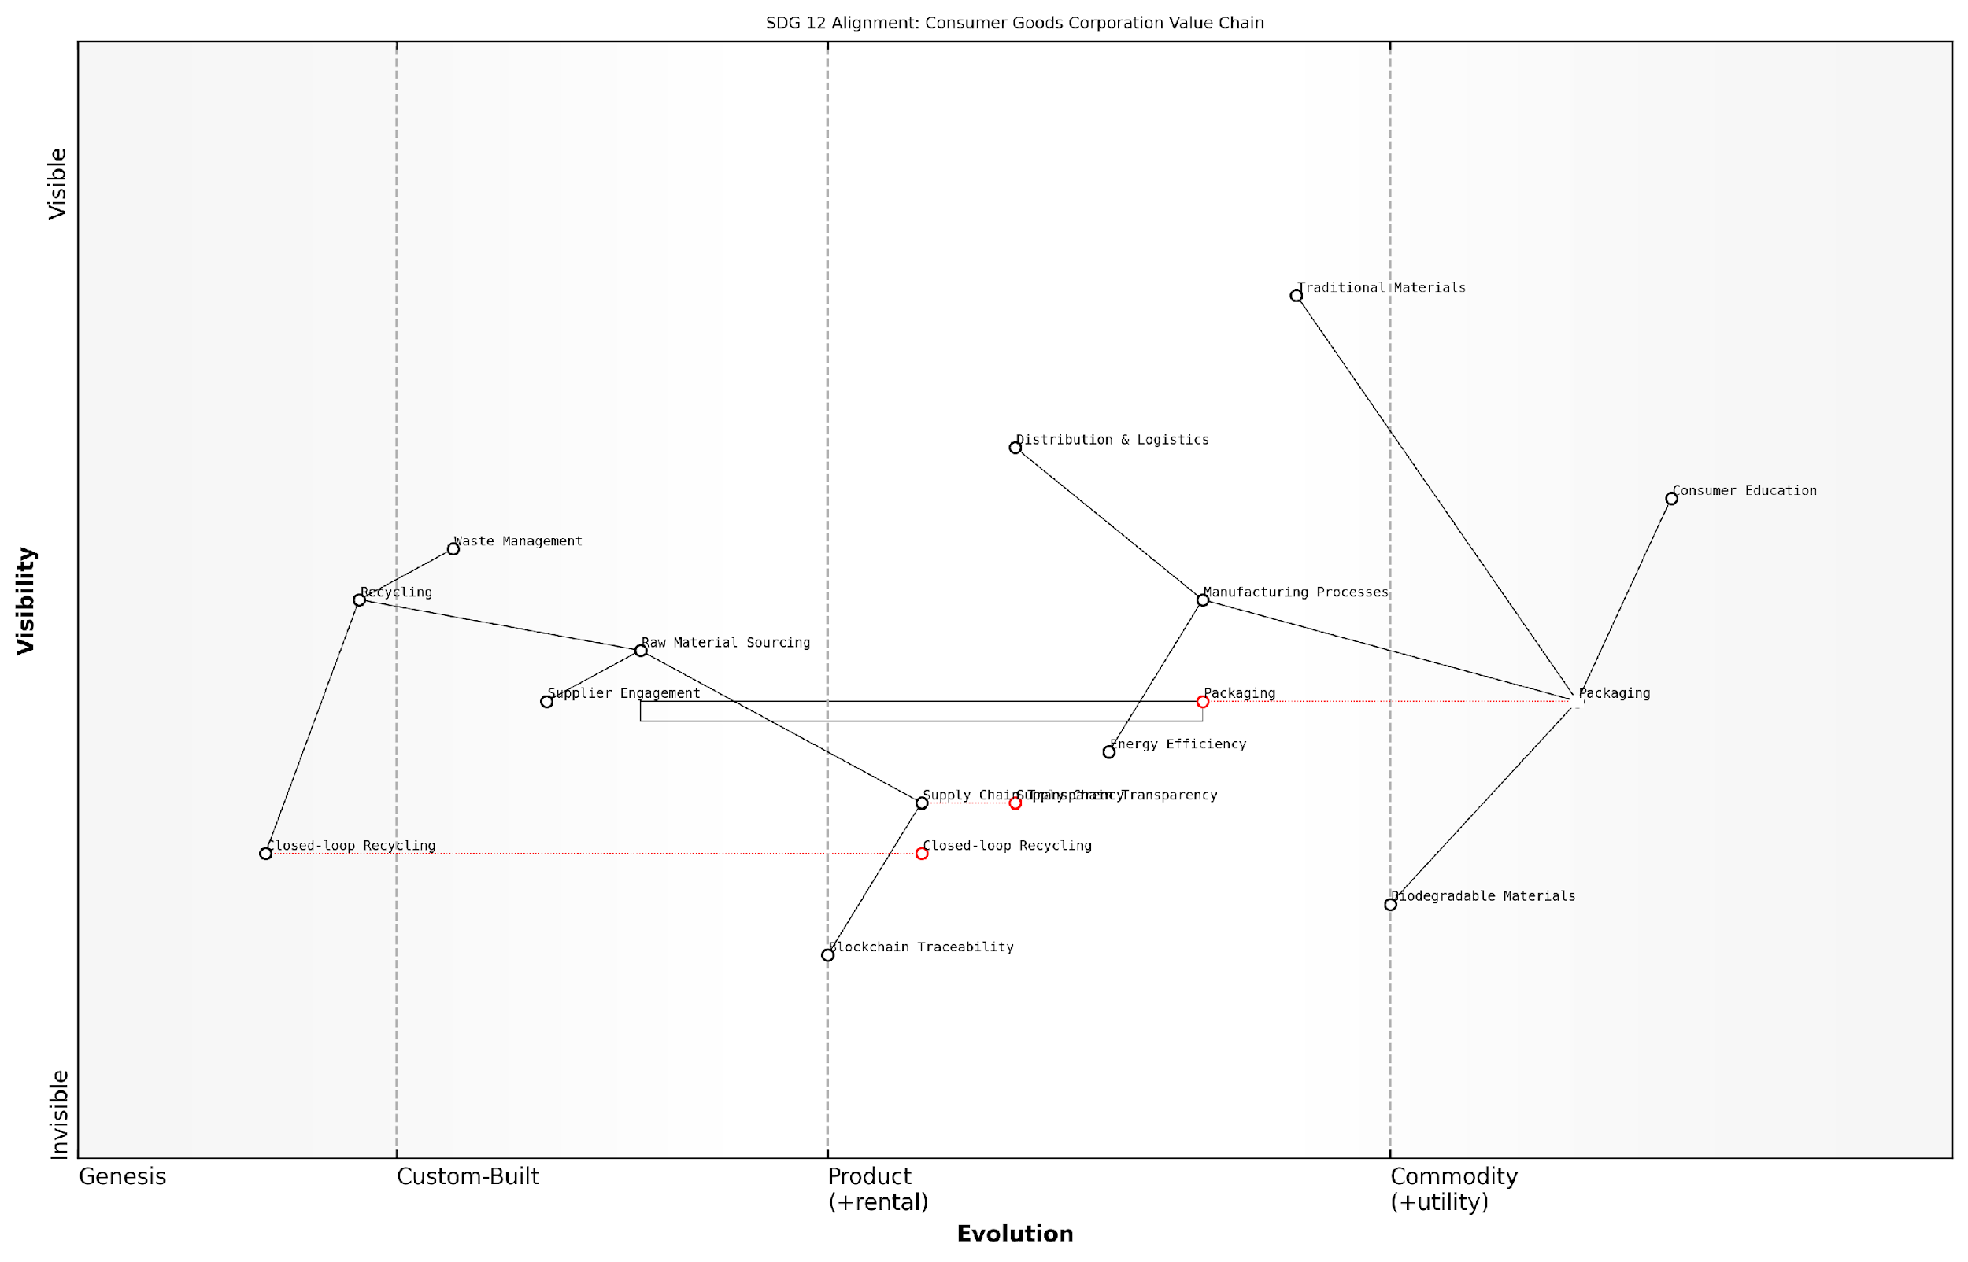

*Draft Wardley Map: [Insert Wardley Map showing the corporation’s value chain with key components related to SDG 12]*

[Edit this draft Wardley Map](https://create.wardleymaps.ai/#clone:bfbf0ba00d4f00c941)

One of the most significant outcomes of the mapping exercise was the identification of packaging as a critical component in need of innovation. The map revealed that while packaging was highly visible to consumers and played a crucial role in brand perception, it was still largely based on traditional, unsustainable materials.

This insight led to a major initiative to develop biodegradable packaging solutions. The corporation invested in R&D to create plant-based plastics and worked with suppliers to scale up production of these materials. The Wardley Map helped justify this investment by clearly showing how such innovation could move packaging from a ‘custom-built’ to a potentially ‘product’ or even ‘commodity’ stage, reducing costs and environmental impact in the long term.

The Wardley Map made it crystal clear that our packaging needed to evolve. It wasn’t just about meeting consumer demands; it was about future-proofing our business in a world moving towards sustainable consumption.

Another key area highlighted by the mapping process was the need for greater transparency and traceability in the supply chain. The map showed that while raw material sourcing was a fundamental component of the value chain, it had low visibility to consumers and was often managed through traditional, opaque processes.

To address this, the corporation implemented a blockchain-based traceability system. This move not only improved supply chain management but also allowed consumers to access detailed information about the origin and journey of their products, thereby increasing trust and supporting more informed purchasing decisions.

The Wardley Mapping process also revealed opportunities for cross-industry collaboration. By visualising the entire value chain, the corporation identified potential partners in the waste management and recycling sectors. This led to the development of a closed-loop recycling programme, where the corporation took responsibility for collecting and recycling its own products, significantly reducing waste and resource consumption.

The impact of these initiatives was substantial:

* 30% reduction in packaging waste within two years
* 15% improvement in energy efficiency across manufacturing plants
* 20% increase in the use of recycled materials in products
* Establishment of a consumer education programme reaching millions of customers annually

Perhaps most importantly, the Wardley Mapping exercise facilitated a shift in corporate culture towards long-term thinking and sustainability. By providing a visual representation of the evolving landscape, it helped executives and employees alike to understand the strategic importance of sustainable practices and their role in securing the company’s future.

Wardley Mapping didn’t just help us align with SDG 12; it fundamentally changed how we think about our business. We now see sustainability not as a cost, but as a driver of innovation and long-term value creation.

This case study demonstrates the power of Wardley Mapping in driving corporate sustainability strategies. By providing a clear visualisation of the value chain and its evolution, it enables companies to identify key areas for innovation, justify investments in sustainable practices, and align their operations with global sustainability goals. As more corporations adopt this approach, we can expect to see accelerated progress towards the achievement of SDG 12 and other Sustainable Development Goals.

### Case Study: Tech Start-up Contributing to SDG 4 (Quality Education)

In the rapidly evolving landscape of educational technology, start-ups are playing an increasingly crucial role in advancing SDG 4: Quality Education. This case study examines how an innovative tech start-up leveraged Wardley Mapping to align its corporate sustainability strategy with the broader goals of SDG 4, whilst simultaneously driving business growth and social impact.

EduTech Innovators, a fictional start-up based in London, developed an AI-powered adaptive learning platform aimed at improving access to quality education in underserved communities. The company’s leadership recognised the potential to contribute significantly to SDG 4, but faced challenges in strategically aligning their business model with sustainable development objectives.

To address this challenge, EduTech Innovators employed Wardley Mapping to visualise their value chain and identify key opportunities for impact. The mapping process revealed several critical insights:

* The company’s core AI technology was in the ‘custom-built’ phase, presenting opportunities for rapid innovation and differentiation.
* Content creation and localisation were identified as key components in the ‘product’ phase, crucial for addressing diverse educational needs.
* Distribution channels, particularly mobile technology infrastructure, were in the ‘commodity’ phase in many target markets, enabling widespread access.
* Teacher training and support emerged as a critical ‘genesis’ component, essential for effective implementation but often overlooked in EdTech solutions.

Armed with these insights, EduTech Innovators developed a comprehensive strategy to maximise their contribution to SDG 4 whilst ensuring business sustainability:

* Collaborative AI Development: The company initiated partnerships with leading universities to accelerate AI innovation, focusing on personalised learning algorithms that adapt to diverse learning styles and cultural contexts.
* Open Content Ecosystem: Recognising the importance of localised content, EduTech Innovators created an open platform for educators worldwide to contribute and adapt curriculum materials, fostering a global community of practice.
* Mobile-First Approach: Leveraging the ubiquity of mobile devices, the company optimised its platform for low-bandwidth environments, ensuring accessibility in regions with limited internet infrastructure.
* Teacher Empowerment Programme: A comprehensive training and support system was developed to empower teachers with digital skills and pedagogical strategies, positioning them as key facilitators of technology-enhanced learning.

By applying Wardley Mapping to our sustainability strategy, we gained a clear vision of where to focus our efforts for maximum impact. It transformed our approach from a tech-centric view to a holistic educational ecosystem perspective.

The Wardley Map also highlighted potential future shifts in the educational landscape, allowing EduTech Innovators to anticipate and prepare for emerging trends:

* The evolution of AI from ‘custom-built’ to ‘product’, suggesting a future focus on AI ethics and governance in education.
* The potential commoditisation of content creation tools, indicating a shift towards curation and quality assurance as key value drivers.
* The emergence of new distribution channels, such as satellite internet and augmented reality, presenting opportunities for innovative delivery methods.

By aligning their corporate strategy with these mapped components and anticipated shifts, EduTech Innovators was able to create a sustainable business model that directly contributed to SDG 4 targets:

* Increased access to quality education in underserved communities, with over 1 million learners reached in the first year.
* Improved learning outcomes, with standardised test scores increasing by an average of 27% in pilot programmes.
* Enhanced teacher effectiveness, with 90% of participating educators reporting increased confidence in using technology for instruction.
* Reduced gender disparities in STEM education, with a 40% increase in girls’ engagement in science and mathematics courses.

The success of EduTech Innovators demonstrates the power of Wardley Mapping in aligning corporate sustainability strategies with SDG objectives. By visualising the entire value chain and its evolution, the company was able to identify strategic leverage points that simultaneously drove business growth and social impact.

Wardley Mapping provided us with a shared language to discuss strategy across our diverse team of educators, technologists, and business leaders. It was instrumental in creating a unified vision that balanced innovation, sustainability, and social impact.

This case study offers valuable lessons for other tech start-ups aiming to contribute to the SDGs:

* Utilise Wardley Mapping to gain a holistic view of your value chain and its position within the broader ecosystem of your chosen SDG.
* Identify key components that are ripe for innovation and those that require collaboration or outsourcing.
* Anticipate future shifts in the landscape to ensure long-term sustainability and relevance.
* Balance technological innovation with human-centred approaches to create comprehensive solutions.
* Leverage partnerships and open ecosystems to amplify impact and foster global collaboration.

As we continue to navigate the complex challenges of global education, the strategic application of tools like Wardley Mapping will be crucial in guiding tech start-ups towards meaningful contributions to the SDGs. By providing a clear visualisation of the evolving landscape, these maps enable companies to align their innovations with the most pressing needs in education, ultimately accelerating progress towards quality education for all.

## NGO and International Organisation Approaches

### Case Study: UN Agency Using Wardley Mapping for SDG 2 (Zero Hunger)

In this case study, we explore how a prominent UN agency leveraged Wardley Mapping to address the complex challenges associated with Sustainable Development Goal 2 (Zero Hunger). This example demonstrates the power of strategic value chain mapping in tackling one of the world’s most pressing issues, showcasing how international organisations can employ this technique to drive meaningful change.

The UN agency in question, responsible for coordinating international action against hunger, recognised the need for a more strategic approach to achieve SDG 2 by 2030. Traditional methods had proven insufficient in addressing the multifaceted nature of global hunger, necessitating a novel approach that could capture the intricate relationships between various components of the food system.

We realised that to make significant progress towards zero hunger, we needed to visualise the entire ecosystem of food production, distribution, and consumption. Wardley Mapping provided us with the perfect tool to achieve this level of strategic insight.

The agency’s approach to mapping SDG 2 can be broken down into several key stages:

* Identifying key components of the food system
* Mapping the value chain from production to consumption
* Analysing evolution and dependencies
* Identifying leverage points for intervention
* Developing targeted strategies based on map insights

1. Identifying key components of the food system:

The agency began by identifying all major components contributing to food security, including agricultural production, supply chain logistics, food processing, distribution networks, and consumer access. This comprehensive approach ensured that no critical elements were overlooked in the mapping process.

1. Mapping the value chain from production to consumption:

Using Wardley Mapping techniques, the agency plotted these components along the value chain, from the most basic needs (visible to consumers) to the underlying infrastructure and technologies (invisible to consumers). This visual representation allowed for a clear understanding of how different elements interacted and contributed to the overall goal of zero hunger.

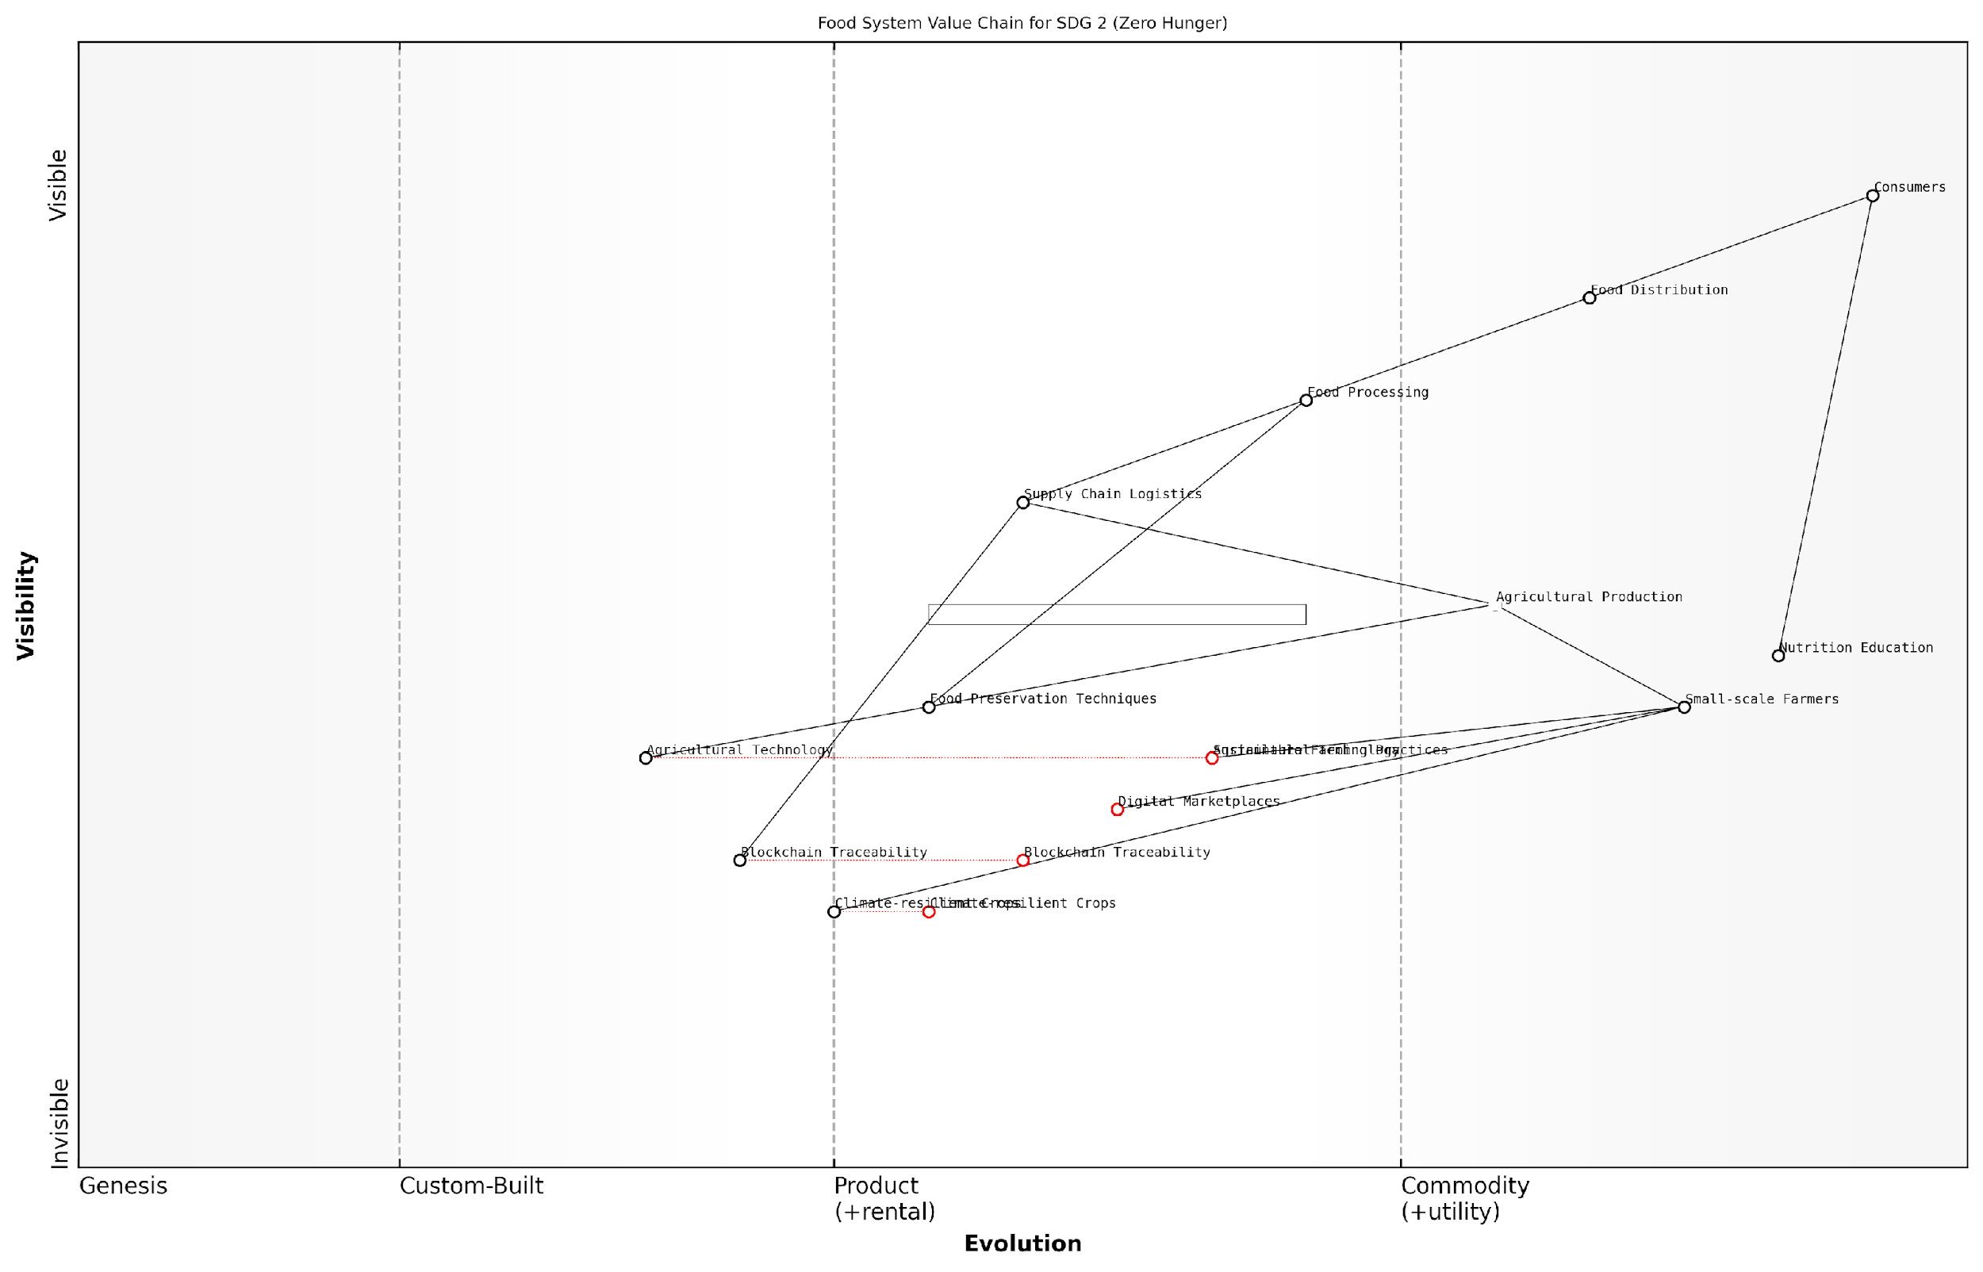

*Draft Wardley Map: [Insert Wardley Map visualising the food system value chain]*

[Edit this draft Wardley Map](https://create.wardleymaps.ai/#clone:417872a74b17a16d70)

1. Analysing evolution and dependencies:

The agency then assessed the evolutionary stage of each component, from genesis to commodity. This analysis revealed which areas were ripe for innovation and which were stable and well-understood. Additionally, they identified dependencies between components, highlighting critical relationships that could impact the entire system.

The evolutionary perspective provided by Wardley Mapping was eye-opening. It allowed us to see where we needed to focus our innovation efforts and where we could leverage existing commoditised solutions to accelerate progress.

1. Identifying leverage points for intervention:

By analysing the completed map, the agency identified key leverage points where interventions could have the most significant impact. These included areas such as improving small-scale farmer access to technology, enhancing supply chain efficiency through digital platforms, and developing innovative food preservation techniques.

1. Developing targeted strategies based on map insights:

Armed with these insights, the agency developed a series of targeted strategies to address SDG 2. These strategies were tailored to the specific needs and evolutionary stages of different components within the food system. For example:

* Investing in research and development for climate-resilient crop varieties
* Partnering with tech companies to create digital marketplaces connecting farmers directly to consumers
* Implementing blockchain technology to enhance traceability and reduce food waste in supply chains
* Developing education programmes to promote sustainable farming practices and nutrition awareness

The use of Wardley Mapping in this context provided several key benefits:

* Holistic understanding: The map offered a comprehensive view of the entire food system, allowing for more informed decision-making.
* Strategic alignment: It ensured that all interventions were aligned with the overall goal of achieving zero hunger.
* Resource optimisation: By identifying key leverage points, the agency could allocate resources more effectively.
* Collaboration facilitation: The visual nature of the map made it easier to communicate strategies and foster collaboration with partners across sectors.
* Adaptability: The map could be easily updated to reflect changes in the landscape, ensuring strategies remained relevant over time.

The impact of this approach was significant. Within two years of implementing strategies based on the Wardley Map, the agency reported:

* A 15% increase in small-scale farmer productivity in target regions
* A 20% reduction in post-harvest losses through improved supply chain management
* A 25% increase in access to nutritious food in urban food deserts

Wardley Mapping transformed our approach to tackling hunger. It provided a common language and visual framework that allowed us to align efforts across diverse stakeholders and make more informed, strategic decisions.

This case study demonstrates the powerful potential of Wardley Mapping in addressing complex global challenges like SDG 2. By providing a strategic, visual representation of the entire value chain, it enables international organisations to develop more effective, targeted interventions. As we continue to work towards the 2030 goals, such innovative approaches will be crucial in accelerating progress and ensuring no one is left behind in the fight against hunger.

### Case Study: International NGO Tackling SDG 6 (Clean Water and Sanitation)

In this case study, we examine how an international NGO leveraged Wardley Mapping to address the complex challenges associated with SDG 6: Clean Water and Sanitation. This example illustrates the power of strategic mapping in navigating the intricate landscape of global water security and hygiene improvement initiatives.

The NGO in question, which we’ll refer to as ‘WaterForward’, has been operating for over two decades in various developing countries. Despite their extensive experience, they found themselves struggling to create lasting impact in regions with particularly challenging water and sanitation issues. The decision to employ Wardley Mapping came from a need to better understand the value chain of their interventions and identify key leverage points for sustainable change.

We had been working tirelessly for years, but it felt like we were constantly fighting an uphill battle. Wardley Mapping offered us a new lens through which to view our challenges and opportunities.

Let’s break down how WaterForward applied Wardley Mapping to their SDG 6 efforts:

* Mapping the Current Landscape
* Identifying Key Components and Dependencies
* Analysing Evolution and Movement
* Developing Strategic Interventions
* Implementing and Iterating

1. Mapping the Current Landscape:

WaterForward began by creating a comprehensive map of the current water and sanitation landscape in their target region. This involved identifying all relevant components, from basic infrastructure like wells and latrines to more abstract elements such as local governance structures and cultural attitudes towards hygiene.

1. Identifying Key Components and Dependencies:

Through the mapping process, WaterForward uncovered critical dependencies that had previously been overlooked. For instance, they realised that the success of their sanitation projects heavily relied on local community leadership buy-in, which in turn was influenced by traditional gender roles and economic factors.

The mapping exercise was a real eye-opener. We discovered connections and dependencies that we had never explicitly considered before, despite years of field experience.

1. Analysing Evolution and Movement:

By plotting the components on the evolution axis, WaterForward gained insights into which areas were ripe for innovation and which required standardisation. They identified that while water purification technology was rapidly evolving, community education methods had stagnated and needed a fresh approach.

1. Developing Strategic Interventions:

Armed with these insights, WaterForward developed a multi-pronged strategy that addressed both technological and social aspects of water and sanitation challenges. They focused on:

* Investing in modular, easily maintainable water purification systems
* Developing a community leadership programme with a focus on women’s empowerment
* Creating partnerships with local tech startups to improve data collection and monitoring
* Implementing a ‘train the trainer’ model for hygiene education to ensure sustainability

1. Implementing and Iterating:

WaterForward implemented their new strategy in phases, starting with pilot projects in two communities. They continued to update their Wardley Map as new information emerged, allowing for agile adjustments to their approach.

The beauty of Wardley Mapping is that it’s not a one-and-done exercise. We found ourselves regularly returning to the map, refining our understanding, and adjusting our strategy accordingly.

The results of WaterForward’s Wardley Mapping approach were significant. Within 18 months of implementation, they saw:

* A 40% increase in the number of households with access to clean water
* A 60% reduction in waterborne diseases in target communities
* A 30% increase in community-led sanitation initiatives
* Improved retention of local staff and volunteers

Perhaps most importantly, the mapping process enabled WaterForward to communicate their strategy more effectively to donors and partners, leading to increased funding and support for their initiatives.

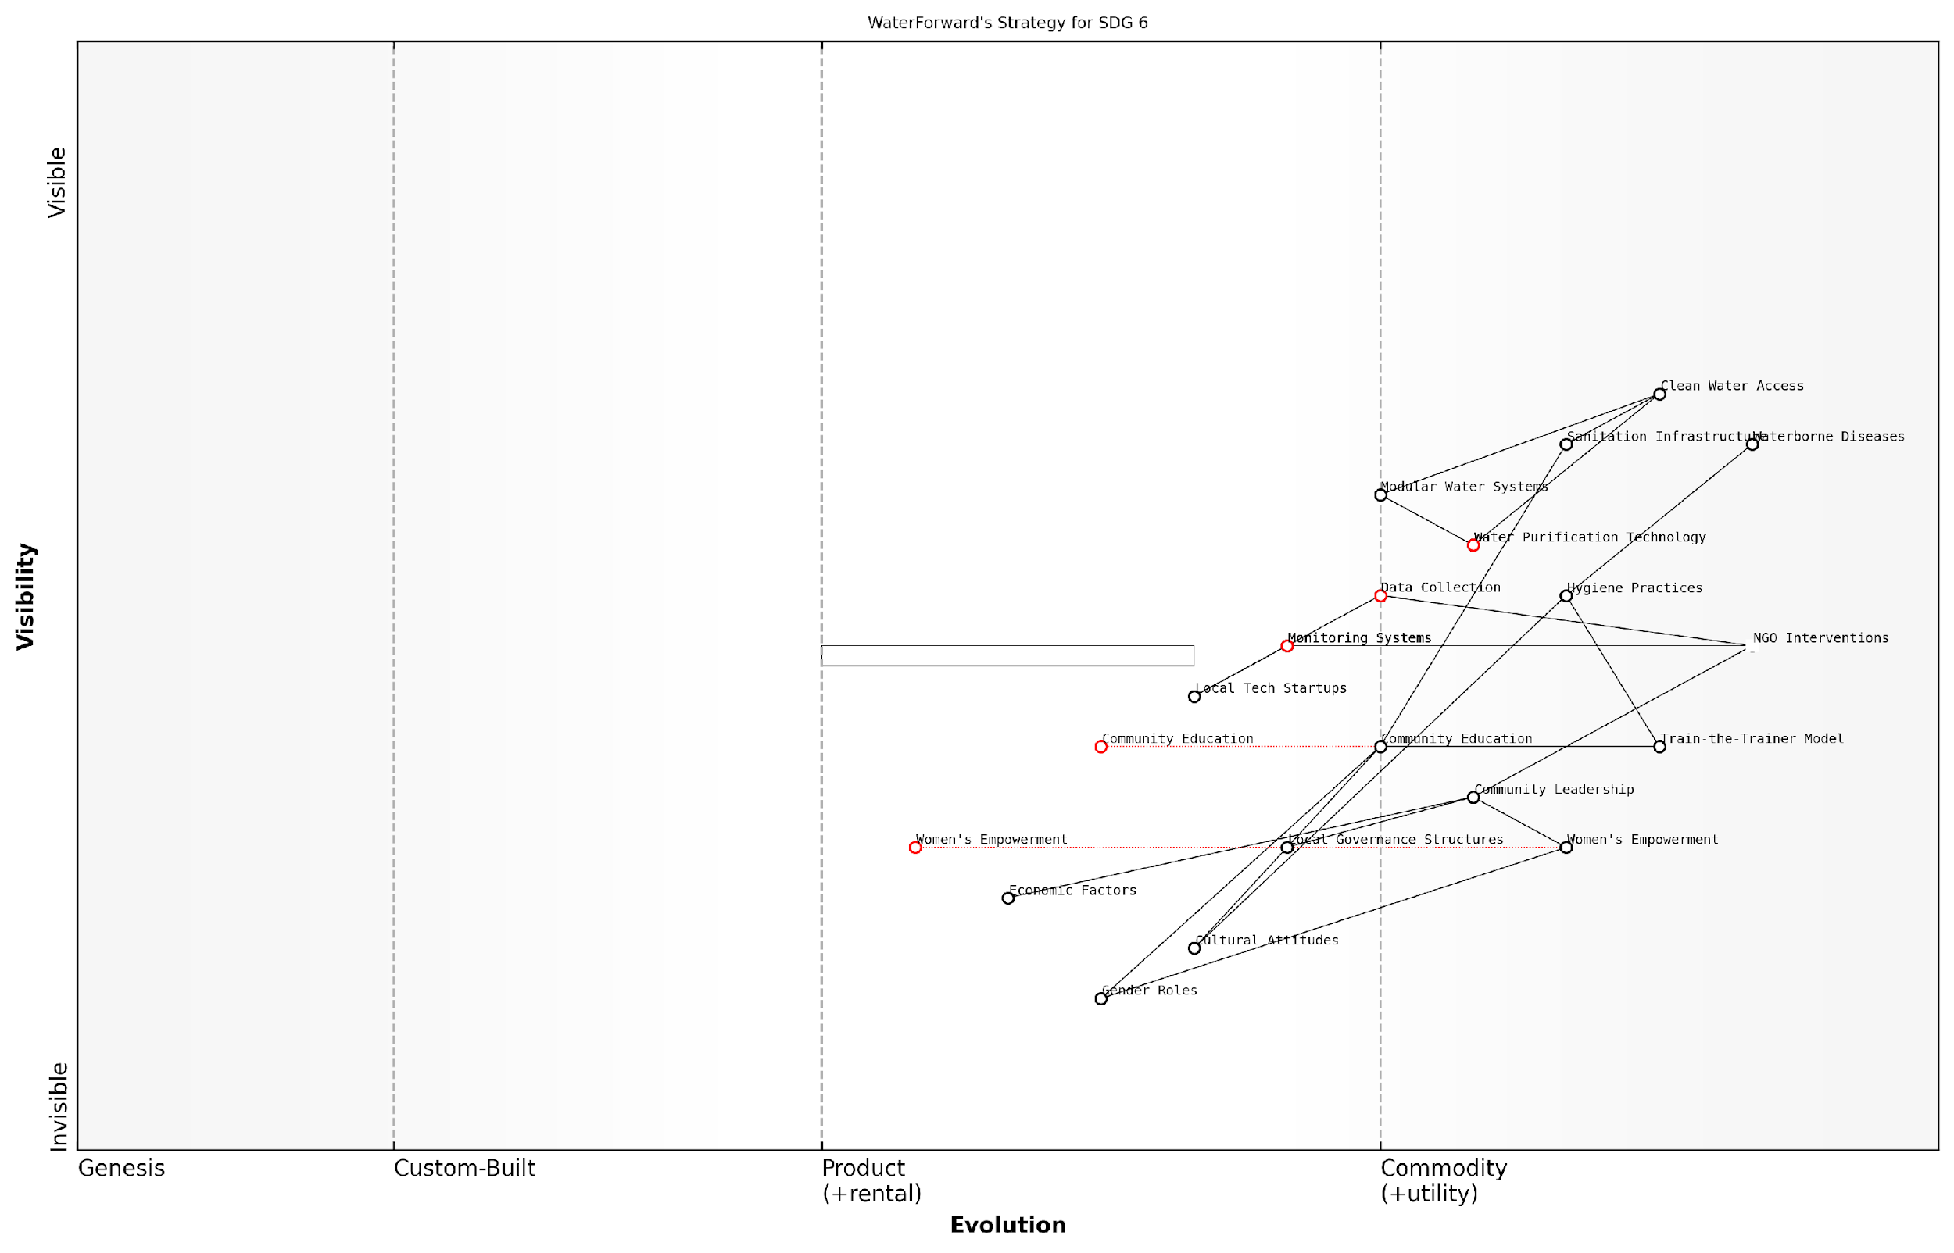

*Draft Wardley Map: [Insert Wardley Map visualising WaterForward’s strategy for SDG 6]*

[Edit this draft Wardley Map](https://create.wardleymaps.ai/#clone:03130ef664633a2eab)

This case study demonstrates the power of Wardley Mapping in tackling complex, multifaceted challenges like those presented by the SDGs. By providing a visual representation of the entire value chain, it allows organisations to identify hidden dependencies, anticipate future developments, and craft more effective, sustainable strategies.

For other NGOs and international organisations working towards the SDGs, this example offers valuable lessons:

* The importance of visualising the entire ecosystem, not just direct interventions
* The value of understanding evolutionary stages of different components
* The need for flexibility and continuous iteration in strategy
* The power of Wardley Mapping in communicating complex strategies to stakeholders

As we continue to work towards the 2030 Agenda for Sustainable Development, tools like Wardley Mapping will be crucial in navigating the complex, interconnected challenges presented by the SDGs. By providing a clear, strategic view of the landscape, they enable organisations to move beyond short-term fixes and create lasting, sustainable impact.

# Future Scenarios and Adaptive Strategies

## Anticipating Change in the Sustainability Landscape

### Technological Disruptions and Their Impact on SDGs

In the rapidly evolving landscape of global sustainability, technological disruptions play a pivotal role in shaping the trajectory of the United Nations Sustainable Development Goals (SDGs). As we navigate the complex interplay between innovation and sustainable development, it becomes increasingly crucial to anticipate and strategically respond to these technological shifts. This section delves into the profound impact of emerging technologies on the SDGs, exploring how Wardley Mapping can be leveraged to navigate this dynamic terrain and inform adaptive strategies for the future.

The advent of transformative technologies such as artificial intelligence, blockchain, the Internet of Things (IoT), and advanced biotechnology is reshaping the very fabric of our approach to sustainable development. These innovations offer unprecedented opportunities to accelerate progress towards the SDGs, whilst simultaneously presenting new challenges and ethical considerations that must be carefully navigated.

The Fourth Industrial Revolution is not just changing what we do and how we do it, but who we are. It’s reshaping government, education, healthcare, and commerce—almost every aspect of life. In the context of the SDGs, this presents both immense opportunities and significant risks that we must proactively address.

To effectively anticipate technological disruptions and their impact on the SDGs, we must first understand the key areas where these innovations are likely to have the most significant influence:

* Data Collection and Analysis: Advanced AI and machine learning algorithms are revolutionising our ability to gather, process, and interpret vast amounts of data related to SDG indicators.
* Resource Efficiency: IoT and smart technologies are enabling more efficient use of resources, from energy to water, supporting goals related to sustainable consumption and production.
* Financial Inclusion: Blockchain and fintech innovations are creating new pathways for financial inclusion, potentially transforming approaches to poverty reduction and economic growth.
* Healthcare Delivery: Telemedicine, AI-assisted diagnostics, and biotechnology advancements are reshaping healthcare systems, impacting goals related to health and well-being.
* Education Access: Digital platforms and virtual reality technologies are expanding access to quality education, particularly in remote or underserved areas.
* Climate Action: Clean energy technologies, carbon capture innovations, and climate modelling tools are crucial for addressing climate change and environmental sustainability goals.

Applying Wardley Mapping to these technological disruptions provides a strategic framework for understanding their evolution and potential impact on the SDGs. By mapping these technologies along the value chain from genesis to commodity, we can anticipate shifts in the sustainability landscape and develop more robust, future-proof strategies.

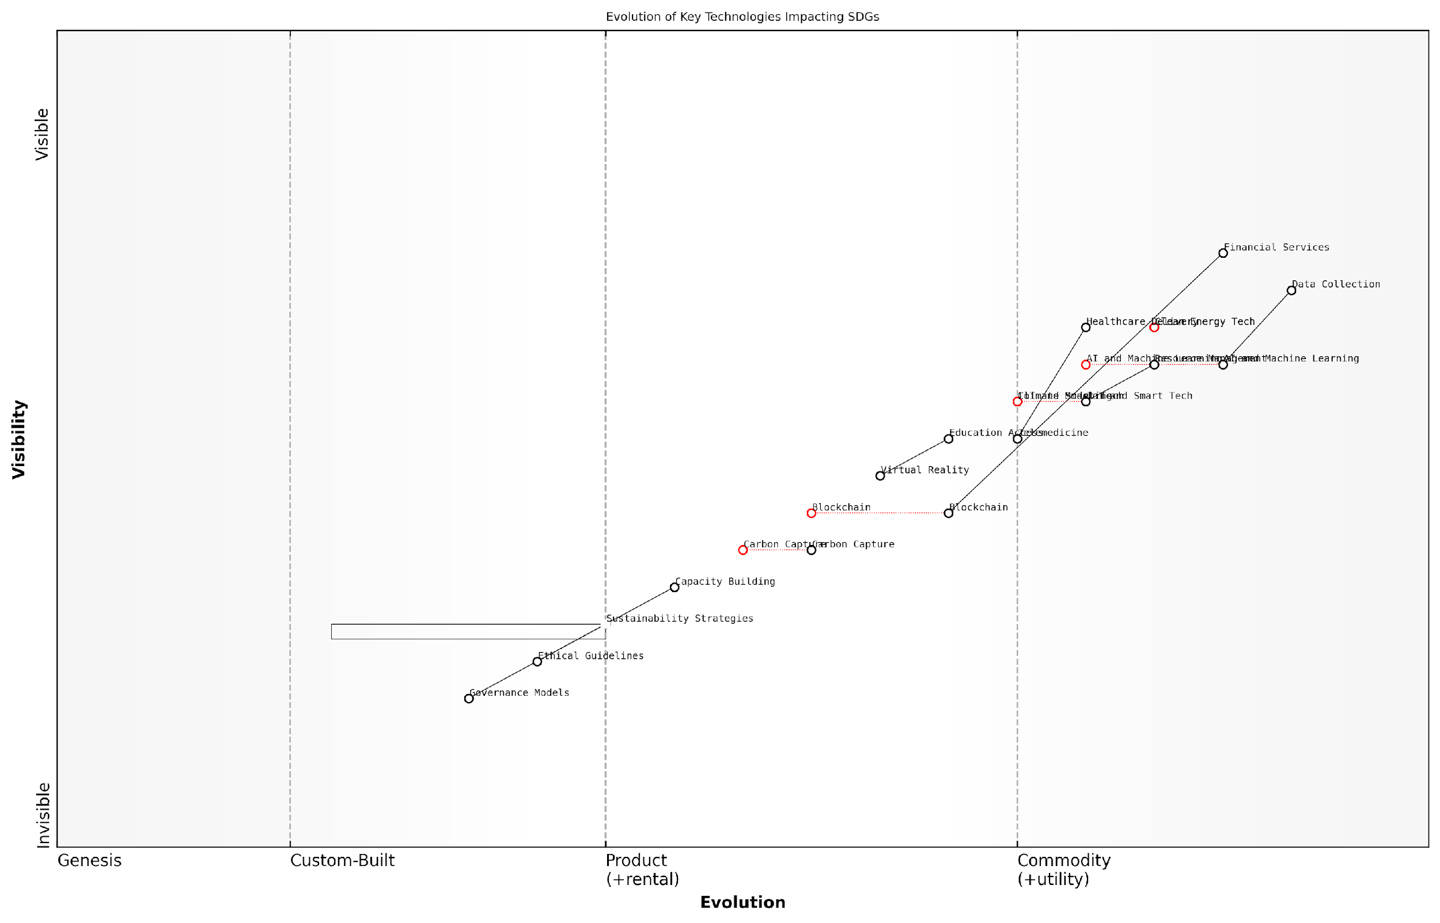

*Draft Wardley Map: [Insert Wardley Map: Evolution of Key Technologies Impacting SDGs]*

[Edit this draft Wardley Map](https://create.wardleymaps.ai/#clone:15f873d39841f8b015)

Consider, for instance, the evolution of renewable energy technologies. A Wardley Map might reveal the progression of solar panel technology from a custom-built solution to a commodity, highlighting potential points of disruption along the value chain. This insight allows policymakers and sustainability practitioners to anticipate market shifts, identify emerging opportunities, and strategically allocate resources to maximise impact on SDG 7 (Affordable and Clean Energy) and SDG 13 (Climate Action).

However, it’s crucial to recognise that technological disruptions can also introduce new challenges and ethical considerations. For example, the rapid advancement of AI and automation may contribute to job displacement, potentially conflicting with SDG 8 (Decent Work and Economic Growth). Wardley Mapping can help identify these potential conflicts early, allowing for the development of mitigating strategies and policies.

In my experience advising government bodies on sustainable development strategies, I’ve found that those who proactively map and anticipate technological disruptions are far better positioned to harness their potential while mitigating associated risks. It’s not just about adopting new technologies; it’s about understanding their place in the evolving landscape of sustainability efforts.

To effectively leverage Wardley Mapping for anticipating technological disruptions in the context of SDGs, consider the following strategic approaches:

* Regular Horizon Scanning: Implement a systematic process for monitoring emerging technologies and their potential applications to SDGs.
* Cross-Sector Collaboration: Engage with technology experts, industry leaders, and academia to gain diverse perspectives on technological trends and their implications for sustainability.
* Scenario Planning: Use Wardley Maps to develop multiple future scenarios, allowing for more flexible and resilient SDG strategies.
* Ethical Framework Development: Establish robust ethical guidelines for the adoption and implementation of new technologies in pursuit of the SDGs.
* Adaptive Governance Models: Design governance structures that can quickly respond to technological shifts and their impact on SDG implementation strategies.
* Capacity Building: Invest in developing the skills and knowledge necessary to understand and leverage emerging technologies within the sustainability sector.

By integrating these approaches into the strategic planning process, governments and organisations can better position themselves to harness the potential of technological disruptions while navigating the complex landscape of sustainable development.

As we look towards the future, it’s clear that the interplay between technological innovation and sustainable development will only grow more complex. Wardley Mapping offers a powerful tool for navigating this complexity, providing a visual and strategic framework for anticipating change, identifying opportunities, and developing adaptive strategies. By embracing this approach, we can work towards a future where technological disruptions serve as catalysts for accelerating progress towards the SDGs, rather than obstacles to overcome.

The key to success in this rapidly evolving landscape is not just to react to technological disruptions, but to anticipate and shape them. Wardley Mapping gives us the strategic foresight to do just that, ensuring our efforts towards the SDGs remain relevant, impactful, and future-proof.

### Geopolitical Shifts and Global Cooperation

In the realm of sustainable development, geopolitical shifts and global cooperation play a pivotal role in shaping the landscape of the United Nations Sustainable Development Goals (SDGs). As we apply Wardley Mapping to anticipate changes in this dynamic environment, it becomes crucial to understand how evolving international relations, power dynamics, and collaborative efforts impact the implementation and success of the SDGs.

Geopolitical shifts can significantly alter the trajectory of sustainable development efforts, influencing resource allocation, policy priorities, and international agreements. By leveraging Wardley Mapping, we can visualise these shifts and their potential impacts on the SDGs, enabling more robust and adaptive strategies for global cooperation.

The interplay between geopolitics and sustainable development is akin to a complex dance. As the music of international relations changes, so too must our steps in pursuing the SDGs. Wardley Mapping provides us with the choreography to navigate this intricate performance.

Let us explore the key aspects of geopolitical shifts and global cooperation through the lens of Wardley Mapping, and how they influence our approach to the SDGs:

* Shifting Power Dynamics and Their Impact on SDG Priorities
* The Role of Emerging Economies in Shaping the Sustainability Agenda
* Climate Diplomacy and Its Influence on Global Cooperation
* Technological Advancements and Their Geopolitical Implications for SDGs
* The Evolution of International Institutions and Governance Structures

Shifting Power Dynamics and Their Impact on SDG Priorities:

As the global balance of power evolves, so too do the priorities and approaches to sustainable development. Wardley Mapping allows us to visualise how these shifts affect the positioning of different SDGs within the value chain of global sustainability efforts. For instance, as emerging economies gain more influence, we may see a greater emphasis on SDGs related to economic growth and poverty reduction, potentially altering the landscape of international development cooperation.

The Role of Emerging Economies in Shaping the Sustainability Agenda:

Emerging economies are increasingly asserting their influence on the global stage, bringing new perspectives and priorities to the sustainable development discourse. By mapping the value chains of these economies in relation to the SDGs, we can identify areas of alignment and potential friction with established sustainability frameworks. This analysis enables more inclusive and effective global cooperation strategies.

The rise of emerging economies is not just changing the economic landscape, but also reshaping our collective approach to sustainability. Their unique challenges and innovative solutions are becoming integral components of the global SDG roadmap.

Climate Diplomacy and Its Influence on Global Cooperation:

Climate change has emerged as a central issue in international relations, with climate diplomacy becoming a critical factor in global cooperation. Wardley Mapping can help us visualise the complex interplay between climate action (SDG 13) and other goals, revealing how progress or setbacks in climate negotiations can ripple through the entire SDG framework. This insight is invaluable for developing adaptive strategies that account for the evolving nature of climate diplomacy.

Technological Advancements and Their Geopolitical Implications for SDGs:

Rapid technological progress is reshaping geopolitical dynamics and creating new opportunities and challenges for SDG implementation. By mapping the evolution of key technologies alongside geopolitical trends, we can anticipate how innovations in areas such as artificial intelligence, renewable energy, or biotechnology might influence global power structures and, consequently, approaches to sustainable development.

The Evolution of International Institutions and Governance Structures:

As geopolitical realities shift, so too must the international institutions and governance structures that support global cooperation on the SDGs. Wardley Mapping can help us visualise how these institutions are evolving, identifying areas where they may need to adapt to remain effective in a changing world. This analysis can inform strategies for institutional reform and the development of new collaborative frameworks that are more responsive to emerging geopolitical realities.

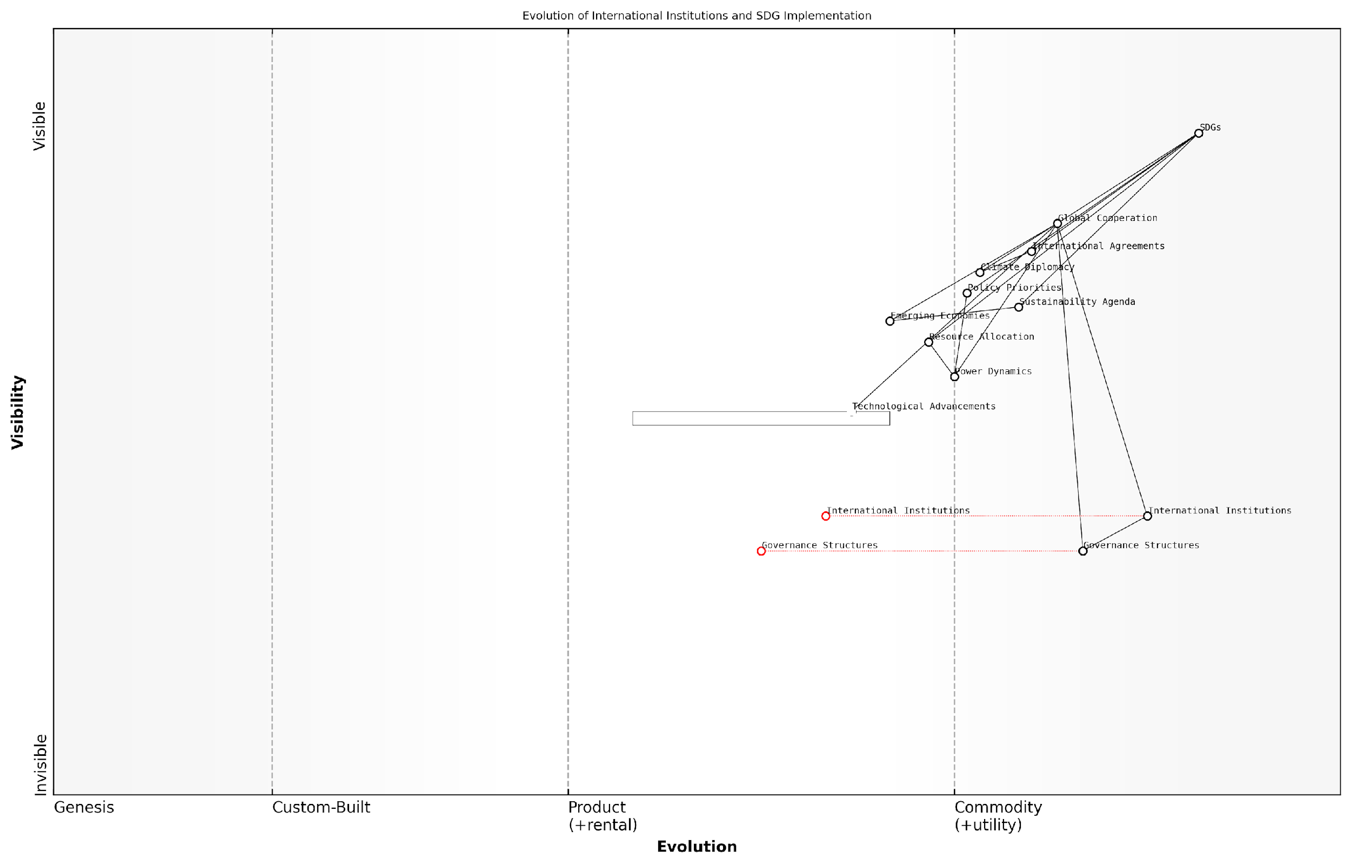

*Draft Wardley Map: [Insert Wardley Map illustrating the evolution of international institutions and their relationship to SDG implementation]*

[Edit this draft Wardley Map](https://create.wardleymaps.ai/#clone:9db4fabe78b0a6917b)

By applying Wardley Mapping to these aspects of geopolitical shifts and global cooperation, we can develop more nuanced and adaptive strategies for SDG implementation. This approach allows us to:

* Anticipate potential disruptions to existing cooperation frameworks
* Identify emerging opportunities for collaboration and innovation
* Develop flexible strategies that can adapt to changing geopolitical realities
* Foster more inclusive and equitable approaches to global sustainable development
* Enhance the resilience of SDG implementation efforts in the face of geopolitical uncertainties

As we navigate the complex interplay between geopolitics and sustainable development, Wardley Mapping emerges as an invaluable tool for policymakers, diplomats, and development practitioners. By providing a visual representation of the evolving landscape, it enables more informed decision-making and fosters a shared understanding of the challenges and opportunities that lie ahead in our collective pursuit of the SDGs.

In the face of geopolitical uncertainty, our commitment to the SDGs must remain unwavering. Wardley Mapping offers us a compass to navigate these turbulent waters, ensuring that our global cooperation efforts remain agile, inclusive, and effective in the pursuit of a more sustainable world.

As we continue to refine our approach to Wardley Mapping for the SDGs, it is crucial to maintain an open dialogue between diverse stakeholders, embracing the dynamic nature of geopolitics while staying true to the core principles of sustainable development. By doing so, we can forge a path towards a more resilient and cooperative global future, where the aspirations of the SDGs can be realised even in the face of geopolitical challenges.

### Climate Change Scenarios and Adaptation Strategies

As we delve into the critical intersection of climate change scenarios and adaptation strategies within the context of Wardley Mapping for the UN Sustainable Development Goals (SDGs), it becomes evident that this topic is pivotal in shaping the future landscape of global sustainability efforts. The dynamic nature of climate change necessitates a strategic approach that can anticipate and respond to evolving environmental challenges while aligning with the broader objectives of the SDGs.

To effectively map climate change scenarios and develop robust adaptation strategies, we must consider several key aspects:

* Scenario Planning and Risk Assessment
* Adaptive Capacity Building
* Technology and Innovation Integration
* Policy and Governance Frameworks
* Cross-sectoral Collaboration

Scenario Planning and Risk Assessment: The foundation of effective climate change adaptation lies in comprehensive scenario planning. By utilising Wardley Mapping techniques, we can visualise potential climate futures and their impacts on various components of the value chain. This approach allows for the identification of critical vulnerabilities and opportunities within the system.

Effective scenario planning is not about predicting the future, but about preparing for multiple plausible futures. It’s about building resilience into our strategies and systems.

In my experience advising government bodies on climate resilience, I’ve found that integrating climate models with Wardley Maps provides a powerful tool for decision-makers. It allows them to see how different climate scenarios might affect the evolution of technologies, practices, and policies along the value chain.

Adaptive Capacity Building: Once potential scenarios are mapped, the next crucial step is building adaptive capacity within systems and institutions. This involves developing flexible strategies that can respond to changing conditions and new information as it becomes available.

A key principle in adaptive capacity building is the concept of ‘no-regret’ strategies – actions that provide benefits under any future scenario. For instance, investing in green infrastructure or improving water management systems can yield positive outcomes regardless of the specific climate trajectory.

Technology and Innovation Integration: Emerging technologies play a crucial role in climate change adaptation. Wardley Mapping can help identify where technological innovations are positioned along the evolution axis and how they might impact adaptation strategies.

* AI and machine learning for improved climate modelling
* IoT sensors for real-time environmental monitoring
* Blockchain for transparent carbon trading and offsetting
* Biotechnology for climate-resilient agriculture

By mapping these technologies, we can anticipate their movement from genesis to commodity and strategise on how to leverage them effectively in our adaptation efforts.

Policy and Governance Frameworks: Adapting to climate change requires robust policy and governance frameworks. Wardley Mapping can illuminate the relationships between different policy levers and their potential impacts on climate resilience.

The most effective climate policies are those that are adaptive themselves, capable of evolving as our understanding of climate impacts deepens and as new technologies emerge.

In my work with various government agencies, I’ve observed that policies mapped using Wardley techniques tend to be more resilient and effective. They account for the evolving nature of climate challenges and the interdependencies between different sectors and stakeholders.

Cross-sectoral Collaboration: Climate change adaptation requires unprecedented levels of collaboration across sectors and disciplines. Wardley Mapping provides a common language and visual framework for diverse stakeholders to align their efforts and identify synergies.

For example, when mapping adaptation strategies for coastal cities, we might identify overlapping interests between urban planners, marine biologists, and renewable energy developers. This can lead to integrated solutions that address multiple SDGs simultaneously.

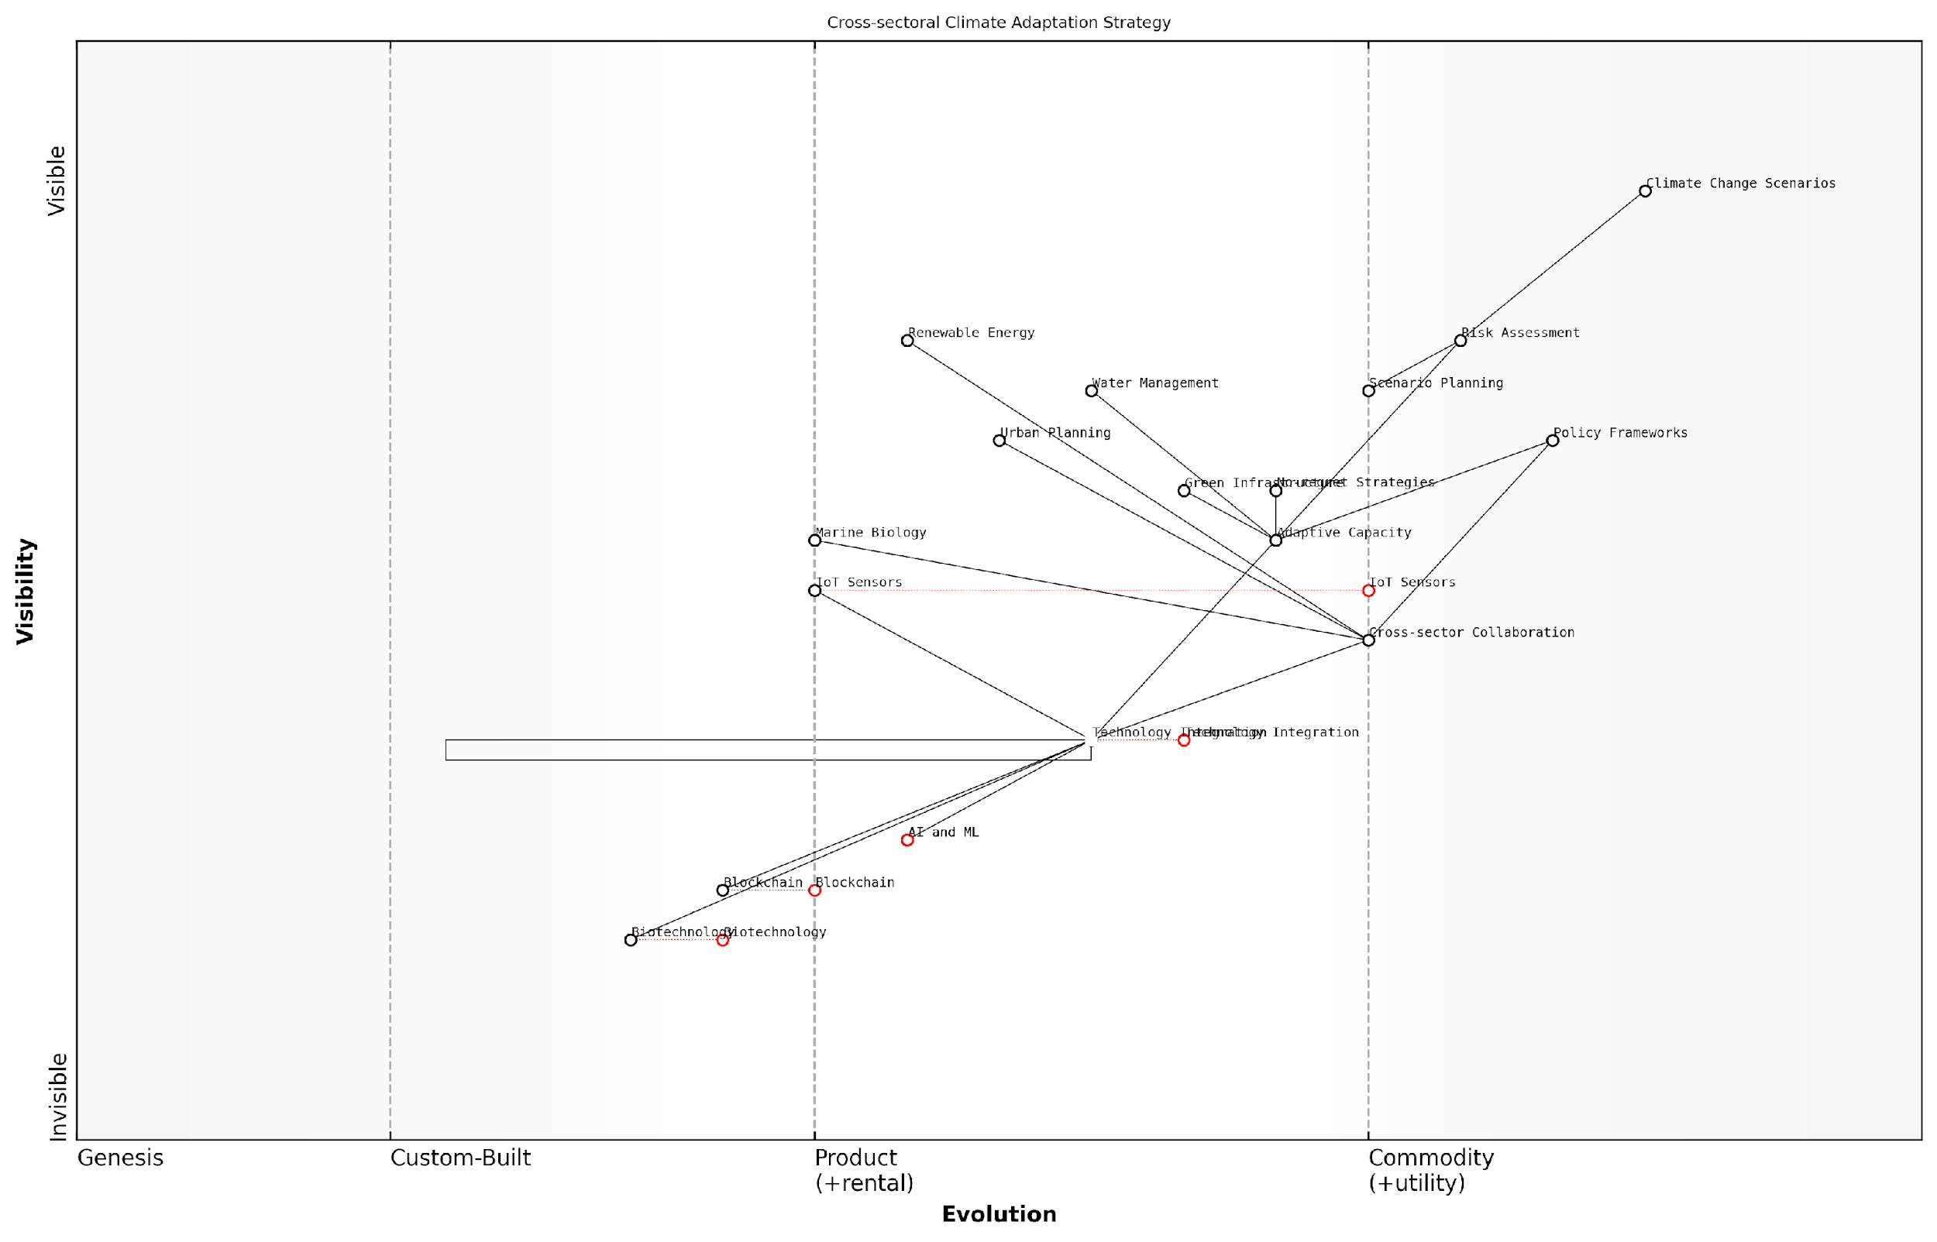

*Draft Wardley Map: [Insert Wardley Map: Cross-sectoral Climate Adaptation Strategy]*

[Edit this draft Wardley Map](https://create.wardleymaps.ai/#clone:04c61311ff2c1fe7fc)

As we look to the future, it’s clear that our approach to climate change adaptation must be as dynamic and evolving as the challenge itself. Wardley Mapping provides a powerful tool for navigating this complexity, allowing us to anticipate changes, identify strategic opportunities, and build resilience into our systems and institutions.

By integrating climate scenarios into our Wardley Maps for the SDGs, we create a more holistic and adaptive approach to sustainable development. This not only enhances our ability to respond to climate challenges but also ensures that our efforts towards the SDGs remain relevant and effective in a changing world.

The true measure of our success in addressing climate change will not be in our ability to prevent it, but in our capacity to adapt and thrive in the face of it. Wardley Mapping gives us the strategic foresight to do just that.

## Evolving Wardley Maps for Dynamic SDG Implementation

### Continuous Mapping and Strategy Refinement

In the dynamic landscape of sustainable development, the implementation of the United Nations Sustainable Development Goals (SDGs) requires a flexible and adaptive approach. Continuous Mapping and Strategy Refinement is a crucial component in evolving Wardley Maps for dynamic SDG implementation, ensuring that strategies remain relevant and effective in the face of changing global conditions, technological advancements, and shifting stakeholder priorities.

The process of continuous mapping and strategy refinement can be broken down into several key components:

* Regular reassessment of the value chain
* Incorporation of new data and insights
* Adaptation to evolving stakeholder needs
* Iterative strategy development
* Agile implementation methodologies

Regular reassessment of the value chain is fundamental to maintaining an accurate and useful Wardley Map for SDG implementation. As a senior adviser to multiple government bodies, I’ve observed that the most successful sustainable development initiatives are those that consistently re-evaluate their position on the evolution axis. This involves reassessing the maturity of components within the value chain, identifying emerging technologies or practices that may disrupt existing strategies, and recognising shifts in the competitive landscape.

The key to effective SDG implementation lies not in creating a perfect strategy, but in developing a system that can rapidly adapt to change. Continuous mapping allows us to stay ahead of the curve and pivot our approach as needed.

Incorporating new data and insights is critical for refining SDG strategies. The field of sustainable development is constantly evolving, with new research, technologies, and methodologies emerging regularly. Governments and organisations must establish robust systems for data collection, analysis, and integration into their Wardley Maps. This might involve leveraging big data analytics, artificial intelligence, and machine learning to process vast amounts of information and identify trends that can inform strategy refinement.

Adapting to evolving stakeholder needs is another crucial aspect of continuous mapping and strategy refinement. The complex nature of the SDGs means that a wide range of stakeholders are involved, each with their own priorities and perspectives. Regular stakeholder engagement and feedback mechanisms should be integrated into the mapping process to ensure that strategies remain aligned with the needs and expectations of all parties involved.

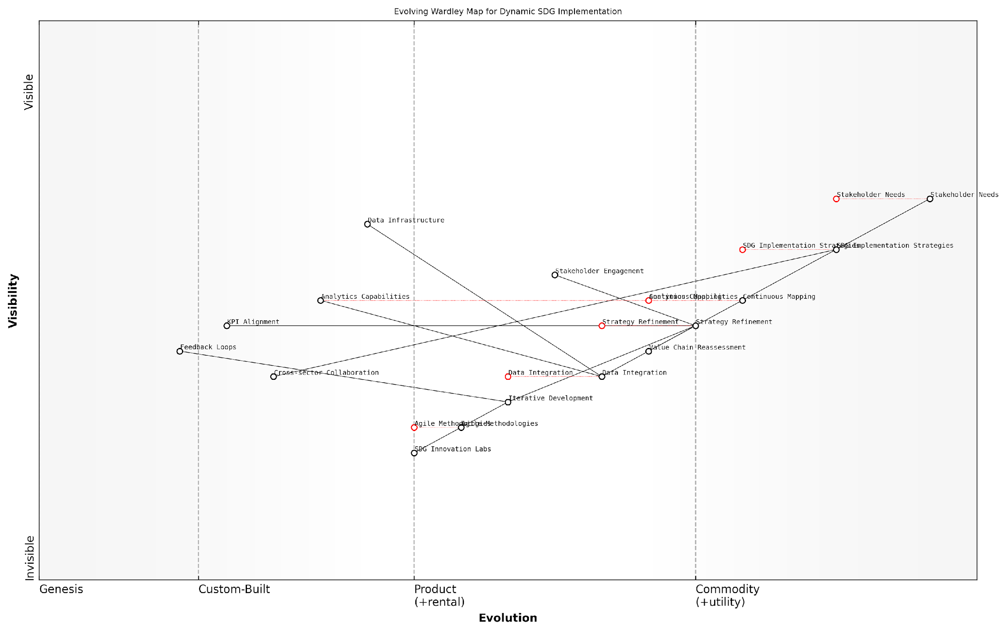

*Draft Wardley Map: [Insert Wardley Map illustrating the evolution of stakeholder needs over time and their impact on SDG implementation strategies]*

[Edit this draft Wardley Map](https://create.wardleymaps.ai/#clone:5c8f49c8f39d9d4de4)

Iterative strategy development is a natural outcome of continuous mapping. As new information is incorporated and stakeholder needs evolve, strategies must be refined accordingly. This iterative approach allows for more agile and responsive SDG implementation, enabling governments and organisations to capitalise on emerging opportunities and mitigate potential risks quickly.

In my experience advising on large-scale sustainable development projects, I’ve found that adopting agile implementation methodologies can significantly enhance the effectiveness of continuous mapping and strategy refinement. Agile approaches, traditionally used in software development, can be adapted for SDG implementation to allow for rapid prototyping, testing, and iteration of strategies.

Agile methodologies in SDG implementation allow us to fail fast, learn quickly, and continuously improve our strategies. It’s about creating a culture of experimentation and learning within the sustainable development ecosystem.

To effectively implement continuous mapping and strategy refinement, organisations should consider the following best practices:

* Establish a dedicated team or function responsible for ongoing Wardley Mapping and strategy refinement
* Implement regular review cycles (e.g., quarterly) to reassess and update maps
* Develop key performance indicators (KPIs) that align with SDG targets and can be used to measure the effectiveness of strategies
* Create feedback loops with implementation teams to quickly identify challenges and opportunities on the ground
* Invest in data infrastructure and analytics capabilities to support evidence-based decision-making
* Foster a culture of innovation and adaptability within the organisation
* Engage in cross-sector collaborations to share insights and best practices

One particularly effective approach I’ve seen in practice is the establishment of ‘SDG Innovation Labs’ within government departments. These labs serve as hubs for continuous mapping and strategy refinement, bringing together multidisciplinary teams to experiment with new approaches, analyse data, and rapidly prototype solutions. By creating a dedicated space for innovation and learning, organisations can accelerate their ability to adapt and respond to the complex challenges of SDG implementation.

It’s important to note that continuous mapping and strategy refinement is not without its challenges. Resistance to change, resource constraints, and the complexity of coordinating across multiple stakeholders can all pose significant obstacles. However, by embedding this process into the core of SDG implementation strategies, organisations can build the resilience and adaptability needed to navigate the uncertain future of sustainable development.

The SDGs represent a complex, interconnected system of challenges and opportunities. Our approach to implementing them must be equally dynamic and interconnected. Continuous mapping isn’t just a tool; it’s a mindset that enables us to navigate the complexity of sustainable development in an ever-changing world.

In conclusion, continuous mapping and strategy refinement is an essential component of evolving Wardley Maps for dynamic SDG implementation. By embracing this approach, governments and organisations can ensure that their strategies remain relevant, effective, and aligned with the rapidly changing landscape of global sustainable development. As we move forward in our collective efforts to achieve the SDGs, the ability to adapt and refine our approaches will be key to our success.

### Incorporating Emerging Data and Insights

In the dynamic landscape of sustainable development, the ability to incorporate emerging data and insights into Wardley Maps is crucial for maintaining their relevance and effectiveness. As an expert in applying Wardley Mapping to the United Nations Sustainable Development Goals (SDGs), I can attest that this process is not merely about updating information, but about evolving the entire strategic approach to SDG implementation.

The incorporation of new data and insights into Wardley Maps for SDGs can be broken down into several key areas:

* Data Integration and Analysis
* Stakeholder Feedback Loops
* Technological Advancements
* Policy and Regulatory Changes
* Environmental and Social Indicators

Let’s explore each of these areas in detail:

1. Data Integration and Analysis:

The proliferation of big data and advanced analytics has revolutionised our ability to track progress towards the SDGs. Incorporating these new data sources into Wardley Maps requires a systematic approach:

* Establish data pipelines: Create robust systems for collecting and processing data from various sources, including IoT devices, satellite imagery, and social media.
* Develop data standards: Ensure consistency and comparability of data across different regions and time periods.
* Implement machine learning algorithms: Utilise AI to identify patterns and trends that may not be immediately apparent in complex datasets.
* Create dynamic visualisations: Develop interactive Wardley Maps that can be updated in real-time as new data becomes available.

The integration of real-time data into our Wardley Maps has transformed our ability to respond to rapidly changing conditions on the ground. It’s like having a living, breathing strategy document.

1. Stakeholder Feedback Loops:

Effective SDG implementation requires continuous engagement with a wide range of stakeholders. Incorporating their feedback into Wardley Maps ensures that strategies remain relevant and responsive to local needs:

* Establish multi-channel feedback mechanisms: Utilise surveys, focus groups, and digital platforms to gather insights from beneficiaries, implementers, and policymakers.
* Conduct regular stakeholder mapping exercises: Identify new actors and changing power dynamics within the SDG ecosystem.
* Implement participatory mapping sessions: Involve stakeholders directly in the process of updating and refining Wardley Maps.
* Develop adaptive governance structures: Create flexible decision-making processes that can quickly incorporate new insights into strategic planning.

1. Technological Advancements:

The rapid pace of technological change can significantly impact the feasibility and effectiveness of SDG strategies. Keeping Wardley Maps up-to-date with these advancements is essential:

* Monitor emerging technologies: Regularly assess new technologies that could disrupt or enable progress towards the SDGs.
* Update component evolution: Revise the positioning of components on the evolution axis as technologies mature or new solutions emerge.
* Identify new dependencies: Map out how technological changes create new relationships between components in the value chain.
* Scenario planning: Use Wardley Maps to explore potential futures based on different technological trajectories.

By incorporating emerging technologies into our Wardley Maps, we’ve been able to anticipate and leverage disruptive innovations, turning potential threats into opportunities for accelerating SDG progress.

1. Policy and Regulatory Changes:

The policy landscape surrounding the SDGs is constantly evolving. Wardley Maps must be updated to reflect these changes and their implications for implementation strategies:

* Policy tracking systems: Implement mechanisms to monitor policy changes at local, national, and international levels.
* Regulatory impact analysis: Assess how new regulations affect the positioning and relationships of components within Wardley Maps.
* Cross-border considerations: Update maps to reflect changes in international agreements and their impact on SDG implementation.
* Policy simulation: Use Wardley Maps to model the potential effects of proposed policy changes on SDG strategies.

1. Environmental and Social Indicators:

As our understanding of complex social and environmental systems improves, it’s crucial to incorporate new indicators and metrics into Wardley Maps for SDGs:

* Expand indicator sets: Integrate newly developed indicators that provide more nuanced insights into SDG progress.
* Update measurement methodologies: Revise how existing indicators are calculated based on improved scientific understanding.
* Incorporate systems thinking: Use Wardley Maps to visualise and analyse the interconnections between different environmental and social indicators.
* Develop composite indices: Create new ways of combining indicators to provide a more holistic view of SDG progress.

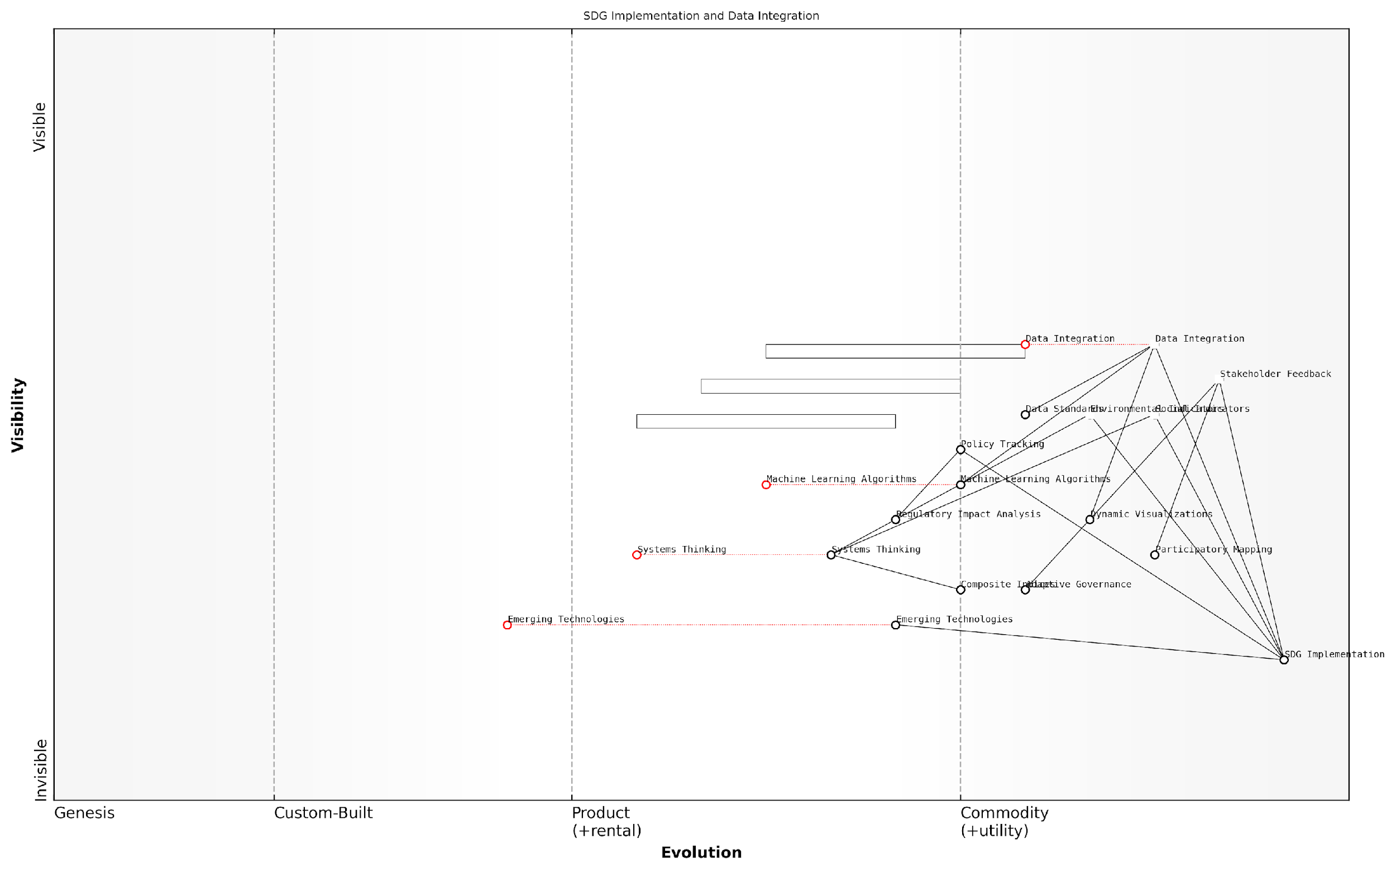

*Draft Wardley Map: [Insert Wardley Map illustrating the evolution of SDG indicators and their interconnections]*

[Edit this draft Wardley Map](https://create.wardleymaps.ai/#clone:11d06db9735457c8b6)

In conclusion, the process of incorporating emerging data and insights into Wardley Maps for SDG implementation is a continuous and iterative one. It requires a commitment to ongoing learning, flexibility in strategic thinking, and a willingness to challenge existing assumptions. By embracing this approach, governments and organisations can ensure that their strategies for achieving the SDGs remain relevant, effective, and responsive to the complex and ever-changing global landscape.

The true power of Wardley Mapping for SDGs lies not in creating static plans, but in fostering a dynamic, data-driven approach to sustainable development that can adapt and evolve as quickly as the world around us.

### Adapting to Changing Stakeholder Needs and Expectations

In the dynamic landscape of sustainable development, adapting to changing stakeholder needs and expectations is paramount for the successful implementation of the United Nations Sustainable Development Goals (SDGs). As we navigate the complexities of global sustainability challenges, Wardley Mapping emerges as a powerful tool for visualising and responding to these evolving demands. This section explores the critical importance of maintaining flexibility in our strategic approach to SDG implementation, leveraging the unique capabilities of Wardley Mapping to ensure our efforts remain relevant, impactful, and aligned with the shifting priorities of diverse stakeholders.

The ability to adapt to changing stakeholder needs is not merely a desirable trait; it is an essential component of effective SDG implementation. As a senior adviser to multiple government bodies on sustainable development strategies, I have witnessed firsthand the consequences of rigid, inflexible approaches. Wardley Mapping, with its emphasis on value chain evolution and strategic positioning, provides a robust framework for anticipating and responding to these changes.

Wardley Mapping is not just a static tool, but a dynamic process that allows us to continuously reassess and realign our strategies with the evolving landscape of sustainable development. It’s about staying ahead of the curve and ensuring our efforts remain relevant and impactful.

Let us explore the key aspects of adapting Wardley Maps to changing stakeholder needs and expectations in the context of SDG implementation:

* Continuous Stakeholder Engagement and Feedback Loops
* Iterative Map Refinement
* Scenario Planning and Horizon Scanning
* Agile Implementation Strategies
* Cross-Sector Collaboration and Knowledge Sharing

Continuous Stakeholder Engagement and Feedback Loops:

To effectively adapt to changing stakeholder needs, it is crucial to establish robust mechanisms for ongoing engagement and feedback. This involves creating platforms for regular dialogue with diverse stakeholders, including government agencies, civil society organisations, private sector entities, and local communities. By integrating these perspectives into our Wardley Maps, we can ensure that our strategies remain aligned with the evolving priorities and expectations of those we aim to serve.

In my work with a national sustainable development council, we implemented a quarterly stakeholder forum that brought together representatives from various sectors to review and provide input on our SDG implementation strategies. This regular engagement allowed us to identify emerging concerns and opportunities, which were then reflected in our evolving Wardley Maps.

Iterative Map Refinement:

Wardley Maps should not be viewed as static documents but as living tools that require constant refinement. As new data emerges, technologies evolve, and stakeholder priorities shift, it is essential to revisit and update our maps regularly. This iterative process ensures that our strategic positioning remains relevant and responsive to the changing landscape of sustainable development.

The power of Wardley Mapping lies in its ability to capture the dynamic nature of value chains. By regularly updating our maps, we can identify emerging opportunities and potential disruptions before they become critical, allowing us to proactively adjust our strategies.

Scenario Planning and Horizon Scanning:

Incorporating scenario planning and horizon scanning techniques into our Wardley Mapping process enables us to anticipate potential future changes in stakeholder needs and expectations. By exploring multiple plausible futures and their implications for SDG implementation, we can develop more robust and adaptable strategies.

For instance, when working with a ministry of environment on climate action strategies, we used Wardley Mapping in conjunction with scenario planning to explore how different global climate policy scenarios might impact national stakeholder expectations. This approach allowed us to develop flexible strategies that could be quickly adjusted based on evolving international agreements and domestic priorities.

Agile Implementation Strategies:

To effectively respond to changing stakeholder needs, it is crucial to adopt agile implementation strategies that allow for rapid adjustments and course corrections. This involves breaking down SDG implementation into smaller, manageable initiatives that can be quickly adapted based on feedback and changing circumstances.

Wardley Mapping can support this agile approach by helping to identify key components of the value chain that are most susceptible to change or have the greatest impact on stakeholder satisfaction. By focusing on these critical elements, we can prioritise our adaptation efforts and ensure that our strategies remain responsive to evolving needs.

Cross-Sector Collaboration and Knowledge Sharing:

Adapting to changing stakeholder needs often requires leveraging expertise and resources from across different sectors. Wardley Mapping can facilitate this cross-sector collaboration by providing a common visual language for discussing strategic challenges and opportunities.

In my experience working with a multi-stakeholder SDG taskforce, we used Wardley Maps as a tool for knowledge sharing and collaborative problem-solving. By bringing together diverse perspectives and expertise, we were able to identify innovative solutions that addressed the evolving needs of multiple stakeholder groups simultaneously.

Wardley Mapping serves as a powerful catalyst for cross-sector collaboration. It allows us to break down silos and create a shared understanding of the complex systems involved in SDG implementation, enabling more effective and adaptive strategies.

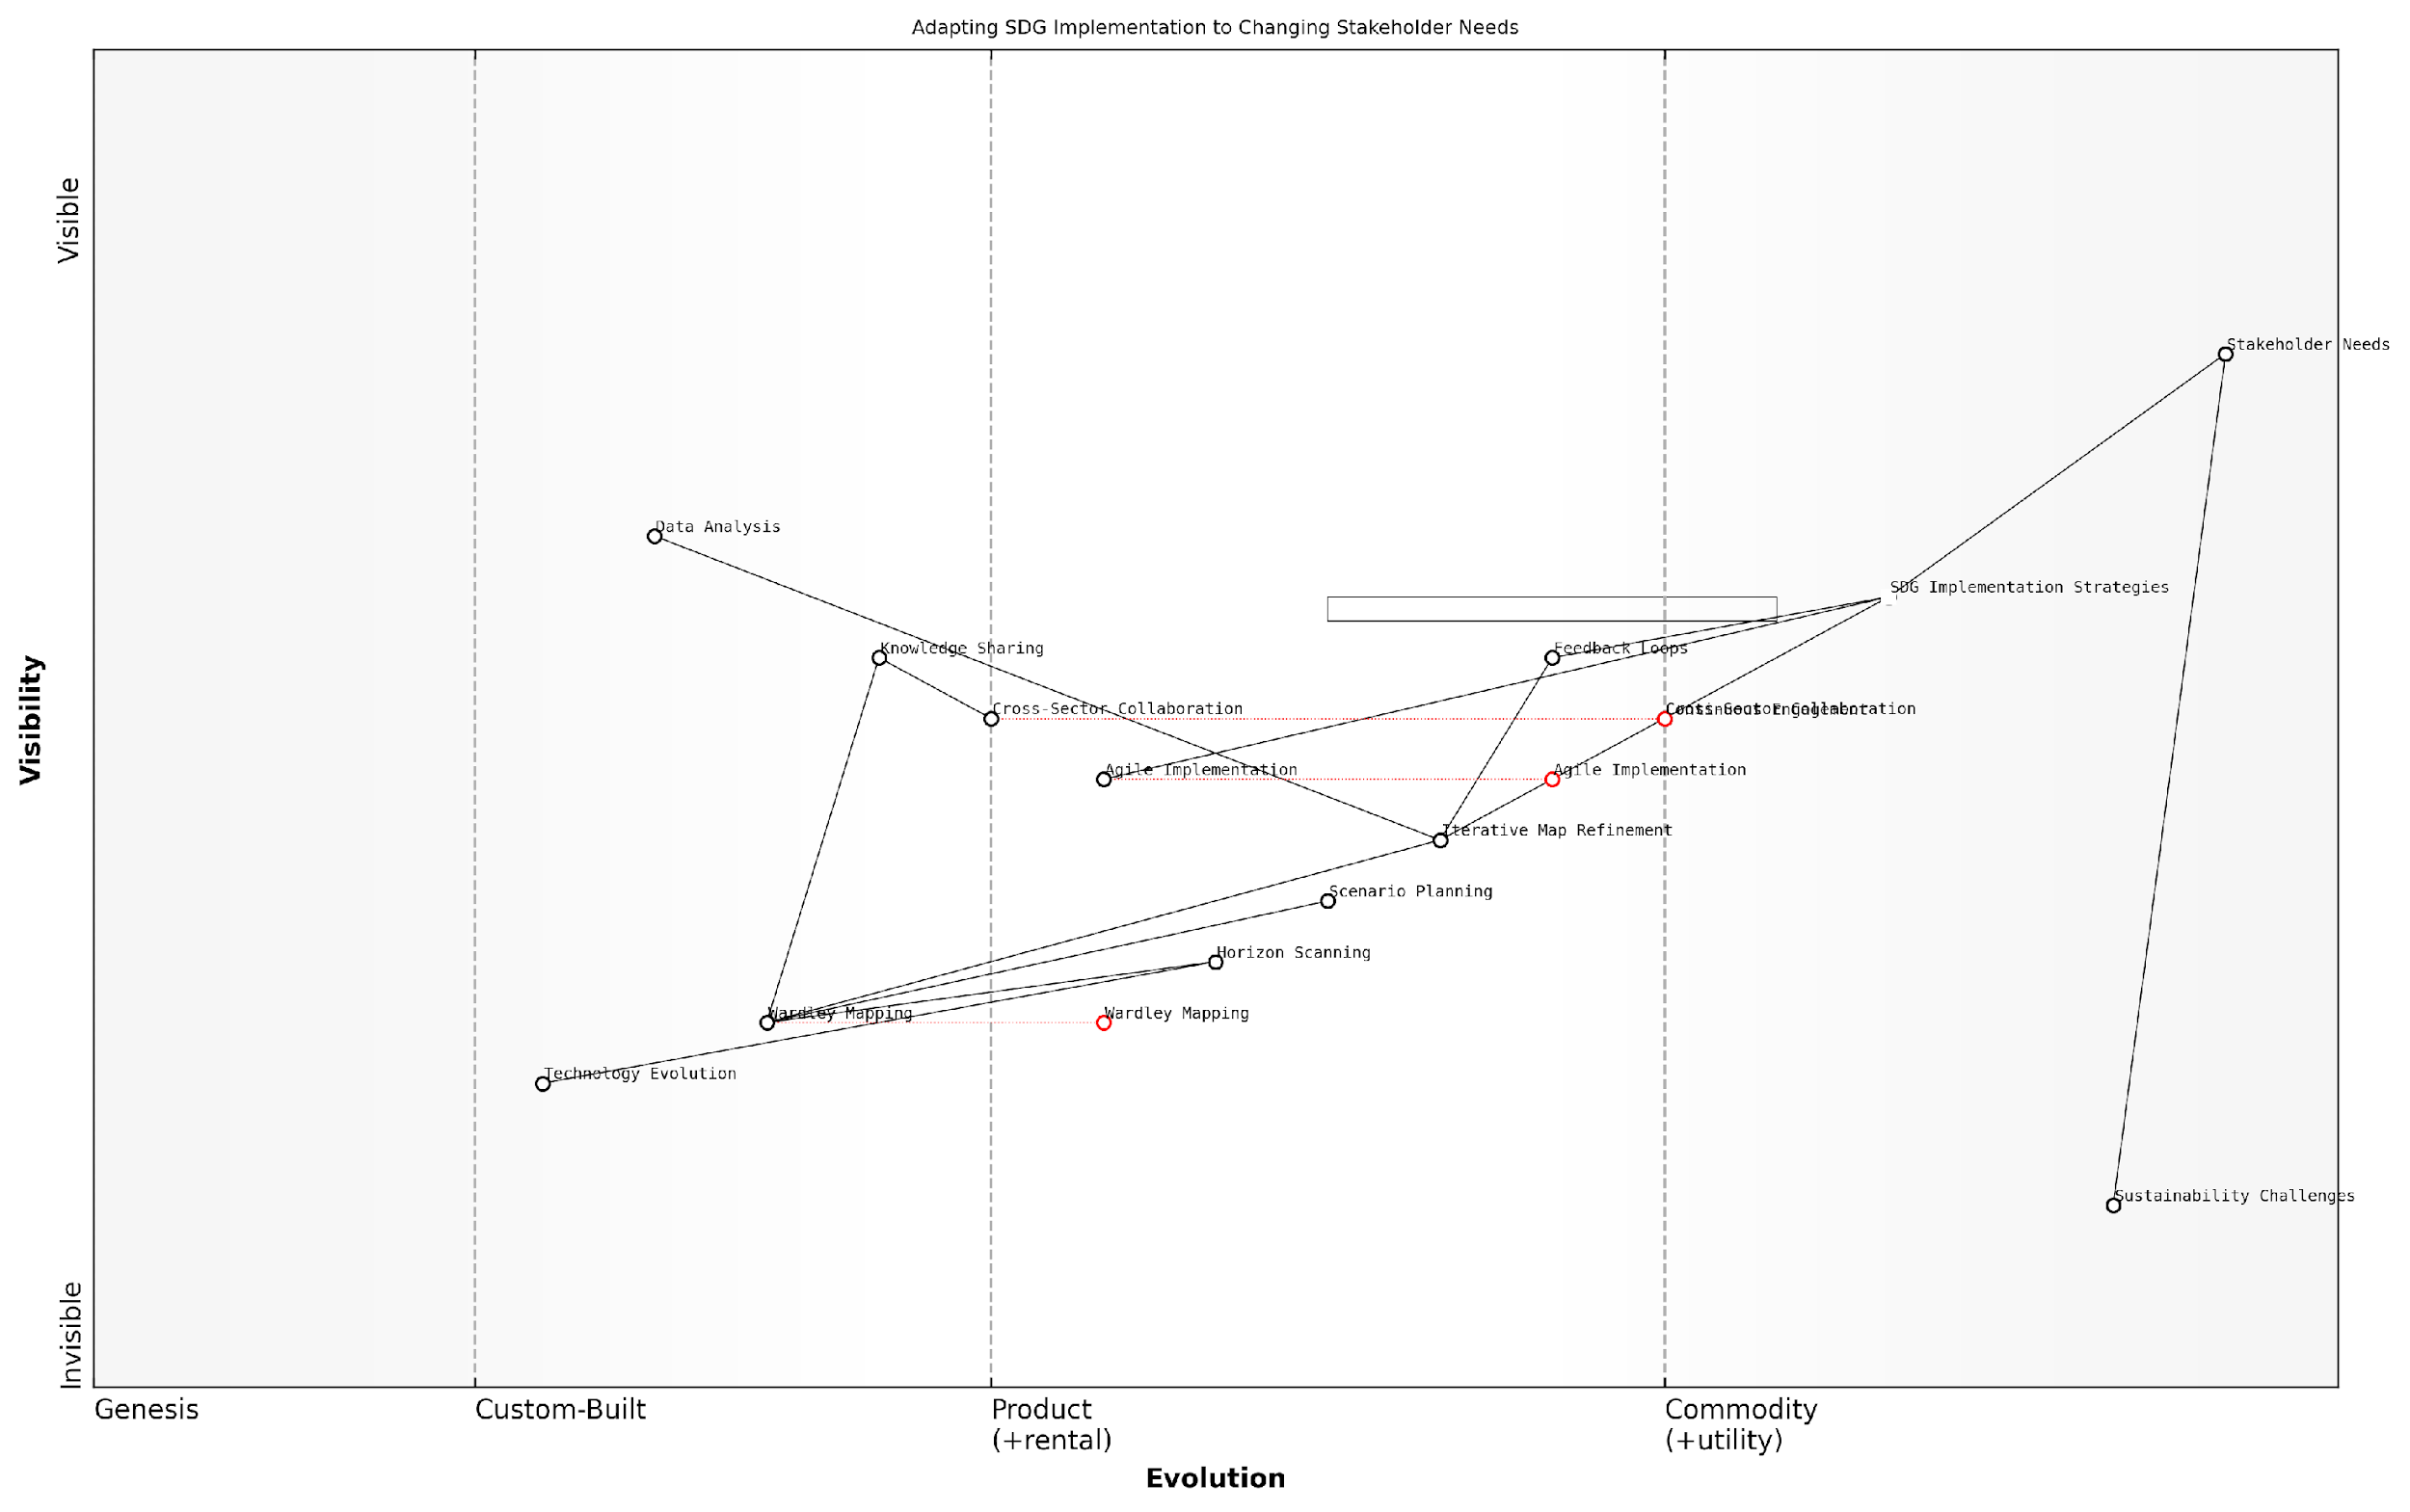

*Draft Wardley Map: [Insert Wardley Map illustrating the evolution of stakeholder needs and adaptive strategies for SDG implementation]*

[Edit this draft Wardley Map](https://create.wardleymaps.ai/#clone:bab81da0ff86a88e75)

In conclusion, adapting to changing stakeholder needs and expectations is a critical success factor in the effective implementation of the UN Sustainable Development Goals. By leveraging the power of Wardley Mapping and embracing an adaptive, iterative approach to strategy development, we can ensure that our efforts remain relevant, impactful, and aligned with the evolving priorities of diverse stakeholders. As we continue to navigate the complex landscape of global sustainability, this flexibility and responsiveness will be key to achieving the transformative vision of the SDGs.

## Building Resilience into SDG Strategies

### Identifying and Mitigating Risks

In the context of implementing the United Nations Sustainable Development Goals (SDGs) through Wardley Mapping, identifying and mitigating risks is a crucial component of building resilience into SDG strategies. As we navigate the complex landscape of global sustainability, it is essential to anticipate potential challenges and develop robust mechanisms to address them. This subsection explores the intricate process of risk identification and mitigation within the framework of Wardley Mapping for SDGs, drawing upon best practices and real-world experiences from government and public sector contexts.

Wardley Mapping provides a unique lens through which we can visualise and analyse the risks associated with SDG implementation. By mapping the value chain of each goal and its components, we can identify potential vulnerabilities, dependencies, and areas of uncertainty that may pose risks to successful implementation. This approach allows for a more comprehensive and strategic view of risk management in the context of sustainable development.

Wardley Mapping has revolutionised our approach to risk management in SDG implementation. It allows us to see the interconnected nature of risks across different goals and sectors, enabling more effective mitigation strategies.

Let us delve into the key aspects of identifying and mitigating risks using Wardley Mapping for SDGs:

* Systematic Risk Identification
* Cross-Goal Risk Analysis
* Dynamic Risk Assessment
* Collaborative Risk Mitigation
* Leveraging Technology for Risk Management

Systematic Risk Identification: Wardley Mapping facilitates a structured approach to identifying risks across the entire value chain of each SDG. By visualising the components and their evolution, we can pinpoint potential areas of failure, bottlenecks, or external threats that may impede progress. For instance, when mapping SDG 6 (Clean Water and Sanitation), we might identify risks such as water source depletion, infrastructure vulnerabilities, or regulatory challenges. This systematic approach ensures that no critical risk factors are overlooked.

Cross-Goal Risk Analysis: One of the unique strengths of using Wardley Mapping for SDGs is the ability to analyse risks across multiple goals simultaneously. By overlaying maps of different SDGs, we can identify how risks in one area may cascade and impact others. For example, risks associated with climate action (SDG 13) may have direct implications for goals related to poverty reduction (SDG 1) or food security (SDG 2). This holistic view enables policymakers to develop more comprehensive and integrated risk mitigation strategies.

Dynamic Risk Assessment: The evolving nature of the sustainability landscape necessitates a dynamic approach to risk assessment. Wardley Mapping allows for continuous updating and refinement of risk profiles as components move along the evolution axis. This dynamic assessment helps in anticipating emerging risks and adapting strategies accordingly. For instance, as new technologies emerge in the renewable energy sector, the risk landscape for SDG 7 (Affordable and Clean Energy) may shift, requiring adjustments in implementation strategies.

The dynamic nature of Wardley Mapping has been instrumental in our ability to stay ahead of emerging risks in our SDG implementation efforts. It’s like having a constantly updated risk radar for sustainable development.

Collaborative Risk Mitigation: Effective risk mitigation for SDGs often requires collaboration across various stakeholders. Wardley Mapping provides a common visual language that facilitates communication and coordination among government agencies, private sector entities, and civil society organisations. By sharing maps and collaboratively identifying risks, stakeholders can pool resources and expertise to develop more robust mitigation strategies. This collaborative approach is particularly crucial for addressing complex, cross-cutting risks that span multiple SDGs.

Leveraging Technology for Risk Management: As we build resilience into SDG strategies, leveraging technology plays a vital role in risk identification and mitigation. Wardley Mapping can be enhanced with data analytics and artificial intelligence to provide more accurate risk predictions and scenario analyses. For example, machine learning algorithms can analyse historical data and current trends to identify potential risks that may not be immediately apparent through manual mapping alone. This integration of technology with Wardley Mapping creates a powerful tool for proactive risk management in SDG implementation.

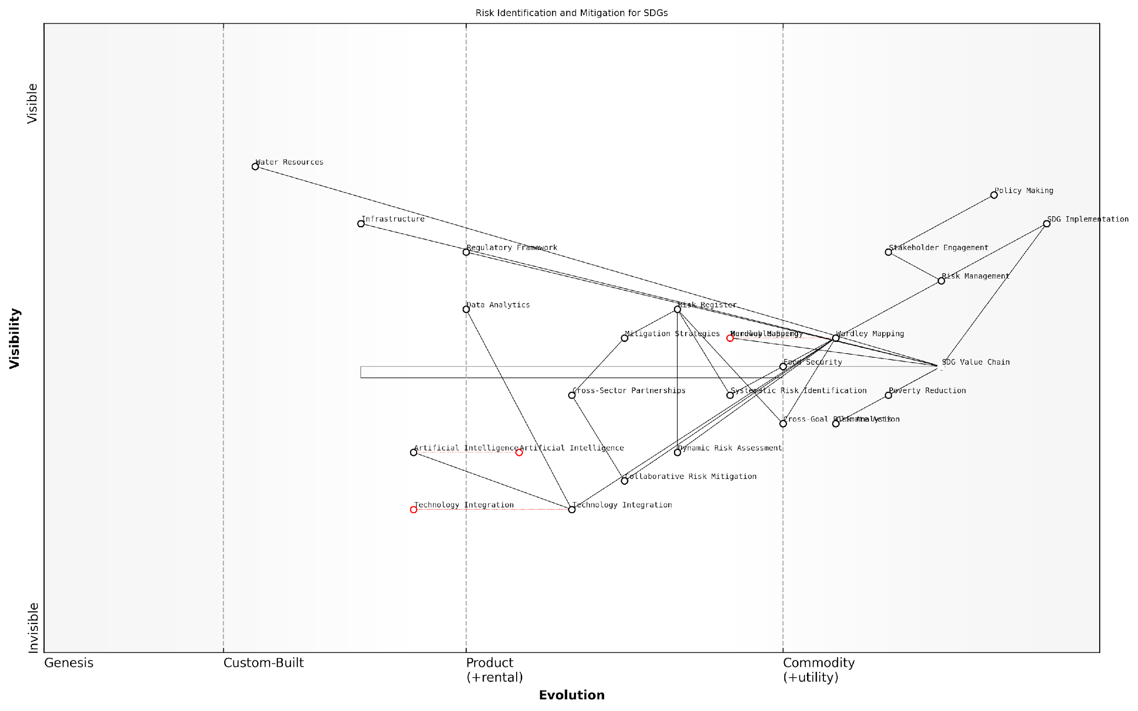

*Draft Wardley Map: [Insert Wardley Map illustrating risk identification across multiple SDGs, highlighting interconnected risks and potential mitigation strategies]*

[Edit this draft Wardley Map](https://create.wardleymaps.ai/#clone:861cf724ea90f9945f)

In practice, the process of identifying and mitigating risks using Wardley Mapping for SDGs involves several key steps:

* Create detailed Wardley Maps for each SDG, identifying all components and their current evolutionary stage.
* Analyse each component for potential risks, considering factors such as technological obsolescence, resource constraints, and external threats.
* Overlay maps of related SDGs to identify cross-cutting risks and dependencies.
* Engage stakeholders in collaborative workshops to validate identified risks and brainstorm mitigation strategies.
* Develop a prioritised risk register, mapping risks to specific components and stages of evolution.
* Implement mitigation strategies, leveraging cross-sector partnerships where appropriate.
* Regularly update maps and risk assessments to reflect changing conditions and emerging threats.

By following this structured approach, governments and organisations can build more resilient SDG strategies that are better equipped to navigate the complex and often unpredictable landscape of global sustainability efforts.

The integration of Wardley Mapping into our risk management processes has transformed our ability to anticipate and address challenges in SDG implementation. It’s not just about identifying risks; it’s about understanding their place in the broader ecosystem of sustainable development.

In conclusion, identifying and mitigating risks is a critical component of building resilience into SDG strategies. Wardley Mapping provides a powerful framework for visualising, analysing, and addressing these risks in a systematic and dynamic manner. By leveraging this approach, policymakers and practitioners can develop more robust and adaptive strategies for achieving the ambitious goals set forth in the UN 2030 Agenda for Sustainable Development. As we continue to face global challenges, the ability to anticipate and mitigate risks will be crucial in ensuring the long-term success and impact of our sustainability efforts.

### Creating Flexible Implementation Frameworks

In the dynamic landscape of global sustainability efforts, creating flexible implementation frameworks is crucial for the successful realisation of the United Nations Sustainable Development Goals (SDGs). As we navigate the complexities of interconnected global challenges, our strategies must be adaptable, resilient, and capable of evolving in response to emerging trends, unforeseen obstacles, and shifting priorities. This section explores the critical components of flexible implementation frameworks within the context of Wardley Mapping for SDGs, offering insights into how governments and organisations can build agility into their sustainability strategies.

Flexible implementation frameworks are essential for several reasons:

* They allow for rapid response to changing circumstances and new information
* They facilitate the integration of innovative solutions and emerging technologies
* They enable more effective collaboration between diverse stakeholders
* They promote continuous learning and improvement in SDG strategies

To create truly flexible implementation frameworks for SDGs using Wardley Mapping, we must consider several key elements:

1. Modular Strategy Design

One of the most effective ways to build flexibility into SDG implementation frameworks is through modular strategy design. This approach involves breaking down the overall strategy into discrete, interchangeable components that can be adjusted, replaced, or scaled independently. In the context of Wardley Mapping, this means creating sub-maps for different aspects of each SDG, which can then be reconfigured as needed.

Modular strategy design allows us to adapt quickly to changes without having to overhaul our entire approach. It’s like having a set of building blocks that we can rearrange as the sustainability landscape evolves.

1. Scenario Planning and Alternative Pathways

Incorporating scenario planning into the Wardley Mapping process for SDGs enables the development of alternative pathways for implementation. By mapping out multiple potential futures and their corresponding value chains, organisations can prepare for various outcomes and pivot their strategies more effectively when faced with unexpected challenges or opportunities.

1. Agile Governance Structures

Flexible implementation frameworks require governance structures that can support rapid decision-making and adaptation. This may involve creating cross-functional teams, establishing clear feedback loops, and empowering local actors to make decisions within a broader strategic framework. Wardley Mapping can help visualise these governance structures and identify areas where increased flexibility is needed.

1. Continuous Monitoring and Evaluation

To maintain flexibility, it’s crucial to establish robust systems for continuous monitoring and evaluation of SDG implementation efforts. This involves regularly updating Wardley Maps to reflect changes in the landscape, tracking key performance indicators, and conducting periodic reviews of strategy effectiveness.

In my experience advising government bodies, those that implement rigorous monitoring and evaluation processes are far more successful in adapting their strategies to meet evolving sustainability challenges.

1. Stakeholder Engagement and Co-creation

Flexible frameworks should incorporate mechanisms for ongoing stakeholder engagement and co-creation. This ensures that strategies remain relevant and responsive to the needs of affected communities and partners. Wardley Mapping can be used as a collaborative tool to facilitate this engagement, allowing diverse stakeholders to contribute their perspectives and expertise to the evolving strategy.

1. Technology Integration and Innovation Pipelines

To remain flexible in an era of rapid technological advancement, implementation frameworks must include clear pathways for integrating new technologies and innovations. This involves creating innovation pipelines within Wardley Maps, identifying areas where emerging technologies could disrupt or enhance current approaches to SDG implementation.

1. Adaptive Funding Mechanisms

Flexible implementation requires equally flexible funding mechanisms. This may involve creating pooled funds that can be rapidly reallocated, establishing outcome-based funding models, or developing innovative financing instruments that can adapt to changing priorities and opportunities within the SDG landscape.

1. Capacity Building for Adaptability

Building flexibility into SDG strategies also requires investing in the capacity of individuals and organisations to adapt. This includes training in agile methodologies, systems thinking, and the use of Wardley Mapping as a dynamic strategy tool. By fostering a culture of adaptability, organisations can ensure that their implementation frameworks remain flexible at all levels.

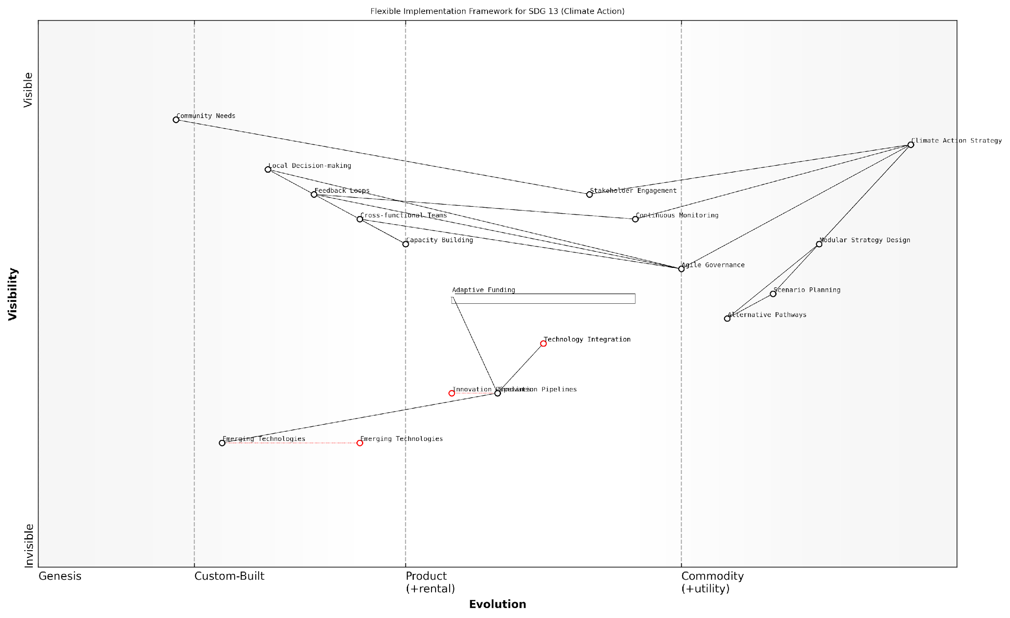

*Draft Wardley Map: [Insert Wardley Map illustrating a flexible implementation framework for SDG 13 (Climate Action), showing modular components, alternative pathways, and points of adaptability]*

[Edit this draft Wardley Map](https://create.wardleymaps.ai/#clone:677bea381bd74ba806)

In conclusion, creating flexible implementation frameworks for SDGs through Wardley Mapping is not just about building adaptability into our strategies; it’s about fundamentally changing how we approach global sustainability challenges. By embracing modularity, scenario planning, agile governance, and continuous adaptation, we can create frameworks that are resilient in the face of uncertainty and capable of driving meaningful progress towards the SDGs in an ever-changing world.

The most successful SDG strategies I’ve seen in practice are those that treat flexibility not as a feature, but as the very foundation of their approach to implementation.

### Fostering Innovation and Adaptability in Sustainability Efforts

In the dynamic landscape of global sustainability, fostering innovation and adaptability is crucial for the successful implementation of the United Nations Sustainable Development Goals (SDGs). As we navigate the complexities of environmental, social, and economic challenges, our strategies must be agile and responsive to emerging trends, technologies, and societal shifts. This section explores how Wardley Mapping can be leveraged to cultivate a culture of innovation and adaptability within SDG strategies, ensuring that our efforts remain relevant and impactful in the face of rapid global change.

Wardley Mapping, with its emphasis on visualising the evolution of components within a value chain, provides an ideal framework for identifying opportunities for innovation and areas requiring increased adaptability. By mapping the SDG landscape, we can pinpoint where emerging technologies or novel approaches might disrupt traditional methods, and where flexibility in implementation is most critical.

Wardley Mapping allows us to see beyond the horizon of current sustainability practices, revealing the pathways to transformative innovation that can accelerate our progress towards the SDGs.

Let us explore the key aspects of fostering innovation and adaptability in sustainability efforts through the lens of Wardley Mapping:

* Identifying Innovation Opportunities
* Cultivating Adaptive Capacity
* Leveraging Emerging Technologies
* Encouraging Cross-Sector Collaboration
* Implementing Agile Governance Models

Identifying Innovation Opportunities: Wardley Maps can reveal areas within the SDG value chain where innovation is most needed and likely to have the greatest impact. By analysing the evolution of components from genesis to commodity, we can identify ‘innovation gaps’ – areas where current solutions are insufficient or where leapfrog technologies could dramatically accelerate progress.

For instance, in mapping SDG 7 (Affordable and Clean Energy), we might identify that while solar panel technology is becoming commoditised, energy storage solutions are still in the custom-built phase. This insight could guide investment and research efforts towards innovative battery technologies or alternative energy storage methods.

Cultivating Adaptive Capacity: Adaptability is key to long-term success in sustainability efforts. Wardley Mapping can help organisations build adaptive capacity by visualising the entire ecosystem of an SDG and identifying potential points of disruption or change. By understanding the interdependencies between different components, we can develop strategies that are flexible enough to respond to shifts in technology, policy, or societal needs.

In the realm of sustainability, the only constant is change. Our strategies must be as dynamic as the challenges we face, and Wardley Mapping provides the blueprint for this adaptability.

Leveraging Emerging Technologies: The rapid pace of technological advancement offers unprecedented opportunities for addressing sustainability challenges. Wardley Mapping can help identify where emerging technologies such as artificial intelligence, blockchain, or the Internet of Things can be most effectively applied to SDG efforts. By mapping these technologies alongside existing solutions, we can anticipate their impact and integrate them strategically into our sustainability initiatives.

For example, in addressing SDG 14 (Life Below Water), a Wardley Map might reveal opportunities to use AI-powered drones for marine conservation efforts, or blockchain technology for transparent and sustainable fisheries management.

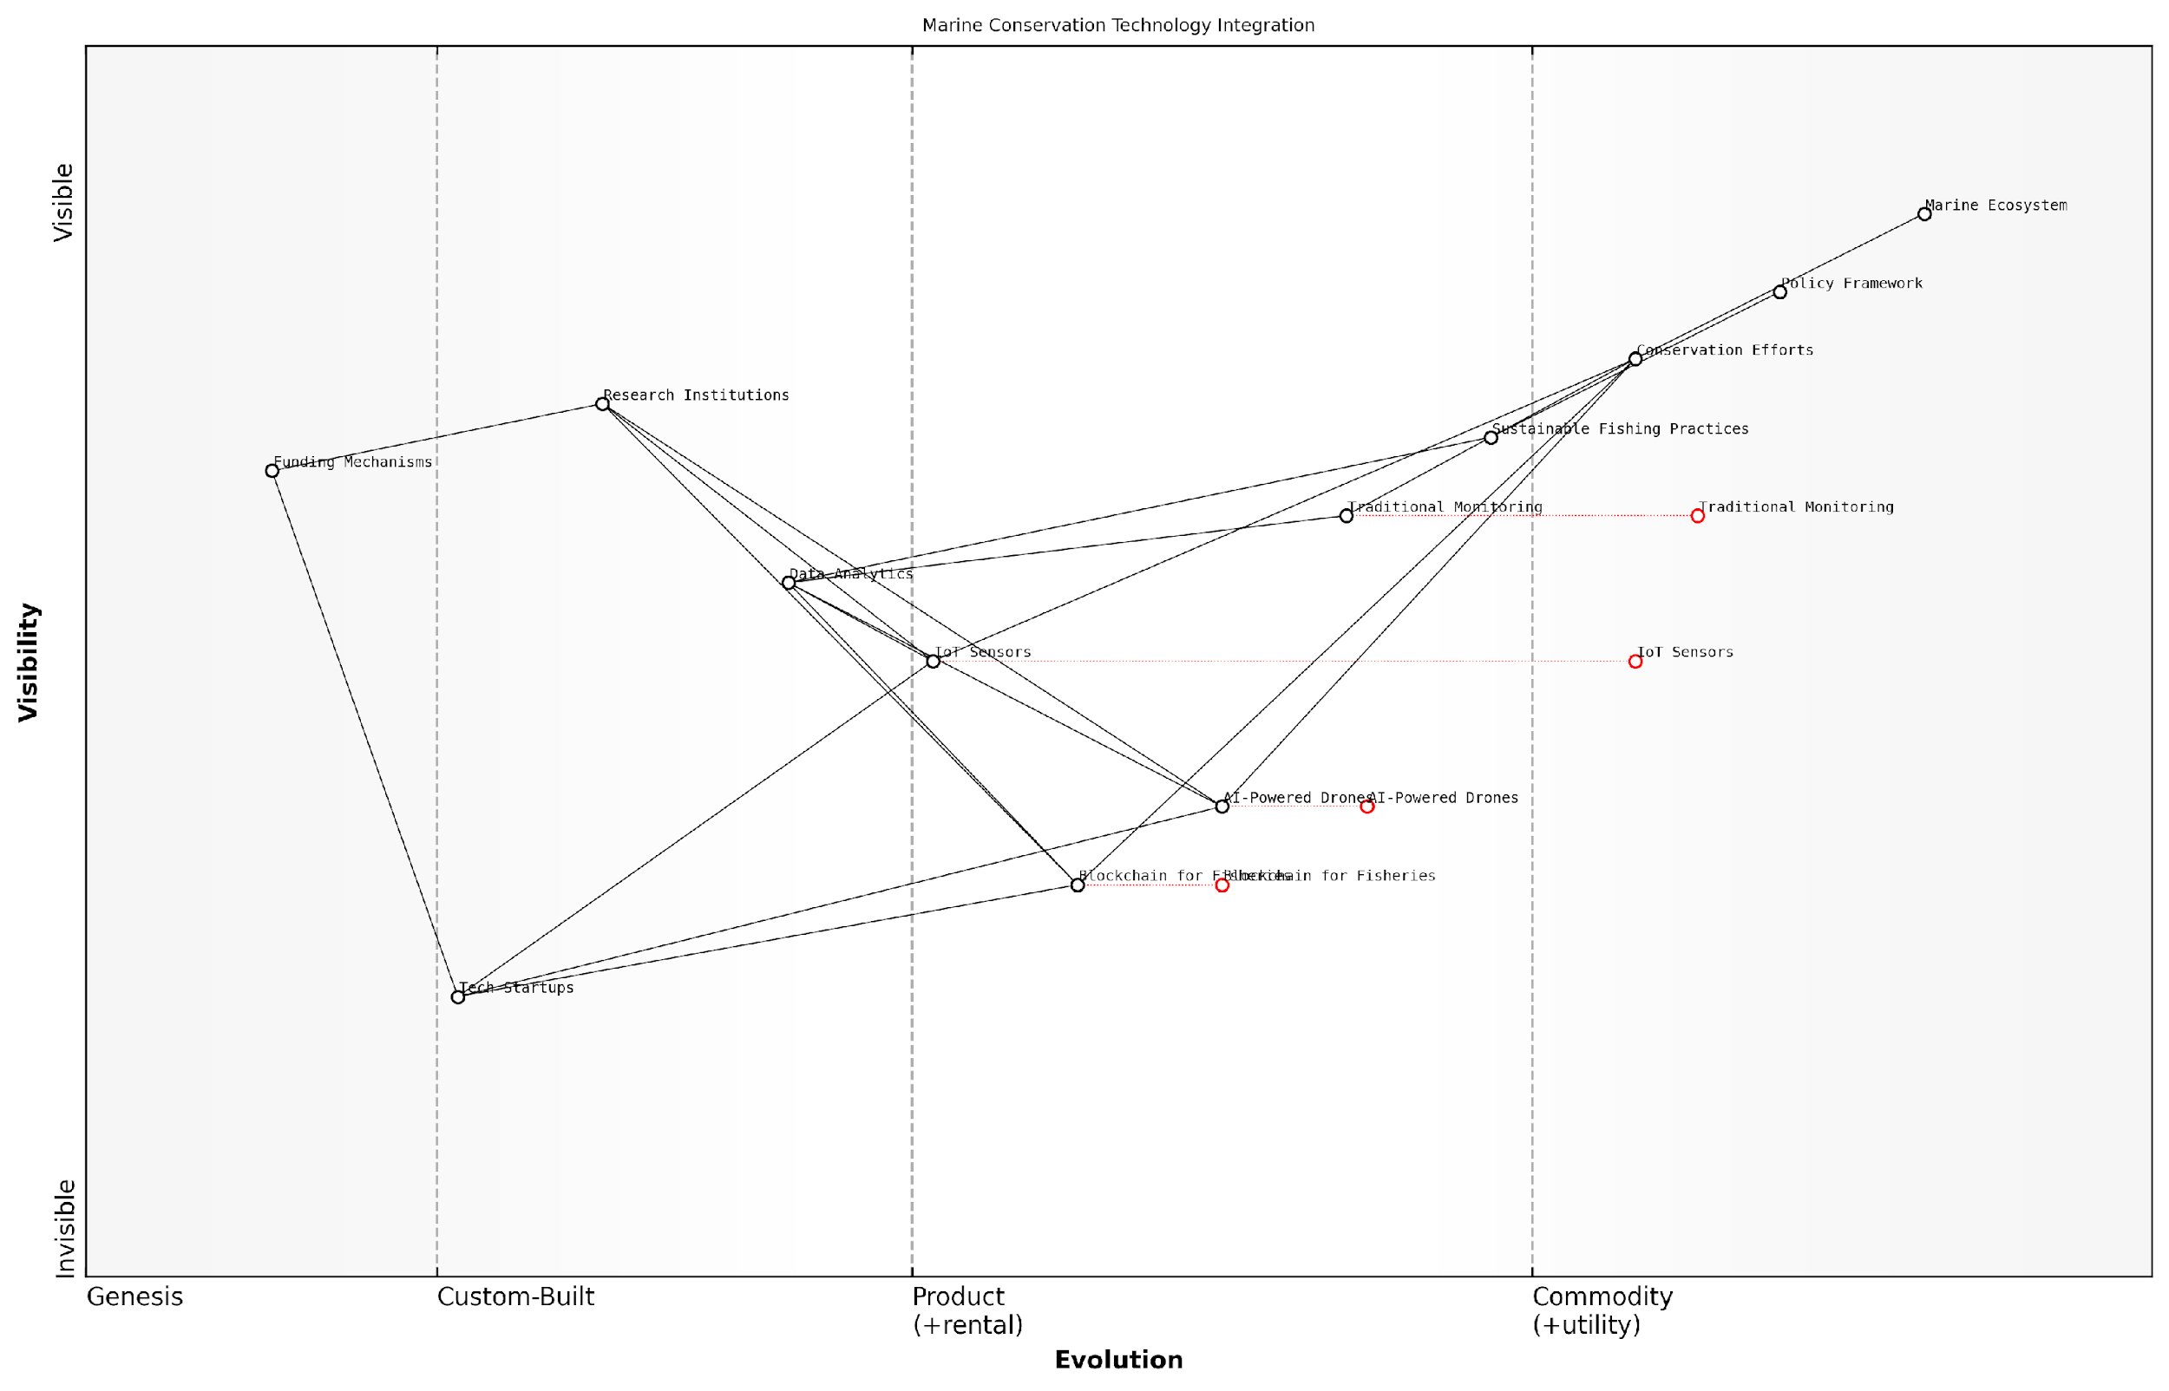

*Draft Wardley Map: [Insert Wardley Map illustrating the integration of emerging technologies in marine conservation efforts]*

[Edit this draft Wardley Map](https://create.wardleymaps.ai/#clone:fb771684dc13cd1479)

Encouraging Cross-Sector Collaboration: Innovation often occurs at the intersection of different sectors and disciplines. Wardley Mapping can facilitate cross-sector collaboration by providing a common visual language for stakeholders from government, industry, academia, and civil society. By mapping the value chains of multiple SDGs simultaneously, we can identify synergies and opportunities for collaborative innovation that might otherwise be overlooked.

Implementing Agile Governance Models: Traditional governance models can sometimes hinder innovation and adaptability in sustainability efforts. Wardley Mapping can inform the development of more agile governance structures by visualising the evolving landscape of SDG implementation and identifying where flexibility is most needed. This might involve creating adaptive policy frameworks, establishing rapid feedback loops, or developing scenario-based planning approaches.

Agile governance is not about moving fast and breaking things; it’s about creating systems that can sense and respond to change effectively. Wardley Mapping gives us the situational awareness to govern with agility and purpose.

To effectively foster innovation and adaptability in sustainability efforts, consider the following practical steps:

* Regularly update Wardley Maps to reflect changes in the SDG landscape
* Establish innovation hubs or labs focused on SDG challenges
* Create cross-functional teams to address complex sustainability issues
* Develop scenario planning exercises based on Wardley Map insights
* Implement rapid prototyping and piloting of new sustainability solutions
* Foster a culture of continuous learning and knowledge sharing
* Engage with startups and innovators working on SDG-related technologies
* Establish flexible funding mechanisms for innovative sustainability projects

In conclusion, fostering innovation and adaptability is essential for building resilience into SDG strategies. Wardley Mapping provides a powerful tool for visualising the evolving landscape of sustainability efforts, identifying opportunities for innovation, and developing adaptive approaches to implementation. By embracing these principles, we can create sustainability strategies that are not only robust in the face of change but are also drivers of transformative innovation in their own right.

The future of sustainability lies not in rigid plans, but in our capacity to innovate and adapt. Wardley Mapping equips us with the strategic foresight to turn the challenges of tomorrow into the opportunities of today.

# Conclusion: Empowering Global Sustainability Through Strategic Mapping

## Key Takeaways for SDG Implementation

### The Transformative Power of Wardley Mapping for SDGs

As we conclude our exploration of Wardley Mapping for the United Nations Sustainable Development Goals (SDGs), it is crucial to underscore the transformative power this strategic approach holds for global sustainability efforts. Wardley Mapping, when applied to the complex landscape of the SDGs, offers a paradigm shift in how we conceptualise, plan, and implement sustainable development strategies.

The application of Wardley Mapping to the SDGs represents a significant leap forward in our ability to navigate the intricate web of interconnected goals and targets. By providing a visual representation of the value chain and evolution of components within each SDG, Wardley Mapping enables policymakers, organisations, and stakeholders to gain unprecedented insights into the strategic landscape of sustainable development.

Wardley Mapping has revolutionised our approach to the SDGs. It’s like having a strategic compass that not only shows us where we are but also illuminates the path forward in the complex terrain of global sustainability.

Let us delve into the key aspects that make Wardley Mapping a transformative tool for SDG implementation:

* Enhanced Strategic Visibility
* Dynamic Adaptation to Change
* Cross-Sector Collaboration Facilitation
* Efficient Resource Allocation
* Innovation Catalysis

Enhanced Strategic Visibility: Wardley Mapping provides unparalleled clarity in visualising the entire value chain of SDG implementation. This bird’s-eye view allows decision-makers to identify critical components, dependencies, and potential bottlenecks that might otherwise remain hidden. For instance, when mapping SDG 6 (Clean Water and Sanitation), we can clearly see the interplay between water infrastructure, policy frameworks, community engagement, and technological innovations. This visibility enables more informed decision-making and targeted interventions.

Dynamic Adaptation to Change: The evolving nature of Wardley Maps aligns perfectly with the dynamic challenges of sustainable development. As new technologies emerge, societal needs shift, or environmental conditions change, Wardley Maps can be readily updated to reflect these changes. This adaptability is crucial for maintaining relevant and effective strategies in the face of global uncertainties, such as climate change or economic fluctuations.

The beauty of Wardley Mapping lies in its dynamism. It’s not a static snapshot, but a living document that evolves with our understanding and the changing global landscape. This makes it an invaluable tool for long-term sustainability planning.

Cross-Sector Collaboration Facilitation: One of the most powerful aspects of Wardley Mapping for SDGs is its ability to foster collaboration across different sectors and stakeholders. By providing a common visual language, it breaks down silos and enables diverse actors - from government agencies to private corporations and NGOs - to align their efforts more effectively. For example, when addressing SDG 13 (Climate Action), a Wardley Map can illustrate how actions in the energy sector intersect with transportation, urban planning, and agriculture, facilitating coordinated strategies across these domains.

Efficient Resource Allocation: In the context of limited resources for SDG implementation, Wardley Mapping offers a strategic advantage in resource allocation. By clearly showing the maturity and importance of different components within an SDG’s value chain, it allows for more informed decisions on where to invest time, money, and effort. This is particularly crucial for developing countries grappling with multiple pressing needs and limited budgets.

Innovation Catalysis: Wardley Mapping serves as a powerful tool for identifying areas ripe for innovation within the SDG framework. By mapping out the current state and desired future state of SDG components, it becomes easier to spot gaps and opportunities for innovative solutions. This can drive targeted research and development efforts, stimulate public-private partnerships, and encourage the adoption of cutting-edge technologies in sustainable development initiatives.

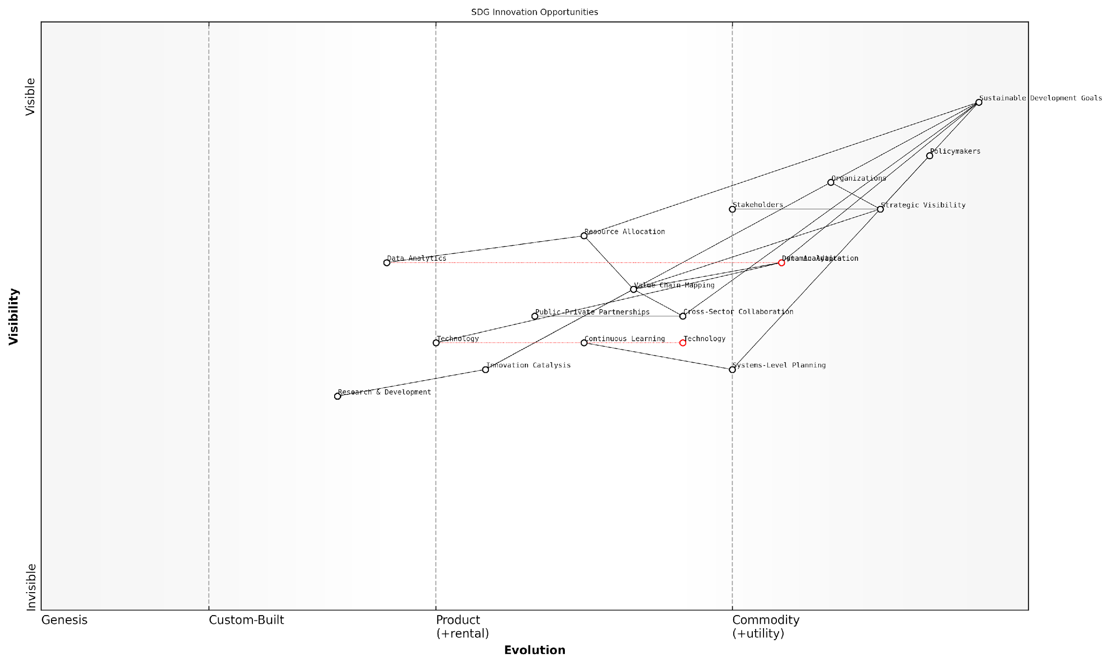

*Draft Wardley Map: [Insert Wardley Map illustrating the innovation opportunities across multiple SDGs]*

[Edit this draft Wardley Map](https://create.wardleymaps.ai/#clone:b8ddcde8e292a51dc4)

The transformative power of Wardley Mapping for SDGs extends beyond these individual aspects. It represents a fundamental shift in how we approach global sustainability challenges. By providing a structured yet flexible framework for strategic thinking, it empowers stakeholders at all levels to move from reactive problem-solving to proactive, systems-level planning.

Moreover, the application of Wardley Mapping to SDGs fosters a culture of continuous learning and improvement. As maps are created, shared, and refined, they become repositories of collective knowledge and experience. This accumulation of insights can accelerate progress across all SDGs by allowing stakeholders to learn from successes and failures in different contexts and regions.

Wardley Mapping has transformed our organisation’s approach to SDG implementation. It’s not just a planning tool; it’s a catalyst for cultural change, pushing us towards more strategic, collaborative, and innovative ways of working.

In conclusion, the transformative power of Wardley Mapping for SDGs lies in its ability to bring clarity, adaptability, collaboration, efficiency, and innovation to the complex challenge of global sustainability. As we move forward in our efforts to achieve the 2030 Agenda for Sustainable Development, embracing and mastering this strategic approach will be crucial for governments, organisations, and individuals committed to creating a more sustainable and equitable world.

The journey of mapping our way to a sustainable future has only just begun, and with Wardley Mapping as our guide, we are better equipped than ever to navigate the complexities and uncertainties that lie ahead. It is now up to us to harness this transformative power and turn our mapped strategies into tangible, lasting change for the benefit of people and planet alike.

### Best Practices for Sustainable Development Strategies

As we conclude our exploration of Wardley Mapping for the United Nations Sustainable Development Goals (SDGs), it is crucial to distil the key best practices that have emerged from our comprehensive analysis. These best practices represent the culmination of strategic insights, practical applications, and lessons learned from successful implementations across various sectors and geographies.

The integration of Wardley Mapping with SDG implementation strategies has revealed a powerful synergy that enhances the effectiveness and efficiency of sustainable development efforts. By leveraging the visual and analytical strengths of Wardley Maps, organisations and governments can navigate the complex landscape of global sustainability with greater clarity and purpose.

* Holistic System Thinking: Embrace a comprehensive view of the SDGs as an interconnected system.
* Value Chain Optimisation: Identify and focus on the most impactful components of the value chain for each SDG.
* Cross-Sector Collaboration: Utilise Wardley Maps to facilitate partnerships and align efforts across different sectors.
* Adaptive Strategy Formulation: Develop flexible strategies that can evolve with changing landscapes and emerging technologies.
* Data-Driven Decision Making: Incorporate robust data collection and analysis into the mapping process for informed strategy development.
* Stakeholder Engagement: Ensure inclusive participation in the mapping process to capture diverse perspectives and foster buy-in.
* Continuous Learning and Iteration: Regularly update maps and strategies based on new insights and changing conditions.

One of the most critical best practices is the adoption of a holistic systems thinking approach. As a senior sustainability advisor notes, ‘The SDGs are not isolated targets, but a web of interconnected goals. Wardley Mapping allows us to visualise and navigate these connections, leading to more effective interventions.’

Value chain optimisation emerges as another cornerstone of successful SDG implementation strategies. By mapping the entire value chain for each goal, organisations can identify key leverage points where interventions will yield the greatest impact. This approach ensures efficient resource allocation and maximises the effectiveness of sustainability initiatives.

Wardley Mapping has revolutionised our approach to SDG implementation. It’s not just about identifying what needs to be done, but understanding the evolutionary stage of each component and how they interact. This insight allows us to craft strategies that are both ambitious and achievable.

Cross-sector collaboration, facilitated by the shared visual language of Wardley Maps, has proven to be a game-changer in SDG implementation. Maps serve as a powerful tool for aligning diverse stakeholders, from government agencies to private sector entities and civil society organisations. This alignment is crucial for addressing the complex, multifaceted challenges presented by the SDGs.

The importance of adaptive strategy formulation cannot be overstated in the context of global sustainability. The dynamic nature of social, economic, and environmental systems demands strategies that can evolve in response to new information and changing circumstances. Wardley Mapping provides a framework for continuous strategy refinement, ensuring that SDG implementation efforts remain relevant and effective over time.

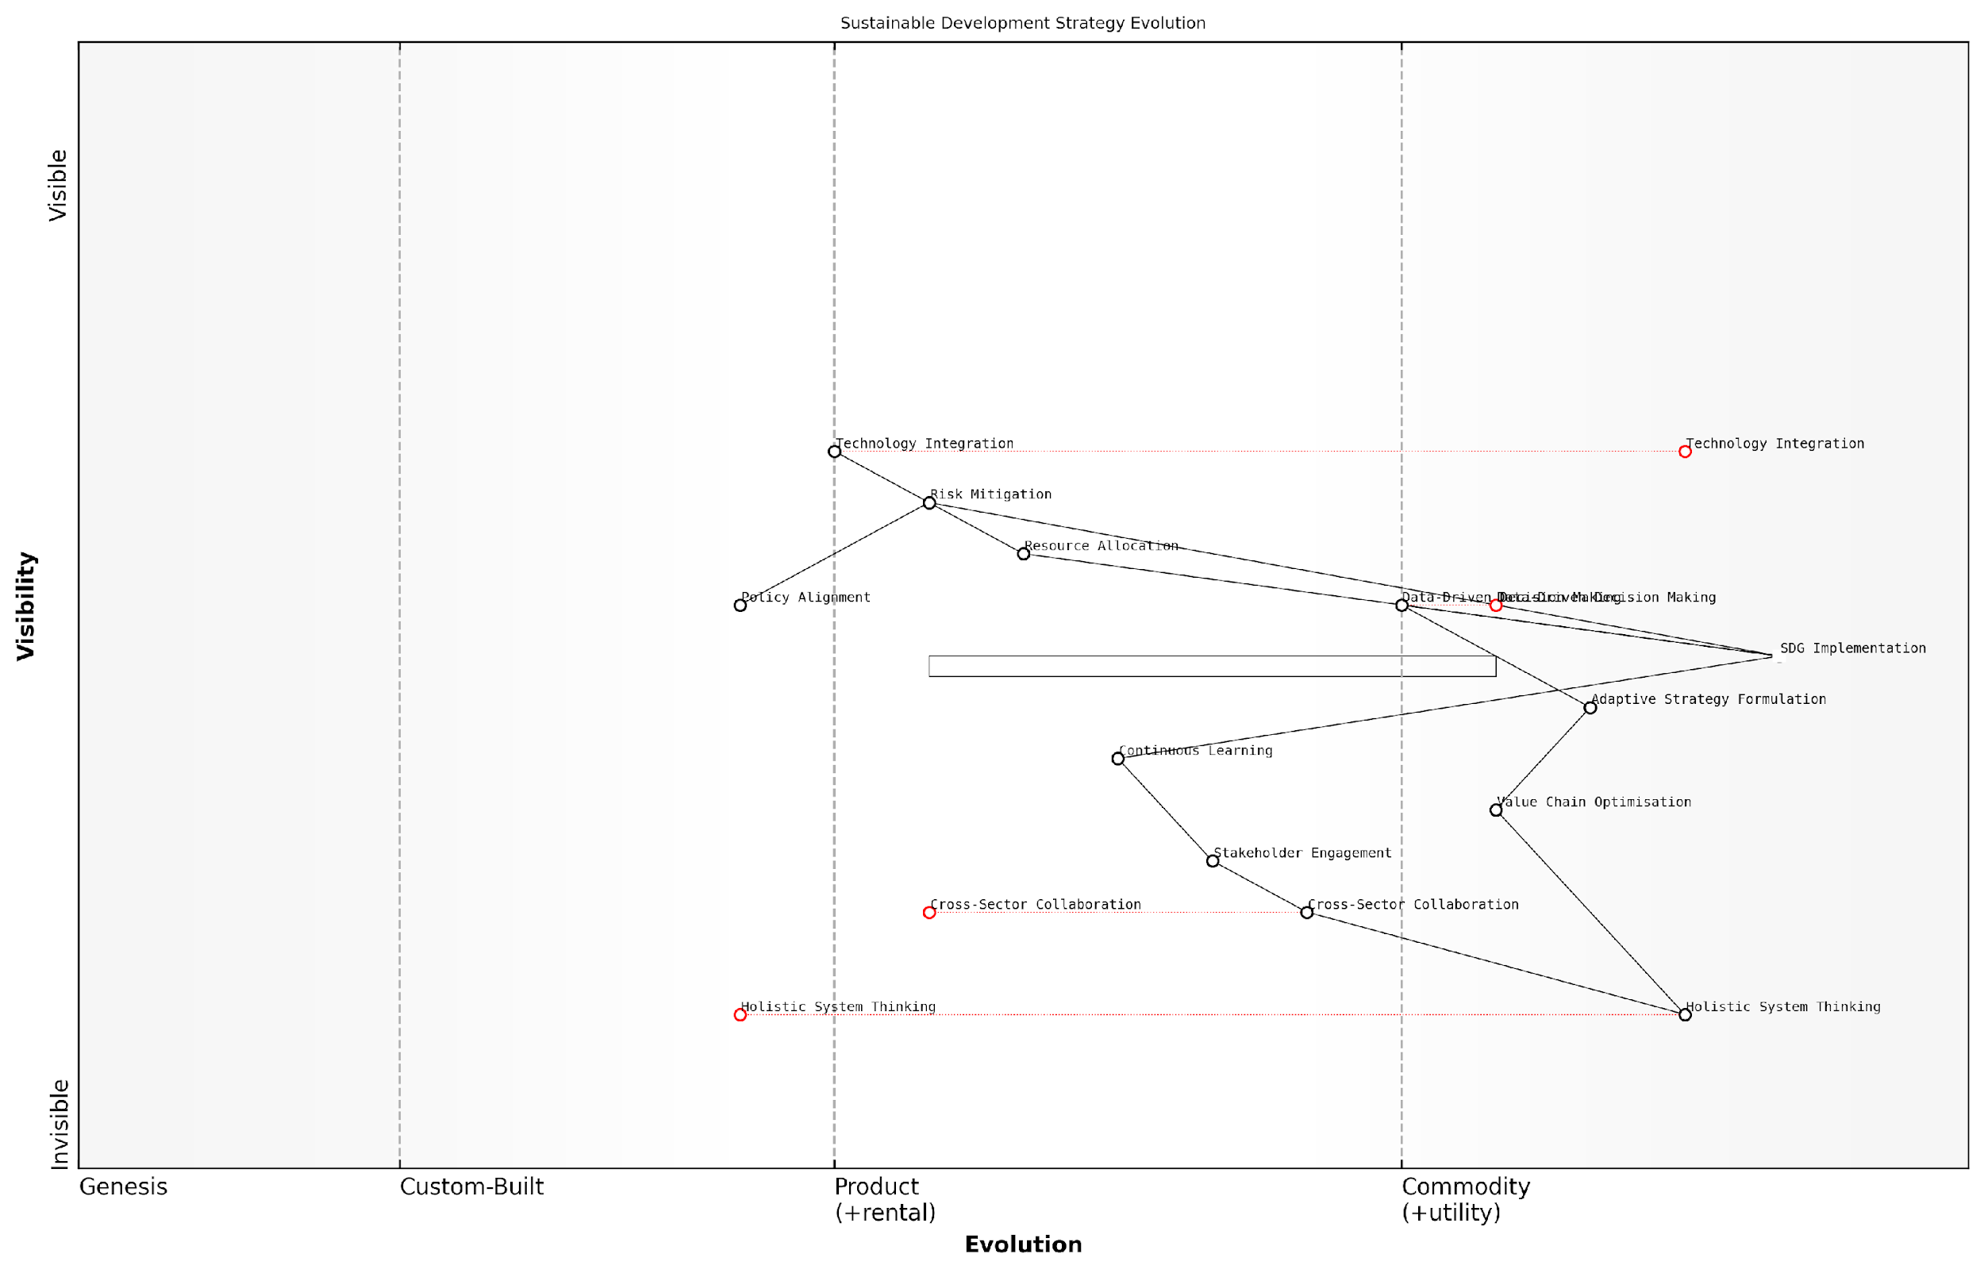

*Draft Wardley Map: [Insert Wardley Map illustrating the evolution of a sustainable development strategy over time, highlighting key decision points and adaptations]*

[Edit this draft Wardley Map](https://create.wardleymaps.ai/#clone:2b22af45576c6ab113)

Data-driven decision making is another critical best practice that has emerged from successful SDG implementations. The integration of robust data collection and analysis into the Wardley Mapping process enables more accurate positioning of components and informed strategy development. This approach helps to mitigate risks and capitalise on opportunities in the pursuit of sustainable development goals.

Stakeholder engagement throughout the mapping and strategy development process is essential for ensuring the relevance and effectiveness of SDG initiatives. Inclusive participation not only enriches the mapping process with diverse perspectives but also fosters a sense of ownership and commitment among stakeholders, which is crucial for long-term success.

The power of Wardley Mapping lies not just in the final map, but in the collaborative process of creating it. When stakeholders from different sectors come together to map out SDG strategies, we see a remarkable alignment of vision and purpose that drives real progress.

Finally, the practice of continuous learning and iteration stands out as a hallmark of effective SDG implementation strategies. The complex and evolving nature of global sustainability challenges requires a commitment to ongoing learning and adaptation. Regular updates to Wardley Maps and corresponding strategies ensure that efforts remain aligned with the latest developments and insights in the field.

In conclusion, these best practices for sustainable development strategies, grounded in the principles of Wardley Mapping, offer a robust framework for advancing the UN Sustainable Development Goals. By embracing these practices, organisations and governments can enhance their capacity to drive meaningful progress towards a more sustainable and equitable world.

As we look to the future of global sustainability efforts, the integration of these best practices with emerging technologies and evolving geopolitical landscapes will be crucial. The flexibility and insight provided by Wardley Mapping will continue to play a vital role in navigating the complexities of sustainable development, ensuring that our collective efforts yield the greatest possible impact in creating a better world for all.

### Overcoming Challenges in Global Sustainability Efforts

As we conclude our exploration of Wardley Mapping for the United Nations Sustainable Development Goals (SDGs), it is crucial to address the significant challenges that global sustainability efforts face. By leveraging the strategic insights gained through Wardley Mapping, we can develop more robust approaches to overcome these obstacles and accelerate progress towards the SDGs.

The complexity and interconnectedness of global sustainability challenges require a multifaceted approach. Wardley Mapping provides a powerful framework for visualising these complexities and identifying strategic opportunities for intervention. Let us examine some key challenges and how Wardley Mapping can help address them:

* Siloed Approaches and Lack of Coordination
* Resource Constraints and Competing Priorities
* Data Gaps and Measurement Challenges
* Technological Disparities
* Policy Incoherence and Conflicting Incentives

Siloed Approaches and Lack of Coordination: One of the most significant challenges in global sustainability efforts is the tendency for organisations and sectors to work in isolation. Wardley Mapping can help overcome this by providing a common visual language that facilitates cross-sector collaboration and highlights interdependencies between different SDGs.

Wardley Mapping has revolutionised our approach to SDG implementation. It’s like having a shared blueprint that allows diverse stakeholders to see how their efforts fit into the bigger picture, fostering unprecedented levels of collaboration.

By creating integrated maps that span multiple SDGs, policymakers and practitioners can identify synergies and potential conflicts, leading to more coherent and effective strategies. For instance, a Wardley Map comparing SDG 7 (Affordable and Clean Energy) with SDG 13 (Climate Action) might reveal opportunities for joint initiatives that address both goals simultaneously.

Resource Constraints and Competing Priorities: In a world of limited resources, governments and organisations often struggle to allocate funds and attention effectively across the 17 SDGs. Wardley Mapping can provide a strategic advantage in this context by highlighting the most impactful areas for investment and intervention.

By mapping the value chains associated with different SDGs, decision-makers can identify key leverage points where relatively small investments can yield significant returns across multiple goals. This approach allows for more efficient resource allocation and helps build a case for increased funding in critical areas.

Using Wardley Mapping, we’ve been able to identify ‘force multiplier’ initiatives that address multiple SDGs simultaneously. This has been instrumental in securing buy-in from stakeholders and maximising the impact of our limited resources.

Data Gaps and Measurement Challenges: Accurate measurement of progress towards the SDGs remains a significant challenge, particularly in developing countries. Wardley Mapping can help address this issue by highlighting critical data needs and potential sources of information.

By mapping the evolution of data collection and analysis capabilities, organisations can develop strategies to fill data gaps and improve measurement methodologies. This might involve identifying opportunities for leveraging emerging technologies, such as satellite imagery or mobile data collection, to gather more comprehensive and timely information on SDG indicators.

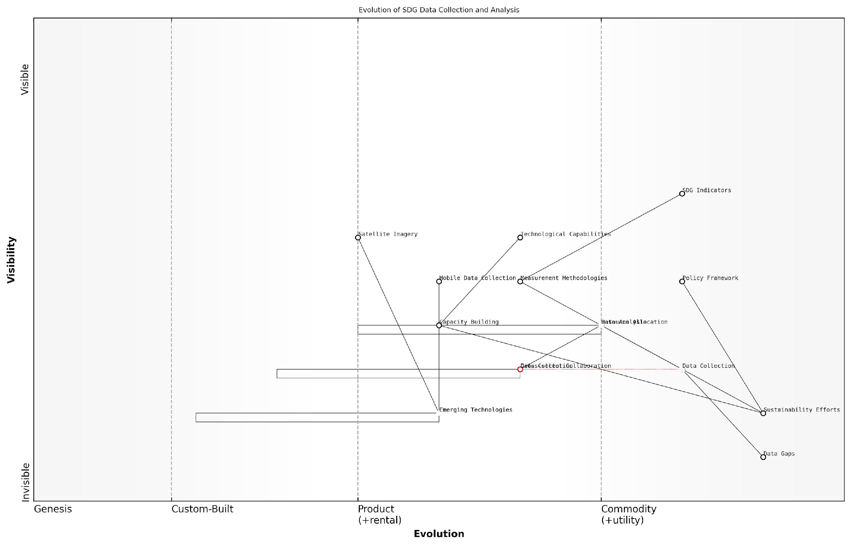

*Draft Wardley Map: [Insert Wardley Map: Evolution of SDG Data Collection and Analysis]*

[Edit this draft Wardley Map](https://create.wardleymaps.ai/#clone:a35e68cfe9a0102b10)

Technological Disparities: The uneven distribution of technological capabilities across countries and regions poses a significant challenge to global sustainability efforts. Wardley Mapping can help address this by providing a clear visualisation of the technological landscape and identifying opportunities for leapfrogging.

By mapping the evolution of key technologies relevant to the SDGs, policymakers can develop strategies to accelerate technology transfer and capacity building in less developed regions. This might involve identifying emerging technologies that are nearing commoditisation and focusing on their rapid adoption in developing countries.

Wardley Mapping has been instrumental in our efforts to bridge the technological divide. It’s allowed us to pinpoint exactly where and how we can leverage cutting-edge solutions to accelerate progress on the SDGs in developing regions.

Policy Incoherence and Conflicting Incentives: The complex nature of global sustainability challenges often leads to policy incoherence and conflicting incentives across different sectors and levels of government. Wardley Mapping can help address this by providing a holistic view of the policy landscape and its impacts on SDG implementation.

By creating maps that visualise the interactions between different policies and their effects on SDG-related value chains, policymakers can identify areas of misalignment and develop more coherent policy frameworks. This approach can help ensure that policies across different sectors and levels of government are working in harmony towards the achievement of the SDGs.

In conclusion, while the challenges facing global sustainability efforts are significant, Wardley Mapping provides a powerful tool for overcoming them. By offering a strategic, visual approach to understanding complex systems and identifying opportunities for intervention, Wardley Mapping can help accelerate progress towards the SDGs and create a more sustainable future for all.

Wardley Mapping has transformed our approach to tackling global sustainability challenges. It’s not just a tool; it’s a new way of thinking that allows us to navigate complexity, foster collaboration, and drive meaningful change at a global scale.

## The Road Ahead

### Scaling Up Wardley Mapping for Global Impact

As we stand at the precipice of a new era in global sustainability efforts, the potential for Wardley Mapping to revolutionise our approach to the United Nations Sustainable Development Goals (SDGs) cannot be overstated. The road ahead is both challenging and filled with unprecedented opportunities for transformative change. In this subsection, we will explore the strategies and considerations for scaling up Wardley Mapping to achieve global impact in the pursuit of the SDGs.

The process of scaling Wardley Mapping for SDG implementation requires a multi-faceted approach that addresses technological, organisational, and cultural dimensions. Let us delve into each of these critical aspects:

1. Technological Infrastructure:

To scale Wardley Mapping globally, we must first establish a robust technological infrastructure that can support the creation, sharing, and analysis of maps across diverse stakeholders and geographical boundaries. This infrastructure should include:

* Cloud-based platforms for collaborative mapping
* AI-powered tools for map analysis and pattern recognition
* Standardised APIs for integrating mapping data with existing SDG monitoring systems
* Mobile applications for field-based mapping and data collection

1. Capacity Building and Education:

Scaling up requires a critical mass of skilled practitioners who can effectively apply Wardley Mapping to SDG challenges. This necessitates a comprehensive capacity-building programme that encompasses:

* Online learning platforms and MOOCs on Wardley Mapping for SDGs
* Train-the-trainer programmes to create a network of certified instructors
* Integration of Wardley Mapping into sustainability and development curricula in universities
* Workshops and bootcamps for policymakers and development practitioners

1. Standardisation and Best Practices:

To ensure consistency and comparability of Wardley Maps across different contexts and SDGs, it is crucial to develop standardised methodologies and best practices. This includes:

* Establishing a global repository of SDG-specific mapping templates
* Creating guidelines for map validation and peer review processes
* Developing metrics for assessing the impact and effectiveness of Wardley Mapping in SDG implementation
* Formulating protocols for integrating Wardley Maps with other strategic planning tools

Standardisation is not about stifling innovation, but about creating a common language that allows us to collaborate more effectively across borders and sectors in our pursuit of the SDGs.

1. Multi-stakeholder Engagement:

Scaling up Wardley Mapping for SDGs requires active participation from a diverse range of stakeholders. Strategies for engagement should include:

* Establishing a global alliance of governments, NGOs, and private sector entities committed to using Wardley Mapping for SDGs
* Creating platforms for sharing success stories and lessons learned
* Organising annual global summits on Wardley Mapping for Sustainable Development
* Developing incentive structures for organisations that adopt and scale Wardley Mapping in their SDG efforts

1. Policy Integration:

To achieve true global impact, Wardley Mapping must be integrated into policy frameworks at national and international levels. This requires:

* Advocating for the inclusion of Wardley Mapping in national SDG implementation strategies
* Working with UN agencies to incorporate Wardley Mapping into their planning and reporting processes
* Developing policy briefs and recommendations for integrating Wardley Mapping into development cooperation frameworks
* Creating a global index to track the adoption and impact of Wardley Mapping in SDG implementation across countries

1. Continuous Innovation and Adaptation:

As we scale up, it is crucial to maintain a culture of innovation and adaptability. This involves:

* Establishing research partnerships with academic institutions to explore new applications of Wardley Mapping for SDGs
* Creating innovation labs to experiment with emerging technologies like blockchain and IoT in conjunction with Wardley Mapping
* Developing mechanisms for rapid feedback and iteration in mapping methodologies
* Fostering a global community of practice that can collectively address new challenges as they arise

The true power of Wardley Mapping lies not just in its ability to provide strategic clarity, but in its capacity to evolve and adapt to the ever-changing landscape of global sustainability challenges.

By addressing these key areas, we can create a robust ecosystem that supports the global scaling of Wardley Mapping for SDG implementation. However, it is important to recognise that this scaling process is not linear and will require iterative refinement based on real-world experiences and outcomes.

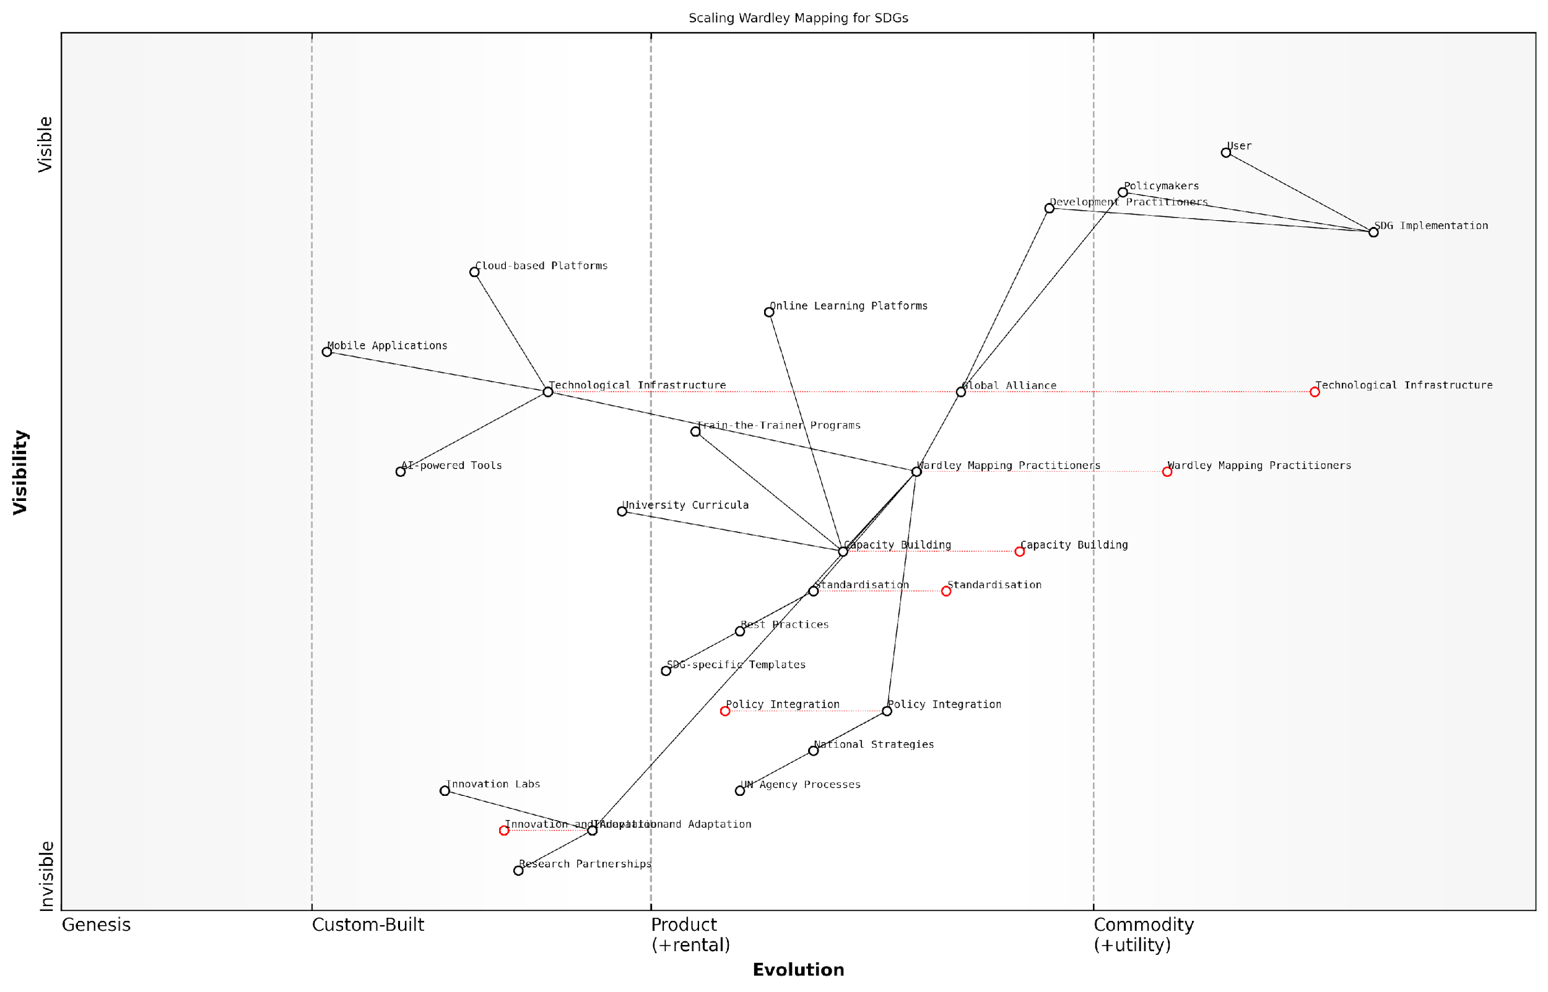

*Draft Wardley Map: [Insert Wardley Map illustrating the evolution and scaling of Wardley Mapping for SDGs, showing the movement from niche application to mainstream adoption across different sectors and geographies]*

[Edit this draft Wardley Map](https://create.wardleymaps.ai/#clone:6994a6c583950e1937)

As we embark on this journey of scaling Wardley Mapping for global impact, we must remain cognisant of the potential challenges, including resistance to change, resource constraints, and the complexity of aligning diverse stakeholder interests. However, the potential rewards – in terms of accelerated progress towards the SDGs and more effective, efficient use of resources – are immense.

The road ahead is undoubtedly challenging, but it is also filled with unprecedented opportunities for transformative change. By leveraging the power of Wardley Mapping at a global scale, we can create a more strategic, coordinated, and impactful approach to achieving the Sustainable Development Goals, ultimately building a more sustainable and equitable world for all.

### Fostering a Community of Practice

As we look towards the future of Wardley Mapping for the United Nations Sustainable Development Goals (SDGs), fostering a robust and dynamic community of practice emerges as a critical factor in driving global sustainability efforts. This community will serve as the backbone for knowledge sharing, innovation, and collaborative problem-solving in the complex landscape of sustainable development.

The concept of a community of practice, when applied to Wardley Mapping for SDGs, encompasses a diverse network of practitioners, policymakers, researchers, and innovators who are committed to leveraging strategic mapping for sustainable development. By nurturing this community, we can accelerate the adoption of Wardley Mapping techniques, refine methodologies, and create a collective intelligence that propels us towards achieving the SDGs.

* Establishing platforms for knowledge exchange
* Developing standardised practices and methodologies
* Encouraging cross-sector collaboration and learning
* Promoting continuous skill development and capacity building
* Facilitating real-world application and case study sharing

One of the primary objectives in fostering this community is to establish robust platforms for knowledge exchange. These platforms can take various forms, from digital forums and collaborative online spaces to regular conferences and workshops. The key is to create environments where practitioners can share their experiences, challenges, and successes in applying Wardley Mapping to SDG-related initiatives.

The power of a community of practice lies in its ability to aggregate diverse perspectives and experiences, creating a collective wisdom that far exceeds the sum of its parts.

Developing standardised practices and methodologies is another crucial aspect of community building. While Wardley Mapping is inherently flexible, establishing a common language and set of best practices for its application to SDGs will enhance collaboration and ensure consistency across different contexts. This standardisation should be an iterative process, evolving as the community gains more insights and experiences.

Cross-sector collaboration is at the heart of successful SDG implementation, and the community of practice should reflect this. By bringing together stakeholders from government, private sector, civil society, and academia, we can foster a holistic approach to sustainable development. This diverse community can help identify synergies between different sectors and SDGs, leading to more integrated and effective strategies.

Continuous skill development and capacity building are essential for maintaining a vibrant and effective community. This involves creating training programmes, mentorship opportunities, and resources that help practitioners at all levels enhance their Wardley Mapping skills and deepen their understanding of the SDGs. As the field evolves, so too must the capabilities of its practitioners.

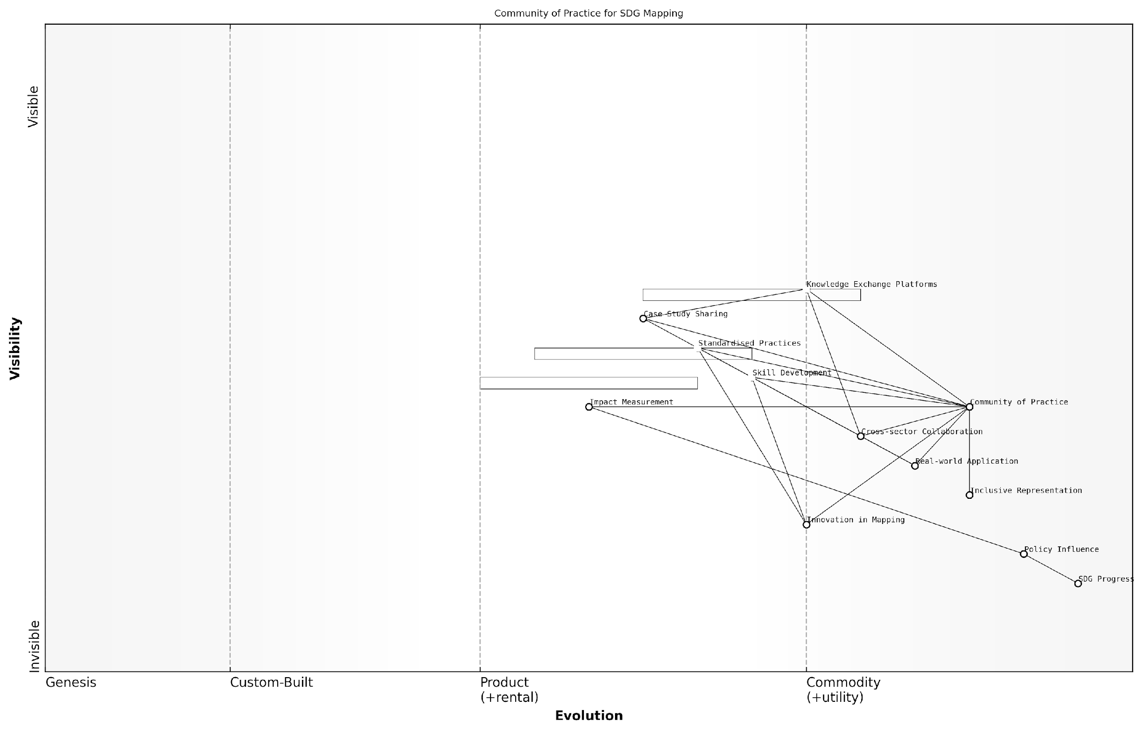

*Draft Wardley Map: [Insert Wardley Map illustrating the evolution of a community of practice for SDG mapping]*

[Edit this draft Wardley Map](https://create.wardleymaps.ai/#clone:5df97d344171d95bbf)

Facilitating real-world application and case study sharing is crucial for demonstrating the tangible impact of Wardley Mapping on SDG implementation. By documenting and disseminating success stories, challenges, and lessons learned, the community can provide valuable insights and inspiration for others embarking on similar journeys. This practical focus ensures that the community remains grounded in real-world outcomes rather than theoretical discussions.

Case studies serve as lighthouses, guiding others through the complexities of SDG implementation and illuminating paths to success that may not have been visible before.

As we look to scale up Wardley Mapping for global impact, the community of practice will play a pivotal role in driving innovation and adaptation. It will serve as a laboratory for new ideas, a testing ground for emerging methodologies, and a catalyst for transformative change in how we approach sustainable development.

However, fostering such a community is not without its challenges. Ensuring inclusivity and representation from diverse geographical and socio-economic contexts is crucial. The community must actively work to bridge digital divides and language barriers, ensuring that voices from all corners of the globe are heard and valued.

* Overcoming geographical and digital divides
* Balancing diverse perspectives and priorities
* Maintaining momentum and engagement over time
* Translating community insights into policy and action
* Measuring and demonstrating the community’s impact on SDG progress

To address these challenges, the community should leverage technology to create accessible and inclusive platforms for engagement. This might include multilingual resources, asynchronous collaboration tools, and partnerships with local organisations to reach underrepresented groups. Additionally, establishing regional hubs or chapters can help tailor activities to local contexts while maintaining a global perspective.

Measuring and demonstrating the community’s impact on SDG progress will be essential for its long-term sustainability and growth. This requires developing metrics and evaluation frameworks that capture both the quantitative and qualitative impacts of the community’s activities. By showcasing tangible outcomes, the community can attract further support, resources, and participation from key stakeholders.

A thriving community of practice is not just a network of individuals; it’s a living ecosystem that nurtures innovation, accelerates learning, and amplifies impact in the pursuit of sustainable development.

In conclusion, fostering a community of practice around Wardley Mapping for SDGs is a strategic imperative as we navigate the road ahead. This community will serve as the engine for continuous learning, innovation, and collaboration, driving us towards more effective and impactful sustainable development strategies. By investing in this community, we are not just building a network; we are cultivating a powerful force for positive change in the world.

### Continuous Learning and Improvement in SDG Strategies

As we conclude our exploration of Wardley Mapping for the United Nations Sustainable Development Goals (SDGs), it is crucial to emphasise the importance of continuous learning and improvement in our strategies. The dynamic nature of global challenges and the evolving landscape of sustainability demand an adaptive approach that embraces ongoing refinement and innovation.

The journey towards achieving the SDGs is not a linear path but rather an iterative process that requires constant evaluation, learning, and adjustment. By integrating continuous improvement into our SDG strategies, we can ensure that our efforts remain relevant, effective, and aligned with the ever-changing global context.

In the realm of sustainable development, stagnation is our greatest enemy. Our strategies must evolve as rapidly as the challenges we face, leveraging new insights and technologies to drive progress towards the SDGs.

Let us explore the key aspects of continuous learning and improvement in SDG strategies, drawing upon the power of Wardley Mapping to guide our approach.

1. Embracing a Culture of Learning

To truly embed continuous improvement in our SDG strategies, we must first cultivate a culture of learning within our organisations and across stakeholder networks. This involves:

* Encouraging experimentation and calculated risk-taking
* Fostering open dialogue and knowledge sharing among diverse stakeholders
* Valuing failure as a learning opportunity rather than a setback
* Investing in capacity building and skill development at all levels

By creating an environment that prioritises learning, we can accelerate the pace of innovation and adaptation in our SDG strategies.

1. Leveraging Data and Analytics

In the age of big data, our ability to gather, analyse, and act upon information is crucial for continuous improvement. Wardley Mapping can serve as a powerful framework for integrating data-driven insights into our strategic decision-making processes. Consider the following approaches:

* Implementing robust monitoring and evaluation systems to track progress towards SDG targets
* Utilising advanced analytics and machine learning to identify patterns and trends in sustainability data
* Developing real-time dashboards that visualise the evolving landscape of SDG implementation
* Incorporating feedback loops that allow for rapid adjustment of strategies based on emerging data

Data is the lifeblood of continuous improvement in SDG strategies. By harnessing the power of analytics, we can transform raw information into actionable insights that drive meaningful progress.

1. Adaptive Strategy Development

The static, long-term plans of yesteryear are ill-suited to the complex and rapidly changing landscape of sustainable development. Instead, we must adopt an adaptive approach to strategy development that allows for flexibility and responsiveness. Wardley Mapping provides an ideal framework for this adaptive strategy, enabling us to:

* Regularly reassess the position of components within our value chains
* Identify emerging technologies and practices that could disrupt current approaches
* Anticipate shifts in the sustainability landscape and proactively adjust our strategies
* Develop scenario-based plans that account for multiple possible futures

By embracing adaptive strategy development, we can ensure that our SDG efforts remain relevant and impactful in the face of changing circumstances.

1. Collaborative Learning Networks

The interconnected nature of the SDGs demands a collaborative approach to learning and improvement. By fostering networks of knowledge exchange and cooperation, we can accelerate the pace of innovation and scale up successful practices. Key strategies include:

* Establishing communities of practice around specific SDGs or cross-cutting themes
* Facilitating peer-to-peer learning exchanges between countries and organisations
* Creating platforms for sharing best practices, lessons learned, and innovative approaches
* Encouraging cross-sector collaborations that bring diverse perspectives to SDG challenges

In the pursuit of the SDGs, we are stronger together. Collaborative learning networks allow us to harness the collective intelligence of the global sustainability community, driving continuous improvement at an unprecedented scale.

1. Iterative Mapping and Strategy Refinement

Wardley Mapping should not be viewed as a one-time exercise but rather as an ongoing process of strategy refinement. By regularly revisiting and updating our maps, we can ensure that our SDG strategies remain aligned with the evolving landscape. This iterative approach involves:

* Conducting periodic mapping sessions to reassess the position and movement of components
* Incorporating new stakeholders and perspectives into the mapping process
* Using updated maps to identify emerging opportunities and potential roadblocks
* Adjusting resource allocation and priorities based on the insights gained from iterative mapping

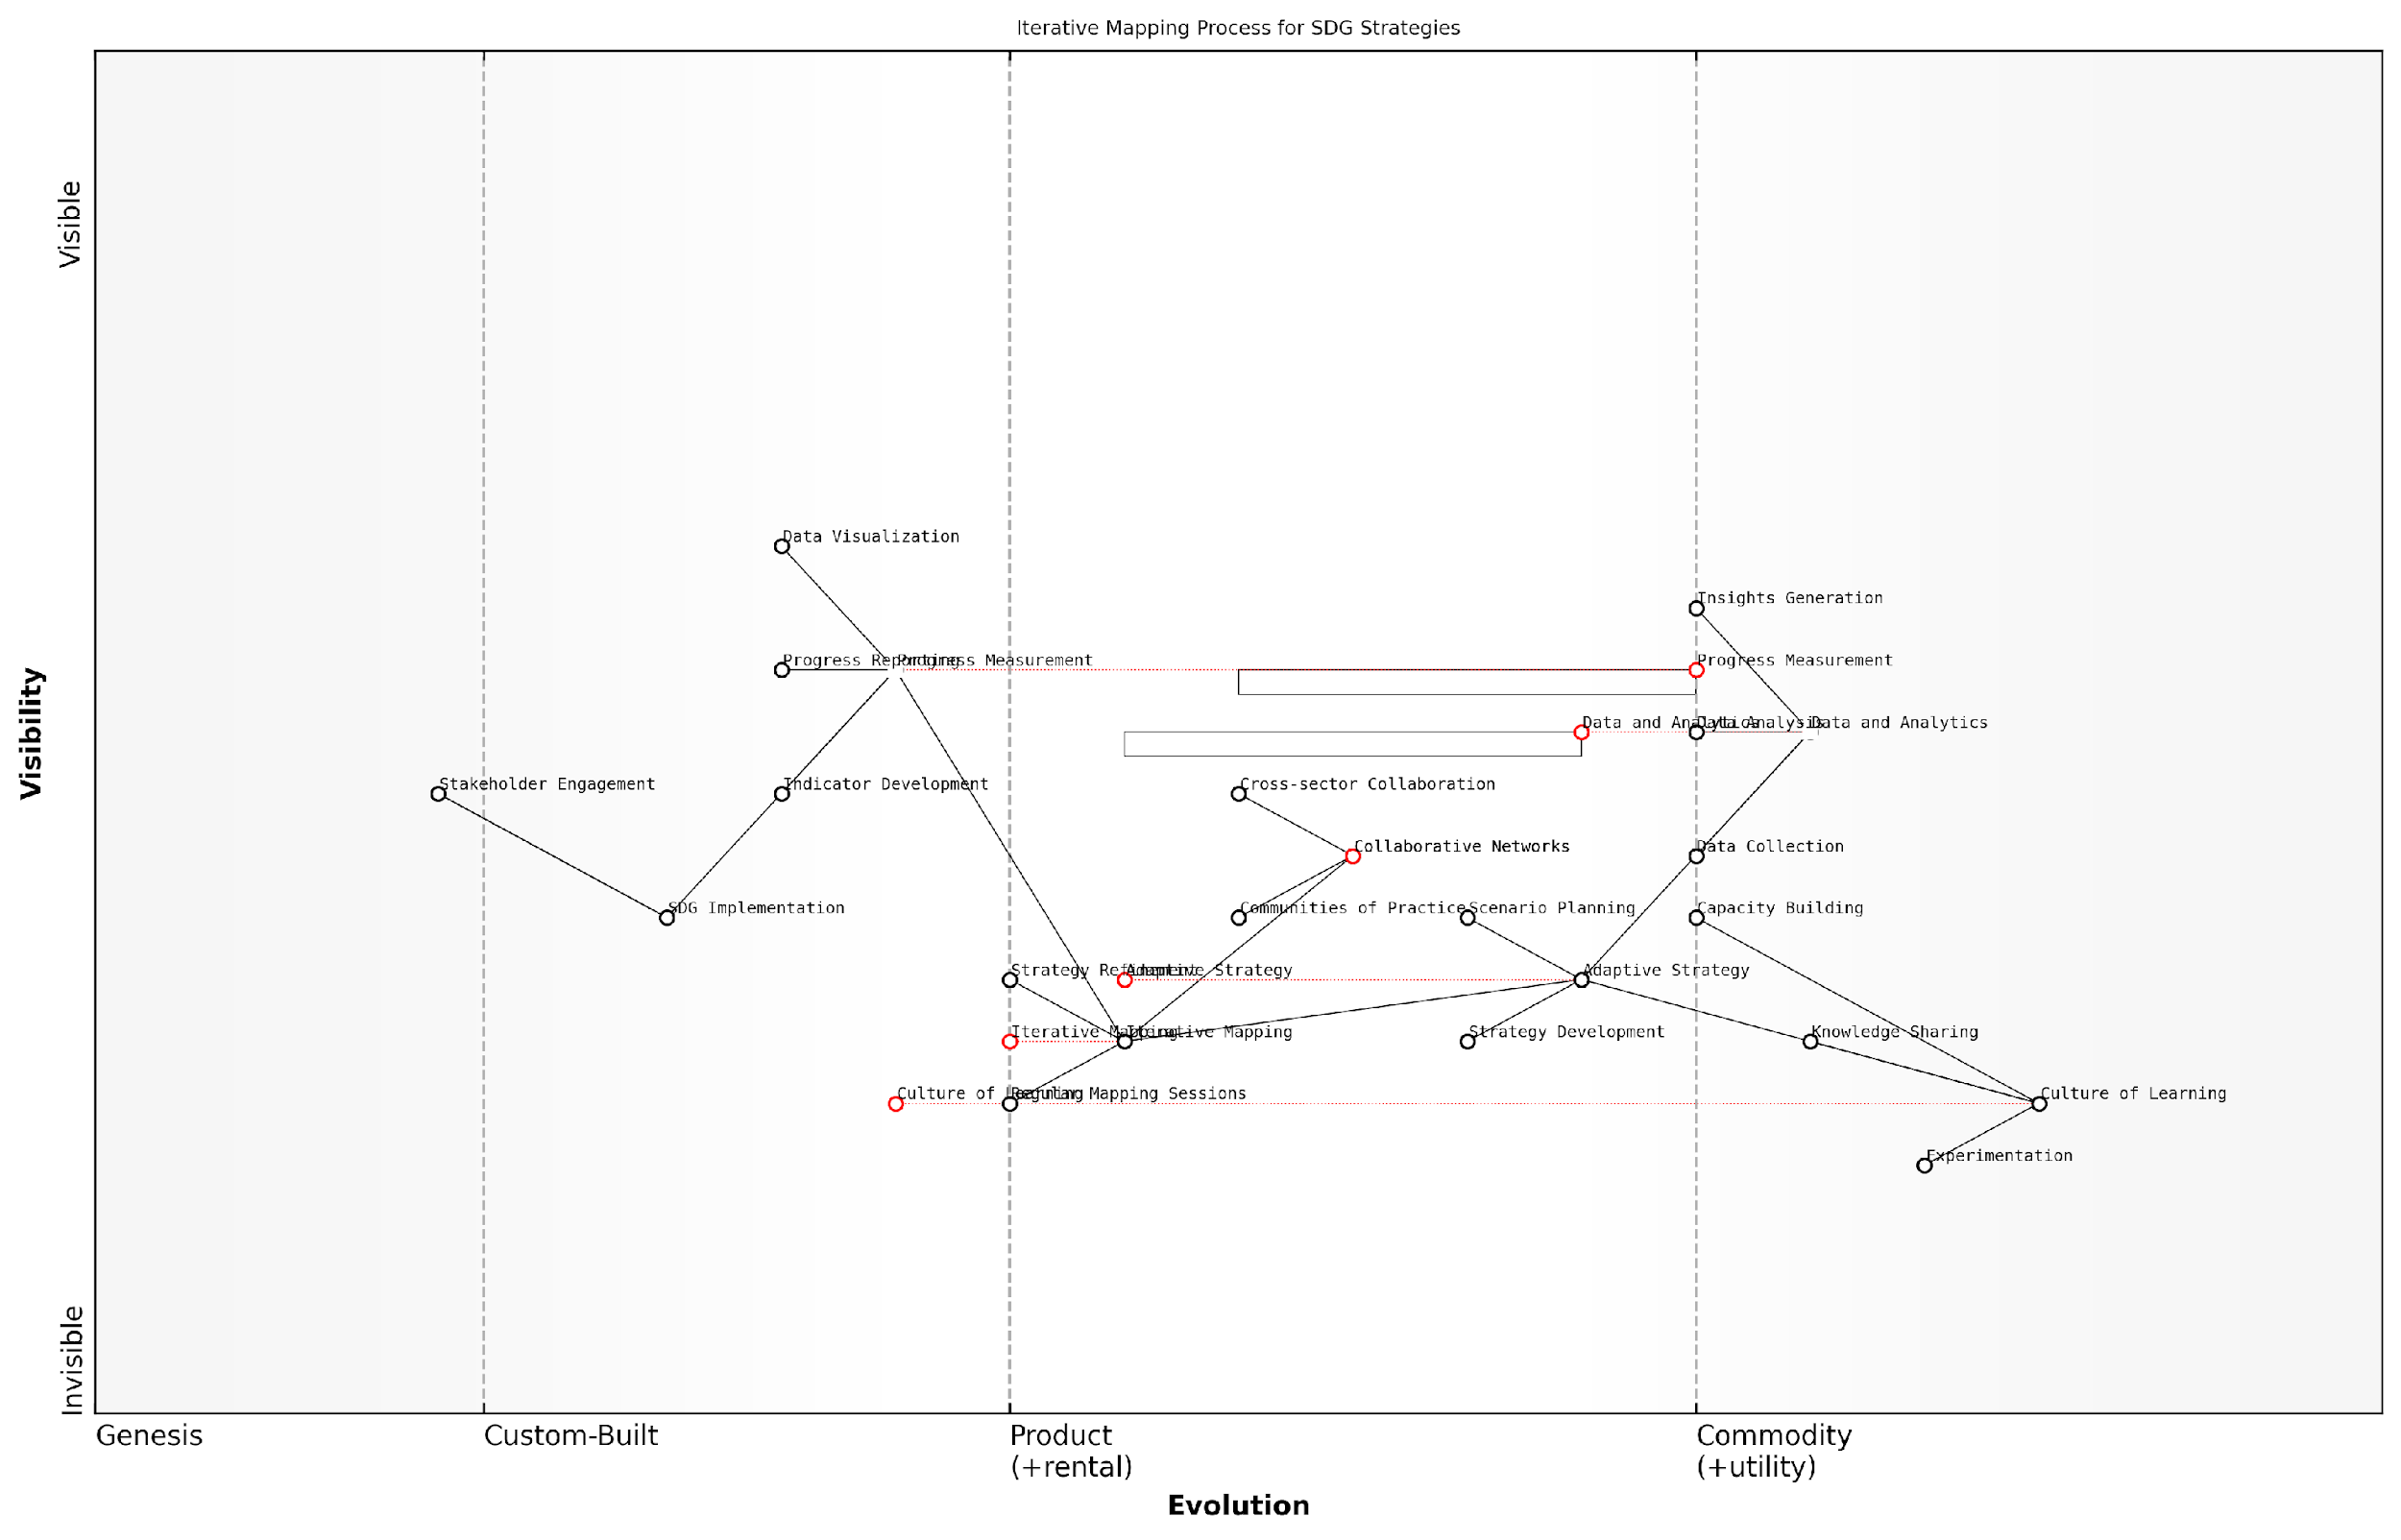

*Draft Wardley Map: [Insert Wardley Map illustrating the iterative mapping process for SDG strategies]*

[Edit this draft Wardley Map](https://create.wardleymaps.ai/#clone:61659ae63848d23c93)

1. Measuring and Communicating Progress

To drive continuous improvement, it is essential to effectively measure and communicate progress towards the SDGs. This not only helps to maintain momentum but also allows for the identification of areas requiring further attention. Consider the following approaches:

* Developing comprehensive sets of indicators that capture both quantitative and qualitative aspects of SDG progress
* Utilising innovative data visualisation techniques to make complex sustainability information accessible
* Regularly publishing progress reports that highlight achievements, challenges, and lessons learned
* Engaging stakeholders in participatory monitoring and evaluation processes

By transparently measuring and communicating our progress, we can foster accountability and drive continuous improvement in our SDG strategies.

In conclusion, continuous learning and improvement are not merely optional extras in our pursuit of the SDGs – they are fundamental to our success. By embracing a culture of learning, leveraging data and analytics, adopting adaptive strategies, fostering collaborative networks, engaging in iterative mapping, and effectively measuring progress, we can ensure that our efforts towards global sustainability remain dynamic, relevant, and impactful.

The path to achieving the SDGs is not a sprint, but a marathon of continuous improvement. With Wardley Mapping as our guide and a commitment to ongoing learning, we can navigate the complex terrain of global sustainability and create lasting positive change for generations to come.